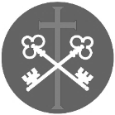
St Peter and the Holy Apostles, Plymouth
Sunday 29th March 2025
Palm Sunday of the Passion of the Lord (Year A)
Welcome to the Parish Mass
Welcome to St Peters Church. This sheet provides all that you will need for today’s Mass. If you need any assistance before, during or after the service or need a large print copy of this order of service please speak to one of our welcome team. (identifiable by a lanyard)
Please respond to the words in non-italic Bold, The Hymns are sung by all. Please inform the people on the door when you enter if you require a Gluten Free Host

No collection is taken during the Mass, but there is a collection box at the back of church for you to give your financial contribution. All money collected helps towards the mission and ministry of our churches. If you would prefer, a card reading machine is available at the back of the church for your contribution
…………………………………………………………………………………
On this day the church recalls the entrance of Christ the Lord into Jerusalem to accomplish his paschal Mystery. accordingly, the memorial of this entrance of the Lord takes place at all Masses, by means of the procession or the Solemn entrance before the principal Mass

We all Gather for the procession into church-

Cantor

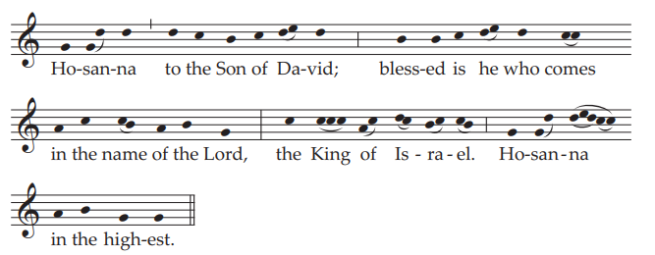

The Introductory Rite
In the name of the Father and of the Son and of the Holy Spirit.
Amen.
Following the greeting we respond. And with your spirit.
The Priest will introduce the Service
Dear brethren (brothers and sisters), since the beginning of lent until now we have prepared our hearts by penance and charitable works. Today we gather together to herald with the whole Church the beginning of the celebration of our lord’s Paschal mystery, that is to say, of his Passion and Resurrection. For it was to accomplish this mystery that he entered his own city of Jerusalem. Therefore, with all faith and devotion, let us commemorate the lord’s entry into the city for our salvation, following in his footsteps, so that, being made by his grace partakers of the Cross, we may have a share also in his Resurrection and in his life.

The Priest says the following prayer-
Let us pray. almighty ever-living God, sanctify + these branches with your blessing, that we, who follow Christ the King in exultation, may reach the eternal Jerusalem through him. Who lives and reigns for ever and ever. amen.

The Gospel concerning the Lords entrance is proclaimed

The Gospel- Matthew 21:1-11

The Lord be with you. And with your spirit.
A reading from the holy Gospel according to (N). Glory to you, O Lord.
When Jesus and his disciples drew near to Jerusalem and came to Bethphage, to the Mount of Olives, then Jesus sent two disciples, saying to them, ‘Go into the village in front of you, and immediately you will find a donkey tied, and a colt with her. Untie them and bring them to me. If anyone says anything to you, you shall say, “The Lord needs them”, and he will send them at once.’ This took place to fulfil what was spoken by the prophet, saying, ‘Say to the daughter of Sion, “Behold, your king is coming to you, humble, and mounted on a donkey, on a colt, the foal of a beast of burden.” ’
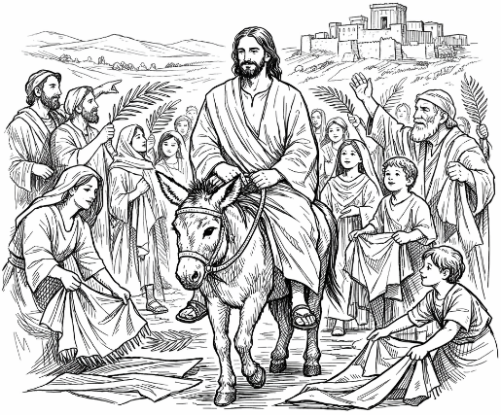
The disciples went and did as Jesus had directed them. They brought the donkey and the colt and put on them their cloaks, and he sat on them. Most of the crowd spread their cloaks on the road, and others cut branches from the trees and spread them on the road. And the crowds that went before him and that followed him were shouting, ‘Hosanna to the Son of David! Blessed is he who comes in the name of the Lord! Hosanna in the highest!’ And when he entered Jerusalem, the whole city was stirred up, saying, ‘Who is this?’ And the crowds said, ‘This is the prophet Jesus, from Nazareth of Galilee.’
The Gospel of the Lord. Praise to you, Lord Jesus Christ.
We process into church
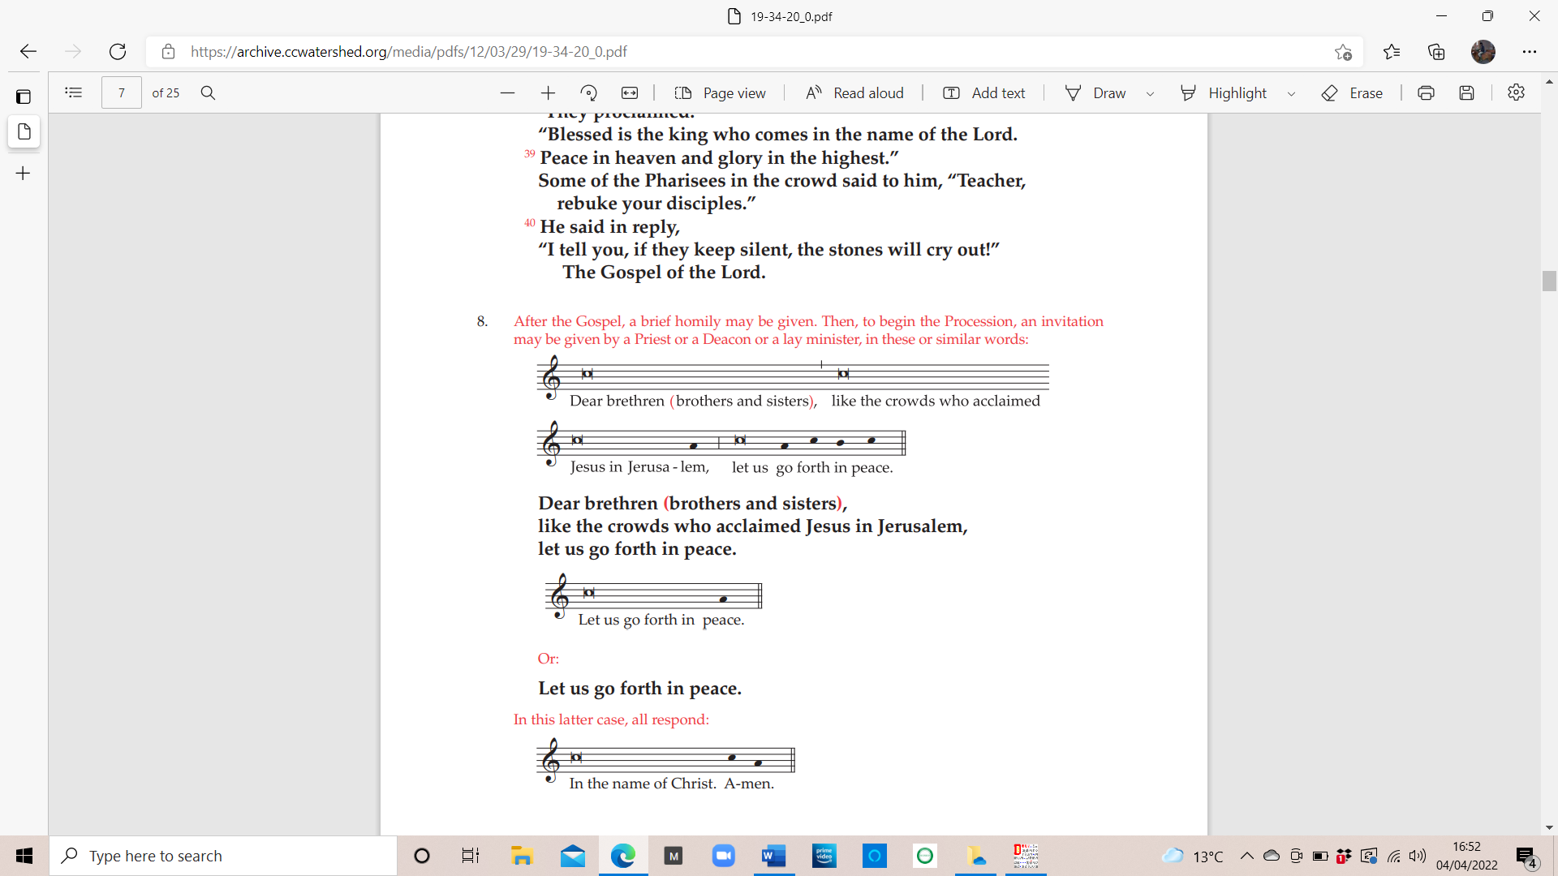
Priest

All


Entrance procession Hymns

All glory, laud, and honour
to thee, Redeemer, King!
to whom the lips of children
made sweet hosannas ring.
1. Thou art the King of Israel,
thou David's royal Son,
who in the Lord's Name comest,
the King and Blessed One. Refrain
2. The company of angels
are praising thee on high;
and mortal men and all things
created make reply. Refrain
3. The people of the Hebrews
with palms before thee went;
our praise and prayer and anthems
before thee we present. Refrain
4. To thee before thy passion
they sang their hymns of praise;
to thee, now high exalted,
our melody we raise. Refrain
5. Thou didst accept their praises;
accept the prayers we bring,
who in all good delightest,
thou good and gracious King. Refrain
…………………………………………………………………………….

1. Ride on! ride on in majesty!
Hark! all the tribes hosanna cry;
O Saviour meek, pursue thy road
with palms and scattered garments strowed.
2. Ride on! ride on in majesty!
In lowly pomp ride on to die;
O Christ, thy triumphs now begin
o'er captive death and conquered sin.
3. Ride on! ride on in majesty!
The Angel-squadrons of the sky
look down with sad and wondering eyes
to see the approaching sacrifice.
4. Ride on! ride on in majesty!
Thy last and fiercest strife is nigh;
the Father on his sapphire throne
expects his own anointed Son.
5. Ride on! ride on in majesty!
In lowly pomp ride on to die;
bow thy meek head to mortal pain,
then take, O God, thy power, and reign.
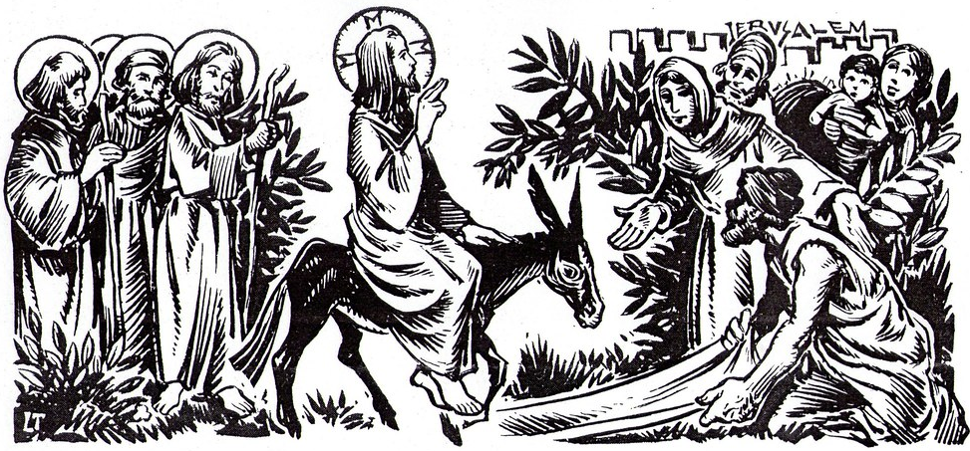

The Collect

Almighty ever-living God, who as an example of humility for the human race to follow caused our Saviour to take flesh and submit to the Cross, graciously grant that we may heed his lesson of patient suffering and so merit a share in his Resurrection. Who lives and reigns with you in the unity of the Holy Spirit, God, for ever and ever.

We sit for The First Reading- Isaiah 50:4-7

The Lord God has given me the tongue of those who are taught, that I may know how to sustain with a word him who is weary. Morning by morning he awakens; he awakens my ear to hear as those who are taught. The Lord God has opened my ear,
and I was not rebellious; I turned not backwards.
I gave my back to those who strike, and my cheeks to those who pull out the beard;
I hid not my face from disgrace and spitting. But the Lord God helps me; therefore I have not been disgraced; therefore I have set my face like a flint, and I know that I shall not be put to shame.

The word of the Lord. Thanks be to God.

Responsorial Psalm- Ps 22(21):8-9. 17-18a. 19-20. 23-24. ℟2a

Response- My God, my God, why have you forsaken me?

All who see me deride me; they curl their lips, they toss their heads:
‘He trusted in the Lord, let him save him; let him release him, for in him he delights.’R

For dogs have surrounded me; a band of the wicked besets me.
They tear holes in my hands and my feet; I can count every one of my bones. R

They divide my clothing among them, they cast lots for my robe.
But you, O Lord, do not stay afar off; my strength, make haste to help me! R

I will tell of your name to my kin, and praise you in the midst of the assembly;
‘You who fear the Lord, give him praise; all descendants of Jacob, give him glory;
revere him, all you descendants of Israel.’ R

Second reading- Philippians 2:6-11

Christ Jesus, though he was in the form of God, did not count equality with God a thing to be grasped, but emptied himself, by taking the form of a servant, being born in the likeness of men. And being found in human form, he humbled himself by becoming obedient to the point of death, even death on a cross. Therefore God has highly exalted him and bestowed on him the name that is above every name, so that at the name of Jesus every knee should bow, in heaven and on earth and under the earth, and every tongue confess that Jesus Christ is Lord, to the glory of God the Father.
The word of the Lord. Thanks be to God.

We Stand for The Gospel Procession and Acclamation- Philippians 2:8-9

Glory to you, O Christ, Glory to you, O Christ, you are the word of God, the word of God, Glory to you, O Christ.

Christ became for us obedient to the point of death, even death on a cross.
Therefore God has highly exalted him and bestowed on him the name that is above every name.

Glory to you, O Christ, Glory to you, O Christ, you are the word of God, the word of God, Glory to you, O Christ.

The Gospel- Matthew 26:14-27:66

The Passion of our Lord Jesus Christ according to Matthew

TO BE FOUND IN SEPARATE BOOKLATE
……………………………………………………………………………

We sit for The Homily

We stand The Creed
I believe in one God, the Father almighty, maker of heaven and earth,
of all things visible and invisible.
I believe in one Lord Jesus Christ, the Only Begotten Son of God, born of the Father before all ages. God from God, Light from Light, true God from true God, begotten, not made, consubstantial with the Father; through him all things were made. For us men and for our salvation he came down from heaven,
At the words that follow, up to and including ‘and became man’, all bow.
and by the Holy Spirit was incarnate of the Virgin Mary, and became man.
For our sake he was crucified under Pontius Pilate, he suffered death and was buried, and rose again on the third day in accordance with the Scriptures.
He ascended into heaven and is seated at the right hand of the Father. He will come again in glory to judge the living and the dead and his kingdom will have no end.
I believe in the Holy Spirit, the Lord, the giver of life, who proceeds from the Father and the Son, who with the Father and the Son is adored and glorified, who has spoken through the prophets.
I believe in one, holy, catholic and apostolic Church. I confess one Baptism for the forgiveness of sins and I look forward to the resurrection of the dead and the life of the world to come. Amen.


We remain standing for The Prayers of the Faithful

Each biding concludes with the following said or sung-
Lord have Mercy, Lord have Mercy, Lord have Mercy on your People.

The Priest Concludes the Prayers of the Faithful
Offertory Hymn

1. My song is love unknown,
my Saviour’s love to me;
love to the loveless shown,
That they might lovely be.
O who am I, that for my sake
my Lord should take frail flesh and die?
2. He came from his blest throne
salvation to bestow;
but men made strange, and none
the longed-for Christ would know.
But O, my Friend, my Friend indeed,
who at my need his life did spend!

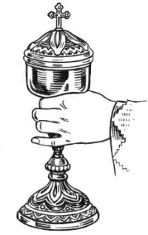
3. Sometimes they strew His way,
and His sweet praises sing;
resounding all the day
hosannas to their King.
Then 'Crucify!' is all their breath,
and for His death they thirst and cry.
4. Why, what hath my Lord done?
What makes this rage and spite?
He made the lame to run,
he gave the blind their sight.
Sweet injuries! yet they at these
themselves displease, and 'gainst him rise.
5. They rise, and needs will have
my dear Lord made away;
a murderer they save,
the Prince of Life they slay.
Yet cheerful He to suffering goes,
that He His foes from thence might free.
6. In life no house, no home
my Lord on earth might have;
in death no friendly tomb
but what a stranger gave.
What may I say? Heav'n was his home;
but mine the tomb wherein he lay.

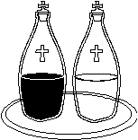
7. Here might I stay and sing:
no story so divine;
never was love, dear King,
never was grief like Thine!
This is my Friend, in Whose sweet praise
I all my days could gladly spend.
Liturgy of the Eucharist
Pray, brethren (brothers and sisters), that my sacrifice and yours may be acceptable to God, the almighty Father.
May the Lord accept the sacrifice at your hands for the praise and glory of his
name, for our good and the good of all his holy Church.

The Lord be with you. And with your spirit.

Lift up your hearts. We lift them up to the Lord.

Let us give thanks to the Lord our God. It is right and just.
The Priest continues with the Preface. The Sanctus is said or sung:
Holy, holy, holy Lord, God of host, heaven and earth are full of your glory. Hosanna in the highest.
Blessed is he who comes in the name of the Lord. Hosanna in the highest.
The Priest continues the Eucharistic prayer. The following is said or sung
The mystery of faith.
Save us, Saviour of the world, save us Saviour of the world- for by your cross and resurrection you have set us free.

The Priest concludes the Eucharistic prayer. Until…
Through him, and with him, and in him, O God, almighty Father, in the unity of the Holy Spirit, all glory and honour is yours, for ever and ever.

All say or sing: Amen.

The Lord’s Prayer
At the Saviour’s command and formed by divine teaching, we dare to say:
Our Father, who art in heaven, hallowed be thy name; thy kingdom come, thy will be done on earth as it is in heaven. Give us this day our daily bread, and forgive us our trespasses, as we forgive those who trespass against us; and lead us not into temptation, but deliver us from evil.
Deliver us, Lord, we pray… and the coming of our Saviour, Jesus Christ.
For the kingdom, the power and the glory are yours now and for ever.

The Peace
Lord Jesus Christ, who said to your Apostles: Peace I leave you, my peace I give you,
look not on our sins, but on the faith of your Church, and graciously grant her peace and unity in accordance with your will. Who live and reign for ever and ever. Amen.
The peace of the Lord be with you always: And with your spirit.
Let us offer each other the sign of peace.
All are invited to share the sign of the peace

The Agnus Dei
All say or sing:
Lamb of God, you take away the sins of the world, have mercy on us.
Lamb of God, you take away the sins of the world, have mercy on us.
Lamb of God, you take away the sins of the world, grant us peace.

The Invitation to Communion
Behold the Lamb of God, behold him who takes away the sins of the world. Blessed are those called to the supper of the Lamb.
Lord, I am not worthy that you should enter under my roof, but only say the word and my soul shall be healed.
Communion Hymn

1. O sacred head, sore wounded,
Defiled and put to scorn;
O kingly head, surrounded
With mocking crown of thorn:
What sorrow mars thy grandeur?
Can death thy bloom deflower?
O countenance whose splendour
The hosts of heaven adore.
2. In thy most bitter passion
My heart to share doth cry,
With thee for my salvation
Upon the Cross to die.
Ah, keep my heart thus movèd
To stand thy Cross beneath,
To mourn thee, well-belovèd,
Yet thank thee for thy death.

3. My days are few, O fail not,
With thine immortal power,
To hold me that I quail not
In death's most fearful hour:
That I may fight befriended,
And see in my last strife
To me thine arms extended
Upon the Cross of life.
We stand for The Prayer After Communion
Nourished with these sacred gifts, we humbly beseech you, O Lord, that, just as through the death of your Son you have brought us to hope for what we believe, so by his Resurrection you may lead us to where you call. Through Christ our Lord.

The priest may give some brief notices
The Concluding Rite
The Lord be with you. And with your spirit.
Bow down for the blessing.
Look, we pray, O Lord, on this your family, for whom our Lord Jesus Christ did not hesitate to be delivered into the hands of the wicked and submit to the agony of the Cross. Who lives and reigns for ever and ever. Amen.
And may the blessing of almighty God, the Father, and the Son, ✠ and the Holy Spirit, come down on you and remain with you for ever. Amen.
Go and announce the Gospel of the Lord. Thanks be to God.
The Final Hymn

1. O Thou, who through this holy week,
Didst suffer for us all,
The sick to heal, the lost to seek,
To raise up them that fall.
2. We cannot understand the woe
Thy love was pleased to bear:
O Lamb of God, we only know
That all our hopes are there.
3. Thy feet the path of suffering trod,
Thy hand the vict’ry won:
What shall we render to our God
For all that He hath done?
4. To God, the blessèd Three in One,
All praise and glory be:
Crown, Lord, Thy servants who have won
The victory through Thee.

The Angelus

The Angel of the Lord brought tidings to Mary.
And she conceived of the Holy Spirit.

Hail Mary, full of grace, The Lord is with Thee; Blessed art thou among women,
And blessed is the fruit of thy womb, Jesus.
Holy Mary, Mother of God, Pray for us sinners, Now and at the hour of our death.

Behold the handmaid of the Lord. Be it done to me according to thy word.
Hail Mary. . .

And the Word was made flesh. And dwelt among us.
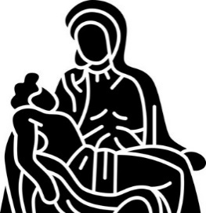
Hail Mary. . .

Pray for us, O holy Mother of God.
That we may be made worthy of the promises of Christ.

Let us pray: Pour forth, we beseech Thee, O Lord, Thy grace into our hearts, that we to whom the Incarnation of Christ Thy Son was made known by the message of an angel, may by His Passion and Cross be brought to the glory of His Resurrection. Through the same Christ Our Lord. Amen.

Holy Week
Holy Week is the most sacred time in the Christian calendar, commemorating the final days of Jesus’ life— his entry into Jerusalem, the Last Supper, crucifixion, burial, and the joy of the Resurrection. By attending church during Holy Week, Christians are invited to “walk with Jesus” through his passion, from Palm Sunday to Easter Sunday.

Holy Week lies at the heart of the Gospel, focusing on the passion, death, and resurrection of Christ. It is a time of deep reflection and spiritual formation, helping believers to contemplate Jesus’ sacrifice and God’s saving love. The Paschal Triduum— Maundy Thursday, Good Friday, and the Easter Vigil—offers the Church’s most intense immersion in this mystery and gives essential context to the celebration of Easter.

Attending church during Holy Week allows believers to experience the story together through powerful worship, ritual, and symbolism. These services strengthen community, deepen faith, renew baptismal promises, and call Christians to lives of love and service, especially through the example of Christ’s humility.

Key days include Palm Sunday, Maundy Thursday, Good Friday, Holy Saturday, and Easter Sunday— each marking an essential moment in the journey from suffering to resurrection and hope.

Holy Week is Sunday 29th March – 5th April

Holy Monday- Mass St Peter’s 10.00am Mass St Batholomew 7.00pm

Holy Tuesday- Mass St Peter’s 10.00am Mass St Francis 7.00pm

Holy Wednesday- Mass St Peter’s 10.00am Mass St Gabriel 7.00pm

Maundy Thursday- Mass of the Lords Supper
followed by watch until midnight St Peter’s 7.30pm


Good Friday- St Peter’s 10.00am Outdoor Stations of The Cross
St Peter’s 3.00pm Liturgy of the Passion

Holy Saturday- St Peter’s Vigil & First mass of Easter 8.00pm
Easter Day- Mass with Hymn- St Thomas 8.30am
Sung Mass- St Peter’s 10.00am

The Notices
Please keep Gwen and Fr Phillip especially in your prayers as she is very ill at this time.

Monday to Wednesday of Holy Week church cleaning from 11.00 -12.00
Holy Saturday from 10.00am All Hands on Deck! To get the church clean and ready for Easter

Easter cards are available on the table in Cloisters, donations in the wooden box

Annual Parochial Church Meeting is on Sunday 19th April at 12.00noon

Easter Flowers for Church- Julian is happy to receive donations for flowers for Easter and/or any offers of help with the flowers on holy Saturday

Kathleen Haydon’s Funeral will take place on Saturday11th April 2026 at 12.00 noon, at St Gabriel’s. Fr Keith would like you to attend the reception following the requiem in the hall at St Gabriel’s

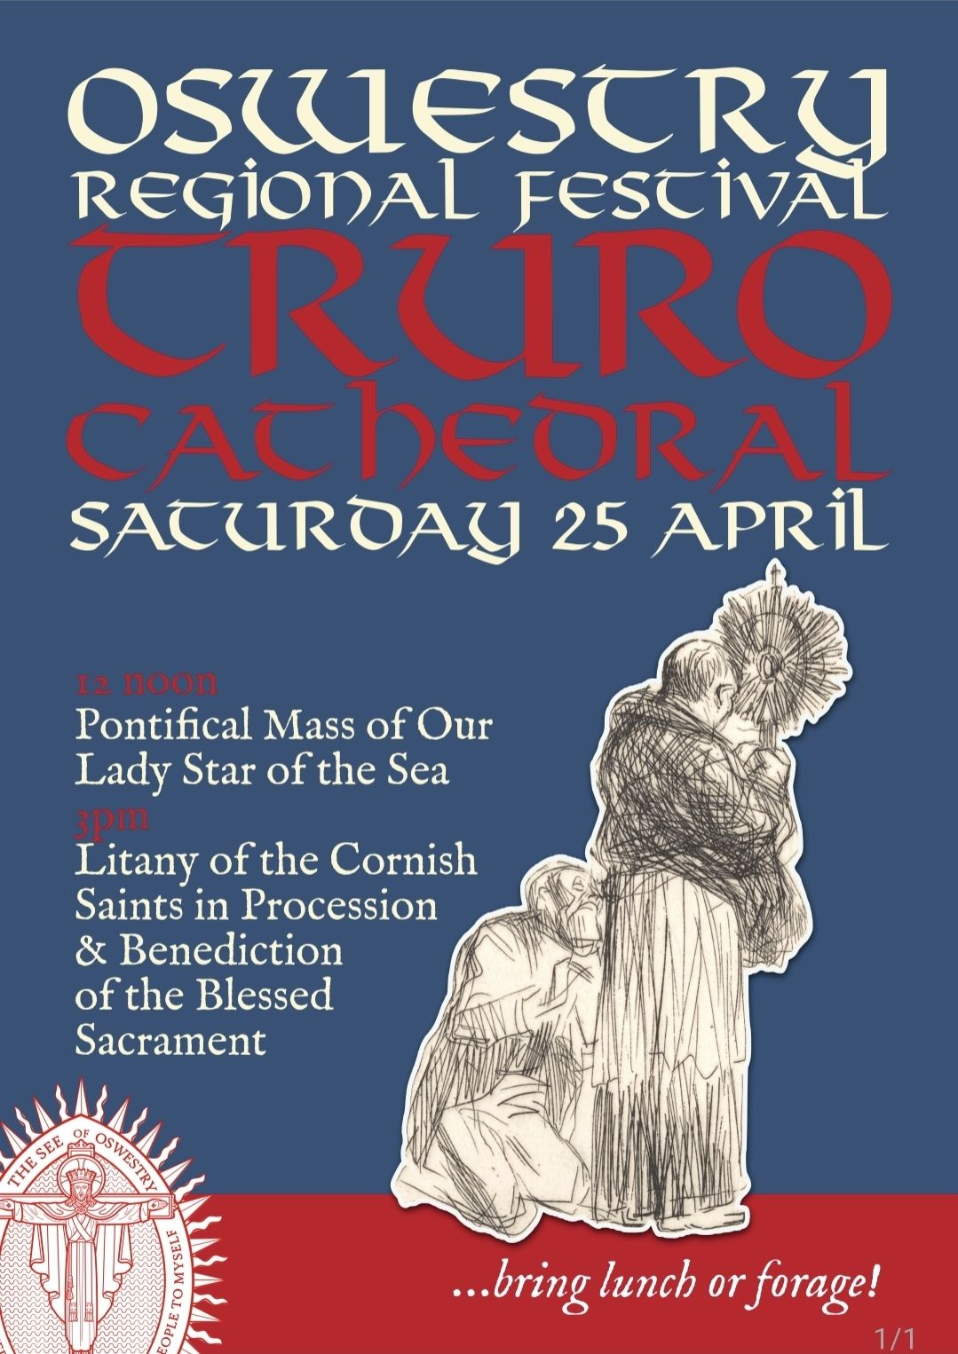

For Prayer

Those who have asked for our prayers…. Denise, Janice Allin, Leslie Porch,
Sheila Tucker, Tina Smart, Bobby Lilicrap, June Brock, Emma Addison, Georgie Maher, Ian Craggs, Brenda Alderson, Lois Tobin, Brenda Steed, Anne Lewis, Jenny Harvey, Jackie Morrison, Anna, Gwen Lamb, Anna Lynch, Helen Lewis, Val Bradden, Cynthia Way, Pauleen Stewart, Amelia Coughlan, Roger Lewis, Shaun Carrie, Fr Jon Bielawski, Catherine Samuel, Julian Davies, Fr Michael Brown.

Recently Departed- Kathy Haydon

Anniversaries of Death-
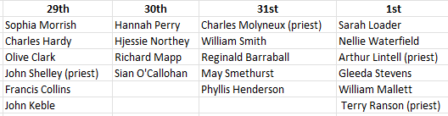


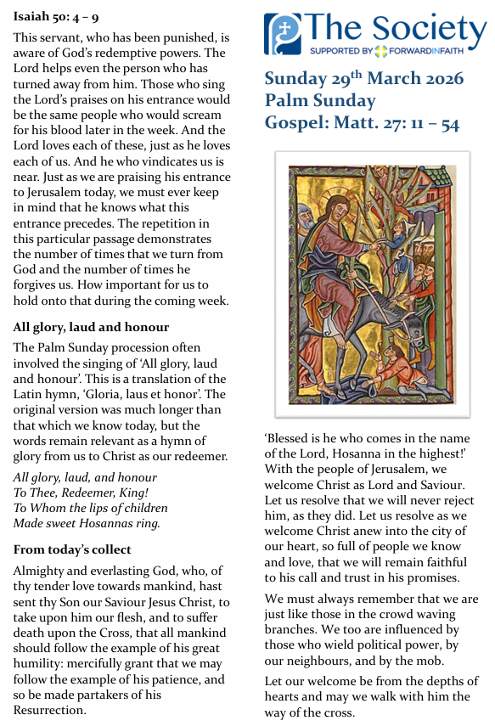
The Mission Community of St Peter and the Holy Apostles
St Peter, Wyndham Square + St Thomas, Royal Navy Avenue + St James-the-Less, Ham Drive

A Church of England Parish in the care of the Bishop of Oswestry

Parish Priest Fr. David Way SSC: 01752 240119 fr.davidway@gmail.com

Mission Development Minister/ LLM/ Parish Ordinand: Ben Otley 07939800544 benotley.mission.plym@gmail.com

Parish Website: plymouthstpeter.co.uk ~ FOR MUCH MORE INFORMATION ON EVENTS, ETC.

This week’s services- Holy Week

Monday 30th-
Holy Monday- Mass St Peter’s 10.00am Mass St Batholomew 7.00pm

Tuesday 31st-
Holy Tuesday- Mass St Peter’s 10.00am Mass St Francis 7.00pm

Wednesday 1st April
Holy Wednesday- Mass St Peter’s 10.00am Mass St Gabriel 7.00pm

Thursday 2nd- Maundy Thursday- Mass of the Lords Supper
followed by watch until midnight St Peter’s 7.30pm

Friday 3rd- Good Friday- St Peter’s 10.00am Outdoor Stations of The Cross
St Peter’s 3.00pm Liturgy of the Passion

Saturday 4th- Holy Saturday- St Peter’s Vigil & First mass of Easter 8.00pm

Sunday 5th- Easter Day- Mass with Hymn- St Thomas 8.30am
Sung Mass- St Peter’s 10.00am

St Peters is open daily 8.30am- 12noon- Place of Welcome, Place of Prayer.

Safeguarding: If you have any concerns regarding the safety of children and others who are vulnerable, regardless of age, you must tell the Duty Priest or our parish Lay Safeguarding Representative- Jackie Morrison- email randj49@gmail.com Tel 07848859124.

For online donations please scan the QR code

