NEWSLETTER NUMBER 312

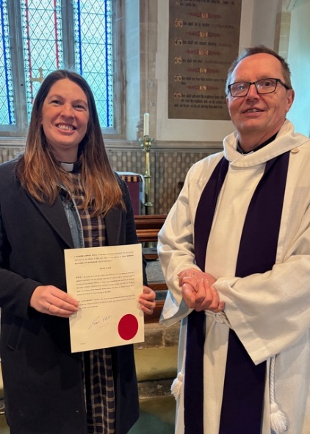
Here is a picture of Archdeacon Simon Hill with our new curate Rev Sarah Rowden following her licensing at Bathealton last Sunday. She will be shadowing Rev Andy for a few weeks, so it will be a good idea if we can all recognise her when she comes and make her feel welcome.

OUR SERVICE ON SUNDAY 15TH MARCH 2026 – LENT 4/MOTHERING SUNDAY
This will be a Mothering Sunday Family Eucharist stating at 10.30 a.m. and will include flower posies for children to give to their mothers. The celebrant will be Rev David Burton. Refreshments will be served after the service so please stay to chat if you can.

LOOKING FORWARDS – REV ANDY

ROTA FOR SUNDAY 15/3/2026
Sidesmen:- Rachel Yates and Angela Setter
Reader:- Not needed
Coffee:- Rachel Yates and Angela Setter
Flowers:- None as Lent

READINGS FOR SUNDAY 15/3/2026 – LENT 4/MOTHERING SUNDAY
Collect:- God of compassion, whose Son Jesus Christ, the child of Mary, shared the life of a home in Nazareth, and on the cross drew the whole human family to himself: strengthen us in our daily living that in joy and in sorrow we may know the power of your presence to bind together and to heal; through Jesus Christ your Son our Lord, who is alive and reigns with you, in the unity of the Holy Spirit, one God, now and for ever. Amen

Readings:-
Colossians Chapter 3, vv 12 - 17
Luke Chapter 2, vv 41 - 52

PRAYER LIST
Elizabeth Miles
Eunice Durrance
Ian Sansom
John Wilkie
Mike Toogood
Pam Wilkie
Paul Tatnall
Stephen Daley
Susan Dobson

YEARS MIND FOR MARCH
16th George Chapling Harris
17th Vera Troake
20th Laurie Fouracre

BIRTHDAY LIST FOR MARCH
19th John Evans
We all hope you have a very enjoyable birthday celebrating with your family.

OUTREACH GROUPS
Soup ‘n’ a Bite
This will be on Saturday 14th March 2026 at 12.00 noon. It will be the normal fare of soup, bread, cheese and fruit combined with lots of conversation!

Recycled Teenagers
The next meeting will take place on Tuesday, 24th March2026 at 2.30 p.m. Come along and enjoy cups of tea plus sandwiches and cakes along with some conversation.

Knit, Sew and Natter
The next meeting will be on Thursday, 2nd March 2026 at 2.00 p.m. It will be the usual meeting with lots of chat and refreshments.
Shanty Singing
The next meeting of this group will be at 6.00 p.m. on Sunday 5th April 2026. You do not have to have been to any previous meeting to join any session of shanty singing.

NEW - Churchyard Group
We have made a start on weeding the raised beds and filling them with compost. If you are willing to help, the next meeting will be at 10.00 a.m. on Tuesday 24th March if anyone is free. Bring your own trowel etc!

OUR NEXT SERVICES
1) The next service at All Saints’ Church will be a Sung Eucharist starting at 10.30 a.m. on Sunday 22nd March 2026. The celebrant will be Rev Andy Barton. There will be coffee and chat after the service.
2) In the afternoon there will be the next Families@4 event. This will include the normal mix of refreshments, craft, songs etc and is aimed at families with primary age children.

OTHER INFORMATION
Annual Parochial Church Meeting
This will take place at 12.00 noon on Sunday 10th May 2026. It will follow on from our service and give us a chance to have coffee first. This is your chance to vote for Churchwardens, PCC members, to see the accounts etc.

Electoral Roll
To be able to attend and speak at the Annual Parochial Church Meeting, you need to be on the Electoral Roll. Please check the list of names on the notice board at the back of the church. If you need to sign up, there are forms to complete on the table by the south door. Please hand completed forms to Sheila Rabson by XXXXXXXX

Communion meditation
You may remember that Anthony Knight came and performed on his violin after our service some years ago. He is now at the Royal College of Music and will be coming to play during communion shortly. He is still raising money for UNICEF. See the poster on the wall.

Rev Andrew Norris writes:-
On the “Home Service” (broadcast on 105.3 FM on Wednesdays at 11.00am) this week:
A chance to listen to the World Day of Prayer service led by Christian women from across the churches in Wellington, utilising material generated by Christian women in Nigeria on the theme of "I will give you rest". Recorded 6th March.
If you have prayer or song requests or want others to know about what is happening in your church, contact revandrew@10Radio.org


FUN CORNER
More items from Lost in translation:-
Notice in an Indian National Park “Ramganga river is inhabited by crocodiles. Swimming is prohibited. Survivors will be prosecuted.”
From Tibet “Reception Centre for the unorganised tourist.”
From China “Little grass is smiling slightly, please walk on the pavement.”
From Germany “It is strictly forbidden on our Black Forest camping site that people of different sex, for instance men and women, live together in one tent unloess they are married with each other for that purpose.”

