Sunday 8th March 2026 St Mary’s, Woodhouse
WE WELCOME YOU, for we are all one in Christ Jesus

MISSION  Our Mission Statement  Our Mission is to make known the Gospel and love of Jesus Christ. We hope that you experience us as a safe, sacramental, welcoming, loving and inclusive Kingdom people who seek to make Christ present in the hearts of all.  Safeguarding  The parishes of St Paul’s, Woodhouse Eaves & St Mary’s, Woodhouse, are committed to the safeguarding of children, young people and adults. We follow the House of Bishops’ guidance and policies, and have our own Parish Safeguarding Officers. If you are concerned that a child or adult has been harmed or may be at risk of harm please contact –  ST PAUL’S - Safeguarding  Co-ordinator: Tony Lane  07977 924 677  ST MARY’S - Safeguarding  Co-ordinator: Andrea Farnsworth 07958 376 963  As a Benefice, we affirm that it is about not just a set of policies and procedures, but about all of us as the body of Christ sharing the responsibility for making God’s Church as safe as we can  Please take this pew sheet  home and recycle it when you’ve read it. Thank you | 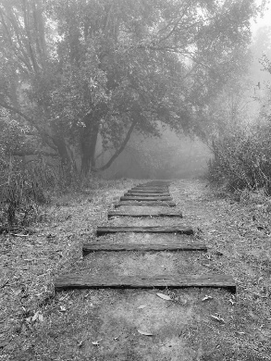 | PRAYER  Let us use our time  before the service  to talk to God,  during the service  may God talk to us, and  after the service  let us talk to one another  If you would like someone to listen or to pray with you, please contact your Parish Priest:  Rev’d Lisa Temperley-Barnes - 01509 890 972  If you would like us to pray for someone by name in our Sunday services and through the week, please email Rev’d Lisa or Stephen  Lent Bible Studies  St Paul’s  Church  1.45pm each  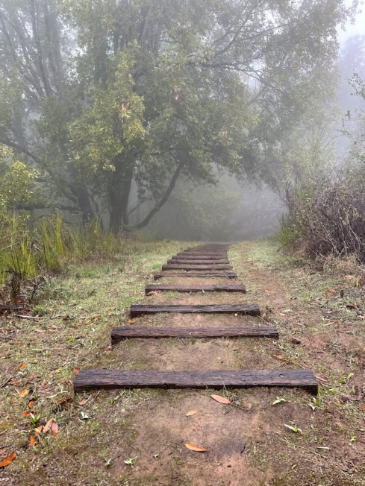  week on -  9th March,  16th March  23rd March  (all Mondays)  Do join us over a cuppa,  as we share thoughts and reflections on the meaning  of Lent in the Bible,  supporting each other on our Lenten journeys.  Photo by Jamie Ginsberg on Unsplash  Holy Week and Easter Services  Palm Sunday: 29th March  9.45am Sung Eucharist, St Paul’s  11.15am Holy Eucharist, St Mary’s  Maundy Thursday: 2nd April  7.00pm Holy Eucharist  and Stripping of the Altars, St Paul’s  Good Friday: 3rd April  11.15am Good Friday Service  of Ante-Communion, St Mary’s  3.00pm Palm Sunday Service, St Paul’s  Easter Sunday: 5th April  9.45am Sung Eucharist, St Paul’s  11.15am Holy Eucharist, St Mary’s |  | We pray for all who are ill  for Dennis, June Shilton,  Sue and John Thorne  We remember before God  the faithful departed  Gill Kelly, Barbara Prince,  Eddie Sykes  and from St Mary’s  Book of Remembrance  Kenneth Frank Richardson  and from St Paul’s  Book of Remembrance  John George Cooper,  Hilary Gail Selby, Helen Lowsley,  Phyllis Margaret Bennett,  Peter William Dutton  Rest eternal grant unto them, O Lord, and let light perpetual shine upon them. May the souls of the faithful departed through the mercy of God, rest in peace and rise in glory. Amen  ASH WEDNESDAY COLLECT  Almighty and everlasting God, who hatest nothing that thou hast made, and dost forgive the sins of all them that are penitent: Create and make in us new and contrite hearts, that we worthily lamenting our sins, and acknowledging our wretchedness, may obtain of thee, the God of all mercy, perfect remission and forgiveness; through Jesus Christ our Lord. Amen  COLLECT FOR THE  3rd SUNDAY IN LENT  We beseech thee, Almighty God, look upon the hearty desires of thy humble servants, and stretch forth the right hand of thy Majesty, to be our defence against all our enemies; through Jesus Christ our Lord. Amen  
3rd Sunday in Lent Sung Eucharist
EPISTLE The Epistle is written in the book of Numbers, the twenty-second chapter, beginning at the twenty-first verse  Balaam got up in the morning, saddled his donkey and went with the Moabite officials. But God was very angry when he went, and the angel of the Lord stood in the road to oppose him. Balaam was riding on his donkey, and his two servants were with him. When the donkey saw the angel of the Lord standing in the road with a drawn sword in his hand, it turned off the road into a field. Balaam beat it to get it back on the road. Then the angel of the Lord stood in a narrow path through the vineyards, with walls on both sides. When the donkey saw the angel of the Lord, it pressed close to the wall, crushing Balaam’s foot against it. So he beat the donkey again. Then the angel of the Lord moved on ahead and stood in a narrow place where there was no room to turn, either to the right or to the left. When the donkey saw the angel of the Lord, it lay down under Balaam, and he was angry and beat it with his staff. Then the Lord opened the donkey’s mouth, and it said to Balaam, ‘What have I done to you to make you beat me these three times?’ Balaam answered the donkey, ‘You have made a fool of me! If only I had a sword in my hand, I would kill you here and now.’ The donkey said to Balaam, ‘Am I not your own donkey, which you have always ridden, to this day? Have I been in the habit of doing this to you?’ ‘No,’ he said. Then the Lord opened Balaam’s eyes, and he saw the angel of the Lord standing in the road with his sword drawn. So he bowed low and fell face down. Numbers 22:21-31  Here endeth the Epistle  GOSPEL  The holy Gospel is written in the Gospel according to St John, the fourth chapter, beginning at the fifth verse  Jesus came to a Samaritan city called Sychar, near the plot of ground that Jacob had given to his |  | son Joseph. Jacob’s well was there, and Jesus, tired out by his  journey, was sitting by the well. It was about noon. A Samaritan woman came to draw water, and Jesus said to her, ‘Give me a drink’. (His disciples had gone to the city to buy food.) The Samaritan woman said to him, ‘How is it that you, a Jew, ask a drink of me, a woman of Samaria?’ (Jews do not share things in common with Samaritans.) Jesus answered her, ‘If you knew the gift of God, and who it is that is saying to you, “Give me a drink”, you would have asked him, and he would have given you living water.’ The woman said to him, ‘Sir, you have no bucket, and the well is deep. Where do you get that living water? Are you greater than our ancestor Jacob, who gave us the well, and with his sons and his flocks drank from it?’ Jesus said to her, ‘Everyone who drinks of this water will be thirsty again, but those who drink of the water that I will give them will never be thirsty. The water that I will give will become in them a spring of water gushing up to eternal life.’ The woman said to him, ‘Sir, give me this water, so that I may never be thirsty or have to keep coming here to draw water.’ Jesus said to her, ‘Go, call your husband, and come back.’ The woman answered him, ‘I have no husband.’ Jesus said to her, ‘You are right in saying, “I have no husband”; for you have had five husbands, and the one you have now is not your husband. What you have said is true!’ The woman said to him, ‘Sir, I see that you are a prophet. Our ancestors worshipped on this mountain, but you say that the place where people must worship is in Jerusalem.’ Jesus said to her, ‘Woman, believe me, the hour is coming when you will worship the Father neither on this mountain nor in Jerusalem. You worship what you do not know; we worship what we know, for salvation is from the Jews. But the hour is coming, and is now here, when the true worshippers will worship the Father, in spirit and truth, for |  | the Father seeks such as these to worship him. God is spirit, and  those who worship him must worship in spirit and truth.’ The woman said to him, ‘I know that Messiah is coming’ (who is called Christ). ‘When he comes, he will proclaim all things to us.’ Jesus said to her, ‘I am he, the one who is speaking to you.’ Just then his disciples came. They were astonished that he was speaking with a woman, but no one said, ‘What do you want?’ or, ‘Why are you speaking with her?’ Then the woman left her water-jar and went back to the city. She said to the people, ‘Come and see a man who told me everything I have ever done! He cannot be the Messiah, can he?’ They left the city and were on their way to him. Meanwhile the disciples were urging him, ‘Rabbi, eat something.’ But he said to them, ‘I have food to eat that you do not know about.’ So the disciples said to one another, ‘Surely no one has brought him something to eat?’ Jesus said to them, ‘My food is to do the will of him who sent me and to complete his work. Do you not say, “Four months more, then comes the harvest”? But I tell you, look around you, and see how the fields are ripe for harvesting. The reaper is already receiving wages and is gathering fruit for eternal life, so that sower and reaper may rejoice together. For here the saying holds true, “One sows and another reaps.” I sent you to reap that for which you did not labour. Others have laboured, and you have entered into their labour.’ Many Samaritans from that city believed in him because of the woman’s testimony, ‘He told me everything I have ever done.’ So when the Samaritans came to him, they asked him to stay with them; and he stayed there for two days. And many more believed because of his word. They said to the woman, ‘It is no longer because of what you said that we believe, for we have heard for ourselves, and we know that this is truly the Saviour of the world.’  John 4:5-42

