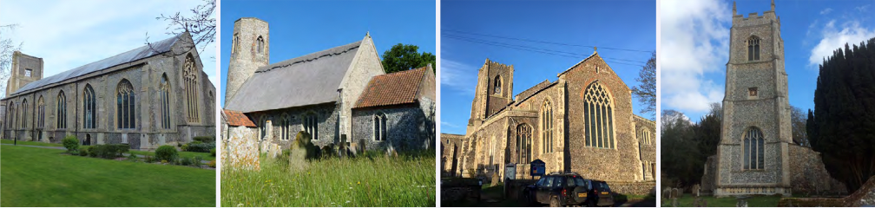

N.E.W.
North Walsham
Edingthorpe
Worstead and Westwick
NEWS
The Magazine for the North Walsham Benefice April 2026 40p
Transformed by Christ: Prayerful, Pastoral, Prophetic

Editor’s Bit

Contents in this issue:
- Vicar’s Page
- From the assistant curate
- Dates from the Diary
- April 2026 service Dates
- Upcoming Events
- Services for Lent and Easter
We hope to see you at our services; you are all welcome.

Please note the date for items to go in the May edition of NEWS needs to be at the Parish office by 20th April 2026 latest.

This magazine is published by the North Walsham Benefice. We reserve the right to edit or decline any material submitted for publication. While reasonable efforts are made to ensure that the contents of the magazine are accurate, no responsibility can be taken for errors and omissions or changes after publication. The material printed does not necessarily represent the views of the Benefice. In accepting advertisements for publication, no recommendation of products or services is implied and we cannot accept responsibility for any unsatisfactory transactions.

Financial Information

Please may we remind you, that if you are giving us a cheque for any of the Churches, they need to be made payable to the following:
St Nicholas’ Church – North Walsham PCC
All Saints’ – Edingthorpe PCC
St Mary’s – Worstead PCC
St Botolph’s – Diocesan Churches Trust
Please may we ask if you are sending any payments to us via an online service that you put a meaningful reference on the payment to ensure we know where the payment should go to.

Live-streamed services are available on YouTube - please search St Nicholas North Walsham. Do you participate in our live-streamed services - we would love to hear your feedback: contact David on 07506 723946 or davidnorthwalsham@gmail.com

If you are considering a change to your Committed Giving for St. Nicholas, please inform Chris Sherman (Committed Giving Officer)
Please support St. Nicholas Church, North Walsham on #easyfundraising, you can raise FREE donations when you shop online with over 5,000 retailers. It is simple and only takes 2 minutes to sign up! Plus, once you have raised your first £15, easy fundraising will match it!
Sign up now: https://www.easyfundraising.org.uk/causes/stnicholaschurchnw/

The Vicar’s page:

Alleluia, Christ is Risen!
As I write this we're living through the reality of Holy Week, and the reality of a world that seems as lost in its own wilderness as ever. Jesus walks the way of the cross and offers himself for the world, and we watch and wait in the darkness for the light to return - let our prayer this Easter be for the return of light and hope to our world.
I'm grateful to all who have offered and all who have attended our Lent offerings, meetings and chances to learn this year. I hope it's been a good experience for all, with challenges and questions along the way!
In May we shall hold the Annual Parochial Church Meetings (APCMs) for each church, and these are good moments to take stock of where we are and where we want to be - they are occasions of legal necessity, but also encouragement as we reflect on God's providence and blessings here. The meetings will be: Worstead 3rd May, Edingthorpe 10th May, North Walsham 31st May
Each year each church community elects two churchwardens, who are a particular focus of lay leadership and responsibility for buildings and share with me and the wider PCCs in oversight and care - we are grateful to those who have served, and to those who will offer themselves to serve for the year ahead.
This year the Deanery Synod representatives (who become ex-officio members of PCC) are also open for election. The Deanery Synod is the first rung of the church's representative bodies and I encourage you to stand if you want to shape our future together not just as parishes but as a wider Deanery and Diocesan family. North Walsham can elect 3 of these and the other churches 1 - it's based on the size of the Electoral Roll. And speaking of the Electoral Roll - it's the nearest thing the Church of England has a membership list (though of course we're here for EVERY person in our parishes), and it's important if you are a regular attender at our churches that you are on the Roll - information will be available about this in all our churches.

Happy Easter! Thank you for being part of God's story here.

David

The Curate’s Page
Holy Week is the most important week in the history, at least for Christians around the world. Jesus’ Passion, Cross, Death and Resurrection are celebrated in the most sombre and poignant ways.

But apart from these mysteries of faith, Holy Week is Holy with additional important events:

It is at the Cross that Jesus offers our Blessed Lady Mary as our mother; it is around the burning coals that Peter shows what it means to be human: scared, not sure and full of doubt.

It is Jesus on the Cross who expresses the worst possible human feeling: ‘My God, my God, why have you forsaken me?’

And finally it is Mary Magdalene who first sees the empty tomb, who confesses her faith when called by her name, who is the first to believe and proclaim: ‘Alleluia, Christ is Risen!’

I invite you all to look and experience the Holy Week afresh, from a different angle, different perspective.
To be there at the foot of the Cross, at the burning coals, and finally at the empty tomb, called by Resurrected Jesus by our names.

Dan


Edingthorpe Village news for April
All Saints Church, Edingthorpe
Services

3rd April Good Friday Compline 6 pm
5th April Easter Vigil 5.45 am
12th April Holy Communion 9.15 am
26th April Morning Prayer 9.15 am

The lovely display of daffodils in the Churchyard is a sign that Spring is on its way and hopefully some warm weather.
On Easter Monday, 6th April we are having a flower festival with cake sales, bric a brac and refreshments of soup, savouries and cakes etc. from 11 am to 2 pm. Our conservation team are arranging an Easter Egg trail together with a quiz. Please come and join us.

Future events
Saturday 6th June at 7 pm. Quiz at the Church Halls, North Walsham
Tickets £10 to include refreshments. Contact 01692 402337.
Saturday 18th July by popular request. Summer Concert at All Saints Church with Joseph Ballard and Jane Everard. Full details in next Village News.

Chris and Karen would like to thank all who continually support the monthly Coffee Mornings held at St. Benet’s Hall on the 2nd Thursday of each month. Do call in for a chat and a cup of coffee.
We always welcome ideas for any social events or activities in the village.
All events and information about the Church are available on the website:
https://www,achurchnearyou,com/church/10076/
or the village website: www.edingthorpe.village.org.uk

June Hannant 01692 402337

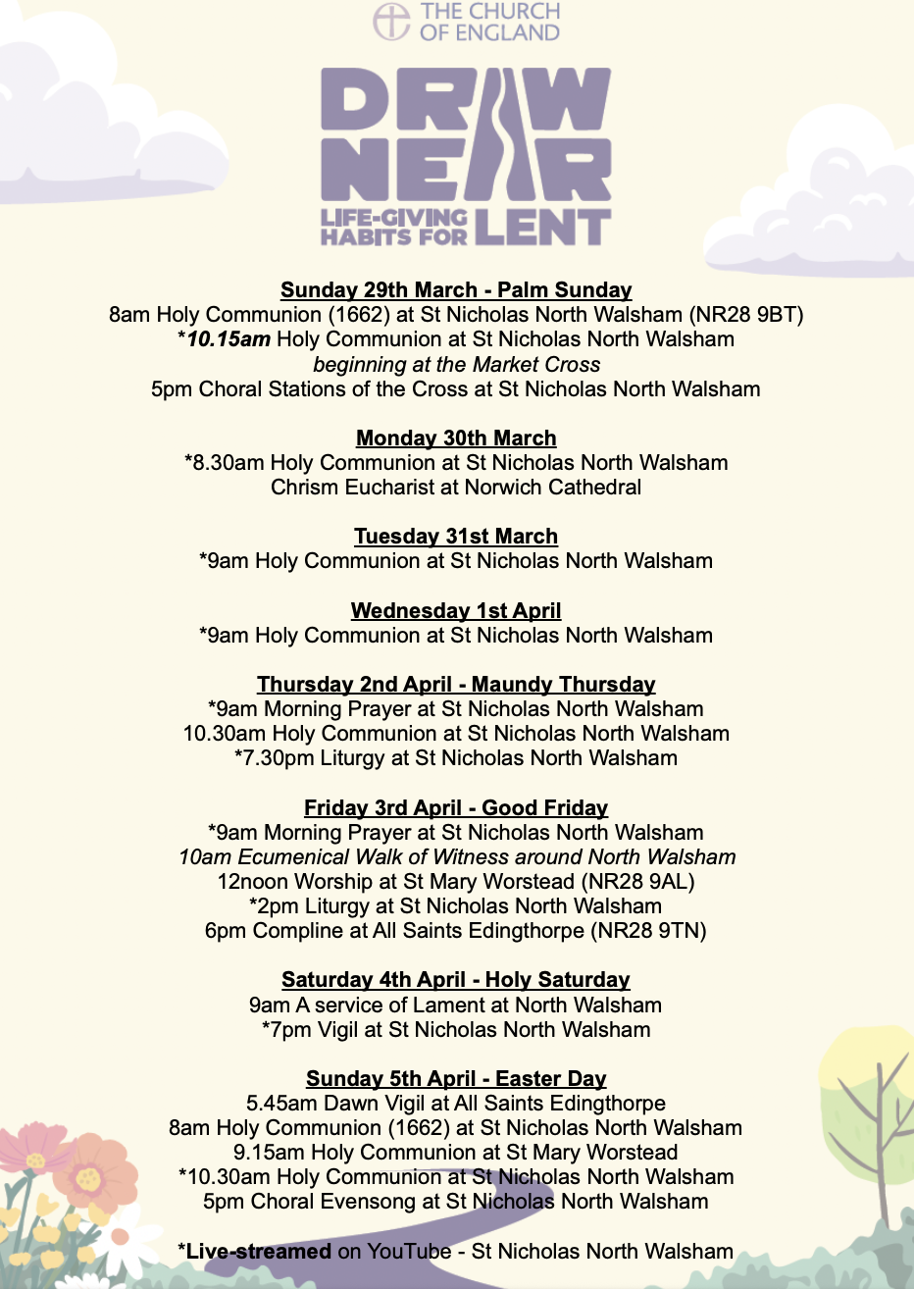

ST MARY’S, WORSTEAD - APRIL 2026
In a Church as old as ours (14th century), there is always something which needs attention.
This time, it’s the Organ. A number of pipes (which provide the sound) have been taken away to be in order for new ones to be made. The likely cost will be in the region of £3500, funds for which have been generously given by the Worstead Festival. Fortunately, the organ can still be played, so, there will be no interruption to our program of weddings this year.
The next, major, project on the horizon will be the renewal of the main Entrance Porch roof. Like so many things, the internal wooden supporting structure has suffered from both rot and water damage, with the inevitable result. Cost is going to be in the region of £25,000 !
We are indebted to our, small and dedicated, band of daffodil pickers for providing a constant supply of these lovely flowers which help to raise much-needed funds for St Mary’s. We are equally indebted to everyone who buys them.
Dates for your Diaries
April 3rd - Good Friday Service at 12 noon.
April 5th - Easter Day (Sunday) at 9.15 am
April 11th (Saturday) The Cawston Band – a group of 25 very talented musicians – will be transporting us to Hollywood and the West End for a musical evening to be long remembered.
The performance starts at 7.00 pm. Tickets are £12.00 (under-18’s free). They can be bought:
1) By using the QR Code on the advertising posters
2) Online from ‘Ticket Source,’ a recognised ticket agency
3) By ‘phoning either Sue (01692-500440 or 07900-073052) or Michael (01263-732003 or 07979-590840).

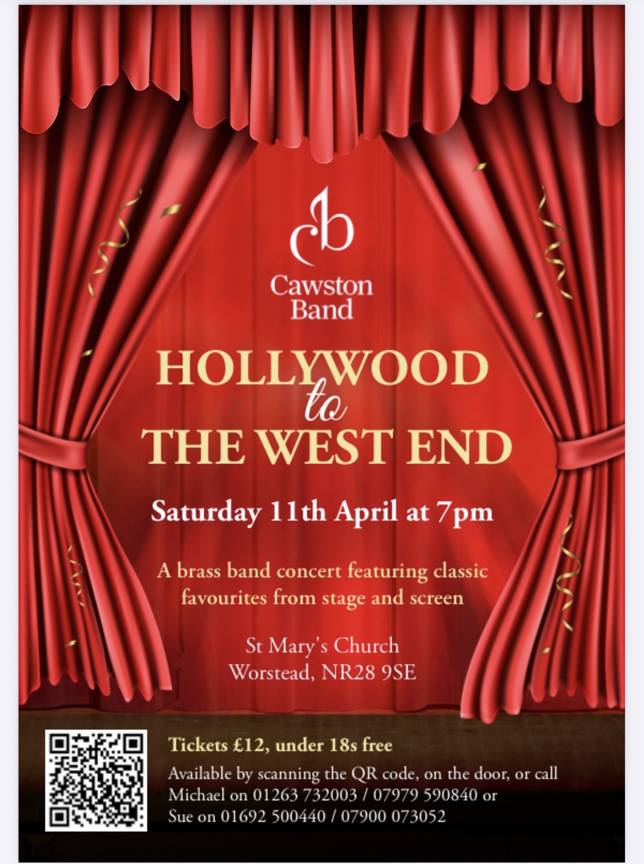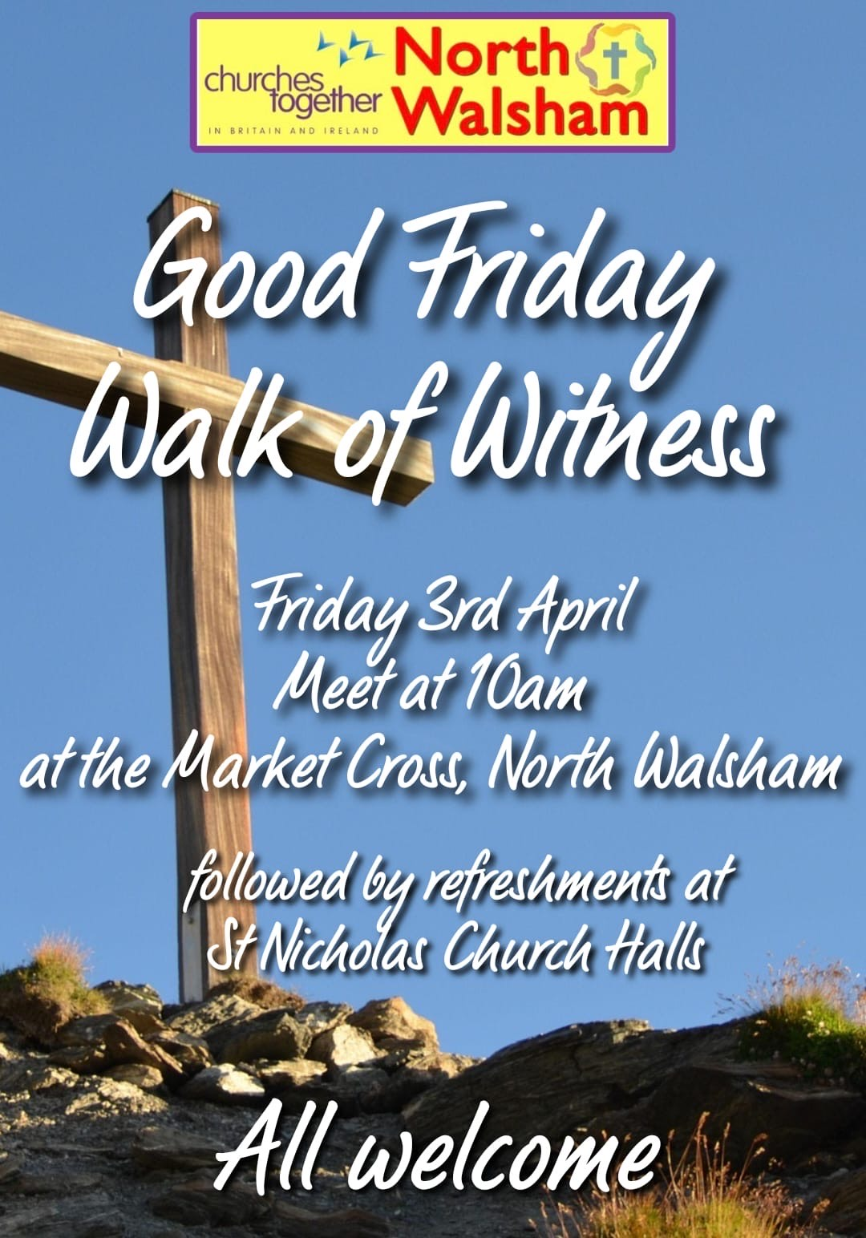
Lent Poetry Group 2026
A group of nine gathered for Lent Poetry 2026 at Rob and Penny’s home and we thank them for their hospitality this year.
Rob and I had chosen the title’ Desert Island Poems’, taking inspiration from the Radio 4 programme, which amazingly was first broadcast in 1942 and has recorded over 3,400 episodes! Rather than choosing audio recordings (which are usually, but not always, music) we asked our group members to pick poems they would like to have with them if they were cast away. We focused on such questions as – why is this poem important to me? What do I especially like about this poet’s writing? How might the poem help me to survive on the island?
The resulting choices were wide ranging, thoughtful, challenging, unsettling, poignant, comforting and, above all, interesting and revealing. All the poems sparked lively discussion- on mortality, memory, relationships, nature, faith, family and so much more. They also prompted us to think about how we would adapt and cope on the island (or not!).
We looked at the work of a large variety of writers, many well known and loved by this group, such as R.S. Thomas, Simon Armitage, Charles Causley, John Clare, Robert Frost, Shakespeare, John Betjeman and Carol Ann Duffy, to name but a few, as well as being introduced to poets we had not previously encountered.
It was a pleasure to spend these 4 evenings in Lent together, enjoying the poems and each other’s company, as we saw, once again, a poet’s unique ability to tap into feelings we all experience and express them in fresh ways. As the Welsh poet and writer Dylan Thomas put it: “Poetry makes you know that you are not alone in the unknown world, that your bliss and suffering is forever shared and forever all your own.”
Sheila Paterson

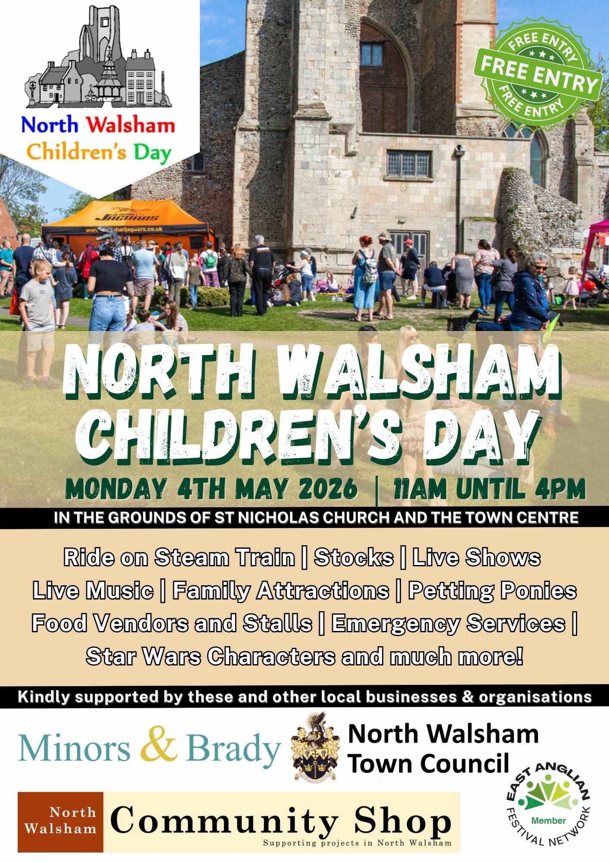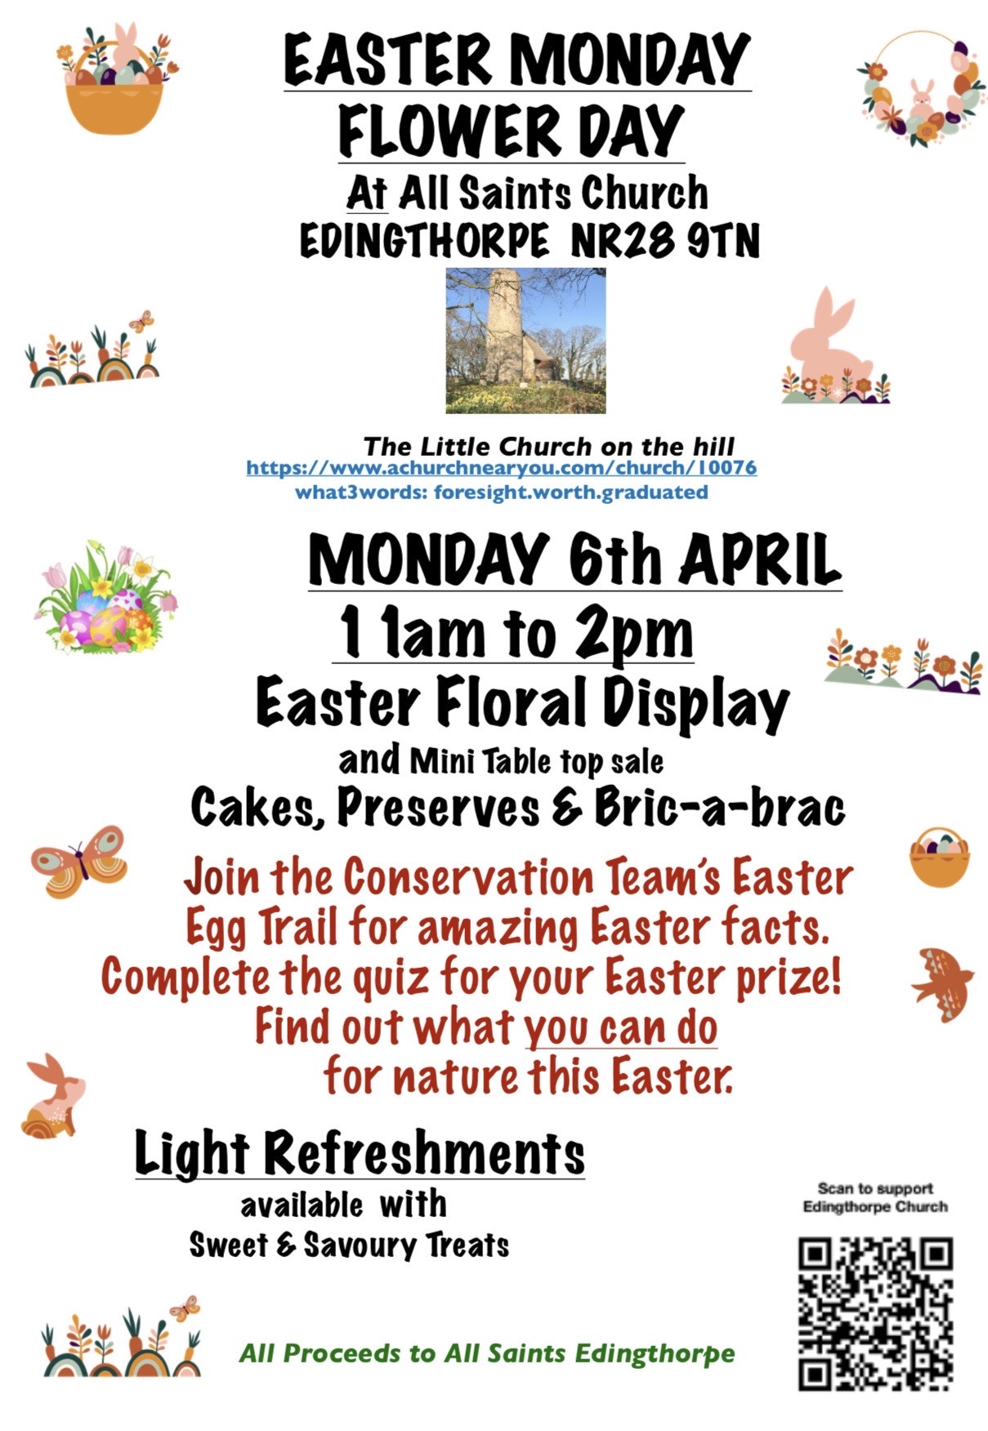
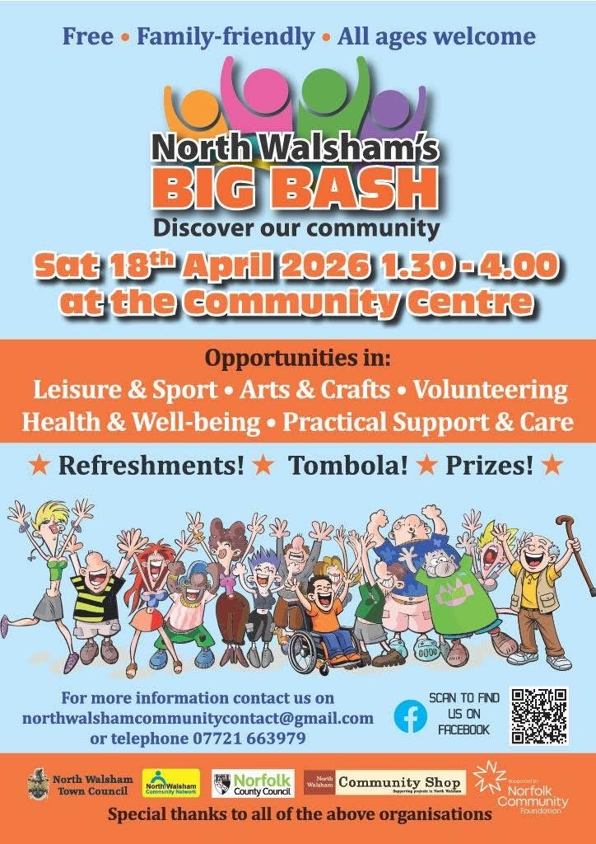

2026 Electoral Roll Review for
St Nicholas, North Walsham
Sequence of Events
27th March 2026 – notice displayed for 14 days before electoral roll review begins
18th April 2026 – electoral roll review begins (15 days minimum)
8th May 2026 – electoral roll review completed
9th May 2026 – display reviewed electoral roll (14 days minimum)
31st May 2026 – Annual Parochial Church meeting (APCM)
Contact Chris Sherman (Electoral Roll Officer), Churchwardens or Ministry Team for Church Electoral Roll application forms.

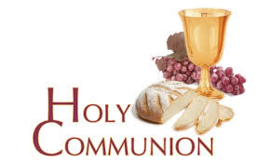
You may have read items in the press relating to the use of 'gluten free' wafers at Holy Communion - for those who require them, we use wafers which are approved and recommended for use by Coeliac UK - more information here. If you need a gluten free wafer, please advise the churchwardens/welcomers when you arrive for the service, and please indicate to the clergy distributing Holy Communion.
The Church teaches that receiving Holy Communion in both kinds (wafer and wine), or in one kind (the wafer or the wine) are acceptable and contain the fulness of the Sacrament. There are many reasons why this will be the case at different times in our lives, and there will be times when we cannot physically receive but join in an Act of Spiritual Communion (as those who watch online do - see below).

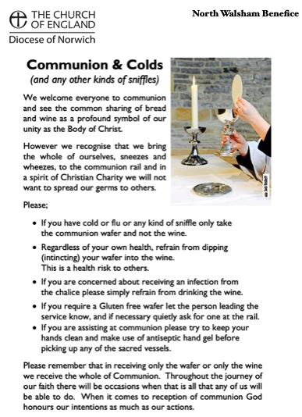
​Intinction (that is, dipping your wafer into the wine) is not permitted, both for hygiene reasons and because it might introduce gluten to the wine, which could be consumed by someone who is allergic to it.
If you wish to discuss any of this, please speak to David.

An Act of Spiritual Communion
In union, O Lord, with the faithful at every altar of your Church, where the Holy Eucharist is celebrated, I desire to offer you praise and thanksgiving. I present to you my soul and body with the earnest wish that I may always be united to you. And since I cannot now receive you sacramentally, I ask you to come spiritually into my heart.
I unite myself to you and embrace you with all the affections of my soul. Let nothing ever separate you from me. May I live and die in your love. Amen.



Why not come along to Sunday Kids and find out how to learn about what we do? We meet on the 1st and 3rd Sunday of the month at St Nicholas Church during the 10.30am service. You are most welcome.

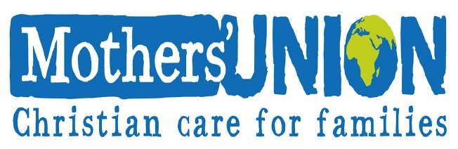

North Walsham Mothers’ Union. We meet in St Nicholas Room on the second Tuesday of the month at 2.00 p.m. Following a short act of worship and a few notices our speaker then takes the floor, after which, over tea and biscuits, there is an opportunity to ask questions and socialise. We usually finish about 3.30 pm.
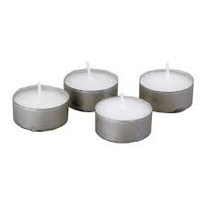
Thanks to all who’ve provided tealights for prayer stations at St Nicholas!
All donations of white, unscented tealights gratefully received!

Services for April 2026

Wednesday 1st April
9am Holy Communion at North Walsham
Thursday 2nd April - Maundy Thursday
9am Morning Prayer at North Walsham
9.30am Market Day coffee morning in the St Nicholas Room
10.30am Holy Communion at North Walsham
7.30pm Liturgy at North Walsham
Friday 3rd April - Good Friday
9am Morning Prayer at North Walsham
10am Churches Together Walk of Witness
12noon Worship at Worstead
2pm Liturgy at North Walsham
6pm Compline at Edingthorpe
Saturday 4th April - Holy Saturday
9am A service of lament at North Walsham
1pm Wedding at Worstead
7pm Vigil at North Walsham

Sunday 5th April - Easter Day
5.45am Vigil at Edingthorpe followed by breakfast
8am Holy Communion (1662) at North Walsham
9.15am Holy Communion at Worstead
10.30am Holy Communion at North Walsham
5pm Choral Evensong at North Walsham
Thursday 9th April
9.30am Market Day coffee morning in the St Nicholas Room
10.30am Holy Communion at North Walsham
Friday 10th April
9.30am Quiet Prayer at North Walsham
10am Cuddles and Catch Up in the St Benet Hall

Sunday 12th April – Easter 2
8am Holy Communion (1662) at North Walsham
9.15am Holy Communion at Edingthorpe
10.30am Holy Communion at North Walsham
5pm Evening Prayer at North Walsham
Monday 13th April
9am Morning Prayer at North Walsham
Tuesday 14th April
9am Morning Prayer at North Walsham
2pm Mothers’ Union at North Walsham
Wednesday 15th April
9am Morning Prayer at North Walsham
Thursday 16th April
9am Morning Prayer at North Walsham
9.30am Market Day coffee morning in the St Nicholas Room
10.30am Holy Communion at North Walsham
Friday 17th April
9am Morning Prayer at North Walsham
9.30am Quiet Prayer at North Walsham
10am Cuddles and Catch Up in the St Benet Hall
Sunday 19th April – Easter 3
8am Holy Communion (1662) at North Walsham
9.15am Holy Communion at Worstead
10.30am Holy Communion at North Walsham
5pm Evening Prayer at North Walsham
Monday 20th April
9am Morning Prayer at North Walsham
Tuesday 21st April
9am Morning Prayer at North Walsham
Wednesday 22nd April
9am Morning Prayer at North Walsham
Thursday 23rd April
9am Morning Prayer at North Walsham
9.30am Market Day coffee morning in the St Nicholas Room
10.30am Holy Communion at North Walsham
Friday 24th April
9am Morning Prayer at North Walsham
9.30am Quiet Prayer at North Walsham
10am Cuddles and Catch Up in the St Benet Hall

Sunday 26th April – Easter 4
8am Holy Communion (1662) at North Walsham
9.15am Morning Prayer at Edingthorpe
10.15am Holy Communion at North Walsham beginning at the Market Cross
5pm Choral Evensong at North Walsham
Monday 27th April
9am Morning Prayer at North Walsham

Tuesday 28th April
9am Morning Prayer at North Walsham
Wednesday 29th April
9am Morning Prayer at North Walsham
Thursday 30th April
9am Morning Prayer at North Walsham
9.30am Market Day coffee morning in the St Nicholas Room
10.30am Holy Communion at North Walsham
Friday 1st May
9am Morning Prayer at North Walsham
10am Cuddles and Catch Up in the St Benet Hall
Sunday 3rd May - Easter 5
8am Holy Communion (1662) at North Walsham
9.15am Morning Prayer at Worstead followed by the APCM
10.30am Holy Communion at North Walsham
5pm Choral Evensong at North Walsham

Each week, the 10.30am service on Sundays, and 9am Morning Prayer Mon-Fri are live-streamed to YouTube - click link below or search 'St Nicholas North Walsham'

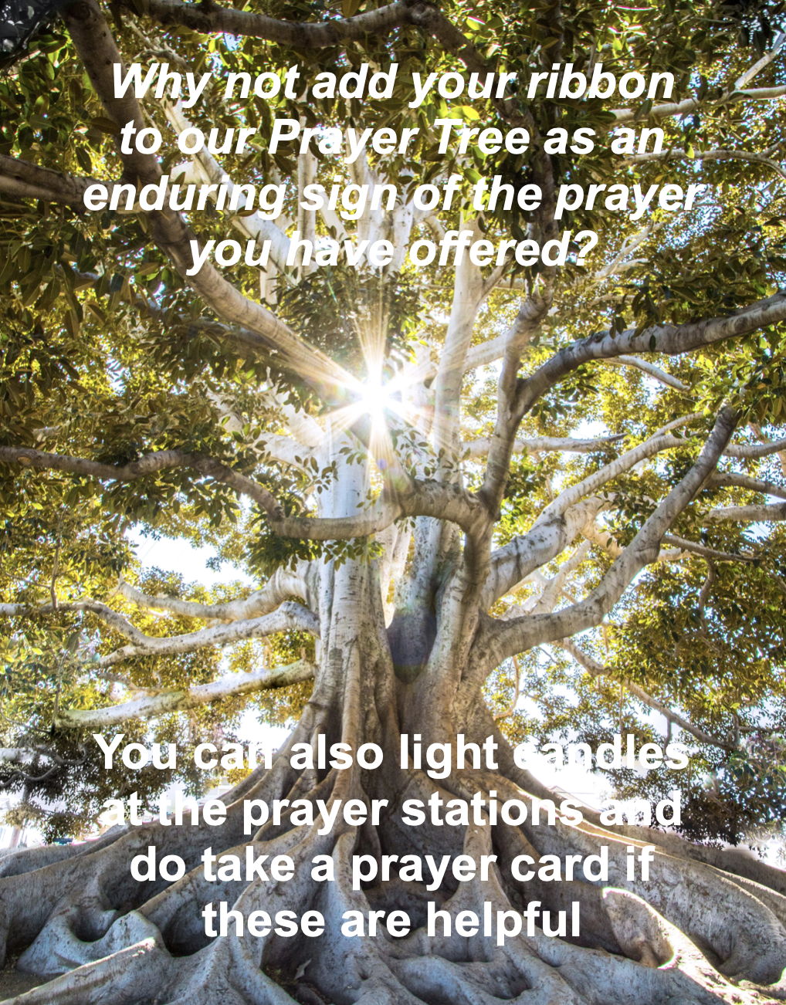

We are privileged to hold special
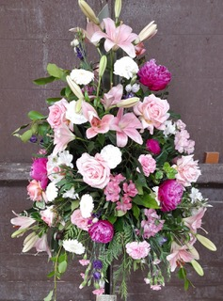
services at any of our churches
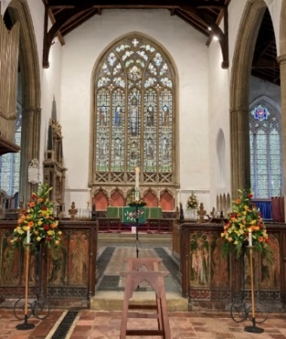
All who live in the benefice are entitled to a baptism, wedding or funeral service in church, and our clergy can officiate at the crematorium and cemeteries too. The church is here for you, through every moment of life.
************************************************************************************


Dates from the Diary

Baptisms
Leelah Topham
Lucas Collins

Wedding
Emily Wylie & Thomas Donoghue

Funerals
Joyce Richardson
Keith Taylor
Margaret Barker
Toby Swann

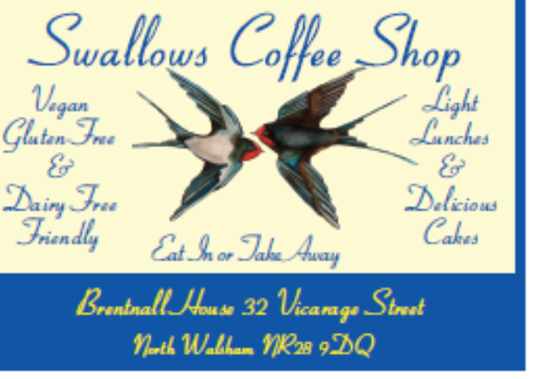




We're pleased that our weekly coffee mornings at North Walsham and Worstead are now registered with Warm Welcome Spaces
North Walsham Market Day Coffee Morning
Thursdays 9.30 – 12.00noon
The space is open to all (and their well-behaved dogs on leads), every Thursday! A warm welcome and refreshments available

Thank you to everyone for raising donations for St. Nicholas Church, North Walsham with #easyfundraising! If you have not signed up yet, it is easy and completely FREE. 8,100 brands will donate to us when you use easy fundraising to do your everyday online shopping - at no extra cost to you! Every donation you raise makes a difference to us so please sign up & share today. https://join.easyfundraising.org.uk/stnicholaschurchnw/XT7MPH/at/TSX8RX7z/RTND2/facebook/
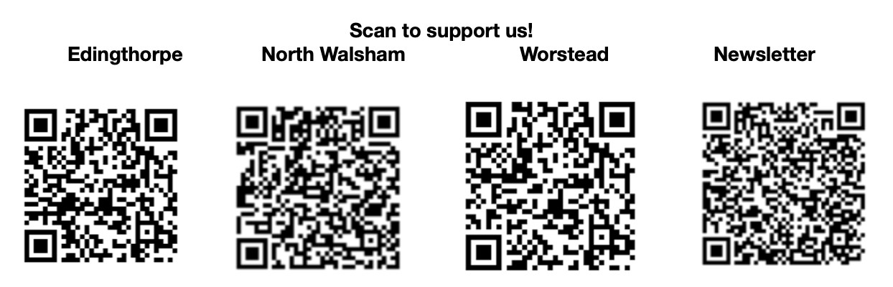


Please support the work of our Churches, by using the contactless giving point at St Nicholas or St Mary’s, leaving your gift on the offering plates or in the wall safes, or through these QR codes. Thank you.

Do you have a Business you would like to advertise in this magazine?
Whole, half or quarter page space is available.
Full Page £ 150.00
Half Page £ 75.00
Quarter Page £ 50.00
Please contact the Benefice office on 01692 408971
or email saintnicholasnw@gmail.com
for details and prices

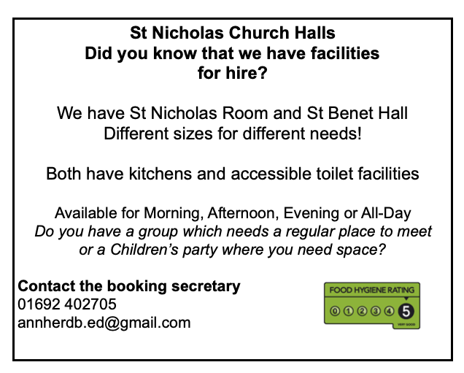
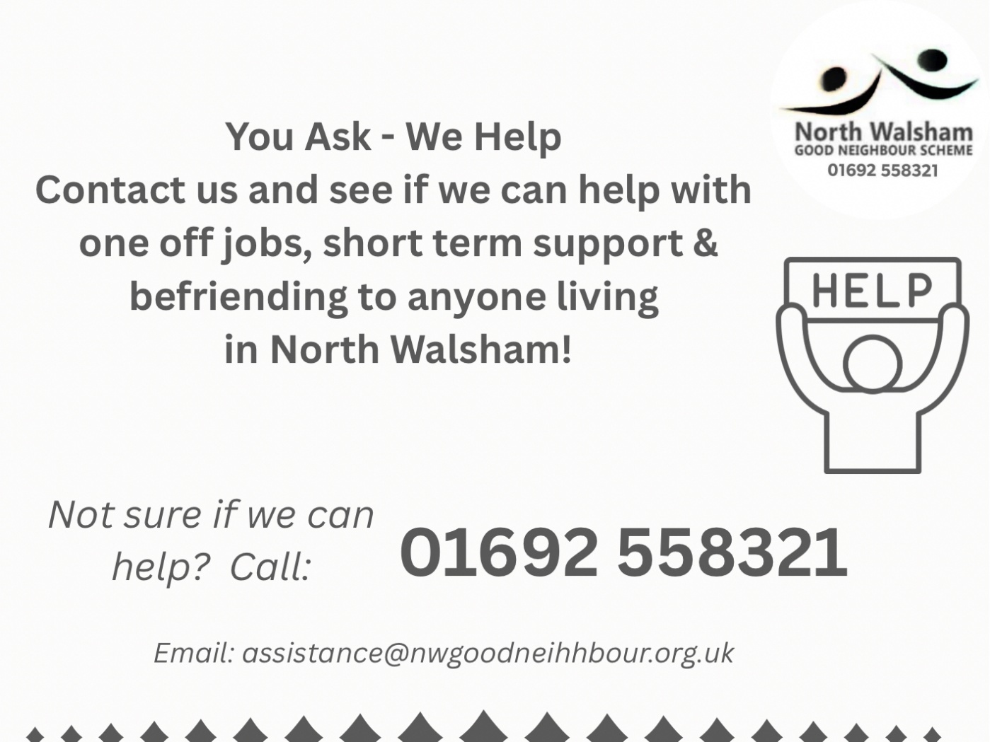

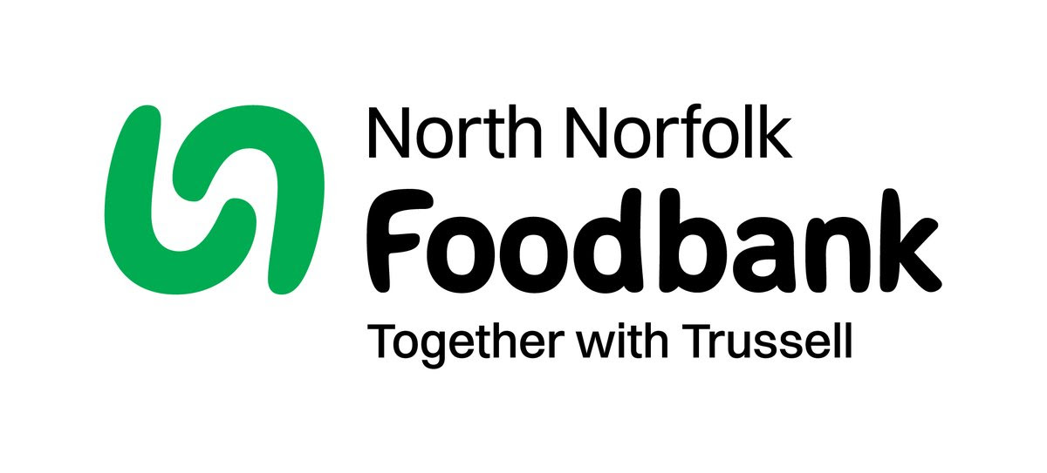
Dear Foodbank supporter,

Thank you for your donation last month from St Nicholas Church, North Walsham of 81.56 kg.
As a small charity we rely on food and financial donations to operate, and we are extremely grateful when people choose to support us.
During the 24/25 year we gave out 2,012 food parcels, providing food for 4,520 people; 2,843 adults and 1,677 children.
Whilst Trussell campaigns to end the need for foodbanks, we will be here helping those who need us right now. But that can only be done with kind donations from our supporters.
To see what we need most right now, our wish list is published on our website and social media, and the list gets updated throughout the month on our donation page https://northnorfolk.foodbank.org.uk/give-help/donate-food/

Thank you for thinking of us and enabling us to serve the people facing hardship across our district.
Kind regards
Julie and the Foodbank team
North Norfolk Foodbank
Cromer Methodist Church Hall, West Street, Cromer, NR27 9DT

Ready to tick off your list – Will Made?

"The Church of England have teamed up with Farewills to provide a free will writing service: Online Will Writing Service | Legal Will In 15 Minutes . Anyone can use this service and it is not compulsory to leave something to your church, but it would be nice if you did. It is important for each one of us to leave our earthly matters in good order so why not take advantage of this opportunity now? It is good to remember a gift in your will to a charity is tax free. If you already have a will, you could consider leaving a legacy to the church by adding a codicil. https://farewill.com/norwich-diocese

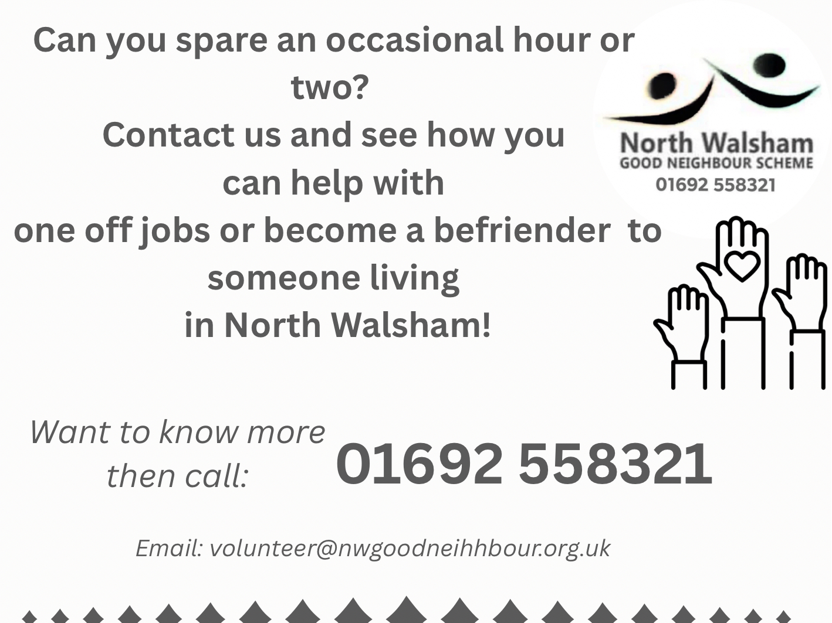

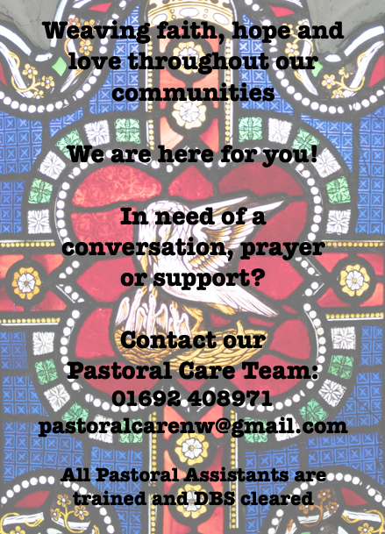

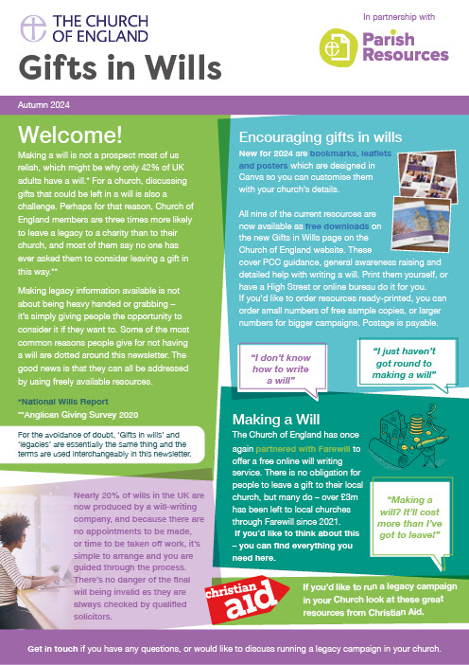
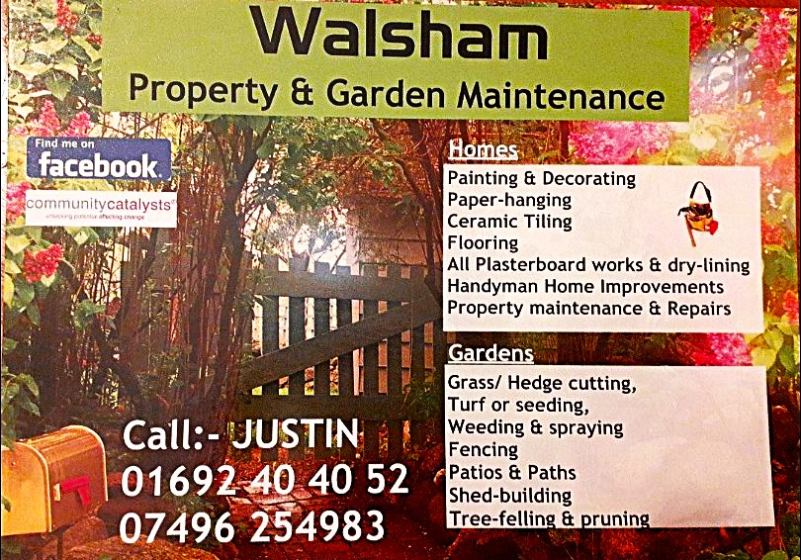

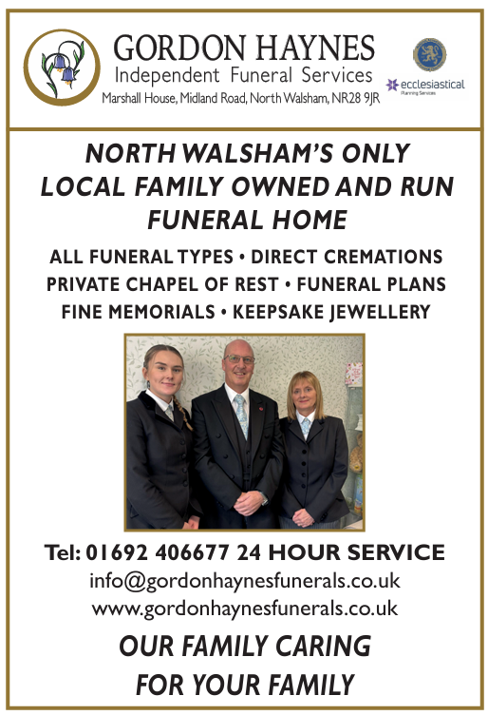
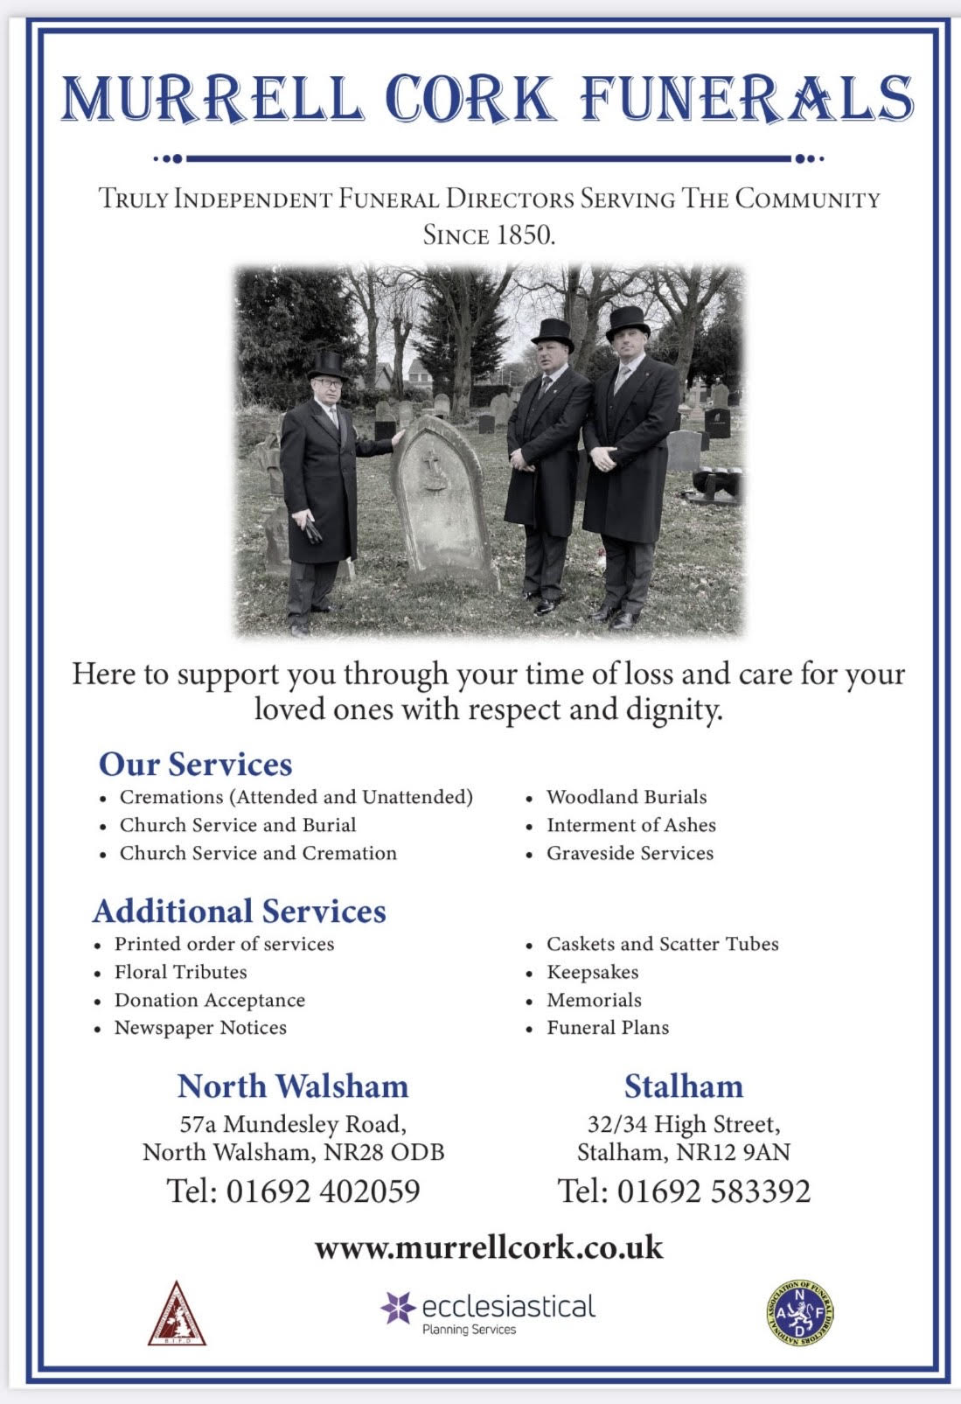
r Sale and Wants Page

Money Matters …
A regular report for our readers written by James Reginald Drake at ClearView Financial Consultants
Burgh Road, Aylsham - 01263 734859, Station Road, Hoveton - 01603 273590 and North Walsham 07773 626662

Lasting Powers of Attorney – Why are they so Important?
Lasting Powers of Attorney (LPA’s) are documents that give an individual you trust (your attorney) the legal authority to make decisions on your behalf should you either lose the mental capacity to make them, or you no longer wish to make these decisions yourself. Lasting Powers of Attorney come in 2 forms, these coming under the heading of ‘Property & Financial Affairs’ and ‘Health & Welfare’
So, how can they help?
The Property & Financial Affairs LPA covers things such as running your bank and savings accounts, making or selling investments, paying bills, buying or selling property and applying for benefits.
The Health & Welfare LPA covers things such as the type of health care and medical treatment you receive (including decisions on life sustaining treatment), where you live, as well as the type of care that you receive in areas such as diet and daily routine.
Given the wide range of areas that these documents cover, it becomes quite obvious as to why they are so important. However, according to ‘The Office of the Public Guardian’ via an article produced in 2022, less than 1% of the UK population have a Lasting Powers of Attorney in place.
So, why do so few people have them in place? One of the most commonly mentioned reasons is that people assume that their spouse will automatically have the right to make decisions for them should they ever reach the stage where they are unable to. This however is a common misconception and it is very often discovered far too late that they actually have no legal authority at all. Cost is another reason people put it off, I can assure you are costs for this type of work are minimal, in the hope this is not a reason to delay.
What should you do?
Well, the answer to this one is quite simple……. get on and set up both types of LPA as soon as you can. It is never too soon to set one up, but it certainly can be too late. By law, once your mental capacity has gone, so has your opportunity to appoint attorneys to act on your behalf. At this point your loved ones will be required to go down a different route and apply to the Court of Protection for a Deputyship order. This requires more forms, more cost and more time, which can all be easily avoided with a bit of forward planning.
So, if setting up Lasting Powers of Attorney(s) is something that you think would benefit you and your loved ones, please feel free to contact me and we can discuss how they can be put in place in a way that is best suited to your own personal requirements.
This short article in no way should be taken by readers as advice.
James can be contacted on either of the above landline numbers or via email at support@smithifa.co.uk
ClearView Financial Consultants is a trading name of Martin Smith Independent Financial Adviser Ltd, a company registered in England
under number 11439150 and authorised and regulated by the Financial Conduct Authority under number 944677.



