Date | Time | Service | Church
Palm Sunday  29th March   | 10.30am  10.30am | Liturgy of the Palms - Start on the car park & process to church for The Liturgy of the Passion with Holy Communion in Church  Palm Sunday Holy Communion | Ratlinghope  Churchstoke
Monday  30th March | 12 noon  7.00pm | Stations of the Cross  Compline Night Prayer | Churchstoke  Myndtown
Tuesday  31st March | 12 noon  7.00pm | Stations of the Cross  Compline Night Prayer | Churchstoke  Lydham
Wednesday  1st April | 12 noon | Stations of the Cross | Churchstoke
Maundy Thursday 2nd April  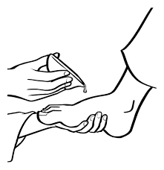 | 7pm  7.30pm | Passover Meal & Holy Communion  Holy Communion with foot washing & stripping of altar | Churchstoke  Wentnor
Good Friday  3rd April  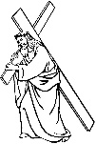 | 11.30 for 12 noon  2pm  5pm | Reflections at the Foot of the Cross  Meditation, Hymns & Reflection  Quiet Evening Prayer (BCP) | Ratchup Hill, Ratlinghope  Churchstoke  More
Easter Eve  Saturday 4th April | 7.00pm | Family Service of Light –  In the churchyard with bonfire, fireworks and glowsticks | Hyssington  
Easter Day  Sunday 5th April  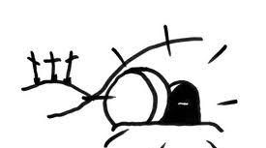 | 10.30am  10.30am  6pm | Benefice Easter Day  Holy Communion  Easter Day Holy Communion  Easter Day Family Service  (includes activities for children) | Norbury  Churchstoke  Sarn Village Hall
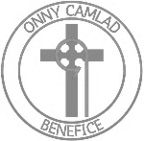
Holy Week & Easter Services
in our Benefice Churches

Everyone is welcome at these services.
Please come and join us this Easter.

