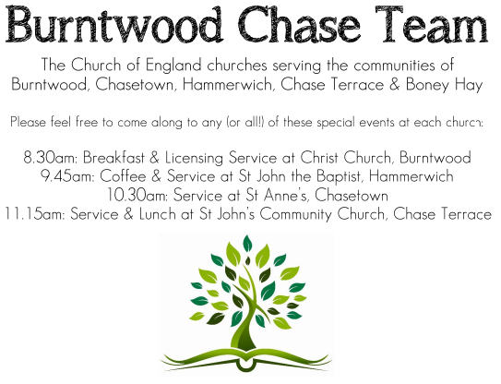
CHRIST CHURCH
Registered Charity Nos. 1217129

SERVICE ON SUNDAY 29th MARCH 2026 at 10am

Palm Sunday Communion

Readings:
Psalm 118: 1-2, 19-29

¹ O give thanks to the Lord, for he is good;
his steadfast love endures for ever!
² Let Israel say,
‘His steadfast love endures for ever.’
¹⁹ Open to me the gates of righteousness,
that I may enter through them
and give thanks to the Lord.
²⁰ This is the gate of the Lord;
the righteous shall enter through it.
²¹ I thank you that you have answered me
and have become my salvation.
²² The stone that the builders rejected
has become the chief cornerstone.
²³ This is the Lord’s doing;
it is marvellous in our eyes.
²⁴ This is the day that the Lord has made;
let us rejoice and be glad in it.
²⁵ Save us, we beseech you, O Lord!
O Lord, we beseech you, give us success!
²⁶ Blessed is the one who comes in the name of the Lord.
We bless you from the house of the Lord.
²⁷ The Lord is God,
and he has given us light.
Bind the festal procession with branches,
up to the horns of the altar.
²⁸ You are my God, and I will give thanks to you;
you are my God, I will extol you.
²⁹ O give thanks to the Lord, for he is good,
for his steadfast love endures for ever.

Matthew 21: 1-11
When they had come near Jerusalem and had reached Bethphage, at the Mount of Olives, Jesus sent two disciples, ² saying to them, ‘Go into the village ahead of you, and immediately you will find a donkey tied, and a colt with her; untie them and bring them to me. ³ If anyone says anything to you, just say this, “The Lord needs them.” And he will send them immediately.’ ⁴ This took place to fulfil what had been spoken through the prophet, saying,
⁵ ‘Tell the daughter of Zion,
Look, your king is coming to you,
humble, and mounted on a donkey,
and on a colt, the foal of a donkey.’
⁶ The disciples went and did as Jesus had directed them; ⁷ they brought the donkey and the colt, and put their cloaks on them, and he sat on them. ⁸ A very large crowd spread their cloaks on the road, and others cut branches from the trees and spread them on the road. ⁹ The crowds that went ahead of him and that followed were shouting,
‘Hosanna to the Son of David!
Blessed is the one who comes in the name of the Lord!
Hosanna in the highest heaven!’
¹⁰ When he entered Jerusalem, the whole city was in turmoil, asking, ‘Who is this?’ ¹¹ The crowds were saying, ‘This is the prophet Jesus from Nazareth in Galilee.’

COLLECT FOR TODAY
Almighty and everlasting God,
who in your tender love towards the human race
sent your Son our Saviour Jesus Christ
to take upon him our flesh
and too suffer death upon the cross:
grant that we may follow the example
of his patience and humility,
and also be made partakers of his resurrection;
through Jesus Christ your Son our Lord,
who is alive and reigns with you,
in the unity of the Holy Spirit,
one God, now and for ever.

WHAT’S GOING ON
Upcoming Services and Events
Wednesday 1st April Morning Prayer 9.30am
Thursday 2nd April Maundy Thursday Communion 7.30pm
Friday 3rd April Children’s Easter Workshop 10am
Sunday 5th April Easter Sunday Holy Communion 10am
Monday 6th April Cameo Cafe 10-12 noon
Wednesday 8th April Morning Prayer 9.30am

DATES FOR YOUR DIARY
Saturday 16th May Spring Fayre
Saturday 27th June Cream Tea
Saturday 11th July Shelfield Choir Concert
Saturday 14th November Christmas Fayre

Decorating Church for Easter
If you would like to help decorate the Church for Easter. Please let me know. It will take place on Saturday 4th April, 10am onwards.
Thank you, Chris Brown

FLOODLIGHTING
If you think about commemorating a special occasion by floodlighting our Church. Please contact Chris Brown on 01543 683862 for details.

PRAYER CHAIN
Christ Church is blessed with a very active prayer chain. If you, or anyone you know, feel that they would like others to pray for them, please speak to Chris Brown on 01543 683862.

HOME COMMUNION
For anyone who is unable to attend church and would like a Home Visit and Communion, please contact the Vicar and he will be able to carry this out.

VICAR CONTACT DETAILS
Rev’d Stephen Morgan Tele: 07305 852152
CHURCH WARDENS CONTACT DETAILS
Judith Rogers Tele: 01543 324718
Mike Holmes Tele: 01543 672970
Church Office Tele: 01543 642187 [leave a message and we will respond]
Church Web Site:www.christchurchburntwood.org.uk
Church Email: christchurchburntwood15@gmail.com
Facebook: www.facebook.com/group/christchurchburntwood/

Other Contacts
Rev’d Matt Wallace St. John’s, Chase Terrace— Tele: 01543 670078

NEXT SUNDAY SERVICE
Sunday 5th April at 10am
Easter Sunday Communion
Acts 10: 34-43
Matthew 28: 1-10

