Sunday 15th February 2026 St Paul’s, Woodhouse Eaves
WE WELCOME YOU, for we are all one in Christ Jesus

MISSION  Our Mission Statement  Our Mission is to make known the Gospel and love of Jesus Christ. We hope that you experience us as a safe, sacramental, welcoming, loving and inclusive Kingdom people who seek to make Christ present in the hearts of all.  Safeguarding  The parishes of St Paul’s, Woodhouse Eaves & St Mary’s, Woodhouse, are committed to the safeguarding of children, young people and adults. We follow the House of Bishops’ guidance and policies, and have our own Parish Safeguarding Officers. If you are concerned that a child or adult has been harmed or may be at risk of harm please contact –  ST PAUL’S - Safeguarding  Co-ordinator: Tony Lane  07977 924 677  ST MARY’S - Safeguarding  Co-ordinator: Andrea Farnsworth 07958 376 963  As a Benefice, we affirm that it is about not just a set of policies and procedures, but about all of us as the body of Christ sharing the responsibility for making God’s Church as safe as we can  Please take this pew sheet  home and recycle it when you’ve read it. Thank you |  | PRAYER  Let us use our time  before the service  to talk to God,  during the service  may God talk to us, and  after the service  let us talk to one another  If you would like someone to listen or to pray with you, please contact your Parish Priest:  Rev’d Lisa Temperley-Barnes - 01509 890 972  If you would like us to pray for someone by name in our Sunday services and through the week, please email Rev’d Lisa or Stephen  Save the dates!  Lent Bible  Studies  St Paul’s  Church  1.45pm each    week on -  9th March,  16th March  23rd March  (all Mondays)  Do join us over a cuppa,  as we share thoughts and reflections on the meaning  of Lent in the Bible,  supporting each other on our Lenten journeys.  Photo by Jamie Ginsberg on Unsplash |  | We pray for all who are ill  for Dennis, Gill Kelly,  June Shilton,  Sue and John Thorne  We remember before God  the faithful departed  Barbara Prince, Eddie Sykes, Doreen Botts, Marlene Nash,  Judy Riley  and from St Mary’s  Book of Remembrance  Merle Enid Taylor  and from St Paul’s  Book of Remembrance  William Joyce Reedman,  Margaret Yorke Parker,  Mary McAteer  Rest eternal grant unto them, O Lord, and let light perpetual shine upon them. May the souls of the faithful departed through the mercy of God, rest in peace and rise in glory. Amen  Eddie Sykes’ funeral is at 2.00pm on 25th February at Loughborough Crematorium  
Sunday next before Lent Sung Eucharist
COLLECT  Almighty Father, whose Son was revealed in majesty before he suffered death upon the cross: give us grace to perceive his glory, that we may be strengthened to suffer with him and be changed into his likeness, from glory to glory; who is alive and reigns with you, in the unity of the Holy Spirit,  one God, now and for ever. Amen  FIRST READING  A reading from the book of Exodus  The Lord said to Moses, “Come up the mountain to me, and while you are here, I will give you two stone tablets which contain all the laws that I have written for the instruction of the people.” Moses and his helper Joshua got ready, and Moses began to go up the holy mountain. Moses said to the leaders, “Wait here in the camp for us until we come back. Aaron and Hur are here with you; and so whoever has a dispute to settle can go to them.”  Moses went up Mount Sinai, and a cloud covered it. The dazzling light of the Lord's presence came down on the mountain. To the Israelites the light looked like a fire burning on top of the mountain. The cloud covered the mountain for six days, and on the seventh day the Lord called to Moses from the cloud. Moses went on up the mountain into the cloud. There he stayed for forty days and nights.  Exodus 24:12-end  This is the word of the Lord  Thanks be to God |  | PSALM 2  Refrain: The Lord is the strength of his people, a safe refuge for his anointed  - Why are the nations in tumult, ♦  and why do the peoples devise a vain plot?  - The kings of the earth rise up,  and the rulers take counsel together, ♦  against the Lord and against his anointed. R  - He who dwells in heaven shall laugh them to scorn; ♦  the Lord shall have them in derision.  - I will proclaim the decree of the Lord; ♦  he said to me: ‘You are my Son; this day have I begotten you.  - ‘Ask of me and I will give you the nations for your inheritance ♦  and the ends of the earth for your possession. R  - Now therefore be wise, O kings; ♦  be prudent, you judges of the earth.  - Happy are all they ♦  who take refuge in the Lord. R  Glory be to the Father, and to the Son, and to the Holy Spirit: as it was in the beginning, is now, and ever shall be, world without end. Amen  GOSPEL  Alleluia, alleluia  “Speak, Lord, your servant is listening. You have the words to eternal life.” Alleluia  Hear the holy Gospel of our Lord Jesus Christ according to St Matthew  -  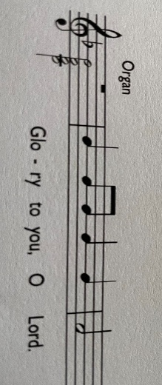 |  | Six days later, Jesus took with him Peter and James and his brother John and led them up a high mountain, by themselves.  And he was transfigured before them, and his face shone like the sun, and his clothes became dazzling white. Suddenly there appeared to them Moses and Elijah, talking with him. Then Peter said to Jesus, ‘Lord, it is good for us to be here; if you wish, I will make three dwellings here, one for you, one for Moses, and one for Elijah.’ While he was still speaking, suddenly a bright cloud overshadowed them, and from the cloud a voice said, ‘This is my Son, the Beloved; with him I am well pleased; listen to him!’ When the disciples heard this, they fell to the ground and were overcome by fear. But Jesus came and touched them, saying, ‘Get up and do not be afraid.’ And when they looked up, they saw no one except Jesus himself alone. As they were coming down the mountain, Jesus ordered them, ‘Tell no one about the vision until after the Son of Man has been raised from the dead.’  Matthew 17:1-9  This is the Gospel of the Lord  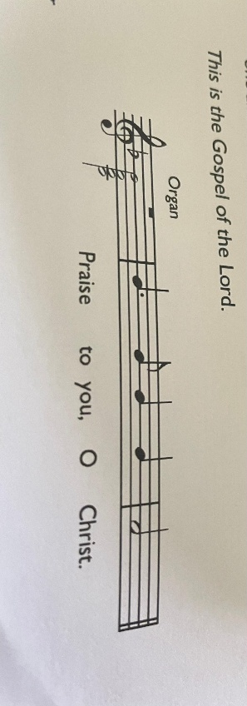  POST COMMUNION  Holy God,  we see your glory in the face of Jesus Christ:  may we who are partakers at his table  reflect his life in word and deed,  that all the world may know his power to change and save.  This we ask through Jesus Christ our Lord. Amen

