Menheniot Church presents: The Barberpapas!

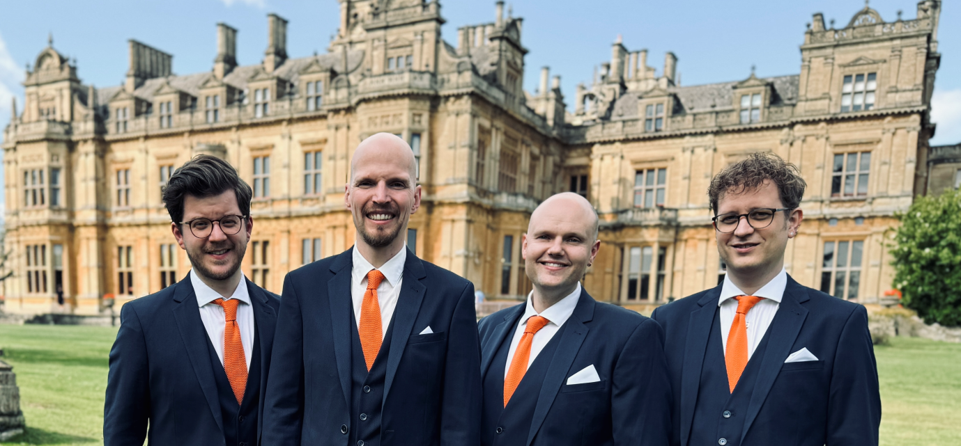

Barbershop in its modern, brilliant, and colourful evening attire: that’s the Barberpapas. On tour in the Southwest – from Europe!

Featuring a highly diverse and exquisitely curated repertoire. From traditional to pop music and musical theatre, all tunes are presented in a classic, dense, and energetic barbershop style. So: put on your best fun-loving outfit, because the next Barberpapas concert will be just like always: splendid spirits in musically formidable attire.

We hope you can join us – tickets £10 on the door.

Wednesday 8th April 2026
7pm
Bar, Nibbles and Great Music

