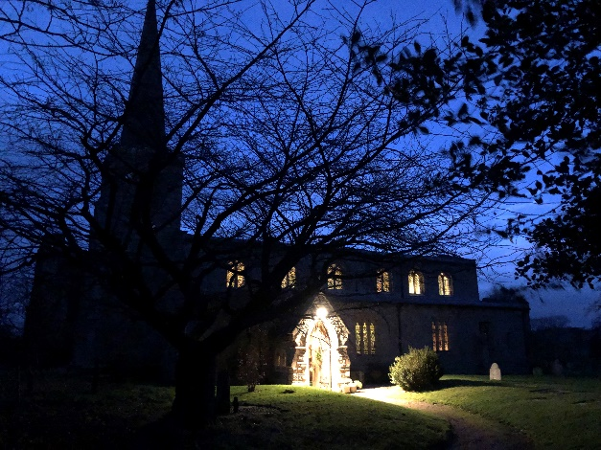
ST MICHAEL AND ALL ANGELS,
HAMSTALL RIDWARE

In the United Benefice of King’s Bromley, the Ridwares
and Yoxall

February 22nd 2026
Lent 1

PARISH NOTICES

UNITED BENEFICE SERVICE ROTA
 | Hamstall Ridware  St Michael and All Angels | Yoxall  St Peter | King’s Bromley  All Saints | Mavesyn Ridware  St Nicholas
February 22nd  Lent 1 | 10.30 am  Service of the Word | 9.00 am  Holy Communion | 10.30 am  Parish Communion
March 1st  Lent 2 | 9.00 am  Holy Communion | 10.30 am  Parish Communion | 4.00 pm  Holy Communion | 10.30 am  Morning Prayer
March 8th  Lent 3 | 4.00 pm  Holy Communion | 10.30 am  Parish Communion | 10.30 am  Parish Communion
March 15th  Mothering Sunday | 10.30 am  Parish Communion | 4.00 pm  Holy Communion | 10.45 am  Mothering Sunday Service | 10.30 am  Parish Communion
March 22nd  Passion Sunday | 10.30 am  Service of the Word | 9.00 am  Holy Communion | 10.30 am  Parish Communion
Please note that services of Holy Communion at 9 am follow the Book of Common Prayer and are said. Services at 10.30 will include hymns and other singing.
There are services of Holy Communion at 10.00 every Wednesday at St Peter’s, Yoxall (except February 25th) and on the first Thursday of each month at All Saints, King’s Bromley.
*******************
Rugeley Food Bank. Please do remember those who depend on Food Banks. They are needed now just as ever. If you wish to donate directly to Rugeley Foodbank at Rugeley Community Centre the Centre is open everyday to receive contributions. Alternatively, the Rugeley Food Bank welcomes financial contributions – see https://rugeley.foodbank.org.uk. Gifts can also be brought to St Michael’s and left in the box at the back of church near the font. If that is not convenient please contact Liz Carter on 07751 068181.
****************
Contact details: If you wish to contact the Rector, Jeremy Brading you can do so on revd@kbhmy.co.uk and Glenis Turner, the PCC Secretary and Benefice Administrator is on admin@kbhmy.co.uk. The churchwardens are Michael Elsom michael.elsom@btopenworld.com and John Ferguson clan.member1954@gmail.com Information about events at church can be found at our webpages at https://www.achurchnearyou.com/church/4451/ and https://kbhmy.co.uk/hamstall/
St Michael’s will continue to be open everyday (weather permitting) between 10.00 am until 4.00 pm. We will revert to shutting the church at 6.00 pm on March 29th 2026
Safeguarding of children and vulnerable adults. If you have any concerns please speak in complete confidence to the Parish Safeguarding Officer, Dr Paul Carter on 01889 504347 or the Diocesan Safeguarding Officer, Neil Spiring on 01543 306030.
PLEASE REMEMBER IN YOUR PRAYERS:
Those who are sick: Mary Mycock, Angela Perkin, Doug, David and Barbara Rudge, May Windley, Pam Payne, Frank and Margaret Finch, Chris Poole, Les Wood, Pat Lomax, Alison Scott and any known personally to you.
The family and friends of Brenda Perkin who has died in her 90th year. Brenda was a regular worshipper and helper at St Michael’s for many, many years until she became housebound.
Those who live and work in the Nursing, Care and Retirement homes in the villages both in and near the parishes of the United Benefice.
Using the Archbishops’ prayer for Ukraine at this time let us remember the people of that war-torn land:
God of peace and justice, we pray for the people of Ukraine today. We pray for peace and the laying down of weapons. We pray for all those who fear for tomorrow, that your Spirit of comfort would draw near to them. We pray for those with power over war or peace, for wisdom, discernment and compassion to guide their decisions. Above all, we pray for all your precious children, at risk and in fear, that you would hold and protect them. We pray in the name of Jesus, the Prince of Peace. Amen
The situation in the Middle East where hopes for a peaceful resolution sometimes appear irretrievably bleak:
O God of all justice and peace, we cry out to you in the midst of the pain and trauma of violence and fear which prevails in the Holy Land. Be with those who need you in these days of suffering; we pray for people of all faiths - Jews, Muslims and Christians and for all people of the land. While we pray to you, O Lord, for an end to violence and the establishment of peace, we also call to you to bring justice and equity to the peoples. Guide us into your kingdom where all people are treated with dignity and honour as your children - for to all of us you are our Heavenly Father. In Jesus' name we pray. Amen.
From the Diocesan Prayer Diary:
Friday 27th: (George Herbert, Priest, Poet, 1633)
Lord, we thank you for the gift of prayer in all its forms, as so elegantly demonstrated in George Herbert's poem called, fittingly, 'Prayer';
Prayer the church's banquet, angel's age, God's breath in man returning to his birth,
The soul in paraphrase, heart in pilgrimage, The Christian plummet sounding heav'n and earth
Engine against th' Almighty, sinner's tow'r, Reversed thunder, Christ-side-piercing spear,
The six-days world transposing in an hour, A kind of tune, which all things hear and fear;
Softness, and peace, and joy, and love, and bliss, Exalted manna, gladness of the best,
Heaven in ordinary, man well drest, The milky way, the bird of Paradise,
Church-bells beyond the stars heard, the soul's blood, The land of spices; something understood.
Saturday 28th:
Lord, on this last day of February, we think of those in our communities who may long for a place to 'fit' but struggle to find it. Like people born on the 29th may wonder where they 'fit' three years out of four, we lift before you all those who long for something to help them better 'fit', a home, a family, a job, better health, or maybe something completely different. Lord, please bless those people with the one perfect fit that they can have - in your loving arms.
LENT 2026
The services on Ash Wednesday in the Benefice marked the start of this very important season of the year for Christians. We continue with Rev’d Jeremy conducting a series of House Groups on Wednesday evenings during Lent. They will be on every Wednesday at 7pm in St Peter’s Church, Yoxall. The title of the course is Answering God’s Call and the sessions will be on 25th Feb, and 4th, 11th, 18th & 25th March.
ADULT CONFIRMATION CLASSES
Following on from the Lent Course, Rev’d Jeremy will be holding an Adult Confirmation Course on Wednesdays at 7 pm. These will start in May and anyone who is thinking of getting confirmed is welcome to contact him – and no doubt would want to come to the Lent House Group meetings as well.

St Michael’s encourages donations by means of this QR code and it will appear (all being well) on all our publications as an invitation to contribute to the important work of the church both
as a place of worship and a community asset where all can share in the wonderful place we have
inherited and wish to pass on to those who come after us.

