SUNDAY MORNING READING SHEET 15th February Sunday Next before Lent
A Reading from Paul’s Letter to the Romans
A Reading from the Second Letter of Peter
For we did not follow cleverly devised myths when we made known to you the power and coming of our Lord Jesus Christ, but we had been eyewitnesses of his majesty. For he received honour and glory from God the Father when that voice was conveyed to him by the Majestic Glory, saying, ‘This is my Son, my Beloved, with whom I am well pleased.’ We ourselves heard this voice come from heaven, while we were with him on the holy mountain. So we have the prophetic message more fully confirmed. You will do well to be attentive to this as to a lamp shining in a dark place, until the day dawns and the morning star rises in your hearts. First of all you must understand this, that no prophecy of scripture is a matter of one’s own interpretation, because no prophecy ever came by human will, but men and women moved by the Holy Spirit spoke from God.
2 Peter 1:16-21

GOSPEL
Six days later, Jesus took with him Peter and James and his brother John and led them up a high mountain, by themselves. And he was transfigured before them, and his face shone like the sun, and his clothes became dazzling white. Suddenly there appeared to them Moses and Elijah, talking with him. Then Peter said to Jesus, ‘Lord, it is good for us to be here; if you wish, I will make three dwellings here, one for you, one for Moses, and one for Elijah.’ While he was still speaking, suddenly a bright cloud overshadowed them, and from the cloud a voice said, ‘This is my Son, the Beloved; with him I am well pleased; listen to him!’ When the disciples heard this, they fell to the ground and were overcome by fear. But Jesus came and touched them, saying, ‘Get up and do not be afraid.’ And when they looked up, they saw no one except Jesus himself alone. As they were coming down the mountain, Jesus ordered them, ‘Tell no one about the vision until after the Son of Man has been raised from the dead.’ Matthew 17:1-9

LENT COURSE: As we approach Lent, everyone is invited to take part in our parish Lent course, Draw Near: Life-Giving Habits for Lent, based on the Church of England resource offering short daily reflections to help deepen our relationship with God. Sunday preaching and home groups will follow shared weekly themes, creating a common rhythm of worship, reflection, and conversation across the church. Home groups will meet weekly where possible, with most able to welcome newcomers as well as three newly formed groups for Lent only. Further details about booklets and groups will be shared soon.

UPCOMING EVENTS :There are a number of events coming up over the next few months to look forward to.
18th April - Cheese and wine evening 2nd & 4th May - Book Fayre 19th June - Hymns and PIMM’ s
20th June - Concert



If you wish to make a donation to the church, then please hold your
phone’s camera over this image then touch the link that appears:
Royston Parish Church
Where all are welcome and God’s love is shared
Sunday 15th February 2026 - Sunday Next before Lent

If you would like regular copies of the Notice Sheet emailed to you please email the Parish Office at admin@roystonparishchurch.org.uk

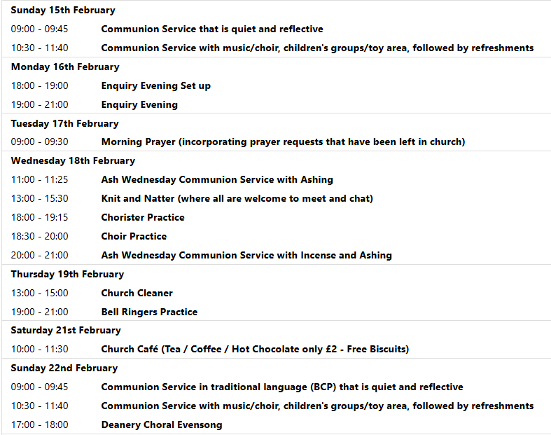

We pray for all Christians worldwide:
For all Christians in Austria, Liechtenstein, Switzerland
For all who are worship at Therfield Chapel: Pauk Dutton
For the work of our mission partners: Vietnamese Church: Pastor Na

Pray for the community of Royston:
For our local health centres
For our employed at our local Indusrial estates

We pray for our world and ECO projects:
The 15th February is World Whale Day. We pray for these beautiful animals and related species, threatened by human activities impacting the ocean.

We pray for the sick and suffering:
1st February 8th February 15th February 22nd February
Lee Cockerill Chris Christou Val Brown Peter Coates Pat Pritchard Paul & Pat Tidey Angie & Ken Rushall Margaret Green
Jackson Herbert Mike Brown Paula Walker Peter Foster Marion Keith & Elaine Edwards Gwen Simmons
Laura O’nyamul (On-Ya-Mul) Maria Turi Katie
Peggy Dawes Janet McElney

We pray for those who have died in the faith of Christ:
Deceased | Bereaved
Harry McDonald | Ruth, Family and friends
Ann Coburn | Kay Blayney, Matt, family and friends
The Turner twins | Heather, Ross family and friends
Morris Mordet | Family and Friends

We pray for those whose anniversaries fall at this time:
Albert Godfrey

NOTICES

ELECTORAL ROLL: If you would like to join the Electoral Roll this year, which enables you to vote at our annual meeting, please apply on this link:
https://roystonparishchurch.org.uk/electoral-roll

CHRISTMAS TREE: The Christmas tree is finally down, and a BIG thank you to all who made it possible this year. We have counted 1056 this year, which is a record. The cards will be prayed over before being cleared away.

BASIC AWARENESS SAFEGUARDING COURSE Three years ago, after the church re-opened, we ran a Basic Awareness Safeguarding Course for anyone who was unable to access the training online and would find it easier to come along to the church to do the training as a group. For some people it is now time to renew their training after three years, for others it will be the first time. This is a relaxed, non threatening way for everyone to join together and learn how we can, as a church, keep everyone safe whether it is children or vulnerable adults. If you would like to take advantage of this opportunity we will be running the course on Monday 23rd February 2026 at 9.30 am in church. Please let me know if you would like to join us.
Alison Bailey, Parish Safeguarding Officer, 01763 250637, safeguarding@roystonparishchurch.org.uk

DEANERY CHORAL EVENSONG on February 22nd at 5pm, our choir will be joined by choirs and singers from across the Deanery to sing Choral Evensong together. No other churches in the Deanery are having evening services as all the church leaders are taking part in the service, and we are also coming together with congregations across the Deanery to worship together in this service, which will be followed by wine and refreshments. If you would like to sing then please speak to Steven, otherwise, please do come along and worship together with our sisters and brothers from across the Deanery.

NEW SUNG SETTING In our 10.30 services from the 8th February (with the choir singing it at the Candlemas service on the 1st February) we shall be singing a new setting of the communion setting (where we sing Lord, have mercy, Glory to God, Holy, Holy, Holy Lord and Lamb of God). The setting is written by David Thorne and is called the Mass of St Thomas. If you would like to get to know it before we start singing it then you can hear it at this link: https://www.youtube.com/watch?v=vVMJxiIXQMs

LOOKING FORWARD, we will also be looking for donations of Easter eggs for the egg hunt on Easter Sunday, 5th April and chocolate items for a chocolate tombola at the Book Fayre, 2nd and 4th May. We are happy to take these at any time from now on so we can take advantage of any offers. Please leave all items in the kitchen. As always we ask that all food items have good dates on them as we cannot include out of date items! Thank you so much, the Events Committee.

