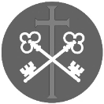
St Peter and the Holy Apostles, Plymouth- Sunday 8th February 2025
The Fifth Sunday in Ordinary Time (Year A)
Welcome to the Parish Mass
Welcome to St Peters Church. This sheet provides all that you will need for today’s Mass. If you need any assistance before, during or after the service or need a large print copy of this order of service please speak to one of our welcome team. (identifiable by a lanyard)
Please respond to the words in non-italic Bold, The Hymns are sung by all. Please inform the people on the door when you enter if you require a Gluten Free Host
…………………………………………………………………………………
We Stand for The Entrance Hymn

1. Son of God, eternal Saviour,
source of life and truth and grace,
Son of Man, whose birth incarnate
hallows all our human race,
thou, our Head, who, throned in glory,
for thine own dost ever plead,
fill us with thy love and pity;
heal our wrongs, and help our need.
2. As thou, Lord, hast lived for others,
so may we for others live;
freely have thy gifts been granted,
freely may thy servants give:
thine the gold and thine the silver,
thine the wealth of land and sea,
we but stewards of thy bounty,
held in solemn trust for thee.
3. Come, O Christ, and reign among us,
King of love, and Prince of peace;
hush the storm of strife and passion,
bid its cruel discords cease;
by thy patient years of toiling,
by thy silent hours of pain,
quench our fevered thirst of pleasure,
shame our selfish greed of gain.
4. Son of God, eternal Saviour,
source of life and truth and grace,
Son of Man, whose birth incarnate
hallows all our human race,
thou who prayedst, thou who willest,
that thy people should be one,
grant, O grant our hope's fruition:
here on earth thy will be done.

The Introductory Rite
In the name of the Father and of the Son and of the Holy Spirit. Amen.
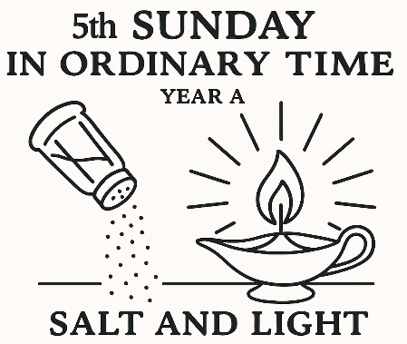
Following the greeting we respond.
And with your spirit.
The Priest introduces the Mass
The Penitential Rite
Brothers and sisters, let us acknowledge our sins,
and so prepare ourselves to celebrate the sacred mysteries.

I confess to almighty God and to you, my brothers and sisters, that I have greatly sinned, in my thoughts and in my words, in what I have done and in what I have failed to do, through my fault, through my fault, through my most grievous fault; therefore I ask blessed Mary ever-Virgin, all the Angels and Saints, and you, my brothers and sisters, to pray for me to the Lord our God.

May almighty God have mercy on us, forgive us our sins, and bring us to everlasting life. Amen.

Either:
Lord, have mercy. Lord, have mercy.
Christ, have mercy. Christ, have mercy.
Lord, have mercy. Lord, have mercy.
Or:
Kyrie, eleison. Kyrie, eleison.
Christe, eleison. Christe, eleison.
Kyrie, eleison. Kyrie, eleison.

The Gloria
Glory to God in the highest, and on earth peace to people of good will.
We praise you, we bless you, we adore you, we glorify you, we give you thanks for your great glory, Lord God, heavenly King, O God, almighty Father.
Lord Jesus Christ, Only Begotten Son, Lord God, Lamb of God, Son of the Father, you take away the sins of the world, have mercy on us; you take away the sins of the world, receive our prayer; you are seated at the right hand of the Father, have mercy on us.
For you alone are the Holy One, you alone are the Lord, you alone are the Most High, Jesus Christ, with the Holy Spirit, in the glory of God the Father. Amen.

The Collect
Keep your family safe, O Lord, with unfailing care, that, relying solely on the hope of heavenly grace, they may be defended always by your protection. Through our Lord Jesus Christ, your Son, who lives and reigns with you in the unity of the Holy Spirit,
God, for ever and ever. Amen.

We sit for The First Reading- Isaiah 58:6-10

Thus says the Lord: Is not this the fast that I choose: to loose the bonds of wickedness,
to undo the straps of the yoke, to let the oppressed go free, and to break every yoke?
Is it not to share your bread with the hungry and bring the homeless poor into your house; when you see the naked, to cover him, and not to hide yourself from your own flesh? Then shall your light break forth like the dawn, and your healing shall spring up speedily; your righteousness shall go before you; the glory of the Lord shall be your rearguard. Then you shall call, and the Lord will answer; you shall cry, and he will say, ‘Here I am.’ If you take away the yoke from your midst, the pointing of the finger, and speaking wickedness, if you pour yourself out for the hungry and satisfy the desire of the afflicted, then shall your light rise in the darkness and your gloom be as the noonday.

The word of the Lord. Thanks be to God.

The Responsorial Psalm- Ps 112(111):4-5. 6-7. 8a, 9. ℟4a

Response- A light rises in the darkness for the upright.

A light rises in the darkness for the upright; he is generous, merciful, and righteous.
It goes well for the man who deals generously and lends,
who conducts his affairs with justice. R

He will never be moved; for ever shall the upright be remembered.
He has no fear of evil news; with a firm heart, he trusts in the Lord. R

With a steadfast heart he will not fear. Open-handed, he gives to the poor;
his justice stands firm for ever. His might shall be exalted in glory. R

The second Reading- 1 Corinthians 2:1-5

I, when I came to you, brothers and sisters, did not come proclaiming to you the testimony of God with lofty speech or wisdom. For I decided to know nothing among you except Jesus Christ and him crucified. And I was with you in weakness and in fear and much trembling, and my speech and my message were not in plausible words of wisdom, but in demonstration of the Spirit and of power, so that your faith might not rest in the wisdom of men but in the power of God.

The word of the Lord. Thanks be to God

We stand for- The Gospel Procession and Acclamation- John 8:12

Alleluia, alleluia.
I am the light of the world, says the Lord;
whoever follows me will have the light of life.
Alleluia.

The Gospel- Matthew 5:13-16

The Lord be with you. And with your spirit.
A reading from the holy Gospel according to N. Glory to you, O Lord.
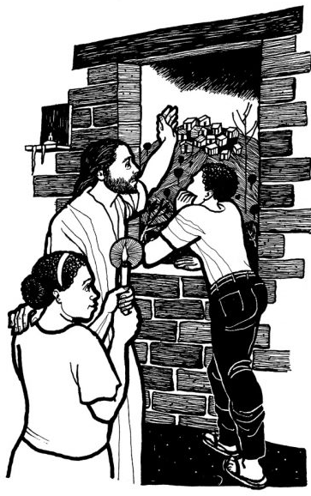
At that time: Jesus said to his disciples, ‘You are the salt of the earth, but if salt has lost its taste, how shall its saltiness be restored? It is no longer good for anything except to be thrown out and trampled under people’s feet.
‘You are the light of the world. A city set on a hill cannot be hidden. Nor do people light a lamp and put it under a basket, but on a stand, and it gives light to all in the house. In the same way, let your light shine before others, so that they may see your good works and give glory to your Father who is in heaven.’

The Gospel of the Lord. Praise to you, Lord Jesus Christ.
We sit for The Homily

We stand The Creed
I believe in one God, the Father almighty, maker of heaven and earth,
of all things visible and invisible.
I believe in one Lord Jesus Christ, the Only Begotten Son of God, born of the Father before all ages. God from God, Light from Light, true God from true God, begotten, not made, consubstantial with the Father; through him all things were made. For us men and for our salvation he came down from heaven,
At the words that follow, up to and including ‘and became man’, all bow.
and by the Holy Spirit was incarnate of the Virgin Mary, and became man.
For our sake he was crucified under Pontius Pilate, he suffered death and was buried, and rose again on the third day in accordance with the Scriptures.
He ascended into heaven and is seated at the right hand of the Father. He will come again in glory to judge the living and the dead and his kingdom will have no end.
I believe in the Holy Spirit, the Lord, the giver of life, who proceeds from the Father and the Son, who with the Father and the Son is adored and glorified, who has spoken through the prophets.
I believe in one, holy, catholic and apostolic Church. I confess one Baptism for the forgiveness of sins and I look forward to the resurrection of the dead and the life of the world to come. Amen.


We remain standing for The Prayers of the Faithful

Each biding concludes with the following said or sung-

We pray to the Lord. Lord in your Mercy hear our prayer.

The Priest Concludes the Prayers of the Faithful
No collection is taken during the Mass, but there is a collection box at the back of church for you to give your financial contribution. All money collected helps towards the mission and ministry of our churches. If you would prefer, a card reading machine is available at the back of the church for your contribution.
The Offertory Hymn
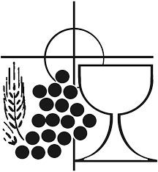
1. Longing for light, we wait in darkness.
Longing for truth, we turn to you.
Make us your own, your holy people,
light for the world to see.
Christ, be our light!
Shine in our hearts.
Shine through the darkness.
Christ, be our light!
Shine in your church gathered today.

2. Longing for peace, our world is troubled.
Longing for hope, many despair.
Your word alone has power to save us.
Make us your living voice.
Christ, be our light!...
3. Longing for food, many are hungry.
Longing for water, many still thirst.
Make us your bread, broken for others,
shared until all are fed.
Christ, be our light!...
4. Longing for shelter, many are homeless.
Longing for warmth, many are cold.
Make us your building, sheltering others,
walls made of living stone.
Christ, be our light!...
5. Many the gifts, many the people,
many the hearts that yearn to belong.
Let us be servants to one another,
making your kingdom come.
Christ, be our light!...

The Liturgy of the Eucharist
Pray, brethren (brothers and sisters), that my sacrifice and yours may be acceptable to God, the almighty Father.
May the Lord accept the sacrifice at your hands for the praise and glory of his name, for our good and the good of all his holy Church.

The Lord be with you. And with your spirit.
Lift up your hearts. We lift them up to the Lord.
Let us give thanks to the Lord our God. It is right and just.

The Priest continues with the Preface. The Sanctus is the said or sung:
Holy, Holy, Holy Lord God of hosts.
Heaven and earth are full of your glory. Hosanna in the highest.
Blessed is he who comes in the name of the Lord. Hosanna in the highest.

The Priest continues the Eucharistic prayer. The following is said or sung
The mystery of faith…. We proclaim your Death, O Lord, and profess your Resurrection until you come again.

The Priest concludes the Eucharistic prayer.

Through him, and with him, and in him, O God, almighty Father, in the unity of the Holy Spirit, all glory and honour is yours, for ever and ever. Amen.

The Lord’s Prayer
At the Saviour’s command and formed by divine teaching, we dare to say:
Our Father, who art in heaven, hallowed be thy name; thy kingdom come, thy will be done on earth as it is in heaven. Give us this day our daily bread, and forgive us our trespasses, as we forgive those who trespass against us; and lead us not into temptation, but deliver us from evil.
Deliver us, Lord, we pray… and the coming of our Saviour, Jesus Christ.
For the kingdom, the power and the glory are yours now and for ever.

The Peace
Lord Jesus Christ, who said to your Apostles: Peace I leave you, my peace I give you,
look not on our sins, but on the faith of your Church, and graciously grant her peace and unity in accordance with your will. Who live and reign for ever and ever. Amen.
The peace of the Lord be with you always: And with your spirit.
Let us offer each other the sign of peace.

All are invited to make an acknowledgement to each other to mark the sign of the peace.

The Agnus Dei
All say or sing:
Lamb of God, you take away the sins of the world,
have mercy on us.
Lamb of God, you take away the sins of the world,
have mercy on us.
Lamb of God, you take away the sins of the world,
grant us peace.
The Invitation to Communion
Behold the Lamb of God, behold him who takes away the sins of the world. Blessed are those called to the supper of the Lamb.
Lord, I am not worthy that you should enter under my roof, but only say the word and my soul shall be healed.

All who are regular communicants in their own tradition are welcome to receive the sacrament if you are not a communicant you are welcome to come forward at this point in the service to receive a blessing To indicate that it is just a blessing you require, please take this service sheet up with you. We have returned to offering the chalice at the time of communion but please do not feel any pressure to receive from the common cup as the church teaches that the sacrament is received fully in one kind. We request that you do not intinct (dip) your host in the Chalice but either take a sip from the cup or return directly to your seat. This is for reasons of good hygiene.

The Communion Hymn

1. Christ be near at either hand,
Christ behind, before me stand,
Christ with me where e’er I go,
Christ around, above, below.
2. Christ be in my head and mind,
Christ within my soul enshrined,
Christ control my wayward heart;
Christ abide and ne’er depart.
3. Christ my life and only way,
Christ my lantern night and day,
Christ be my unchanging friend,
Guide and shepherd to the end.
4. Christ be all my strength and might,
Christ my captain for the fight;
Christ fulfil my soul’s desire;
Christ, ennoble and inspire.
5. Christ the King and Lord of all,
Find me ready at his call;
Christ receive my service whole,
Hand and body, heart and soul.
6. Christ the King of kings descend
And of tyrants make an end;
Christ on us and all below,
Concord, love and peace bestow.
7. Thanks to him, who for our food
Gives his sacred flesh and blood;
Praise to him unceasing rise,
Christ whose glory fills the skies.

We stand for The Prayer After Communion

O God, who have willed that we be partakers in the one Bread and the one Chalice,
grant us, we pray, so to live that, made one in Christ, we may joyfully bear fruit
for the salvation of the world. Through Christ our Lord. Amen
We remain standing for Our Mission Prayer
Lord Jesus, you call us to be your missionary disciples.
Guide and strengthen us to share your love with all we meet.
Give us courage to reach out to help others.
Give us wisdom to know how best to care,
And give us hope to believe we can make a difference.
Bless us all who bring your compassion and mercy to the poor and marginalised.
Together, may we make known your love on earth.
We make our prayer through Christ Our Lord. Amen.

The priest may give some brief notices

The Concluding Rites and The Dismissal

The Lord be with you. And with your spirit.
May almighty God bless you, the Father, and the Son, ✠ and the Holy Spirit. Amen.

Go forth, the Mass is ended. Thanks be to God
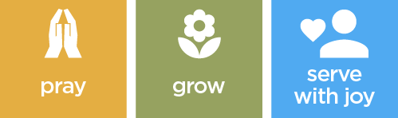

The Final Hymn

1. Christ, whose glory fills the skies,
Christ, the true, the only light,
Sun of Righteousness, arise,
triumph o'er the shades of night;
Dayspring from on high, be near;
Daystar, in my heart appear.
2. Dark and cheerless is the morn
unaccompanied by thee;
joyless is the day’s return
till thy mercy’s beams I see,
till they inward light impart,
glad my eyes, and warm my heart.
3. Visit then this soul of mine,
pierce the gloom of sin and grief;
fill me, radiancy divine;
scatter all my unbelief;
more and more thyself display,
shining to the perfect day.
The Angelus
The Angel of the Lord declared unto Mary. And she conceived of the Holy Spirit.

Hail Mary, full of grace, The Lord is with Thee; Blessed art thou among women,
And blessed is the fruit of thy womb, Jesus.
Holy Mary, Mother of God, Pray for us sinners,
Now and at the hour of our death.

Behold the handmaid of the Lord.
Be it done to me according to thy word.
Hail Mary. . .

And the Word was made flesh.
And dwelt among us.
Hail Mary…

Pray for us, O holy Mother of God.
That we may be made worthy of the promises of Christ.

Let us pray: Pour forth, we beseech Thee, O Lord, Thy grace into our hearts, that we to whom the Incarnation of Christ Thy Son was made known by the message of an angel, may by His Passion and Cross be brought to the glory of His Resurrection. Through the same Christ Our Lord. Amen.
…………………………………………………………………………………
The Notices
PCC meeting Next Sunday after Mass and refreshments
Main Item for the agenda is the Change of Mass times from 10.00am to 11.00am

Help Needed for our Winter night Shelter-
help is needed to support our winter night shelter between December and March on Wednesdays… For further information please speak to Fr David or Ben

Lent 2026
Begins on Wednesday 18th with Ash Wednesday with Mass at 10.00am
Stations of the Cross will be prayed Sundays at 6.00pm
Lent Study Group,looking at prayer will take place on Saturdays 11.00-12.00 with a simple soup lunch, (Volunteers needed for soup)

Chrism Mass Thursday 26th March at 11.00 Exeter Cathedral. Transport is being arranged more information soon.

Big Lent Walk This Lent Fr David is going to take part in the The Big Lent Walk, which involves walking 200km in 40 days. The purpose is to raise money to supply clean water to places in Ethiopia and Peru and is organised by Cafod.

For Prayer

Those who have asked for our prayers…. Denise, Janice Allin, Leslie Porch,
Sheila Tucker, Tina Smart, Kathy Haydon, Bobby Lilicrap, June Brock,
Emma Addison, Georgie Maher, Ian Craggs, Brenda Alderson, Lois Tobin, Brenda Steed, Anne Lewis, Jenny Harvey, Jackie Morrison, Anna, Gwen Lamb, Anna Lynch, Helen Lewis, Val Bradden, Cynthia Way, Pauleen Stewart, Amelia Coughlan, Roger Lewis, Shaun Carrie, Fr Jon Bielawski, Catherine Samuel, Julian Davies,

Recently Departed- Jackie Fisher, Gina Dukes

Anniversaries of Death-
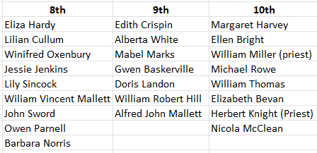


The Mission Community of St Peter and the Holy Apostles
St Peter, Wyndham Square + St Thomas, Royal Navy Avenue + St James-the-Less, Ham Drive
A Church of England Parish in the care of the Bishop of Oswestry
Parish Priest Fr. David Way SSC: 01752 240119 fr.davidway@gmail.com
.com
Mission Development Minister/ LLM/ Parish Ordinand: Ben Otley 07939800544 benotley.mission.plym@gmail.com

Parish Website: plymouthstpeter.co.uk ~ FOR MUCH MORE INFORMATION ON EVENTS, ETC.

This week’s services
Sunday 8th February  The Fifth Sunday in  Ordinary Time | 8.30am St Thomas Fr DW  10.00am St Peter Fr DW | Mass with Hymns  Sung Mass
Monday 9th- Weekday in OT | St Peter 10.00am Fr PL | Mass
Tuesday 10th- St Scholastica | St Peter 10.00am Fr DW | Mass
Wednesday 11th- Weekday in OT/  Our Lady of Lourdes | St Peter 10.00am Fr DW | Mass
Thursday 12th- Weekday in OT | St Peter 10.00am Fr DW | Mass
Friday 13th- Weekday in OT | St Peter 10.00am Fr DW | Mass
Saturday 14th-  St Cyril and St Methodius | St Peter 10.00am Fr DW | Mass
Sunday 15th-  The Sixth Sunday in  Ordinary Time | 8.30am St Thomas Fr DW  10.00am St Peter Fr DW  6.00pm St Peter | Mass with Hymns  Sung Mass  Rosary/ Walsingham Cell
St Peters is open daily 8.30am- 12noon- Place of Welcome, Place of Prayer, food larder etc.

Safeguarding: If you have any concerns regarding the safety of children and others who are vulnerable, regardless of age, you must tell the Duty Priest or our parish Lay Safeguarding Representative- Jackie Morrison- email randj49@gmail.com Tel 07848859124.
For online donations please scan the QR code

