Acrise Church News: March 2026
Services for March (All at 9.30am)
Sunday 1st March Holy Communion Stephen
Sunday 8th March Matins BCP Paul
Sunday 15th March Family Service for Mothering Sunday Janet
Sunday 22nd March Service of the Word CW Diana
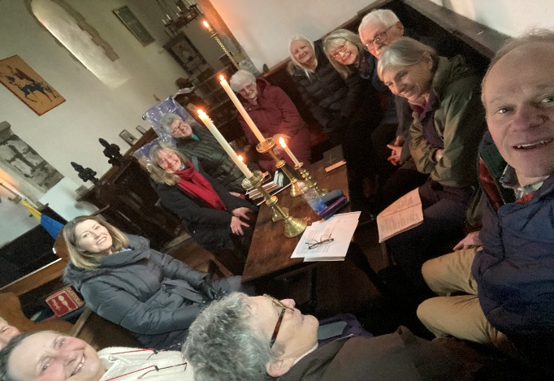

We had no power for the service at 9.30am on 22nd February which was quite a dark morning. As we all sat in the Squire’s pew with candles for light it reminded us of what it must have been like in past centuries when there was no electricity. Thanks to Diana for adapting the service to the circumstances and to those who read the lessons and intercessions.

The Rector’s Wonderings

The season of Lent begins with this reading from Mark’s Gospel in the Bible :
At that time Jesus came from Nazareth in Galilee and was baptized by John in the Jordan. Just as Jesus was coming up out of the water, he saw heaven being torn open and the Spirit descending on him like a dove. And a voice came from heaven: “You are my Son, whom I love; with you I am well pleased.”
At once the Spirit sent him out into the wilderness, and he was in the wilderness forty days, being tempted by Satan. He was with the wild animals, and angels attended him.
At his baptism Jesus realised how much he was loved by God his Father and his identity as God’s beloved Son was affirmed. This was an amazing, joyful experience. But then, he immediately has 40 days of being tempted in the wilderness. This was a time of loneliness, struggle and even danger.
One thing that can challenge our joy is when we go through difficult times.
I wonder if you’ve ever been tempted to think that God sometimes wants bad things to happen to you?
"You are my Son, the Beloved; with you I am well pleased."
In the wilderness, Jesus had to battle with the temptation to deny this truth - the truth that he was dearly loved by God. We might also be tempted to doubt this truth when we go through wilderness times.
Then somehow, somewhere in the wilderness help comes to Jesus. The Gospel tells us, there were angels in the wilderness. Rest comes. Relief comes. I wonder what Jesus’ angels looked like?

Maybe a trickle of water for his parched throat?
A rock to lay his head on?
The swirl of stars on a clear, cloudless night?
A cool breeze in the heat of the day?
I wonder what your angels look like? What have they looked like in the past?
Maybe it’s the friend who meets you for coffee, and you actually have a good laugh together. Or someone bringing a meal, or flowers. A doctor giving the right medication and support. A partner or friend taking you out for the day. Or a beautiful walk by the beach or in the woods.
It’s in those things we find the seeds of joy, a reminder that we too are loved by God.
Over Lent ( 40 days before Easter) take time to give thanks for your ‘angels’.
Prayer : Loving God, we bring before you those we know who are going through wilderness times. Surround them by your goodness, mercy and love. Keep them from running into danger. Strengthen them with the joy of the Lord. Amen.
Revd Carol Bates

Acrise Environmental Group: Heritage Pond Project (From Stephen Scoffham)
Spring – Summer Timetable 2026
The project involves three ponds. They are:
Pillars Wood Pond (at the junction of School Lane and Pay Street)
Winterage Pond (at the Winterage Lane/Acrise Park Road junction by White Lodge)
Ice House Hill Pond (in the dip on the road to the Elham Valley, west of Acrise Wood)

Working Party at Winterage Pond on Saturday 21st February 2.00 – 4.00 pm (Already happened - see overleaf)
Heritage Pond Talk
Sarah-Harrington Jones from the Kent Downs National Landscape unit will be giving a talk about the heritage ponds project and how it is developing. This will be at Elham Village Hall, Peggy Pike Room 7.30 – 9.30pm on Tuesday 28th April.
Archeological test pit
We have been invited to come to Ice House Hill Pond to see the test pit being dug by the Canterbury Archeological Trust. This is timed for mid-March (details to follow).
Ecological Surveys
Three ecological surveys are planned during the spring and summer and a small group (up to half a dozen) will be invited to take part. Dates and time to be arranged.
Archeology Talk
Mark Williams from the Canterbury Archeological Trust will be sharing the findings from pit samples and talking about their work in June. Further details to follow.

Working Party at Winterage Pond on Saturday 21st February
This was Acrise Environmental Group’s first practical task, at Winterage Pond which is in the corner of the field opposite White Lodge where Winterage Lane joins the Acrise Park Road.
The session was organized by District Councillor Stephen Scoffham and led by Senior Ranger Alfie Gay from White Cliffs Countryside Partnership. At first sight it seemed a daunting task to clear the pond but with Alfie’s knowledgeable and encouraging guidance there was a transformation in the appearance of the pond by the end of the session.
There were many tree branches which had fallen into the pond, some quite large, and these had to be sawn into manageable sizes so that they could be carried and made into piles around the pond to give cover to wildlife.
Alfie, wearing waders, moved dead vegetation from the centre of the pond for others to deposit around the edge. This vegetation along with mud was very heavy. Other members of the group planted holly and hawthorn saplings at the Winterage Lane end of the pond, which will give protection as they grow.
This was an enjoyable afternoon and everyone went home with a sense of achievement.
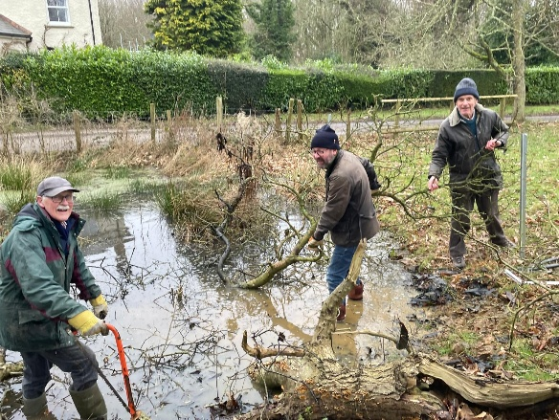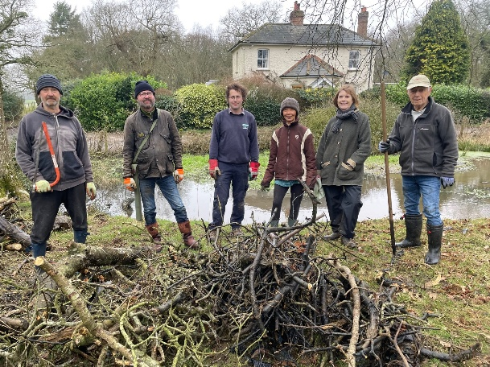

Make a note of the Heritage Pond Talk on 28th April in Elham Village Hall 7.30 – 9.30pm if you are interested.

St Martin’s Church 2026 Garage Sale
This will start on Saturday 27th June and continue until Saturday 4th July when the Grand Raffle Draw will take place that morning.
The Garage Sales Team led by Richard are involved with buying and selling secondhand items throughout the year, and not just at the Garage Sale or other fundraising events.
If you have any unwanted items that could be recycled to raise money for St Martin’s please contact Richard on:
01303 984 584 or 07919393302

Dates for the rest of 2026
Community Open Day on Saturday 18th April
This will be between 11.00am and 4.00pm. Refreshments, including homemade soup and bread, will be available as well as stalls, church records and displays. Any money raised will go towards church maintenance. Details to come soon.
Garage Sale and Grand Raffle from Saturday 27th June until Saturday 4th July
Acrise Festival and Fete with Music and Flowers on Saturday 1st August 10.00am until 5.00pm
Ride and Stride for Kent Churches on Saturday 12th September
Acrise Christmas Fair at Elham Village Hall on Saturday 28th November 10.00am until 2.00pm

Shepway Foodbank: Folkestone Rainbow Centre
We took our latest donations to our local collection centre at the beginning of February. If you can continue to support the foodbank please leave items at the back of the church or in the porch if the church is shut.
Most needed items are: white cooking sauce, curry sauce, custard, long life milk and juice, pickles, coffee, cooking oil, noodles, mayonnaise.

