Sunday 15th February 2026 St Mary’s, Woodhouse
WE WELCOME YOU, for we are all one in Christ Jesus

MISSION  Our Mission Statement  Our Mission is to make known the Gospel and love of Jesus Christ. We hope that you experience us as a safe, sacramental, welcoming, loving and inclusive Kingdom people who seek to make Christ present in the hearts of all.  Safeguarding  The parishes of St Paul’s, Woodhouse Eaves & St Mary’s, Woodhouse, are committed to the safeguarding of children, young people and adults. We follow the House of Bishops’ guidance and policies, and have our own Parish Safeguarding Officers. If you are concerned that a child or adult has been harmed or may be at risk of harm please contact –  ST PAUL’S - Safeguarding  Co-ordinator: Tony Lane  07977 924 677  ST MARY’S - Safeguarding  Co-ordinator: Andrea Farnsworth 07958 376 963  As a Benefice, we affirm that it is about not just a set of policies and procedures, but about all of us as the body of Christ sharing the responsibility for making God’s Church as safe as we can  Please take this pew sheet  home and recycle it when you’ve read it. Thank you | 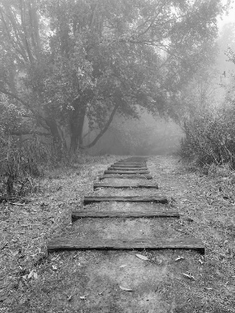 | PRAYER  Let us use our time  before the service  to talk to God,  during the service  may God talk to us, and  after the service  let us talk to one another  If you would like someone to listen or to pray with you, please contact your Parish Priest:  Rev’d Lisa Temperley-Barnes - 01509 890 972  If you would like us to pray for someone by name in our Sunday services and through the week, please email Rev’d Lisa or Stephen  Save the dates!  Lent Bible  Studies  St Paul’s  Church  1.45pm each  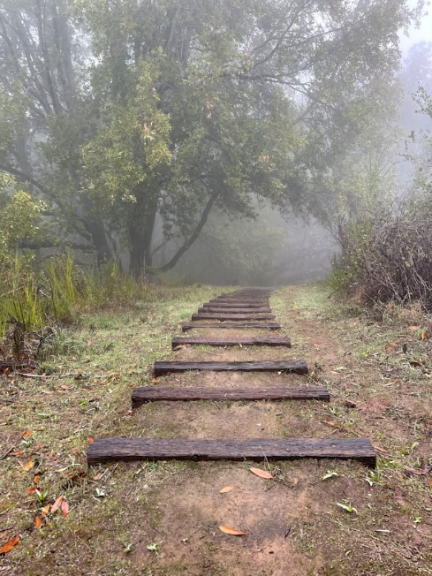  week on -  9th March,  16th March  23rd March  (all Mondays)  Do join us over a cuppa,  as we share thoughts and reflections on the meaning  of Lent in the Bible,  supporting each other on our Lenten journeys.  Photo by Jamie Ginsberg on Unsplash |  | We pray for all who are ill  for Dennis, Gill Kelly,  June Shilton,  Sue and John Thorne  We remember before God  the faithful departed  Barbara Prince, Eddie Sykes, Doreen Botts, Marlene Nash,  Judy Riley  and from St Mary’s  Book of Remembrance  Merle Enid Taylor  and from St Paul’s  Book of Remembrance  William Joyce Reedman,  Margaret Yorke Parker,  Mary McAteer  Rest eternal grant unto them, O Lord, and let light perpetual shine upon them. May the souls of the faithful departed through the mercy of God, rest in peace and rise in glory. Amen  Eddie Sykes’ funeral is at 2.00pm on 25th February at Loughborough Crematorium  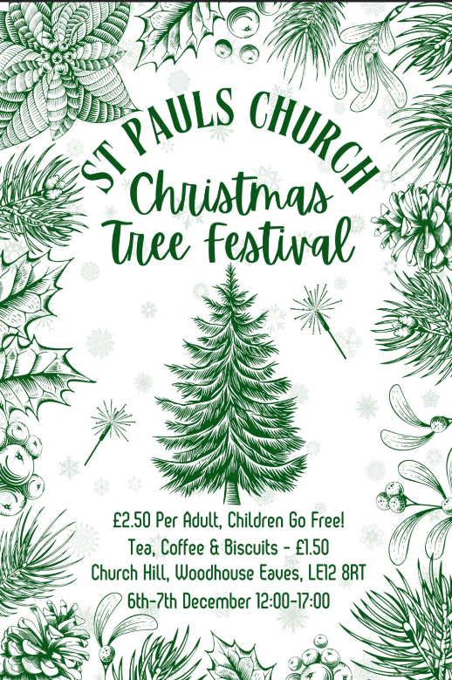
Sunday next before Lent Holy Eucharist
COLLECT  O Lord, who hast taught us that all our doings without charity are nothing worth: Send thy Holy Ghost, and pour into our hearts that most excellent gift of charity, the very bond of peace and of all virtues, without which whosoever liveth is counted dead before thee. Grant this for thine only Son Jesus Christ's sake. Amen |  | EPISTLE  The Epistle is written in the book of Genesis, the ninth chapter, beginning at the eighth verse  Then God said to Noah and to his sons with him: ‘I now establish my covenant with you and with your descendants after you and with every living creature that was with you – the birds, the livestock and all the wild animals, all those that came out of the ark with you – every living creature on earth.  I establish my covenant with you: never again will all life be destroyed by the waters of a flood; never again will there be a flood to destroy the earth.’  And God said, ‘This is the sign of the covenant I am making between me and you and every living creature with you, a covenant for all generations to come:  I have set my rainbow in the clouds, and it will be the sign of the covenant between me and the earth.  Whenever I bring clouds over the earth and the rainbow appears in the clouds, I will remember my covenant between me and you and all living creatures of every kind.  Never again will the waters become a flood to destroy all life.  Whenever the rainbow appears in the clouds, I will see it and remember the everlasting covenant between God and all living creatures of every kind on the earth.’  So God said to Noah, ‘This is the sign of the covenant I have established between me and all life on the earth.’  Genesis 9:8-17  Here endeth the Epistle |  | GOSPEL  The holy Gospel is written in the Gospel according to St Matthew, the seventeenth chapter, beginning at the first verse.  Six days later, Jesus took with him Peter and James and his brother John and led them up a high mountain, by themselves.  And he was transfigured before them, and his face shone like the sun, and his clothes became dazzling white. Suddenly there appeared to them Moses and Elijah, talking with him. Then Peter said to Jesus, ‘Lord, it is good for us to be here; if you wish, I will make three dwellings here, one for you, one for Moses, and one for Elijah.’ While he was still speaking, suddenly a bright cloud overshadowed them, and from the cloud a voice said, ‘This is my Son, the Beloved; with him I am well pleased; listen to him!’ When the disciples heard this, they fell to the ground and were overcome by fear. But Jesus came and touched them, saying, ‘Get up and do not be afraid.’ And when they looked up, they saw no one except Jesus himself alone. As they were coming down the mountain, Jesus ordered them, ‘Tell no one about the vision until after the Son of Man has been raised from the dead.’  Matthew 17:1-9

