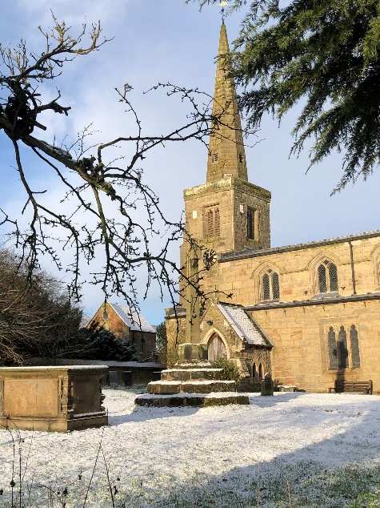
ST MICHAEL AND ALL ANGELS,
HAMSTALL RIDWARE

In the United Benefice of King’s Bromley, the Ridwares
and Yoxall

February 1st 2026
Epiphany 4

PARISH NOTICES

UNITED BENEFICE SERVICE ROTA
 | Hamstall Ridware  St Michael and All Angels | Yoxall  St Peter | King’s Bromley  All Saints | Mavesyn Ridware  St Nicholas
February 1st  Candlemas | 9.00 am  Holy Communion | 10.30 am  Parish Communion | 4.00 pm  Holy Communion | 10.30 am  Morning Prayer
February 8th  2 Before Lent | 4.00 pm  Holy Communion | 10.30 am  Parish Communion | 10.30 am  Parish Communion
February 15th  Next before Lent | 10.30 am  Parish Communion | 4.00 pm  Holy Communion | 9.00 am  Holy Communion | 10.30 am  Parish Communion
February 18th  Ash Wednesday |  | 10.30 am  Holy Communion and Imposition of Ash | 7.00 pm  Holy Communion and Imposition of Ash
February 22nd  Lent 1 | 10.30 am  Service of the Word | 9.00 am  Holy Communion | 10.30 am  Parish Communion
Please note that services of Holy Communion at 9 am follow the Book of Common Prayer and are said. Services at 10.30 will include hymns and other singing.
There are services of Holy Communion at 10.00 every Wednesday at St Peter’s, Yoxall and on the first Thursday of each month at All Saints, King’s Bromley.
*******************
Rugeley Food Bank. Please do remember those who depend on Food Banks. They are needed now just as ever. If you wish to donate directly to Rugeley Foodbank at Rugeley Community Centre the Centre is open everyday to receive contributions. Alternatively, the Rugeley Food Bank welcomes financial contributions – see https://rugeley.foodbank.org.uk. Gifts can also be brought to St Michael’s and left in the box at the back of church near the font. If that is not convenient please contact Liz Carter on 07751 068181.
****************
Contact details: If you wish to contact the Rector, Jeremy Brading you can do so on revd@kbhmy.co.uk and Glenis Turner, the PCC Secretary and Benefice Administrator is on admin@kbhmy.co.uk. The churchwardens are Michael Elsom michael.elsom@btopenworld.com and John Ferguson clan.member1954@gmail.com Information about events at church can be found at our webpages at https://www.achurchnearyou.com/church/4451/ and https://kbhmy.co.uk/hamstall/
St Michael’s will continue to be open everyday (weather permitting) between 10.00 am until 4.00 pm. We will revert to shutting the church at 6.00 pm on March 29th 2026
PLEASE REMEMBER IN YOUR PRAYERS:
Those who are sick: Mary Mycock, Angela Perkin, Doug, David and Barbara Rudge, May Windley, Pam Payne, Frank and Margaret Finch, Chris Poole, Les Wood, Pat Lomax, Alison Scott and any known personally to you.
The family and friends of Brenda Perkin who died this week in her 90th year. Brenda was a regular worshipper and helper at St Michael’s for many, many years until she became housebound.
Those who live and work in the Nursing, Care and Retirement homes in the villages both in and near the parishes of the United Benefice.
At this time when the world order looks more than a trifle uncertain we pray for the leaders of the nations that they may exercise wisdom and understanding when making decisions which will affect not only their own nations, but also their neighbours, friends and allies. May peace prevail and war be averted.
Using the Archbishops’ prayer for Ukraine at this time let us remember the people of that war-torn land:
God of peace and justice, we pray for the people of Ukraine today. We pray for peace and the laying down of weapons. We pray for all those who fear for tomorrow, that your Spirit of comfort would draw near to them. We pray for those with power over war or peace, for wisdom, discernment and compassion to guide their decisions. Above all, we pray for all your precious children, at risk and in fear, that you would hold and protect them. We pray in the name of Jesus, the Prince of Peace. Amen
The situation in the Middle East where hopes for a peaceful resolution sometimes appear irretrievably bleak:
O God of all justice and peace, we cry out to you in the midst of the pain and trauma of violence and fear which prevails in the Holy Land. Be with those who need you in these days of suffering; we pray for people of all faiths - Jews, Muslims and Christians and for all people of the land. While we pray to you, O Lord, for an end to violence and the establishment of peace, we also call to you to bring justice and equity to the peoples. Guide us into your kingdom where all people are treated with dignity and honour as your children - for to all of us you are our Heavenly Father. In Jesus' name we pray. Amen.
From the Diocesan Prayer Diary:
Sunday 1st February: (Brigid, Abbess of Kildare, c.525)
Lord, we pray for your blessing on all our relationships, both personal and professional; teach us to welcome your love and light into them. Jesus, help us to remember that you came to give us life in all its fullness and that you will never leave or forsake us. Grant us the wisdom to turn to you for guidance whenever we need it. Amen.
Monday 2nd: (The Presentation of Christ in the Temple (Candlemas))
Almighty and ever-living God, clothed in majesty, whose beloved Son was this day presented in the Temple, in substance of our flesh: grant that we may be presented to you with pure and clean hearts, by your Son Jesus Christ our Lord, who is alive and reigns with you, in the unity of the Holy Spirit, one God, now and for ever. Amen.
Tuesday 3rd: (Anskar, Archbishop of Hamburg, Missionary in Denmark and Sweden, 865)
On St Werburgh's day, we pray for the three churches in the diocese dedicated to her, at Burslem in Stoke, Hanbury near Burton, and Kingsley in the Staffordshire Moorlands. So too we pray for Trentham Parish Church, sitting alongside the ruins of St Werburgh's Abbey. We pray for your hand of blessing to rest on each of these churches and the communities they serve.
LENT 2026
As you can see from the Benefice Service Rota on the front page, we are already looking forward in the Church’s year to the season of Lent. The services on Ash Wednesday are in Yoxall and King’s Bromley and mark the start of this very important part of the year for Christians.
Rev’d Jeremy will be conducting a series of House Groups on Wednesday evenings at St Peter’s, Yoxall during the season. The first will be on Wednesday February 25th – and all will be in the comfort of the St Chad’s Room in that church. More details will appear here as these dates come closer, but in the meantime please mark your diaries for what promises to be an interesting and rewarding period of study and reflection.
St Michael’s encourages donations by means of this QR code and it will appear (all being well) on all our publications as an invitation to contribute to the important work of the church both
as a place of worship and a community asset where all can share in the wonderful place we have inherited and wish to pass down to those who come after.

