
St Peter and the Holy Apostles, Plymouth- Sunday 15th February 2026
The First Sunday of Lent (Year A)
Welcome to the Parish Mass
Welcome to St Peters Church. This sheet provides all that you will need for today’s Mass. If you need any assistance before, during or after the service or need a large print copy of this order of service please speak to one of our welcome team. (identifiable by a lanyard)
Please respond to the words in non-italic Bold, The Hymns are sung by all. Please inform the people on the door when you enter if you require a Gluten Free Host
…………………………………………………………………………………
We Stand for The Entrance Hymn

1. Praise to the Holiest in the height,
and in the depth be praise:
in all his words most wonderful,
most sure in all his ways.
2. O loving wisdom of our God!
When all was sin and shame,
a second Adam to the fight
and to the rescue came.
3. O wisest love! that flesh and blood,
which did in Adam fail,
should strive afresh against the foe,
should strive and should prevail;
4. And that a higher gift than grace
should flesh and blood refine,
God's presence and his very self,
and essence all-divine.
5. O generous love! that he, who smote
in Man for man the foe,
the double agony in Man
for man should undergo;
6. And in the garden secretly,
and on the cross on high,
should teach his brethren, and inspire
to suffer and to die.
7. Praise to the Holiest in the height,
and in the depth be praise:
in all his words most wonderful,
most sure in all his ways.
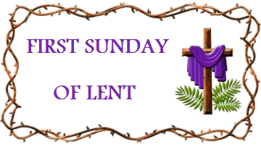
The Introductory Rite
In the name of the Father and of the Son and of the Holy Spirit. Amen.
Following the greeting we respond. And with your spirit.
The Priest introduces the Mass
The Penitential Rite
Brothers and sisters, let us acknowledge our sins,
and so prepare ourselves to celebrate the sacred mysteries.

I confess to almighty God and to you, my brothers and sisters, that I have greatly sinned, in my thoughts and in my words, in what I have done and in what I have failed to do, through my fault, through my fault, through my most grievous fault; therefore I ask blessed Mary ever-Virgin, all the Angels and Saints, and you, my brothers and sisters, to pray for me to the Lord our God.

May almighty God have mercy on us, forgive us our sins, and bring us to everlasting life. Amen.

Either:
Lord, have mercy. Lord, have mercy.
Christ, have mercy. Christ, have mercy.
Lord, have mercy. Lord, have mercy.
Or:
Kyrie, eleison. Kyrie, eleison.
Christe, eleison. Christe, eleison.
Kyrie, eleison. Kyrie, eleison.

The Collect

Grant, almighty God, through the yearly observances of holy Lent, that we may grow in understanding of the riches hidden in Christ and by worthy conduct pursue their effects. Through our Lord Jesus Christ, your Son, who lives and reigns with you in the unity of the Holy Spirit, God, for ever and ever. Amen.

We sit for The First Reading- Genesis 2:7-9; 3:1-7

The Lord God formed the man of dust from the ground and breathed into his nostrils the breath of life, and the man became a living creature. And the Lord God planted a garden in Eden, in the east, and there he put the man whom he had formed. And out of the ground the Lord God made to spring up every tree that is pleasant to the sight and good for food. The tree of life was in the midst of the garden, and the tree of the knowledge of good and evil.
Now the serpent was more crafty than any other beast of the field that the Lord God had made. He said to the woman, ‘Did God actually say, “You shall not eat of any tree in the garden”?’ And the woman said to the serpent, ‘We may eat of the fruit of the trees in the garden, but God said, “You shall not eat of the fruit of the tree that is in the midst of the garden, neither shall you touch it, lest you die.” ’ But the serpent said to the woman, ‘You will not surely die. For God knows that when you eat of it your eyes will be opened, and you will be like God, knowing good and evil.’ So when the woman saw that the tree was good for food, and that it was a delight to the eyes, and that the tree was to be desired to make one wise, she took of its fruit and ate, and she also gave some to her husband who was with her, and he ate. Then the eyes of both were opened, and they knew that they were naked. And they sewed fig leaves together and made themselves loincloths.

The word of the Lord. Thanks be to God.

The Responsorial Psalm- Ps 51(50):3-4. 5-6b. 12-13. 14, 17. ℟ cf. 3a

Response- Have mercy on us, O Lord, for we have sinned.

Have mercy on me, O God, according to your merciful love;
according to your great compassion, blot out my transgressions.
Wash me completely from my iniquity, and cleanse me from my sin. R

My transgressions, truly I know them; my sin is always before me.
Against you, you alone, have I sinned; what is evil in your sight I have done. R

Create a pure heart for me, O God; renew a steadfast spirit within me.
Do not cast me away from your presence; take not your holy spirit from me. R

Restore in me the joy of your salvation; sustain in me a willing spirit.
O Lord, open my lips and my mouth shall proclaim your praise. R

The second Reading- Romans 5:12-19

Brothers and Sisters: Just as sin came into the world through one man, and death through sin, and so death spread to all men because all sinned — for sin indeed was in the world before the law was given, but sin is not counted where there is no law. Yet death reigned from Adam to Moses, even over those whose sinning was not like the transgression of Adam, who was a type of the one who was to come.
But the free gift is not like the trespass. For if many died through one man’s trespass, much more have the grace of God and the free gift by the grace of that one man, Jesus Christ, abounded for many. And the free gift is not like the result of that one man’s sin. For the judgement following one trespass brought condemnation, but the free gift following many trespasses brought justification. For if, because of one man’s trespass, death reigned through that one man; much more will those who receive the abundance of grace and the free gift of righteousness reign in life through the one man Jesus Christ. Therefore, as one trespass led to condemnation for all men, so one act of righteousness leads to justification and life for all men. For as by the one man’s disobedience the many were made sinners, so by the one man’s obedience the many will be made righteous.

The word of the Lord. Thanks be to God

We Stand for- The Gospel Procession and Acclamation- Matthew 4:4b

Glory to you, O Christ, Glory to you O Christ, you are the Word of God, the Word of God, Glory to You O Christ.
Glory to you, O Christ, Glory to you O Christ, you are the Word of God, the Word of God, Glory to You O Christ.
One does not live by bread alone,
but by every word that comes forth from the mouth of God.
Glory to you, O Christ, Glory to you O Christ, you are the Word of God, the Word of God, Glory to You O Christ.

The Gospel- Matthew 4:1-11

The Lord be with you. And with your spirit.
A reading from the holy Gospel according to N. Glory to you, O Lord.

At that time: Jesus was led up by the Spirit into the wilderness to be tempted by the devil. And after fasting forty days and forty nights, he was hungry.
And the tempter came and said to him, ‘If you are the Son of God, command these stones to become loaves of bread.’ But he answered, ‘It is written, “Man shall not live by bread alone, but by every word that comes from the mouth of God.” ’
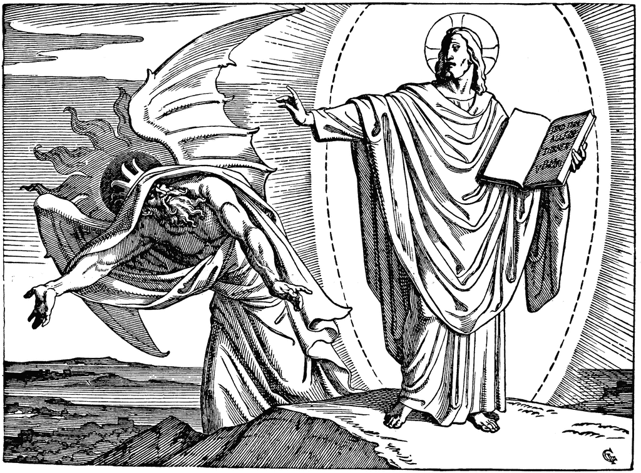
Then the devil took him to the holy city and set him on the pinnacle of the Temple and said to him, ‘If you are the Son of God, throw yourself down, for it is written, “He will command his angels concerning you”, and “On their hands they will bear you up, lest you strike your foot against a stone.” ’ Jesus said to him, ‘Again it is written, “You shall not put the Lord your God to the test.” ’
Again, the devil took him to a very high mountain and showed him all the kingdoms of the world and their glory. And he said to him, ‘All these I will give you, if you will fall down and worship me.’ Then Jesus said to him, ‘Be gone, Satan! For it is written, “You shall worship the Lord your God and him only shall you serve.” ’ Then the devil left him, and behold, angels came and were ministering to him.

The Gospel of the Lord. Praise to you, Lord Jesus Christ.
We sit for The Homily

We stand The Creed
I believe in one God, the Father almighty, maker of heaven and earth,
of all things visible and invisible.
I believe in one Lord Jesus Christ, the Only Begotten Son of God, born of the Father before all ages. God from God, Light from Light, true God from true God, begotten, not made, consubstantial with the Father; through him all things were made. For us men and for our salvation he came down from heaven,
At the words that follow, up to and including ‘and became man’, all bow.
and by the Holy Spirit was incarnate of the Virgin Mary, and became man.
For our sake he was crucified under Pontius Pilate, he suffered death and was buried, and rose again on the third day in accordance with the Scriptures.
He ascended into heaven and is seated at the right hand of the Father. He will come again in glory to judge the living and the dead and his kingdom will have no end.
I believe in the Holy Spirit, the Lord, the giver of life, who proceeds from the Father and the Son, who with the Father and the Son is adored and glorified, who has spoken through the prophets.
I believe in one, holy, catholic and apostolic Church. I confess one Baptism for the forgiveness of sins and I look forward to the resurrection of the dead and the life of the world to come. Amen.
……………………………………………………………………………………………………..

We remain standing for The Prayers of the Faithful

Each biding concludes with the following said or sung-

Lord have mercy, Lord have mercy,
Lord have mercy on your people

The Priest Concludes the Prayers of the Faithful
……………………………………………………………………………………………………..
No collection is taken during the Mass, but there is a collection box at the back of church for you to give your financial contribution. All money collected helps towards the mission and ministry of our churches. If you would prefer, a card reading machine is available at the back of the church for your contribution.

The Offertory Hymn

1. O Jesus, I have promised
To serve thee to the end;
Be thou for ever near me,
My Master and my Friend;
I shall not fear the battle
If thou art by my side,
Nor wander from the pathway
If thou wilt be my guide.
2. O let me hear thee speaking
In accents clear and still,
Above the storms of passion,
The murmurs of self-will;
O speak to reassure me,
To hasten or control;
O speak, and make me listen,
Thou guardian of my soul.
3. O Jesus, thou hast promised
To all who follow thee,
That where thou art in glory
There shall thy servant be;
And Jesus, I have promised
To serve Thee to the end;
O give me grace to follow,
My Master and my Friend.
4. O let me see thy footmarks,
And in them plant mine own;
My hope to follow duly
Is in thy strength alone;
O guide me, call me, draw me,
Uphold me to the end;
And then in heaven receive me,
My Saviour and my Friend.

Liturgy of the Eucharist
Pray, brethren (brothers and sisters), that my sacrifice and yours may be acceptable to God, the almighty Father.
May the Lord accept the sacrifice at your hands for the praise and glory of his name, for our good and the good of all his holy Church.

The Lord be with you. And with your spirit.
Lift up your hearts. We lift them up to the Lord.
Let us give thanks to the Lord our God. It is right and just.
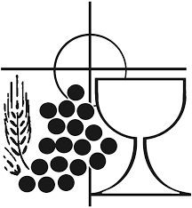
The Priest continues with the Preface. The Sanctus is the said or sung:
Holy, Holy, Holy Lord God of hosts.
Heaven and earth are full of your glory. Hosanna in the highest.
Blessed is he who comes in the name of the Lord. Hosanna in the highest.

The Priest continues the Eucharistic prayer. The following is said or sung
The mystery of faith…. Save us Saviour of the world, Save us Saviour of the world, for by your cross and resurrection, you have set us free.
The Priest concludes the Eucharistic prayer.
Through him, and with him, and in him, O God, almighty Father, in the unity of the Holy Spirit, all glory and honour is yours, for ever and ever. Amen.

The Lord’s Prayer
At the Saviour’s command and formed by divine teaching, we dare to say:
Our Father, who art in heaven, hallowed be thy name; thy kingdom come, thy will be done on earth as it is in heaven. Give us this day our daily bread, and forgive us our trespasses, as we forgive those who trespass against us; and lead us not into temptation, but deliver us from evil.
Deliver us, Lord, we pray… and the coming of our Saviour, Jesus Christ.
For the kingdom, the power and the glory are yours now and for ever.

The Peace
Lord Jesus Christ, who said to your Apostles: Peace I leave you, my peace I give you,
look not on our sins, but on the faith of your Church, and graciously grant her peace and unity in accordance with your will. Who live and reign for ever and ever. Amen.
The peace of the Lord be with you always: And with your spirit.
Let us offer each other the sign of peace.

All are invited to make an acknowledgement to each other to mark the sign of the peace.

The Agnus Dei
All say or sing:
Lamb of God, you take away the sins of the world,
have mercy on us.
Lamb of God, you take away the sins of the world,
have mercy on us.
Lamb of God, you take away the sins of the world,
grant us peace.

The Invitation to Communion
Behold the Lamb of God, behold him who takes away the sins of the world. Blessed are those called to the supper of the Lamb.
Lord, I am not worthy that you should enter under my roof, but only say the word and my soul shall be healed.

All who are regular communicants in their own tradition are welcome to receive the sacrament if you are not a communicant you are welcome to come forward at this point in the service to receive a blessing To indicate that it is just a blessing you require, please take this service sheet up with you. We have returned to offering the chalice at the time of communion but please do not feel any pressure to receive from the common cup as the church teaches that the sacrament is received fully in one kind. We request that you do not intinct (dip) your host in the Chalice but either take a sip from the cup or return directly to your seat. This is for reasons of good hygiene.

The Communion Hymn
1. Soul of my Saviour, sanctify my breast;
Body of Christ, be thou my saving guest;
Blood of my Saviour, bathe me in thy tide,
wash me with water flowing from thy side.
2. Strength and protection may thy passion be;
O blessèd Jesus, hear and answer me;
deep in thy wounds, Lord, hide and shelter me;
so shall I never, never part from thee.
3. Guard and defend me from the foe malign;
in death's dread moments make me only thine;
call me, and bid me come to thee on high,
where I may praise thee with thy saints for aye.

We stand for The Prayer After Communion

Renewed now with heavenly bread, by which faith is nourished, hope increased, and charity strengthened, we pray, O Lord, that we may learn to hunger for Christ, the true and living Bread, and strive to live by every word which proceeds from your mouth. Through Christ our Lord. Amen

The priest may give some brief notices

The Concluding Rites and The Dismissal

The Lord be with you. And with your spirit.
Bow down for the blessing.
May bountiful blessing, O Lord, we pray, come down upon your people, that hope may grow in tribulation, virtue be strengthened in temptation, and eternal redemption be assured. Through Christ our Lord. Amen.
And may the blessing of almighty God, the Father, and the Son, ✠ and the Holy Spirit, come down on you and remain with you for ever. Amen.
Go forth, the Mass is ended. Thanks be to God

The Final Hymn

1. Forty days and forty nights
thou wast fasting in the wild;
forty days and forty nights
tempted, and yet undefiled:
2. Sunbeams scorching all the day;
chilly dewdrops nightly shed;
prowling beasts about thy way;
stones thy pillow, earth thy bed.
3. Shall not we thy sorrows share,
and from earthly joys abstain,
fasting with unceasing prayer,
glad with thee to suffer pain?
4. And if Satan, vexing sore,
flesh or spirit should assail,
thou, his vanquisher before,
grant we may not faint nor fail.
5. So shall we have peace divine;
holier gladness ours shall be;
round us too shall angels shine,
such as ministered to thee.
6. Keep, O keep us, Saviour dear,
ever constant by thy side;
that with thee we may appear
at the eternal Eastertide.

The Angelus
The Angel of the Lord declared unto Mary. And she conceived of the Holy Spirit.

Hail Mary, full of grace, The Lord is with Thee; Blessed art thou among women,
And blessed is the fruit of thy womb, Jesus.
Holy Mary, Mother of God, Pray for us sinners,
Now and at the hour of our death.

Behold the handmaid of the Lord.
Be it done to me according to thy word.
Hail Mary. . .

And the Word was made flesh.
And dwelt among us.
Hail Mary…

Pray for us, O holy Mother of God.
That we may be made worthy of the promises of Christ.

Let us pray: Pour forth, we beseech Thee, O Lord, Thy grace into our hearts, that we to whom the Incarnation of Christ Thy Son was made known by the message of an angel, may by His Passion and Cross be brought to the glory of His Resurrection. Through the same Christ Our Lord. Amen.

The Notices

Help Needed for our Winter night Shelter-
help is needed to support our winter night shelter between December and March on Wednesdays… For further information please speak to Fr David or Ben

Lent 2026
Lent Study Group- looking at prayer will take place on Saturdays 11.00-12.00 with a simple soup lunch, (Volunteers needed for soup) Please see the image attached an support our joint venture Passion For Christ, see the image for details

Bible Study at St Francis- Monday evenings through lent at 6pm at St Francis- lead by Ben Ptley- we will be studying the Book of Exodus

Chrism Mass Thursday 26th March at 11.00 Exeter Cathedral. Transport is being arranged more information soon.

Big Lent Walk This Lent Fr David is going to take part in the The Big Lent Walk, which involves walking 200km in 40 days. The purpose is to raise money to supply clean water to places in Ethiopia and Peru and is organised by Cafod. Thank you So much for those who have sponsored me so far.

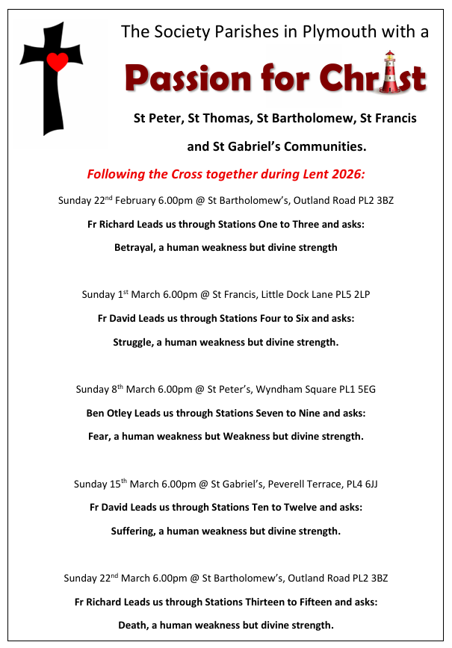

For Prayer

Those who have asked for our prayers…. Denise, Janice Allin, Leslie Porch,
Sheila Tucker, Tina Smart, Kathy Haydon, Bobby Lilicrap, June Brock,
Emma Addison, Georgie Maher, Ian Craggs, Brenda Alderson, Lois Tobin, Brenda Steed, Anne Lewis, Jenny Harvey, Jackie Morrison, Anna, Gwen Lamb, Anna Lynch, Helen Lewis, Val Bradden, Cynthia Way, Pauleen Stewart, Amelia Coughlan, Roger Lewis, Shaun Carrie, Fr Jon Bielawski, Catherine Samuel, Julian Davies.

Recently Departed-

Anniversaries of Death-

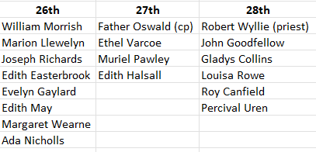

The Mission Community of St Peter and the Holy Apostles
St Peter, Wyndham Square + St Thomas, Royal Navy Avenue + St James-the-Less, Ham Drive
A Church of England Parish in the care of the Bishop of Oswestry
Parish Priest Fr. David Way SSC: 01752 240119 fr.davidway@gmail.com
.com
Mission Development Minister/ LLM/ Parish Ordinand: Ben Otley 07939800544 benotley.mission.plym@gmail.com

Parish Website: plymouthstpeter.co.uk ~ FOR MUCH MORE INFORMATION ON EVENTS, ETC.

This week’s services
Sunday 22nd-  The First Sunday/Week  in Lent | 8.30am St Thomas Fr DW  10.00am St Peter Fr DW  6.00pm St Batholomew | Mass with Hymns  Sung Mass  Stations of the Cross
Monday 23rd- St Polycarp | St Peter 10.00am Fr PL | Mass
Tuesday 24th- Weekday of Lent | St Peter 10.00am Fr DW | Mass
Wednesday 25th- Weekday of Lent | St Peter 10.00am Fr DW | Mass
Thursday 26th- Weekday of Lent | St Peter 10.00am Fr DW | Mass
Friday 27th- Weekday of Lent | St Peter 10.00am Fr DW | Mass
Saturday 28th- Weekday of Lent | St Peter 10.00am Fr DW | Mass
Sunday 1st March  The Second Sunday/Week  in Lent | 8.30am St Thomas Fr DW  10.00am St Peter Fr DW  6.00pm St Peter | Mass with Hymns  Sung Mass  Stations of the Cross
St Peters is open daily 8.30am- 12noon- Place of Welcome, Place of Prayer.

Safeguarding: If you have any concerns regarding the safety of children and others who are vulnerable, regardless of age, you must tell the Duty Priest or our parish Lay Safeguarding Representative- Jackie Morrison- email randj49@gmail.com Tel 07848859124.
For online donations please scan the QR code

