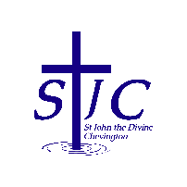
St John the Divine Welcome to our service today
Chevington 8th February 2026
Second Sunday before Lent

What’s on  = . = . = . = . = . = . = . = . = . = . = . = . = . = . = . = . = . = . = . = . = . = . = . = . = . =  This week, please pray for  We pray this week for all those who live in Acklington Road, Chibburn Avenue and Hadston Road and for the Brick Club.  From the memorial book  = . = . = . = . = . = . = . = . = . = . = . = . = . = . = . = . = . = . = . = . = . = . = . = . = . =  Shrove Tuesday  Come along to Church on Tuesday, 17th Feb  at 3 pm!  You’ll find Rev Rachael making ‘whisking up’ a storm on the stove making fresh pancakes for the whole family to enjoy, bring yourself, your family, your neighbour! |  | Church contacts  Priest in charge Revd Rachael Dines  revd.rachael.dines@gmail.com  01665 497631 / 07763 211901  Churchwardens  Anthony Reay – 07429 929537  Sheila Orgill (also Parish Safeguarding Officer) – 07484 825203  Reader Cynthia Bishop – 07498 182350  Website https://www.achurchnearyou.com/church/16282/  Facebook St John the Divine Chevington  Churchwardens St Cuthbert’s Amble  Richard Colson – 07724 687107  Linda Williams – 07720 716794  = . = . = . = . = . = . = . = . = . = . = . = . = . = . = . = . = . = . = . = . = . = . = . = . = . =  Facebook prayers  Did you know that we contribute to St Cuthbert’s daily Facebook prayers? Every Thursday a prayer from Anthony, Cynthia or Sheila appears on their page so why not check it out?  = . = . = . = . = . = . = . = . = . = . = . = . = . = . = . = . = . = . = . = . = . = . = . = . = . =  Christmas knitting  Patterns for our Christmas knitting project are available – see Sheila. We are aiming to knit 400 stars to be placed around the parish in Advent – please pass a pattern to anyone you know who can knit.  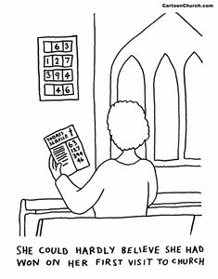  = . = . = . = . = . = . = . = . = . = . = . = . = . = . = . = . = . = . = . = . = . = . = . = . = . =
  Sunday February 8th  9:00am Holy Communion  10:30am Holy Communion  3:00pm Café Chursh | St Cuthbert’s  St John’s  Coquet Tea rooms
  Wednesday February 11th  6:30pm BINGO | Druridge Bay CC
  Sunday February 15th  9:00am Holy Communion  10:30am Holy Communion | St Cuthbert’s  St John’s
  Tuesday February 17th  10:00am Shrove Tuesday  3:00pm Shrove Tuesday  HOMEMADE PANCAKES! | St Cuthbert’s  St John’s  COME ALONG!
  Thomas Algernon | Swan | 1916
  Rita | Woolcombe | 1970
  Ethel | Patton | 2007
  Jane Annie | Tait | 2006
  Elizabeth | Forster | 1986
  Mark Lowthian | Laverick | 2006
  Robert John | Patton | 2008
  Sheila | Shanks | 1990
  Charles Patterson | McCloud | 1916
  Thomas Algernon | Swan | 1916
  Rita | Woolcombe | 1970
  Ethel | Patton | 2007

