
A very warm welcome to you, especially if you are visiting.
Please take this sheet home with you and use it as a basis for prayer.
Children may be at all our services.

Sunday 22nd February 2026
Lowick 9.15 Holy Communion
Etal 11am Holy Communion

Sunday 1st March 2026
Lowick 9.15am Family Worship in Village Hall
Etal 11am Family Communion

Sunday 8th March 2026
Lowick 9.15 Holy Communion
Etal 11am Holy Communion

Sunday 15th March 2026
Mothering Sunday
Lowick 9.15 Holy Communion
Etal 11am Holy Communion

Revd Charlotte Osborn (Vicar) 01289 388591 ceosborn@mail.com 07957 367457
Revd Alex Firman (Assistant Curate) 07935 732811
alex_firman@hotmail.co.uk


40 days and 40 nights
of
Wandering
or
Walking?
Will this Lent be a time of unmaking or remaking? What disciplines will we put in place to help us walk purposefully and be re-made?


Lent Study Groups this year will take place in Lowick Vicarage on Monday evenings from 7-8.30pm. We will be using ‘Lentwise’ by Paula Gooder, Canon Chancellor of St Paul’s Cathedral London. Copies of these will be available at £10 each but are not necessary to follow the sessions.

Tomorrow’s session will look at how we find our life’s direction through turmoil and trust.
- 23rd February
- 2nd March
- 9th March
- 16th March
- 23rd March

Tuesday 3rd March 7 for 7.30pm Norham Deanery Synod Tweedmouth Parish Church

Wednesday 4th March 1.30pm Vicarage Ancroft PCC

Thursday 5th March 2pm Vicarage Lowick PCC

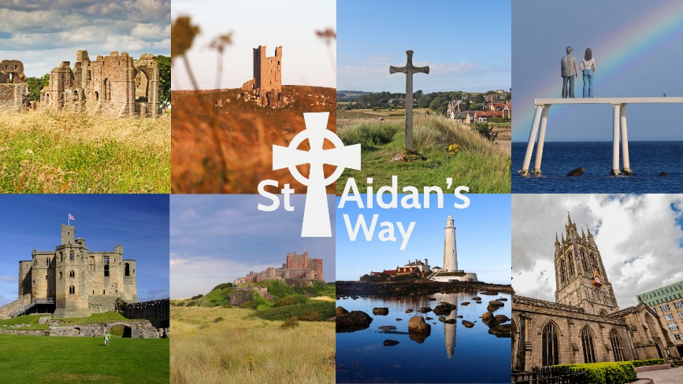
On 7th March, pilgrims will walk from Holy Island to Belford following a short 10am Eucharist Service at St Mary's Church, Holy Island where Bishop Helen-Ann will preside. All are very welcome to join for service, walk or both.
Snacks, water, lunch, sensible clothes and a small towel are advised.
Due to tide times, please meet at 9.30am at St Mary’s Belford, leaving your own car there. There will be a coach leaving Belford from the Blue Bell Hotel at 9.30am to transport pilgrims to Holy Island in time for the 10am Service. Due to travel arrangements, it would be particularly helpful to know numbers in advance. Please contact the Revd Sarah Hills to confirm your attendance (by 25th February) or to ask any questions at incumbentholyisland@gmail.com

Middlemiss Lecture will take place on 22nd April 2026. Details soon.

For our prayers

Please continue to pray for all who suffer in body, mind or spirit, especially Andrew Watson, Heather Piper, Chloe French, George Hall, Gail Calder, Revd Sam Quilty, David and Revd Judith Dobson, Christine Hammell, Kathleen Glenn.

We remember all who have recently died and those who mourn.
We pray for all who mark the anniversaries of death at this time of year: Angela Curle, John Scott.

We seek God’s grace and wisdom for Diocesan Synod, which meets in Hexham Abbey on Saturday 28th February.

Parish Contacts

Ancroft Leigh Yorke 07716 116739
Etal Andrew Joicey 01890 820540
Ford Kathleen Holmes 07951 099668
Lowick Niall Cartlidge 07850 876246

Websites: www.achurchnearyou.com
Instagram: https://www.instagram.com/the_flake_churches/
Facebook: the_flake_churches

Other licensed clergy

Revd Margaret Sentamu 077871 204745, Canon Nick Sagovsky,
Revd Marion Penfold 01289 305664

