The North Lafford Benefice Newsletter
February 2026

Reflection from the Rectory – The Light of Christ in our Lives. Candlemas
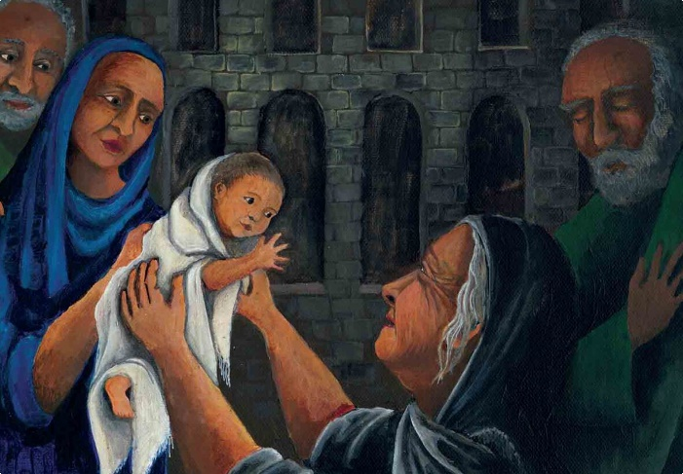
This coming Candlemas, on Sunday the 1st of February, will be celebrated as a Benefice Service this year as we welcome our Bishop, Bishop Stephen, to North Lafford. Candlemas is a time of welcome. It is another name for the feast of the Presentation of the Lord. Forty days after Jesus’ birth, Mary and Joseph bring Jesus to the temple for the traditional rites of purification and dedication. It is the final Epiphany revelation as the two other characters in the story, Simeon and Anna, meet Jesus and his parents and declare to all present, especially Anna, that she has met the Messiah. Simeon declares his praise to God in the very famous song known as the Nunc Dimitis (Luke 2.29-32). The story is bittersweet, the welcome by Simeon and Anna must have gladdened their hearts, but at the same time it would have caused some anxiety at Simeon’s prophesy of a sword piercing Mary’s heart. She would hold on to those words as she did with those of the shepherds as her son grows and became wise.

This is also a time of reflection for us too as we think about where we are in our own stories of discipleship. In only a few short weeks we will enter the season of Lent, a time of personal reflection and an opportunity to join in with the Lent exploration, which this year will be a reflection on the Holy Spirit in our lives (more details to follow). Wherever we might be in our faith journeys, the Holy Spirit is very much there to encourage us as we seek to pray, learn, serve and worship together as church community in parish and Benefice. I pray that you are able to take some time to sit and just be with Jesus and his teachings. No matter how old we might be our Lord Jesus will always open up something new in our lives together with him.
With every blessing.
Reverend Al.

Messy Church
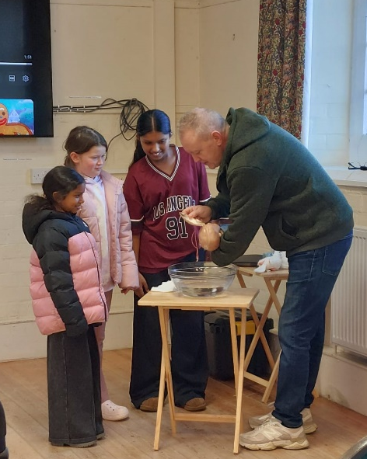
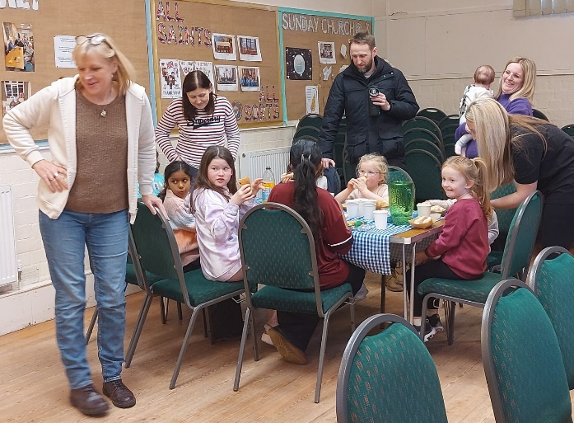
This month Messy Church was all about light and water. Two of the main ingredients of the baptismal story, and of course the Holy Spirit. We had a wonderful time as we explored the baptism of Jesus, sang this little light of mine, and of course prayer. We had a demonstration of baptism using baby Stanley (doll) who belongs to Alexis, Andreanna and Alisha acted as Godparents. We discussed the symbolism of baptism and then went on to our activities. Which included making candles, water marbling, making Holy Spirit Doves and baptism chatterboxes. There are examples at All Saints if you would like to have a look. We finished our day with a communal meal. Thank you to everyone who came and along and those who helped. Come and join us for February 7th at 3pm in the Winchelsea Centre. You are always welcome.

Sunday@3 – 15th of January 2026

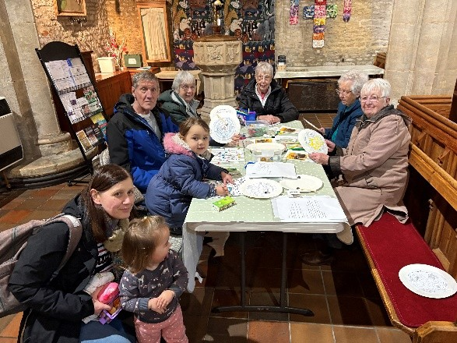
Being a follower of Jesus is very much part of Our Story as Christians. At Sunday@3 this time round we explored what being a follower of Jesus meant to us individually and collectively. There were some truly wonderful insights from those who came to worship. From nervousness about telling others, being gentle when doing so the wonder of invitation to Come and See and the power of personal and collective prayer. . We had an activity which involved magnets, a maze and putting it all together to follow Jesus. Miya was the champion colouring person this time around, with Bruce a close second! Thank you to everyone who came along, and we hope that you might join with us for February’s offering, the 15th at 3pm at All Saints. You are always welcome.

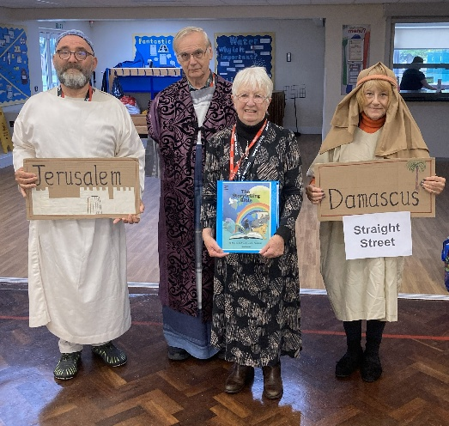
OPEN the BOOK.
We began the academic year by telling the story of Saul's conversion from Acts chapter 9 at the end of September 2025.
In November 2025 we told the story of Peter's healing of Aeneus and resurrection of Tabitha also from Acts chapter 9.
At the end of January 2026, we will be telling the story of Cornelius the Gentile centurion and Peter's eating problem from Acts chapter 10.
All four schools St Andrews, Leasingham, Winchelsea primary, Chestnut Street and Cranwell primary really enjoy our stories and some of the youngsters join us in telling of the stories. The rest of the school provide any sound effect or reactions we need.
We often now appear on the school's social media pages.

Benefice Community – All Sorts

The Benefice all age outreach offering continues through December on Mondays at 2pm in the Winchelsea Centre Ruskington. The space is designed as a time for fellowship, activities, and conversation for people of all ages. Please come along and enjoy time with friends and perhaps make some new ones. You are always welcome.

News from around the Benefice

St Edith’s Church, Anwick

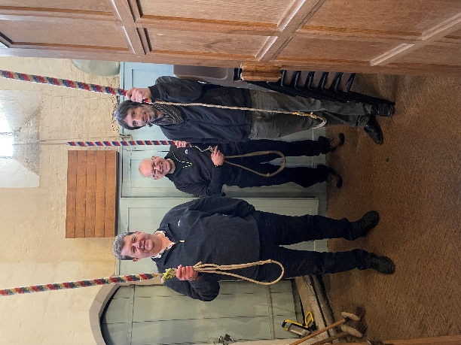
On Friday 16th January we had an Inspection of our Church Bells and surprisingly it was reported they are in good condition. The work done in the early 1900s by Carr's of Smethwick has stood the test of time. .
In the afternoon we had a group of Bell ringers to ring them which was delightful.
Our monthly coffee mornings start again on Saturday 7th February. All are welcome.

News From St Andrew’s Church, Cranwell Village
On Saturday 3rd January St Andrew’s Church, Cranwell held their first coffee morning of the year where attendance showed many parishioners welcomed the opportunity for a gentle catch up and chat with friends and neighbours over a drink and cake after a hectic couple of weeks. There was a small table selling handmade cards.
The Coffee morning in February will be on Saturday 7th February when we welcome back the lady selling her Scentsy products. There will also be a stall fundraising by a local young lady, a member of the 1st Cranwell Scout Troop. She has been selected to attend the World Scout Jamboree in Poland in 2027 and has to raise a substantial amount in order to be able to attend.
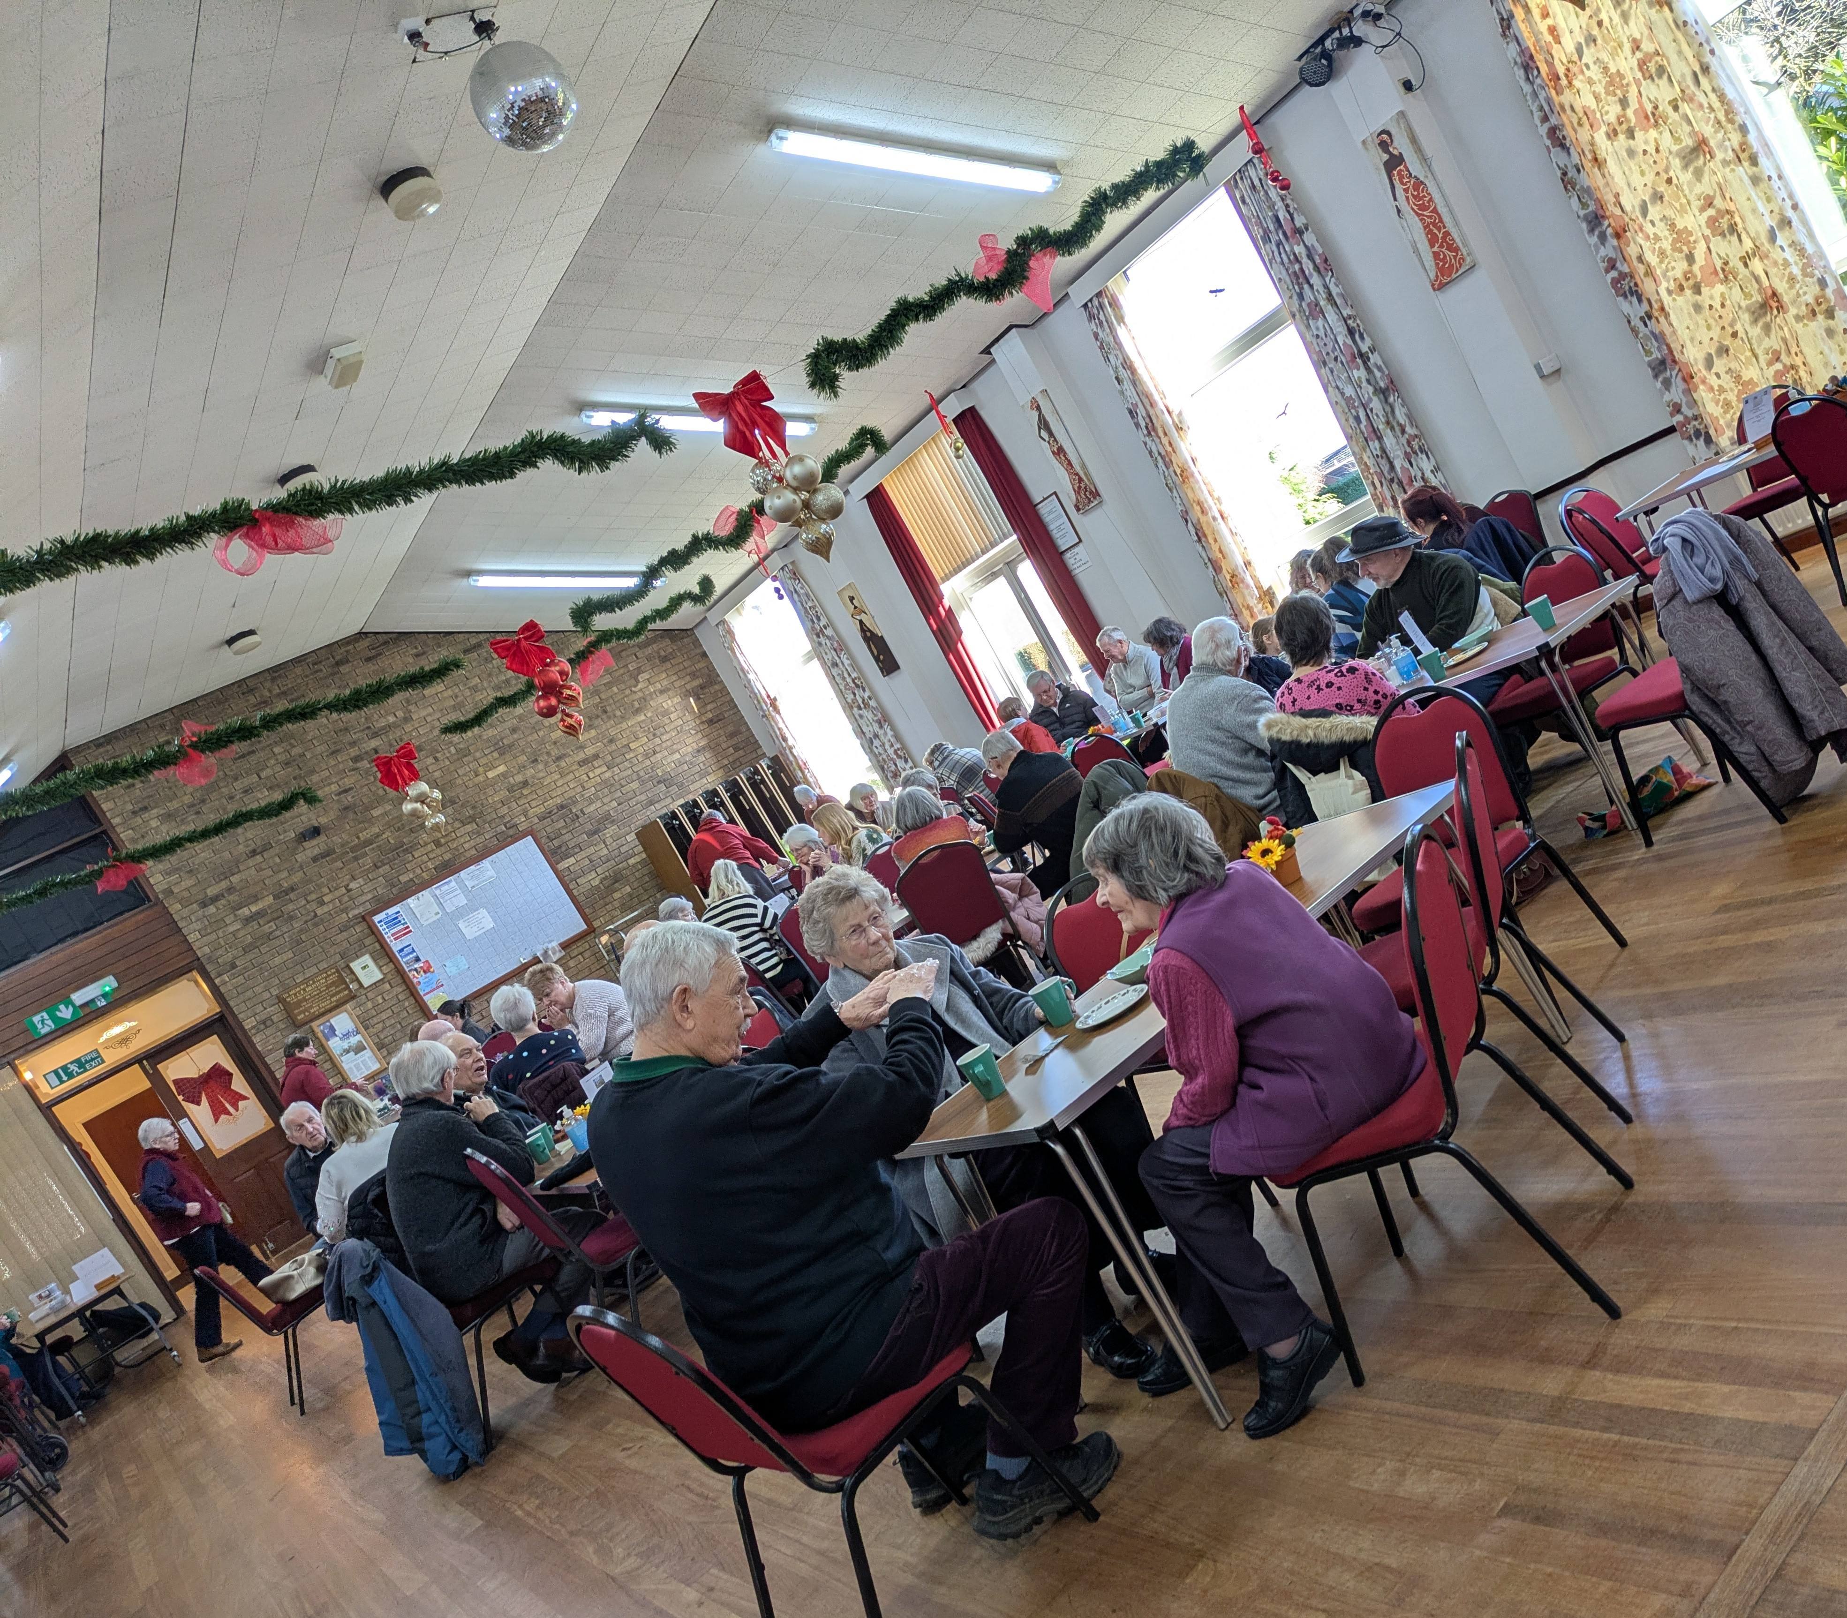
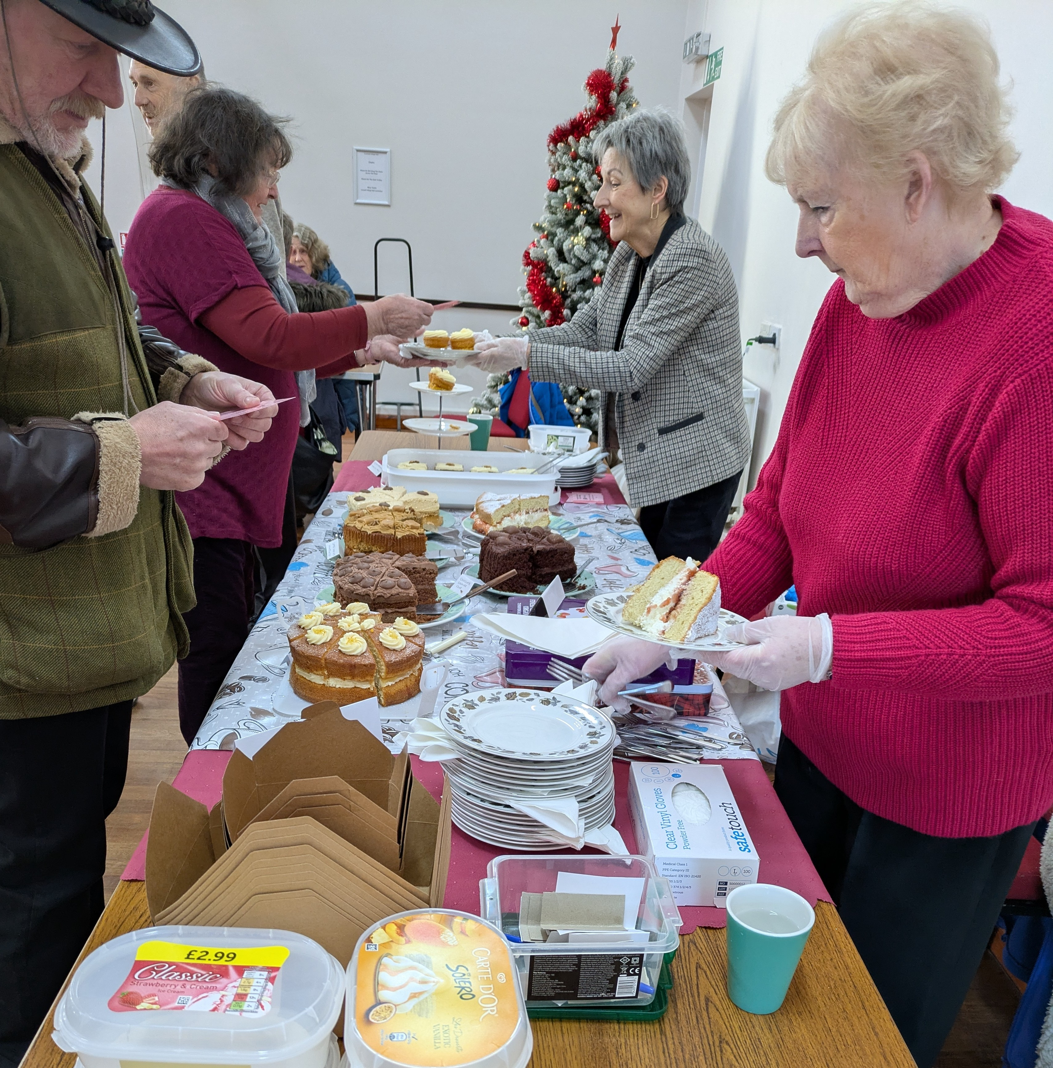

Epiphany
January saw the Kings start their journey home and the stable was packed away for another year at the end of Epiphany at St Andrew's Church in Cranwell.
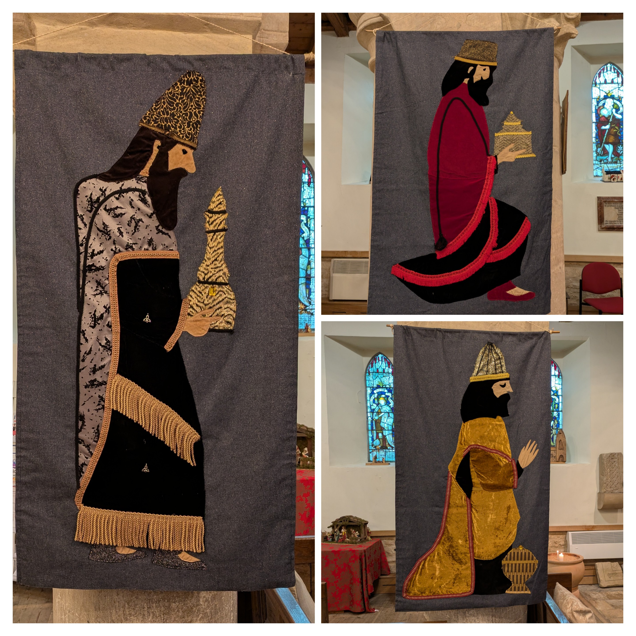

.

February Coffee Mornings around the Benefice


Do you enjoy a coffee and some good conversation on a Saturday morning? With a warm welcome, stalls to tempt and a hot drink to quench your thirst, why not tour the Benefice?

7th February Anwick Village Hall at 10.00am
7th February January Cranwell Village Hall at 10.00am
14th February Leasingham Village Hall 10-11.30am
21st February Ruskington Winchelsea Centre at 9.30am - noon


Please remember to send your Newsletter article to northlafford@gmail.com

Articles should be submitted by the 20th February to ensure its inclusion in March edition

News from the Belfry

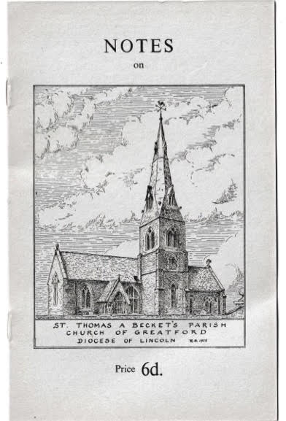
My father was the Vicar of Barholm St Martin with Stowe and Rector of Greatford St Thomas of Canterbury and Wilsthorp. I spent my formative years growing up living in the vicarage at Barholm. I made a wooden cross to mark the graves of my parents at Barholm and periodically I clean and restore it. On one such an occasion this summer I met the churchwarden and tower captain of Greatford church which led to an invitation to bring our Ruskington band to ring the 6 bells at Greatford.
On Sunday 14 December, after ringing for the service at Ruskington, the band travelled to Greatford. We were warmly welcomed at the beautiful church where we rang an assortment of methods on the light ring of 6 bells. We all had a great time and are invited to return again in the future. It was a very special event for me bringing back many boyhood memories.

All Saints’ Knitters

A very happy new year to you all.
Well, we finally produced 72 Pigs-in-Blankets for the church’s Christmas Lunch, so well done all of you who gave up your time and energy to knitting them. I must say, they did look good on the tables when everything had been laid out. I’ve had a number of people asking me to pass on their thanks for our efforts, and I’d personally like to thank Barbara who sewed on 142 ears! I did 2 ears and they were a nightmare!
Moving on, our next meeting will be on Saturday 21st February, 2026 from 10 until 12 o’clock in the Winchelsea Centre as usual. We will be knitting Cadbury Cream Egg-carrying chicks and bunnies for Easter, which require UK size 11 (3mm) needles. If you have any scraps of pastel coloured, brown and grey wools you no longer need, please bring them with you as these little animals should look fun.
Looking forward to seeing you all again so we can start and keeeeeeeeeep knitting
Stella

Readings for February 2026
 | 1st Reading | 2nd Reading | Gospel Reading
1st February  Candlemas  White | Malachi 3:1-5 | Hebrews 2:14-18 | Luke 2:22-40
8th February  2nd Sunday before Lent  Green | Genesis 1:1-5 | Romans 8:18-25 | Matthew 6:25 - 34
15th February  Sunday before Lent  Green | Exodus 24:12-18 | 2 Peter 1:16-21 | Matthew 17:1-9
18th February  Ash Wednesday  Purple | Isaiah 58. 1-12 | 2 Corinthians  5:20b-6.10 | Matthew 6:1-6,16-21
22nd February  1st Sunday of Lent  Purple | Genesis 2:15-17 | Romans 5:12-19 | Matthew 4:1-11
Monthly Sunday Service Planner - North Lafford Group - February 2026
Date | Ruskington |  |  | Service
01 February 2026 | 11am |  |  | Benefice - Holy Communion – Candlemas  with the Bishop of Lincoln
08 February 2026 | 11am |  |  | Morning Praise - Ordinary Time
15 February 2026 | 11am |  |  | Holy Communion - Ordinary Time
15 February 2026 | 3pm |  |  | Sunday@3
18 February 2026 | 7pm |  |  | Benefice Service for Ash Wednesday
22 February 2026 | 11am |  |  | Morning Praise - Lent
Date | Anwick |  |  | Service
01 February 2026 | 11am |  |  | Benefice - Holy Communion – Candlemas  with the Bishop of Lincoln
15 February 2026 | 9.30am |  |  | Holy Communion - Ordinary Time -with St Mary's at Anwick
15 February 2026 | 3pm |  |  | Sunday@3
18 February 2026 | 7pm |  |  | Benefice Service for Ash Wednesday
Date | Cranwell |  |  | Service
01 February 2026 | 11am |  |  | Benefice - Holy Communion – Candlemas  with the Bishop of Lincoln
1 February 2026 | 3pm |  |  | Service of Blessing and Rededication
08 February 2026 | 11am |  |  | Holy Communion - Ordinary Time
15 February 2026 | 11am |  |  | Morning Praise - Ordinary Time
15 February 2026 | 3pm |  |  | Sunday@3
18 February 2026 | 7pm |  |  | Benefice Service for Ash Wednesday
22 February 2026 | 11am |  |  | Morning Praise - Lent
Date | Leasingham |  |  | Service
01 February 2026 | 11am |  |  | Benefice - Holy Communion – Candlemas  with the Bishop of Lincoln
08 February 2026 | 9.30am |  |  | Morning Praise - Ordinary Time
15 February 2025 | 9.30am |  |  | Morning Praise - Ordinary Time
15 February 2025 | 3pm |  |  | Sunday@3
18 February 2026 | 7pm |  |  | Benefice Service for Ash Wednesday
22 February 2026 | 9.30am |  |  | Holy Communion - Lent
Date | Evedon |  |  | Service
01 February 2026 | 11am |  |  | Benefice - Holy Communion – Candlemas  with the Bishop of Lincoln
15 February 2026 | 9.30am |  |  | Holy Communion - Ordinary Time with St Mary's at Anwick
15 February 2026 | 3pm |  |  | Sunday@3
18 February 2026 | 7pm |  |  | Benefice Service for Ash Wednesday

The Ministry Team

Revd Al Jenkins, Priest in Charge
Work Mobile: 07961 654486
revdajenkins@gmail.com

Revd Rosemary Jenkins, Priest
Revd Nigel Panting, Deacon
Richard Vickers, Reader
Corinna Langridge, Reader
Jane Hansford, ALM
Di Holt, ALM
Caroline Morrice, ALM

The North Lafford Benefice Office is located
At Myers House (next to the Winchelsea Centre) Ruskington
Opening hours Tuesday and Friday 9.30am – 12.30pm

