Psalm 2
Please stand, if able, and join in the verses in bold

Why do the nations conspire,
and the peoples plot in vain?
The kings of the earth set themselves,
and the rulers take counsel together,
against the Lord and his anointed, saying,
‘Let us burst their bonds asunder,
and cast their cords from us.’

He who sits in the heavens laughs;
the Lord has them in derision.
Then he will speak to them in his wrath,
and terrify them in his fury, saying,
‘I have set my king on Zion, my holy hill.’
I will tell of the decree of the Lord:
He said to me, ‘You are my son; today I have begotten you.
Ask of me, and I will make the nations your heritage,
and the ends of the earth your possession.
You shall break them with a rod of iron,
and dash them in pieces like a potter’s vessel.’

Now therefore, O kings, be wise;
be warned, O rulers of the earth.
Serve the Lord with fear, with trembling ¹² kiss his feet,
or he will be angry, and you will perish in the way;
for his wrath is quickly kindled.
Happy are all who take refuge in him.

Glory be to the Father and to the Son and to the Holy Spirit,
Social Committee Meeting
Everyone is welcome to this meeting on Sunday 8th March at 11.30am in church after the service.
as it was in the beginning, is now and ever shall be,
world without end. Amen

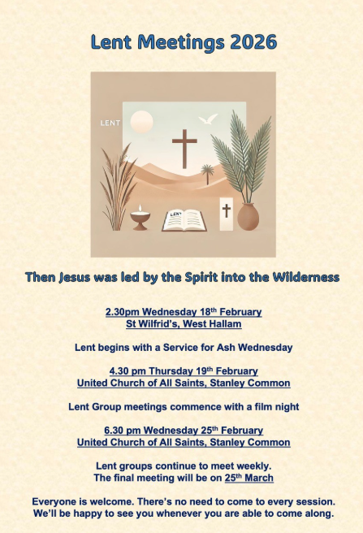
In our weekly prayers for our parish
This week we pray for God’s blessing on Goodwood Crescent, Goole Avenue and Hardwick Place.
Our 4pm services are now in Friendship House until March.
Distribution of Communion –currently the Priest will dip the communion wafer in the wine while we discern a safe way to bring the common cup back into worship, as we want everyone to feel included and safe. We also have gluten free wafers available.
Would you like to go to the Panto? Oh yes you would! Then please contact Julie Jones (the Reader) on 07528021021 as she has tickets at just £5 each for Mother Goose at Horsely Woodhouse by Stargazers at 3pm on Saturday 21st February. Lift might be possible too.
Refreshments After the Morning Service
Please stay seated after the service and a hot drink will be brought to you in the pews. Do not get up and head to the back of church, it is becoming a hazard, and a risk as trays of hot drinks could be knocked over.
Church contact information
Contact: Rev’d Christine - revchristine@outlook.com
The Rectory, The Village, West Hallam, DE7 6GR
Landline 0115 646 1497
Rev’d Ailsa -revailsahunt@gmail.com
Tel - 07356064856

Churchwardens – Mrs Janet Wheeldon, -Tel: 0115 8771593
Mrs Linda Gregory – linda.gregory3@icloud.com
https://www.achurchnearyou.com/church/13402/
https://www.facebook.com/allsaintskirkhallam
All Saints Church
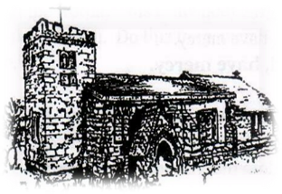
Kirk Hallam
Disabled Toilet in Friendship House.
Disabled Toilet in Friendship House.

Working with God to transform lives & communities.
Please can you ensure your mobile is on silence, or off during the service, it is affecting people with hearing aids and the loop system.

15th February – Sunday Next Before Lent
10.00am CW Communion Service with Rev’d Jan & Eileen
1.00pm Baptism of Ralph David Kieman
3.00pm Building Faith at Community Centre
4.00pm Holy Communion with Rev’d Christine

Forthcoming Events
Tues 17th 10.30am Funeral for Iris Howe at UCAS
Tues 17th 6.00pm Home Group in Friendship House
Weds 18th 9.30am Morning Prayer at UCAS
Weds 18th 2.30pm Ash Wednesday Service at
St Wilfrid’s Church, West Hallam
Thurs 19th 4.30pm Lent film at UCAS – Les Misérables
Fri 20th 6.00pm Choir Practise in Friendship House
Sat 21st 10.00am Prayer Meeting in Friendship Huse

22nd February – First Sunday of Lent
10.00am CW Communion Service with Rev’d Alan
4.00pm Evening Prayer with Julie
It’s Good to Talk! If you spot that someone is missing, please pop a news sheet through their door, & if you’ve time, call for a chat - just to check they’re OK & to let them know that they are not forgotten!
“Trust in the Lord with all your heart and lean not on your own understanding” Proverbs 3: 5

