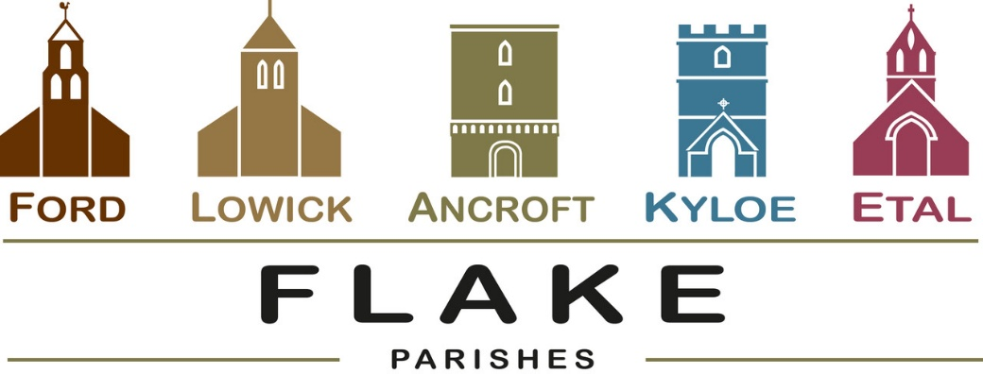
A very warm welcome to you, especially if you are visiting.
Please take this sheet home with you and use it as a basis for prayer.
Children may be at all our services.

Sunday 8th February 2026
Lowick 9.15am Holy Communion
Etal 11am Holy Communion

Sunday 15th February 2026
Lowick 9.15 Holy Communion
Etal 11am Holy Communion

Sunday 22nd February 2026
Lowick 9.15 Holy Communion
Etal 11am Holy Communion

Sunday 1st March 2026
Lowick 9.15am Family Communion in Village Hall
Etal 11am Family Communion

Revd Charlotte Osborn (Vicar) 01289 388591 ceosborn@mail.com 07957 367457
Revd Alex Firman (Assistant Curate) 07935 732811
alex_firman@hotmail.co.uk


Is this even possible for us, given the state of our world today?
Jesus taught it – urged it, even commanded it and still requires it for good reason and for our blessing.

So…maybe the clue is in the word ‘so’?

Ford and Etal PCC meets in the Estate Office at 5.30 pm on Tuesday 10th February.

Soup Saturday Lowick Village Hall 14th February 12-1.30pm.

Ash Wednesday 18th February. Holy Communion with Imposition of Ashes at both Etal and Lowick at 9.30am.

The next gathering of DDG’s (Deanery Development Groups) across the Diocese will be at St Aidan’s, Morpeth on Saturday 21st February from 10am. An open meeting to discuss Buildings for Mission, including fundraising opportunities, Net Zero resources, the 101 Sustainable Churches Checklist, and a new calculator tool from the National Churches Trust to demonstrate the social impact of your church. Speak to Charlotte for a lift.


Lent Study Groups this year will take place in Lowick Vicarage on Monday evenings from 7-8.30pm. We will be using ‘Lentwise’ by Paula Gooder, Canon Chancellor of St Paul’s Cathedral London. Copies of these will be available at £10 each but are not necessary to follow the sessions.
- 23rd February
- 2nd March
- 9th March
- 16th March
- 23rd March

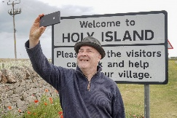

Launch of St Aidan’s Way,
Holy Island
Saturday 7th March,
Walk to Bamburgh

Middlemiss Lecture will take place on 22nd April 2026. Details soon.

Other news
Davey Greene, a member of our youth group from Lowick, is training to run the Edinburgh half marathon in March this year in aid of Macmillan Cancer Support. He would be very glad of any encouragement in the form of sponsorship or donation and there are flyers at the back of church with details of how to give.

For our prayers

Please continue to pray for all who suffer in body, mind or spirit, especially Andrew Watson, Heather Piper, Chloe French, George Hall, Gail Calder, Revd Sam Quilty, David and Revd Judith Dobson, Christine Hammell.
We remember all who have recently died and those who mourn them, including the friends and family of Mary Servin and we pray for all who mark the anniversaries of death at this time: Sheila White, Kevin Morris-Roe, Angela Curle.
We seek God’s grace and wisdom for Diocesan Synod, which meets in Hexham Abbey on Saturday 28th February.

St John the Baptist, Lowick is registered on #easyfundraising which means you can raise free funds for them as you shop online this year, at no extra cost!
All the big names like John Lewis & Partners, Argos, eBay and more are ready to donate. Every donation makes a difference.
https://join.easyfundraising.org.uk/stjohnlowick/f43jbj/s2s/KlKNhASV/SE866/facebook/
We will shortly set up pages for Ford and Etal and Ancroft too.
Parish Contacts

Ancroft Leigh Yorke 07716 116739
Etal Andrew Joicey 01890 820540
Ford Kathleen Holmes 07951 099668
Lowick Niall Cartlidge 07850 876246

Websites: www.achurchnearyou.com
Instagram: https://www.instagram.com/the_flake_churches/
Facebook: the_flake_churches

Other licensed clergy
Revd Margaret Sentamu 077871 204745, Canon Nick Sagovsky,
Revd Marion Penfold 01289 305664

