Sunday 1st February 2026
Welcome to our service of Holy Communion
Led by Rev Liz Rowles

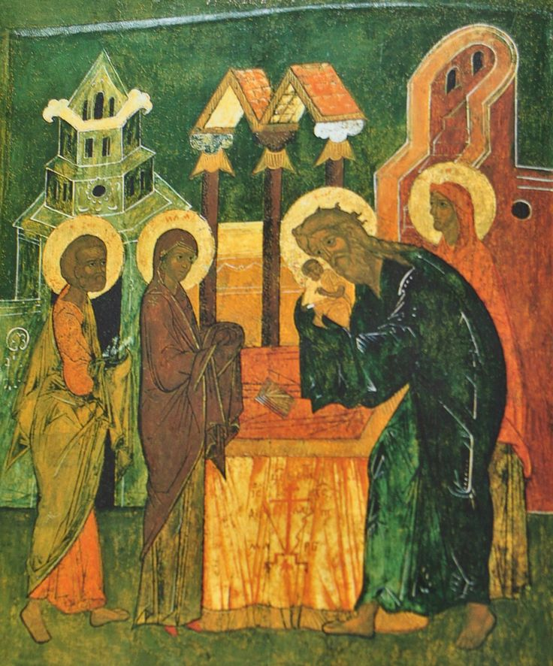

Hymns
89 MP Come down, O Love divine
Christ be our Light (See below)
323 STJ Purify my heart
66 MP Broken for me
249 MP How lovely on the Mountains

Christ be our Light

Longing for light, we wait in darkness
Longing for truth, we turn to You
Make us Your own, Your holy people
Light for the world to see
Christ, be our light
Shine in our hearts
Shine through the darkness
Christ, be our light
Shine in Your church gathered today

Longing for shelter, many are homeless
Longing for warmth, many are cold
Make us Your building, sheltering others
Walls made of living stone

Christ, be our light
Shine in our hearts
Shine through the darkness
Christ, be our light
Shine in Your church gathered today

Many the gifts, many the people
Many the hearts that yearn to belong
Let us be servants to one another
Making Your kingdom come

Christ, be our light
Shine in our hearts
Shine through the darkness
Christ, be our light
Shine in Your church gathered today

Readings
Malachi 3.1-5
Hebrews 2.14-end
Gospel
Luke 2.22-40

In our Prayers (St John’s)
Lily Barnes, Anne Clarke, Margaret Curtis, Anne Frost, Helena Oakes, Eileen Kilner, Debra Maskrey, Brenda Millward, Freda Paulson, Sofia Ribeiro, Joyce Ross, Ray and Catty Smith

In Memoriam (St John’s)
Joan Burke, Sue Callon, Lesley Anne Campbell, Thomas Eckersall, Frank Forrest, Clement Richarson, Richard Taylor, Jane Wild and John Young

This week’s services

Holy Communion and Bible Discussion Group at St John’s – Cancelled
Back next week!!

Holy Communion at St Paul’s – Wednesday 4th February 9:45am
Followed by refreshments, all welcome.

EVENTS AND NEWS

Coffee and Conversation at The Heaton Pub– Monday 2nd February 1:30pm-3:30pm
All welcome.

Candlemass Party at St John’s – Saturday 7th February 5pm-7pm
Bring and Share meal, tea/coffee provided or bring your own bottle (and glasses!) Fun and games for all ages! This is a free event (but donations are very welcome)

Prayer and Meditation at St John’s – Thursday 12th February at 7:30pm
Everyone welcome to join us as we think and pray on the theme of Candlemas.

Next Sunday’s services (Sunday 8th Feb)
Holy Communionm at St Paul’s – 9:30am
Holy Communion at St John’s – 11:15am

Next Sundays Rota
Welcomer: Ruth Taylor
Reader: Suzie McNeil
Prayers: Jonathan Tennet
Communion Assist: Ruth Taylor

Peace be with you,
Liz Rowles. Revd Liz Rowles
Team Vicar at St John’s, Heaton Mersey &
St Paul’s, Heaton Moor
E: revlizrowles@outlook.com T: 0161 964 3928
Jacquie Brennan (St John’s) T: 07880 932 171
Peter Smith Reader Emeritus. T: 07709649789. petercelia16@gmail.com.
Anne Pinkerton (admin) stjohnsandstpaulsa@gmail.com
Jonathan Tennet Church Warden (St John’s) E: jonathantennet@yahoo.co.uk
Alan and Joan Lowe Deputy Church Wardens (St John’s) E: lowejoan13@gmail.com or lowealan3@sky.com
Ann Worthington Deputy Church warden St Paul’s T: 07831 747416
Visit our A Church Near You page:
https://www.achurchnearyou.com/church/15829/service-and-events/events-all/
https://www.achurchnearyou.com/church/15828/
Or visit the QR code:



