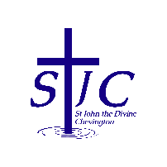
St John the Divine Welcome to our service today
Chevington 1st March 2026
Second Sunday of Lent

This week, please pray for  We pray this week for all those who live in Brandling Way, Ladyburn Way and The Pines and for everyone who lives or works at Elpha Lodge  From the memorial book  = . = . = . = . = . = . = . = . = . = . = . = . = . = . = . = . = . = . = . = . = . = . = . = . = . =  Magazine error  Due to an editorial error (Sheila’s fault!) the magazine lists Stations of the Cross on Fridays in March.  We have decided NOT to hold these services this year – apologies for the mistake – please make sure to pass this message on to anyone you think might have been planning to attend.  = . = . = . = . = . = . = . = . = . = . = . = . = . = . = . = . = . = . = . = . = . = . = . = . = . =  Lent Group – Wednesdays at 2pm in St Cuthbert’s  Come along and join us on Wednesday at 2pm as we continue our Lent Group.  A bible and a notebook would be helpful.  Nothing else needed apart from a desire to participate and learn together.  Speak to Sheila if you need transport.  = . = . = . = . = . = . = . = . = . = . = . = . = . = . = . = . = . = . = . = . = . = . = . = . = . =  Quiz Night at St Cuthbert’s  Tickets are £10 – see Sheila if you would like to go.  = . = . = . = . = . = . = . = . = . = . = . = . = . = . = . = . = . = . = . = . = . = . = . = . = . =  Happy St David’s Day  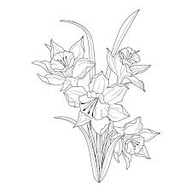 |  | What’s on  = . = . = . = . = . = . = . = . = . = . = . = . = . = . = . = . = . = . = . = . = . = . = . = . = . =  Church contacts  Priest in charge Revd Rachael Dines  revd.rachael.dines@gmail.com  01665 497631 / 07763 211901  Churchwardens  Anthony Reay – 07429 929537  Sheila Orgill (also Parish Safeguarding Officer) – 07484 825203  Reader Cynthia Bishop – 07498 182350  Website https://www.achurchnearyou.com/church/16282/  Facebook St John the Divine Chevington  Churchwardens St Cuthbert’s Amble  Richard Colson – 07724 687107  Linda Williams – 07720 716794
  Dennis | Blakey | 2015
  Edward | Conroy | 1915
  Robert | Currie | 1979
  Norah | Henderson | 2012
  Joan | Hetherington | 2007
  Isabella | Keen | 2001
  Sunday March 1st  9:00am Holy Communion  10:30am Holy Communion | St Cuthbert’s  St John’s
  Monday March 2nd  2:00pm Bill Johnson’s funeral | St John’s
  Wednesday March 4th  10:30am Creating Soul Space  2:00pm Lent Group | St Cuthbert’s  St Cuthbert’s
  Thursday March 5th  7:00pm Making Space | St John’s
  Saturday March 7th  10:00am Coffee morning | St Cuthbert’s
  Sunday March 8th  9:00am Holy Communion  10:30am Holy Communion  11:45am PCC  3:00pm Café Church | St Cuthbert’s  St John’s  St John’s  Coquet tea rooms

