Psalm 121
Please stand, if able, and join in the verses in bold

I lift up my eyes to the hills—
from where will my help come?
My help comes from the Lord,
who made heaven and earth.

He will not let your foot be moved;
he who keeps you will not slumber.
He who keeps Israel
will neither slumber nor sleep.

The Lord is your keeper;
the Lord is your shade at your right hand.
The sun shall not strike you by day,
nor the moon by night.

The Lord will keep you from all evil;
he will keep your life.
The Lord will keep your going out and your coming in
from this time on and for evermore.

Glory be to the Father and to the Son and to the Holy Spirit,
as it was in the beginning, is now and ever shall be,
world without end. Amen

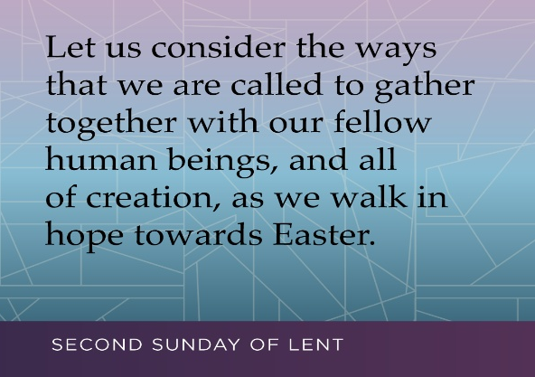


Once again, we are asking everyone if they could please collect their change over Lent and then bring it in on Easter Day.
If you need a jar, there are some spare ones in church.

Thank you – together we can make a difference
A message from Christine Buxton…
I have, over the years, enjoyed playing the organ and getting to know
the people at All Saint’s who are so very friendly. It was a sad day for me to say goodbye to my friends there and more so that it was the anniversary of my dear husband’s death.
The presentation on Sunday morning was a surprise to me, the colouring bible and the yearly text calendar made me weep. It made to realise how much you and the church means to me. I thank everybody for the cards and the kind thoughts written therein.
I may be able to get a lift from Pat Doyle occasionally. I will have to see. I sold my car today so I have to get used to getting the bus instead, if I can make it to the bus stop. I have applied for a bus pass, I will see what I can manage. May God bless you and all of All Saint’s church.
In our weekly prayers for our parish
This week we pray for God’s blessing on Hilary Place, Kenilworth Drive & Keswick Close.
Our 4pm services are now in Friendship House
until the end of March.
Distribution of Communion –currently the Priest will dip the communion wafer in the wine while we discern a safe way to bring the common cup back into worship, as we want everyone to feel included and safe. We also have gluten free wafers available.
Refreshments After the Morning Service
Please stay seated after the service and a hot drink will be brought to you in the pews. Do not get up and head to the back of church, it is becoming a hazard, and a risk as trays of hot drinks could be knocked over.
Church contact information
Contact: Rev’d Christine - revchristine@outlook.com
The Rectory, The Village, West Hallam, DE7 6GR
Landline 0115 646 1497
Rev’d Ailsa -revailsahunt@gmail.com
Tel - 07356064856

Churchwardens – Mrs Janet Wheeldon, -Tel: 0115 8771593
Mrs Linda Gregory – linda.gregory3@icloud.com
https://www.achurchnearyou.com/church/13402/
https://www.facebook.com/allsaintskirkhallam
All Saints Church
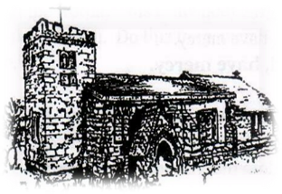
Kirk Hallam
Disabled Toilet in Friendship House.
Disabled Toilet in Friendship House.

Working with God to transform lives & communities.
Please can you ensure your mobile is on silence, or off during the service, it is affecting people with hearing aids and the loop system.

1st March – Second Sunday of Lent
10.00am CW Communion Service with Rev’d Ailsa
4.00pm Evening Prayer with Rev’d Christine

Forthcoming Events
Mon 2nd 11.00am Internment of ashes of Arnold Watson
Mon 2nd 12noon Internment of ashes of Susan Oakes
Tues 3rd 6.00pm Home Group in Friendship House
Weds 4th 9.30am Morning Prayer at UCAS
Weds 4th 2.00pm Mothers’ Union meeting in church
Weds 4th 6.30pm Lent Group at UCAS
Fri 6th 11.00am Funeral of Margaret Hallam at St Andrew’s
Fri 6th 6.00pm Choir Practise in Friendship House
Sat 7th 10.00am Prayer Meeting in Friendship Huse

8th March – Second Sunday of Lent
10.00am CW Communion Service with Rev’d Alan Fitch
11.15am Social Committee Meeting – all welcome
4.00pm Evening Prayer with Rev’d Christine
“Be on your guard; stand firm in the faith; be courageous, be strong” 1 Corinthians 16:13
It’s Good to Talk! If you spot that someone is missing, please pop a news sheet through their door, & if you’ve time, call for a chat - just to check they’re OK & to let them know that they are not forgotten!

