
SPIRE & LIGHT United Churches
United Benefice of St Keverne, St Ruan with St Grade & St.Wynwallow (The Lizard)

*If you do not wish to receive these notices, please let your Churchwarden know*

22nd February 2026
Lent 1


Readings
Genesis 2:15-17, 3:1-7
Psalm 32
Romans 5:12-19
Matthew 4:1-11

9.30am – Morning Prayer - St.Peter’s, Coverack
9.30am – Holy Communion - St.Ruan, Ruan Minor
11am – Holy Communion – St.Keverne CHURCH HALL
11.15am – Café Church – St.Wynwallow, The Lizard

Next week – Sunday 1st March
9.30am – Holy Communion - St.Peter’s, Coverack
9.30am – Holy Communion (BCP) - St.Wynwallow, The Lizard
11am – Morning Prayer (BCP) - St.Keverne
11.15am – Morning Prayer – St.Ruan, Ruan Minor



*PLEASE NOTE – UNTIL FURTHER NOTICE
ALL ST.KEVERNE SERVICES WILL TAKE PLACE IN THE CHURCH HALL *

Lent Course


The St Keverne Square Bible Study Group
will be doing a weekly Lent course starting on
Monday 16th February 2026 at 11.00 am
in The Methodist Hall, St Keverne.
If anyone is interested then please do come along
Any questions please contact Claire Thomson
Email claire.thomson2009@gmail.com
or Mobile 01171025927


The Prayer Spot

At the start of this New Year in our Benefice, remind us we are all Brothers and Sisters in Christ brought to faith by the same saviour Jesus Christ with a duty to everyone in our benefice - those in church and those outside the church, we need to pray for them all. We also ned to pray for those in care homes and all their families and all who care for them, that they will receive the help they need to do all required of them. We pray for all NHS staff, for our own health centres and all clergy during this time of year. We pray that God will guide them in all they have to do. We belong to a benefice of six churches of the Lizard, Ruan, Grade, Cadgwith, Coverack , St Keverne - we have a duty of care to all those in our churches to be together in all we do in the name of Jesus Christ our Saviour. God has given us this great gift of prayer to pray for his help and guidance in our lives and the lives of others to ask him to be with us in all we do in his Name.
We pray for –
- those in our community who need God’s help in their lives which can sometimes be difficult.
- the people in the Ukraine who need God’s help in these difficult times. We pray for God’s presence in their lives
- all those who need hospital treatment, that God will be present with them and their families and will meet their needs
- the churches in our Benefice - that God will give us all the gift of love to share with all our church members
- for our Clergy, that God will guide them in all they do for us
We thank you Heavenly Father for those gifts given to us of forgiveness, kindness , justice, generosity and peace, all gifts to share with others.
Remember God is ever present in your life and will answer your prayers in Jesus wonderful name. Be blessed in all you do.
Faithful Father we begin today giving you thanks, your love endures for ever, it never fails. Though there are many ways which we have failed, we have not exceeded the supply of your mercy and grace. We thank you for revealing yourself to us through your word, as we open our bibles today, we pray you would hear our voice. We ask that your Holy Spirt would be at work in opening our ears to hear and our heart to receive your word. May we be transformed into your likeness, through Jesus Christ our Lord. Amen
Sam Buchanan
The Diocese of Truro’s Prayer Diary for this week and next

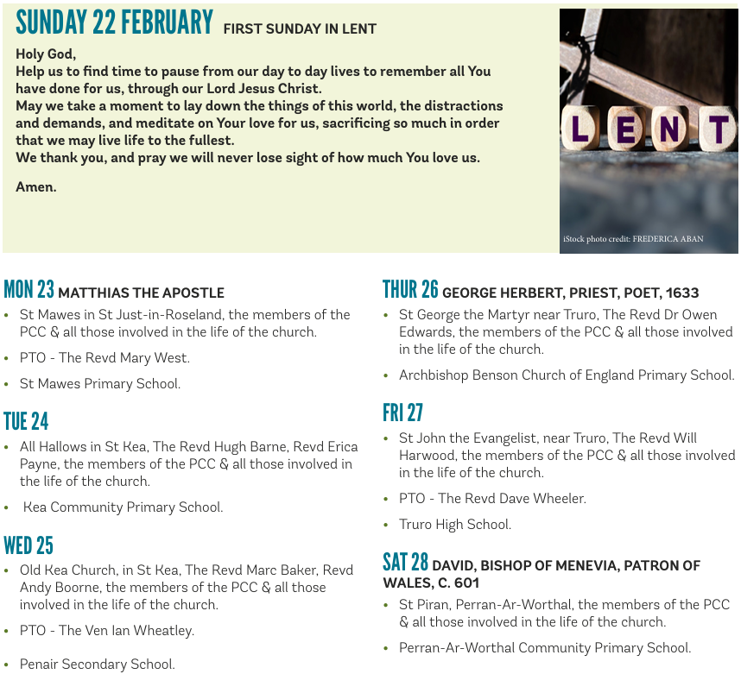

On the Way Prayers

Let us be still at the start of our Lenten journey asking God to help us on our way. Living and Loving God, the God of all our journeying, we give you thanks and praise that you are always ‘On the Way’ with us, walking step by step along the pilgrim path. God within us, God beside us, God behind us, God before us.

On Ash Wednesday we prayed for all our churches and congregations in Kerrier as we prepare to keep Lent and prepare for Easter with its glorious message of hope. We pray for all the special things we’ll be doing during Lent in our churches, and that we can all find ways of making our communities just pause and think, as they buy their Easter Eggs, eat their hot cross buns and plan for the Easter holidays.

We continue to pray that people are being called to apply for the two vacancies we currently have advertised – people who will come and join our ministry team and help us all to become more fruitful and sustainable. As our clergy begin a really busy season, let us pray for them and for all the lay ministers who support them.

And now let’s take a moment to pray for anyone who needs the power of our collective prayers right now including Bob and Jane Dunnett, John Palmer, anyone suffering with a recent diagnosis of cancer and all who care for loved ones. Lord, comfort all who suffer in any way and bring them peace.

As we wash away the remnants of our ash crosses, let us also wash away any unworthy thoughts we have, let us feel clean, not just on our faces, but in our hearts and let us carry the sign of the cross with us throughout our Lenten journey. If we are fasting or giving something up this Lent, let us not just do it to lose weight or to make ourselves feel good, but let’s do it to bring ourselves closer to you. And if we are taking up something this Lent let us do it not for ourselves, but to become your hands, your feet, your eyes in this place in this time. For Christ has no body on this earth but ours.

Amen

