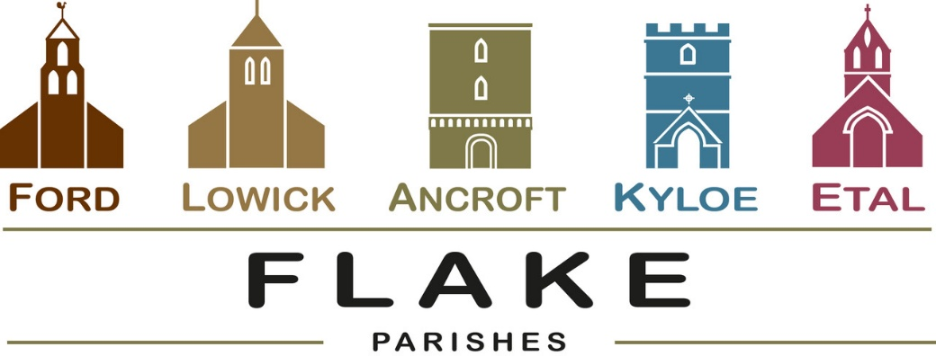
A very warm welcome to you, especially if you are visiting.
Please take this sheet home with you and use it as a basis for prayer.
Children may be at all our services.

Sunday 15th February 2026
Lowick 9.15 Holy Communion
Etal 11am Holy Communion

Sunday 22nd February 2026
Lowick 9.15 Holy Communion
Etal 11am Holy Communion

Sunday 1st March 2026
Lowick 9.15am Family Worship in Village Hall
Etal 11am Family Communion

Sunday 8th March 2026
Lowick 9.15 Holy Communion
Etal 11am Holy Communion

Revd Charlotte Osborn (Vicar) 01289 388591 ceosborn@mail.com 07957 367457
Revd Alex Firman (Assistant Curate) 07935 732811
alex_firman@hotmail.co.uk


What does glory look like to you? A prism through which to view the multi-faceted and indescribable glory and majesty of Jesus Christ? A glimpse behind the veil? Light from light?

Why did Jesus keep this hidden?

Youth Group meets this evening at 6pm at the vicarage for Games and Pancakes.
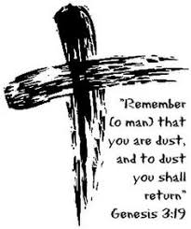

Ash Wednesday 18th February.
Holy Communion
with Imposition of Ashes

Lowick at 9.30am.
Etal at 9.30am

The next gathering of DDG’s (Deanery Development Groups) across the Diocese will be at St Aidan’s, Morpeth on Saturday 21st February from 10am. An open meeting to discuss Buildings for Mission. Speak to Charlotte for a lift.

Tuesday 3rd March 7 for 7.30pm Norham Deanery Synod

Wednesday 4th March 1.30pm Vicarage Ancroft PCC

Thursday 5th March 2pm Vicarage Lowick PCC
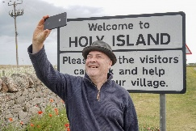
Launch of St Aidan’s Way,
Holy Island, St Mary’s Church 10am
Saturday 7th March,
Walk to Belford. All welcome…


Lent Study Groups this year will take place in Lowick Vicarage on Monday evenings from 7-8.30pm. We will be using ‘Lentwise’ by Paula Gooder, Canon Chancellor of St Paul’s Cathedral London. Copies of these will be available at £10 each but are not necessary to follow the sessions.
- 23rd February
- 2nd March
- 9th March
- 16th March
- 23rd March

Middlemiss Lecture will take place on 22nd April 2026. Details soon.

Other news
Davey Greene, a member of our youth group from Lowick, is training to run the Edinburgh half marathon in March this year in aid of Macmillan Cancer Support. He would be very glad of any encouragement in the form of sponsorship or donation and there are flyers at the back of church with details of how to give.
Easy Fundraising:
To support St Michael and All Angels, Ford use this link:

https://www.easyfundraising.org.uk/support-a-good-cause/step-1/?char=406827&invite=p5wnq4&referral-campaign=c2s&utm_campaign=web-referral
For our prayers

Please continue to pray for all who suffer in body, mind or spirit, especially Andrew Watson, Heather Piper, Chloe French, George Hall, Gail Calder, Revd Sam Quilty, David and Revd Judith Dobson, Christine Hammell, Kathleen Glenn.

We remember all who have recently died and those who mourn them, including the friends and family of Mary Servin and Anne Waite and we pray for all who mark the anniversaries of death at this time of year: Michael Jeffrey, and David Banks.

We seek God’s grace and wisdom for Diocesan Synod, which meets in Hexham Abbey on Saturday 28th February.

Parish Contacts

Ancroft Leigh Yorke 07716 116739
Etal Andrew Joicey 01890 820540
Ford Kathleen Holmes 07951 099668
Lowick Niall Cartlidge 07850 876246

Websites: www.achurchnearyou.com
Instagram: https://www.instagram.com/the_flake_churches/
Facebook: the_flake_churches

Other licensed clergy

Revd Margaret Sentamu 077871 204745, Canon Nick Sagovsky,
Revd Marion Penfold 01289 305664

