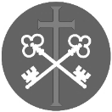
St Peter and the Holy Apostles, Plymouth- Sunday 15th February 2026
The Sixth Sunday in Ordinary Time (Year A)
The Sunday Next Before Lent
Welcome to the Parish Mass
Welcome to St Peters Church. This sheet provides all that you will need for today’s Mass. If you need any assistance before, during or after the service or need a large print copy of this order of service please speak to one of our welcome team. (identifiable by a lanyard)
Please respond to the words in non-italic Bold, The Hymns are sung by all. Please inform the people on the door when you enter if you require a Gluten Free Host
…………………………………………………………………………………
We Stand for The Entrance Hymn
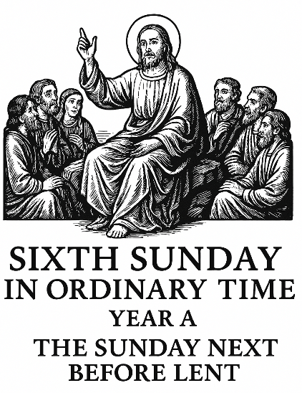
1. Praise the Lord, his glories show, Alleluia!
saints within his courts below, Alleluia!
angels round the throne above, Alleluia!
all that see and share his love, Alleluia!
2. Earth to heaven, and heaven to earth, Alleluia!
tell his wonders, sing his worth; Alleluia!
age to age and shore to shore, Alleluia!
praise him, praise him evermore! Alleluia!
3. Praise the Lord, his mercies trace; Alleluia!
praise his providence and grace, Alleluia!
all that he for us has done, Alleluia!
all he sends us through his Son. Alleluia!
4. Strings and voices, hands and hearts, Alleluia!
in the concert, bear your parts; Alleluia!
all that breathe, your Lord adore, Alleluia!
praise him, praise him evermore. Alleluia!
The Introductory Rite
In the name of the Father and of the Son and of the Holy Spirit. Amen.
Following the greeting we respond.
And with your spirit.
The Priest introduces the Mass
The Penitential Rite
Brothers and sisters, let us acknowledge our sins,
and so prepare ourselves to celebrate the sacred mysteries.

I confess to almighty God and to you, my brothers and sisters, that I have greatly sinned, in my thoughts and in my words, in what I have done and in what I have failed to do, through my fault, through my fault, through my most grievous fault; therefore I ask blessed Mary ever-Virgin, all the Angels and Saints, and you, my brothers and sisters, to pray for me to the Lord our God.

May almighty God have mercy on us, forgive us our sins, and bring us to everlasting life. Amen.

Either:
Lord, have mercy. Lord, have mercy.
Christ, have mercy. Christ, have mercy.
Lord, have mercy. Lord, have mercy.
Or:
Kyrie, eleison. Kyrie, eleison.
Christe, eleison. Christe, eleison.
Kyrie, eleison. Kyrie, eleison.

The Gloria
Glory to God in the highest, and on earth peace to people of good will.
We praise you, we bless you, we adore you, we glorify you, we give you thanks for your great glory, Lord God, heavenly King, O God, almighty Father.
Lord Jesus Christ, Only Begotten Son, Lord God, Lamb of God, Son of the Father, you take away the sins of the world, have mercy on us; you take away the sins of the world, receive our prayer; you are seated at the right hand of the Father, have mercy on us.
For you alone are the Holy One, you alone are the Lord, you alone are the Most High, Jesus Christ, with the Holy Spirit, in the glory of God the Father. Amen.

The Collect

O God, who teach us that you abide in hearts that are just and true, grant that we may be so fashioned by your grace as to become a dwelling pleasing to you. Through our Lord Jesus Christ, your Son, who lives and reigns with you in the unity of the Holy Spirit, God, for ever and ever. Amen.

We sit for The First Reading- Sirach 15:15-20

If you desire, you will keep the commandments, and to act faithfully is a matter of choice. He has placed before you fire and water: stretch out your hand for whichever you wish. Life and death are in front of people, and whichever one chooses will be given to him. For great is the wisdom of the Lord; he is mighty in power and sees everything; his eyes are on those who fear him, and he knows a person’s every deed. He has not commanded anyone to be ungodly, and he has not given anyone permission to sin.

The word of the Lord. Thanks be to God.

The Responsorial Psalm- Ps 119(118):1-2. 4-5. 17-18. 33-34. ℟1b

Response- Blessed are those who walk in the law of the Lord!

Blessed are those whose way is blameless, who walk in the law of the Lord!
Blessed are those who keep his decrees! With all their hearts they seek him. R

You have laid down your precepts to be carefully kept.
May my ways be firm in keeping your statutes. R

Deal bountifully with your servant, that I may live and keep your word.
Open my eyes, that I may see the wonders of your law. R

Lord, teach me the way of your statutes, and I will keep them to the end.
Grant me insight that I may keep your law, and observe it wholeheartedly. R

The second Reading- 1 Corinthians 2:6-10

Brothers and Sisters: Among the mature we do impart wisdom, although it is not a wisdom of this age or of the rulers of this age, who are doomed to pass away. But we impart a secret and hidden wisdom of God, which God decreed before the ages for our glory. None of the rulers of this age understood this, for if they had, they would not have crucified the Lord of glory. But, as it is written,
‘What no eye has seen, nor ear heard,
nor the heart of man imagined,
what God has prepared for those who love him’ —
these things God has revealed to us through the Spirit. For the Spirit searches everything, even the depths of God.

The word of the Lord. Thanks be to God

We stand for- The Gospel Procession and Acclamation- Cf. Matthew 11:25

Alleluia, alleluia.
I thank you, Father, Lord of heaven and earth,
you have revealed the secrets of the kingdom to little children.
Alleluia

The Gospel- Matthew 5:17-37

The Lord be with you. And with your spirit.
A reading from the holy Gospel according to N. Glory to you, O Lord.
At that time: Jesus said to his disciples, ‘Do not think that I have come to abolish the Law or the Prophets; I have not come to abolish them but to fulfil them. For truly, I say to you, until heaven and earth pass away, not an iota, not a dot, will pass from the Law until all is accomplished. Therefore whoever relaxes one of the least of these commandments and teaches others to do the same will be called least in the kingdom of heaven, but whoever does them and teaches them will be called great in the kingdom of heaven. For I tell you, unless your righteousness exceeds that of the scribes and Pharisees, you will never enter the kingdom of heaven.
‘You have heard that it was said to those of old, “You shall not murder; and whoever murders will be liable to judgement.” But I say to you that everyone who is angry with his brother will be liable to judgement; whoever insults his brother will be liable to the council; and whoever says, “You fool!” will be liable to the hell of fire. So if you are offering your gift at the altar and there remember that your brother has something against you, leave your gift there before the altar and go. First be reconciled to your brother, and then come and offer your gift. Come to terms quickly with your accuser while you are going with him to court, lest your accuser hand you over to the judge, and the judge to the guard, and you be put in prison. Truly, I say to you, you will never get out until you have paid the last penny.
‘You have heard that it was said, “You shall not commit adultery.” But I say to you that everyone who looks at a woman with lustful intent has already committed adultery with her in his heart. If your right eye causes you to sin, tear it out and throw it away. For it is better that you lose one of your members than that your whole body be thrown into hell. And if your right hand causes you to sin, cut it off and throw it away. For it is better that you lose one of your members than that your whole body go into hell.
‘It was also said, “Whoever divorces his wife, let him give her a certificate of divorce.” But I say to you that everyone who divorces his wife, except on the ground of sexual immorality, makes her commit adultery, and whoever marries a divorced woman commits adultery.
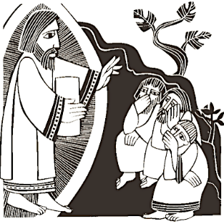
‘Again you have heard that it was said to those of old, “You shall not swear falsely, but shall perform to the Lord what you have sworn.” But I say to you: Do not take an oath at all, either by heaven, for it is the throne of God, or by the earth, for it is his footstool, or by Jerusalem, for it is the city of the great King. And do not take an oath by your head, for you cannot make one hair white or black. Let what you say be simply “Yes” or “No”; anything more than this comes from evil.’
The Gospel of the Lord. Praise to you, Lord Jesus Christ.
We sit for The Homily

We stand The Creed
I believe in one God, the Father almighty, maker of heaven and earth,
of all things visible and invisible.
I believe in one Lord Jesus Christ, the Only Begotten Son of God, born of the Father before all ages. God from God, Light from Light, true God from true God, begotten, not made, consubstantial with the Father; through him all things were made. For us men and for our salvation he came down from heaven,
At the words that follow, up to and including ‘and became man’, all bow.
and by the Holy Spirit was incarnate of the Virgin Mary, and became man.
For our sake he was crucified under Pontius Pilate, he suffered death and was buried, and rose again on the third day in accordance with the Scriptures.
He ascended into heaven and is seated at the right hand of the Father. He will come again in glory to judge the living and the dead and his kingdom will have no end.
I believe in the Holy Spirit, the Lord, the giver of life, who proceeds from the Father and the Son, who with the Father and the Son is adored and glorified, who has spoken through the prophets.
I believe in one, holy, catholic and apostolic Church. I confess one Baptism for the forgiveness of sins and I look forward to the resurrection of the dead and the life of the world to come. Amen.

We remain standing for The Prayers of the Faithful

Each biding concludes with the following said or sung-

We pray to the Lord. Lord in your Mercy hear our prayer.

The Priest Concludes the Prayers of the Faithful
No collection is taken during the Mass, but there is a collection box at the back of church for you to give your financial contribution. All money collected helps towards the mission and ministry of our churches. If you would prefer, a card reading machine is available at the back of the church for your contribution.
The Offertory Hymn

1. Love is his word, love is his way,
feasting with men, fasting alone,
living and dying, rising again,
Love, only love, is his way.
Richer than gold is the love of my Lord:
better than splendour and wealth.
2. Love is his way, love is his mark,
sharing his last Passover feast,
Christ at his table, host to the twelve.
Love, only love, is his mark.
Richer than gold is the love of my Lord:
better than splendour and wealth.
3. Love is his mark, love is his sign,
bread for our strength, wine for our joy,
"This is my body, this is my blood",
Love, only love, is his sign.
Richer than gold is the love of my Lord:
better than splendour and wealth.
4. Love is his sign, love is his news,
"Do this," he said, "lest you forget
all my deep sorrow, all my dear blood."
Love, only love, is his news.
Richer than gold is the love of my Lord:
better than splendour and wealth.
5. Love is his news, love is his name,
we are his own, chosen and called,
family, brethren, cousins and kin.
Love, only love, is his name.
Richer than gold is the love of my Lord:
better than splendour and wealth.
6. Love is his name, love is his law.
Hear his command, all who are his:
"Love one another, I have loved you."
Love, only love, is his law.
Richer than gold is the love of my Lord:
better than splendour and wealth.
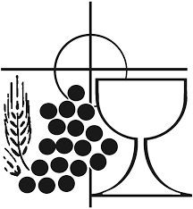
7. Love is his law, love is his word:
love of the Lord, Father and Word,
love of the Spirit, God ever one.
Love, only love, is his word.
Richer than gold is the love of my Lord:
better than splendour and wealth.

The Liturgy of the Eucharist
Pray, brethren (brothers and sisters), that my sacrifice and yours may be acceptable to God, the almighty Father.
May the Lord accept the sacrifice at your hands for the praise and glory of his name, for our good and the good of all his holy Church.

The Lord be with you. And with your spirit.
Lift up your hearts. We lift them up to the Lord.
Let us give thanks to the Lord our God. It is right and just.

The Priest continues with the Preface. The Sanctus is the said or sung:
Holy, Holy, Holy Lord God of hosts.
Heaven and earth are full of your glory. Hosanna in the highest.
Blessed is he who comes in the name of the Lord. Hosanna in the highest.

The Priest continues the Eucharistic prayer. The following is said or sung
The mystery of faith…. We proclaim your Death, O Lord, and profess your Resurrection until you come again.

The Priest concludes the Eucharistic prayer.
Through him, and with him, and in him, O God, almighty Father, in the unity of the Holy Spirit, all glory and honour is yours, for ever and ever. Amen.

The Lord’s Prayer
At the Saviour’s command and formed by divine teaching, we dare to say:
Our Father, who art in heaven, hallowed be thy name; thy kingdom come, thy will be done on earth as it is in heaven. Give us this day our daily bread, and forgive us our trespasses, as we forgive those who trespass against us; and lead us not into temptation, but deliver us from evil.
Deliver us, Lord, we pray… and the coming of our Saviour, Jesus Christ.
For the kingdom, the power and the glory are yours now and for ever.

The Peace
Lord Jesus Christ, who said to your Apostles: Peace I leave you, my peace I give you,
look not on our sins, but on the faith of your Church, and graciously grant her peace and unity in accordance with your will. Who live and reign for ever and ever. Amen.
The peace of the Lord be with you always: And with your spirit.
Let us offer each other the sign of peace.
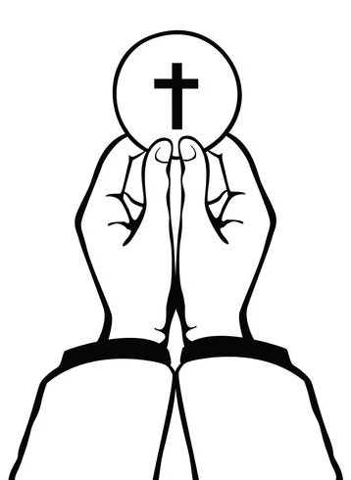
All are invited to make an acknowledgement to each other to mark the sign of the peace.

The Agnus Dei
All say or sing:
Lamb of God, you take away the sins of the world,
have mercy on us.
Lamb of God, you take away the sins of the world,
have mercy on us.
Lamb of God, you take away the sins of the world,
grant us peace.

The Invitation to Communion
Behold the Lamb of God, behold him who takes away the sins of the world. Blessed are those called to the supper of the Lamb.
Lord, I am not worthy that you should enter under my roof, but only say the word and my soul shall be healed.

All who are regular communicants in their own tradition are welcome to receive the sacrament if you are not a communicant you are welcome to come forward at this point in the service to receive a blessing To indicate that it is just a blessing you require, please take this service sheet up with you. We have returned to offering the chalice at the time of communion but please do not feel any pressure to receive from the common cup as the church teaches that the sacrament is received fully in one kind. We request that you do not intinct (dip) your host in the Chalice but either take a sip from the cup or return directly to your seat. This is for reasons of good hygiene.

The Communion Hymn

1. Take my life, and let it be
consecrated, Lord, to thee;
take my moments and my days,
let them flow in ceaseless praise.
2. Take my hands, and let them move
at the impulse of thy love;
take my feet, and let them be
swift and beautiful for thee.
3. Take my voice, and let me sing
always, only, for my King;
take my lips, and let them be
filled with messages from thee.
4. Take my will, and make it thine:
it shall be no longer mine;
take my heart: it is thine own;
it shall be thy royal throne.
5. Take my love; my Lord, I pour
at thy feet its treasure-store;
take myself, and I will be
ever, only, all for thee.

We stand for The Prayer After Communion

Having fed upon these heavenly delights, we pray, O Lord, so that we may always long for that food by which we truly live. Through Christ our Lord. Amen

We remain standing for Our Mission Prayer
Lord Jesus, you call us to be your missionary disciples.
Guide and strengthen us to share your love with all we meet.
Give us courage to reach out to help others.
Give us wisdom to know how best to care,
And give us hope to believe we can make a difference.
Bless us all who bring your compassion and mercy to the poor and marginalised.
Together, may we make known your love on earth.
We make our prayer through Christ Our Lord. Amen.

The priest may give some brief notices

The Concluding Rites and The Dismissal

The Lord be with you. And with your spirit.
May almighty God bless you, the Father, and the Son, ✠ and the Holy Spirit. Amen.

Go forth, the Mass is ended. Thanks be to God
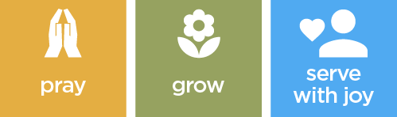

The Final Hym

1. Alleluya, song of sweetness,
Voice of joy that cannot die;
Alleluya is the anthem
Ever dear to choirs on high:
In the house of God abiding
Thus they sing eternally.
2. Alleluya thou resoundest,
True Jerusalem and free;
Alleluya, joyful mother,
All thy children sing with thee;
But by Babylon's sad waters
Mourning exiles now are we.
3. Alleluya cannot always
Be our song while here below;
Alleluya our transgressions
Make us for awhile forgo;
For the solemn time is coming
When our tears for sin must flow.
4. Therefore in our hymns we pray thee,
Grant us, blessèd Trinity,
At the last to keep thine Easter
In our home beyond the sky,
There to thee for ever singing
Alleluya joyfully.

The Angelus
The Angel of the Lord declared unto Mary. And she conceived of the Holy Spirit.

Hail Mary, full of grace, The Lord is with Thee; Blessed art thou among women,
And blessed is the fruit of thy womb, Jesus.
Holy Mary, Mother of God, Pray for us sinners,
Now and at the hour of our death.

Behold the handmaid of the Lord.
Be it done to me according to thy word.
Hail Mary. . .
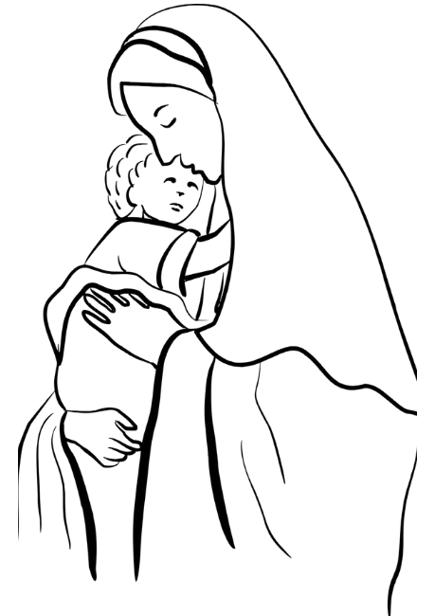
And the Word was made flesh.
And dwelt among us.
Hail Mary…

Pray for us, O holy Mother of God.
That we may be made worthy of the promises of Christ.

Let us pray: Pour forth, we beseech Thee, O Lord, Thy grace into our hearts, that we to whom the Incarnation of Christ Thy Son was made known by the message of an angel, may by His Passion and Cross be brought to the glory of His Resurrection. Through the same Christ Our Lord. Amen.
…………………………………………………………………………………

The Notices
PCC Meeting at 12.00 noon today

Lent 2026
Begins on Wednesday 18th with Ash Wednesday with Mass at St Peter’s 10.00am and St Francis at 7.00pm
Stations of the Cross will be prayed Sundays at 6.00pm
Lent Study Group, looking at prayer will take place on Saturdays 11.00-12.00 with a simple soup lunch, (Volunteers needed for soup)
Lent Boxes We have Lent Boxes available this year on behalf of Mission Direct. Mission Direct is the charitable wing of The Society of the Holy Cross, they give small grants to parishes served by SSC priests.

Chrism Mass Thursday 26th March at 11.00 Exeter Cathedral. Transport is being arranged more information soon.

Big Lent Walk This Lent Fr David is going to take part in the The Big Lent Walk, which involves walking 200km in 40 days. The purpose is to raise money to supply clean water to places in Ethiopia and Peru and is organised by Cafod.

For Prayer

Those who have asked for our prayers…. Denise, Janice Allin, Leslie Porch,
Sheila Tucker, Tina Smart, Kathy Haydon, Bobby Lilicrap, June Brock,
Emma Addison, Georgie Maher, Ian Craggs, Brenda Alderson, Lois Tobin, Brenda Steed, Anne Lewis, Jenny Harvey, Jackie Morrison, Anna, Gwen Lamb, Anna Lynch, Helen Lewis, Val Bradden, Cynthia Way, Pauleen Stewart, Amelia Coughlan, Roger Lewis, Shaun Carrie, Fr Jon Bielawski, Catherine Samuel, Julian Davies.

Recently Departed-

Anniversaries of Death-
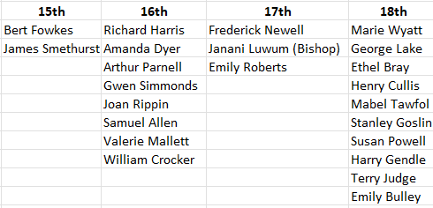
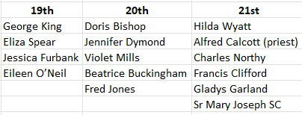

The Mission Community of St Peter and the Holy Apostles
St Peter, Wyndham Square + St Thomas, Royal Navy Avenue + St James-the-Less, Ham Drive
A Church of England Parish in the care of the Bishop of Oswestry
Parish Priest Fr. David Way SSC: 01752 240119 fr.davidway@gmail.com
.com
Mission Development Minister/ LLM/ Parish Ordinand: Ben Otley 07939800544 benotley.mission.plym@gmail.com

Parish Website: plymouthstpeter.co.uk ~ FOR MUCH MORE INFORMATION ON EVENTS, ETC.

This week’s services
Sunday 15th-  The Sixth Sunday in  Ordinary Time | 8.30am St Thomas Fr DW  10.00am St Peter Fr PL  6.00pm St Peter Fr DW | Mass with Hymns  Sung Mass  Rosary/ Walsingham Cell
Monday 16th- Weekday in OT | St Peter 10.00am Fr PL | Mass
Tuesday 17th- Weekday in OT | St Peter 10.00am Fr DW | Mass
Wednesday 18th- Ash Wednesday | St Peter 10.00am Fr DW | Mass
Thursday 19th- Day of Lent | St Peter 10.00am Fr DW | Mass
Friday 20th- Day of Lent | St Peter 10.00am Fr DW | Mass
Saturday 21st- Day of Lent | St Peter 10.00am Fr DW | Mass
Sunday 22nd-  The First Sunday/Week  in Lent | 8.30am St Thomas Fr DW  10.00am St Peter Fr DW  6.00pm St Peter | Mass with Hymns  Sung Mass  Stations of the Cross
St Peters is open daily 8.30am- 12noon- Place of Welcome, Place of Prayer.

Safeguarding: If you have any concerns regarding the safety of children and others who are vulnerable, regardless of age, you must tell the Duty Priest or our parish Lay Safeguarding Representative- Jackie Morrison- email randj49@gmail.com Tel 07848859124.
For online donations please scan the QR code

