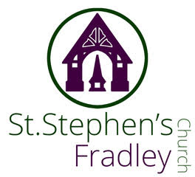
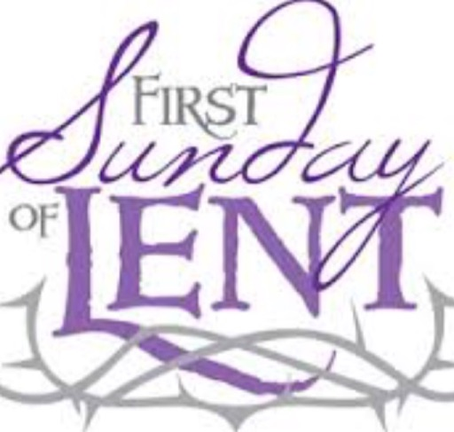

WEEKLY BULLETIN
22nd FEBRUARY 2026
10.30am Family Communion
Welcome to our Worship today. If you are visiting for the first time, please introduce yourself so that we may welcome you personally. Refreshments are served after the service
ST. STEPHEN’S CHURCH IS OPEN 10am-3pm daily for Private Prayer and Reflection
Collect  Heavenly Father,  your Son battled with the powers of darkness,  and grew closer to you in the desert:  help us to use these days to grow in wisdom and prayer  that we may witness to your saving love  in Jesus Christ our Lord.  Readings  Genesis 2.15-17;3.1-7 Romans 5.12-19  Matthew 4. 1-11  Post Communion  Lord God,  you have renewed us with the living bread from heaven;  by it you nourish our faith,  increase our hope,  and strengthen our love:  teach us always to hunger for him who is the true and living bread,  and enable us to live by every word  that proceeds from out of your mouth;  through Jesus Christ our Lord. | Diary Dates  February  Tuesday 24th 7-9pm Community Choir rehearsal  Wednesday 26th 2-4 Wednesday Welcome  SAVE THE DATE  Sunday 1st March 1-4pm  Wedding Fayre All Saints, Alrewas  Friday 22nd May 5pm  The Licensing of Revd Jonathan Nicholas to Alrewas, Fradley and Wychnor by The Rt Revd Dr Michael Ipgrave OBE  Saturday 30th May 7.30pm  Fradley Community Choir Concert  Saturday 13th June 11am  Dedication of the Memorial Light Box to all RAF Personnel  Bishop Michael will officiate at this dedication at St Stephen’s Church.
Memory Tree  Our Memory Tree is in church. Please write a name of a loved one on a ‘heart’ and hang on the tree.  The tree will remain in place for the National Day of Reflection (8th March) and Mothering Sunday 15th March.  Loving God,  You hold all our times in your hands, our past, our present, our future. Be close to us now as we remember all the difficulties and disappointments of the past year. Be especially close to all of us who are thinking of someone we loved and knew, but see no longer, whether family, friend, colleague or neighbour. Help us to trust that they are at peace with you,  and comfort us with your presence.  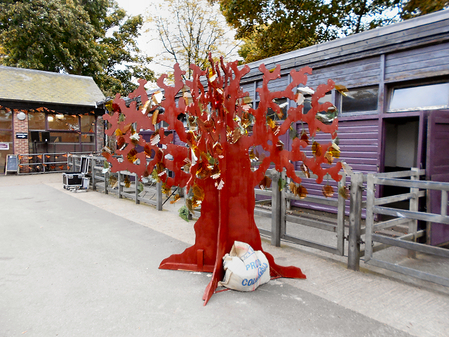 | Valentine’s Coffee Morning  Thank you to all who worked so hard or contributed in any way for our first Coffee Morning of 2026. Over £320 was raised. There was good footfall, much fun and a lot of coffee drunk!  A great effort!    Dementia Friendly Church  Our special Dementia Friendly Service will take place on Sunday 1st March at 10.30am. Our Dementia Champion Jenny Summers will be giving a short talk and the Music Group will be leading music. Do join us and stay for refreshments afterwards as we support all those impacted by this illness.

Notices for inclusion in the bulletin please email me by Tuesday of each week
Officeststephenfradley@gmail.com Please take bulletin away with you

If you would like to support St Stephen’s Church at this time donations can be made via our Just Giving Page. We are grateful for donations large or small
https://www.justgiving.com/fundraising/ststephensfradley

Contact us
Revd Elizabeth Wall 01543 254891
Email: ayton265@gmail.com
Churchwarden
Marian Derry 01283 791573
St Stephen’s Administrator: Di Cooper
07930162991 officeststephenfradley@gmail.com
Find us on ACNY https://www.achurchnearyou.com/church/4123/
Facebook www.facebook.comststephensfradley

