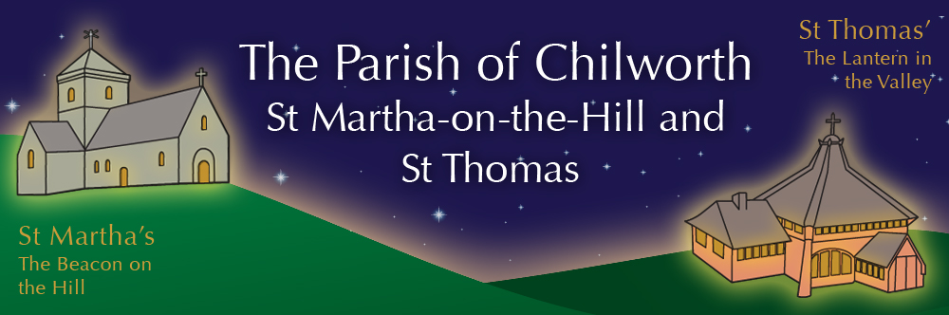

NOTICES: - 22nd FEBRUARY 2026
Priest David Oakden – Revdavid@parishofchilworth.org.uk - 01483 534293 (day off Friday)
Do let me know of anybody or anything that you would like to be prayed for.
www.parishofchilworth.org.uk and find us on https://www.achurchnearyou.com

********* Matthew 4:10-11 (NRSVA)*******
Jesus said to him, ‘Away with you, Satan! For it is written, “Worship the Lord your God, and serve only him.” Then the devil left him, and suddenly angels came and waited on him.
***********************************

Opportunities to pray together: -
Ecumenical Prayer Breakfast 1st Saturday of the month at the Vicarage, from 9am, prayer, coffee and croissant. Next is the 7th March – Thursday evening at St Thomas at 6:00 pm for an hour every other week. 5th & 19th March 2026.

This Sunday Services: – 1st Sunday LENT
9:30 St Peter & St Paul Holy Communion with Rector.
11:15 St Martha’s Holy Communion with David.

Next Sunday Services: - 1st March
9:30 St Thomas Holy Communion with David.
11:15 St Martha’s Mattins with James Hanson.

Looking further ahead: -
Tots and Toddlers: St T’s Monday 9:15am
Lent Courses: 23rd Feb – see note below
Day of Prayer for Bishop Andrew: 23rd Feb Noon till 10pm at the Cathedral, pop in and pray.
Albury Pastoral Tea: 26th Feb Vicarage 16:00pm

Food & Hygiene Bank: -
The Foodbank Larder box is located in the porch of St Thomas Church. Suggested items: - Long life milk /tins tuna/ tins meat/ sachets microwaveable rice /pasta sauces/curry sauces/cereal/spreads/ tea/ coffee/ hot chocolate/ tins soup/ baked beans

Chilworth Tinies and Toddler Group: -
Mondays from 9:15 -10:30 meet in St Thomas, play chat, pray and support.

LENT Course news: -
For our Lenten journey this year we will be venturing into the wilds of faith with the help of the team at Lectio 365. Join us as we embark on a life-changing, forty-day journey into the wilderness. Alongside the Bible, we will be diving into the ancient wisdom of the Desert Fathers and Mothers: a radically counter-cultural movement that chose to live, work and pray away from civilised society, in the foreboding desert landscape through the third and fourth centuries AD.
Lent Lunch reflections on Art at St Thomas during Lent on Monday lunchtimes, simple soup and a roll from 12:00 with some art and discussion.
Monday Evenings Join us at 7.30pm at the Gomshall Club for any or all of the five Monday evenings: February 23rd and March 2nd, 9th, 16th, & 23rd
Services We will link each week’s theme into our sermons on the Sunday before.
Daily Devotion – download the prayer App: search for Lectio365 in the Apple or Google .
Palm Sunday we will walk a donkey up to St Martha’s, have a short service and then picnics to follow. 12:30 in the car park of Halfpenny Lane.

Bishop Andrew: -
We heard last week that Bishop Andrew has been diagnosed with inoperable Pancreatic Cancer. – He said, whatever the future holds, I remain deeply grateful to God for the journey of the past 64 years – not least for the privilege of serving as Bishop in a diocese where the vision of a Transforming Church, Transforming Lives has been lived out in quite such a rich and joyous variety of ways.
Please pray for Andrew, Beverley and family as they navigate through this.

Harry Moss’s next Adventure: -
Harry Moss, who generously helps out with so many maintenance tasks at both Churchs, is driving in a convoy to Ukraine, for CONVOY4UKRAINE. Do support him and the charity with prayer and financially via his JustGiving page https://www.justgiving.com/page/harry-moss-2?utm_medium=FR&utm_source=EM

