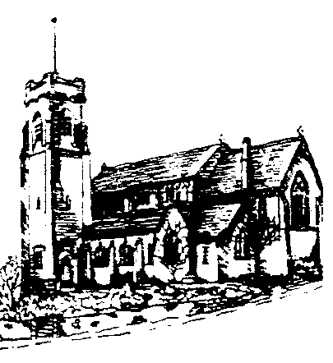
ST. ANN’S, BELFIELD NEWS LETTER
WORSHIP

Church open
St Ann’s is open for public worship Sundays and Wednesdays at 10.30am

Streamed service
On-line via twitch.tv/revdgill and for 1 week after. Downloads on request.

Prayers for the sick
Ghislaine Glover, Cath Boon, Roger and Trevor

Prayers for home members
Bob (in Mona Cliffe Care Home), Dorothy (in Braeside)

Those who have died
Kathleen (Kath) Chadwick.
Kath’s funeral will be at St Ann’s, Monday 2nd Feb 12.15pm

The anniversary of the dearly departed George Chrimes, Albert Hornby, James Wilson, Vera Mills, David Johnston, Mary Hilton, Janet Pilling and Annie Wrigley.


Scan this with your phone to contribute to St Ann’s mission and ministry

Benefice Motto, 2026
“In everything by prayer and supplication… let your requests be made known to God. And the peace of God which surpasses all understanding, will guard your hearts and your minds in Christ Jesus.” Philippians 4:6-7

Hope Community
Please pray for Carmina and the new team as Hope Funtime resumes on Saturday 31st at 11am.

Schools Visit
Please pray for Shawclough Y1 classes visiting Christ Church on Tuesday morning.

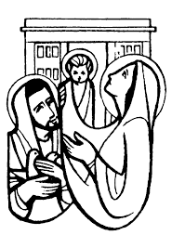

Sunday 1st February, 2026 10.30am
Presentation of Christ in the Temple
Eucharist: Rev.Gill.

Hymns :- All NEH
443 Rejoice the Lord is King
95 When I Survey
86 My song is love unknown
84 It is a thing most wonderful
398 Lift your hearts

NOTICES
Equip – Youthscape
An invitation to all those who help with youth and children’s work in church. These sessions will be a valuable resource for anyone passionate about engaging young people with the Christian faith. Tuesday, 3rd February | 7:00 PM – 9:00 PM
Oldham Parish Church, OL1 3UH
Booking Link: https://www.eventbrite.co.uk/e/1980626881319?aff=oddtdtcreator

Benefice Prayer Meeting
7pm, Tuesday 3rd Feb at Julie and Paul’s

Vocations Day, Sat 7th Feb
Explore your calling – meet lay and ordained ministers, take part in interactive workshops and explore your vocation. 10am – 2.30pm
Vocations Day Tickets, Sat, Feb 7, 2026 at 10:00 AM | Eventbrite

Breathe
Quiet, contemporary worship, 7pm, Christ Church Hall – Sun 8th Feb. All welcome

Jumble Sale
From 11am, Sat 14th Feb. Christ Church Hall

