First Reading at Service
Reading from the New Testament
Hebrews 2: verses 14 to 18

Since, therefore, the children share flesh and blood, he himself likewise shared the same things, so that through death he might destroy the one who has the power of death, that is, the devil, and free those who all their lives were held in slavery by the fear of death. For it is clear that he did not come to help angels, but the descendants of Abraham. Therefore he had to become like his brothers and sisters in every respect, so that he might be a merciful and faithful high priest in the service of God, to make a sacrifice of atonement for the sins of the people. Because he himself was tested by what he suffered, he is able to help those who are being tested.
This is the word of the Lord.
All: Thanks be to God.

Second Reading at Service
Gospel Reading
Luke 2: verses 22 to 40

Hear the Gospel of our Lord Jesus Christ according to Luke.
All: Glory to you, O Lord.

Jesus Is Presented in the Temple
When the time came for their purification according to the law of Moses, they brought him up to Jerusalem to present him to the Lord (as it is written in the law of the Lord, ‘Every firstborn male shall be designated as holy to the Lord’), and they offered a sacrifice according to what is stated in the law of the Lord, ‘a pair of turtle-doves or two young pigeons.’ Now there was a man in Jerusalem whose name was Simeon; this man was righteous and devout, looking forward to the consolation of Israel, and the Holy Spirit rested on him. It had been revealed to him by the Holy Spirit that he would not see death before he had seen the Lord’s Messiah. Guided by the Spirit, Simeon came into the temple; and when the parents brought in the child Jesus, to do for him what was customary under the law, Simeon took him in his arms and praised God, saying, ‘Master, now you are dismissing your servant in peace, according to your word;
for my eyes have seen your salvation, which you have prepared in the presence of all peoples, a light for revelation to the Gentiles
and for glory to your people Israel.’ And the child’s father and mother were amazed at what was being said about him. Then Simeon blessed them and said to his mother Mary, ‘This child is destined for the falling and the rising of many in Israel, and to be a sign that will be opposed so that the inner thoughts of many will be revealed—and a sword will pierce your own soul too.’ There was also a prophet, Anna the daughter of Phanuel, of the tribe of Asher. She was of a great age, having lived with her husband for seven years after her marriage, then as a widow to the age of eighty-four. She never left the temple but worshipped there with fasting and prayer night and day. At that moment she came, and began to praise God and to speak about the child to all who were looking for the redemption of Jerusalem.

The Return to Nazareth
When they had finished everything required by the law of the Lord, they returned to Galilee, to their own town of Nazareth. The child grew and became strong, filled with wisdom; and the favour of God was upon him.
This is the Gospel of the Lord.
All: Praise to you, O Christ.

Reading from the Old Testament
Malachi 3: verses 1 to 5
The Coming Messenger

See, I am sending my messenger to prepare the way before me, and the Lord whom you seek will suddenly come to his temple. The messenger of the covenant in whom you delight—indeed, he is coming, says the Lord of hosts. But who can endure the day of his coming, and who can stand when he appears? For he is like a refiner’s fire and like fullers’ soap; he will sit as a refiner and purifier of silver, and he will purify the descendants of Levi and refine them like gold and silver, until they present offerings to the Lord in righteousness. Then the offering of Judah and Jerusalem will be pleasing to the Lord as in the days of old and as in former years. Then I will draw near to you for judgement; I will be swift to bear witness against the sorcerers, against the adulterers, against those who swear falsely, against those who oppress the hired workers in their wages, the widow, and the orphan, against those who thrust aside the alien, and do not fear me, says the Lord of hosts.
Notices
Refreshments – do join us for a cuppa and a biscuit after the service at the back of church. If you can help with serving drinks please do sign up to help in February. You just need to bring milk and biscuits.

Village Fete Representative - Margaret wishes to stand down as the church representative on the Village Fete Committee which has a few meetings in the run up to the July 12th 2026 fete. Please consider taking on this light role. Have a word with Margaret if you need further information. Thank you.


Next Week

8th February – The Second Sunday before Lent
9.30am – Morning Prayer


Contacts



Mr Michael Heap – Kirk Langley Warden
Tel: 07760 266361
E-mail: redbrickinteractive117@gmail.com
Sue Silcock – Mackworth Contact
Tel: 07748072135
E-mail: susan_silcock@hotmail.com
Dr Bryan Jones - Reader
Tel: 01332 541713 or 07504 827808
E-mail: bryanjones@bcs.org
Emma Jones – Administrator
Email: emvicjones@gmail.com
For more information please visit our website: www.klmm-parishes.org.uk or follow us on Facebook: www.facebook.com/klmmparishes
If you would like to include a notice in the pew sheet, please contact Emma Jones.

WELCOME TO
ST MICHAEL’S CHURCH
KIRK LANGLEY

Sunday 1st February 2026
The Presentation of Christ in the Temple

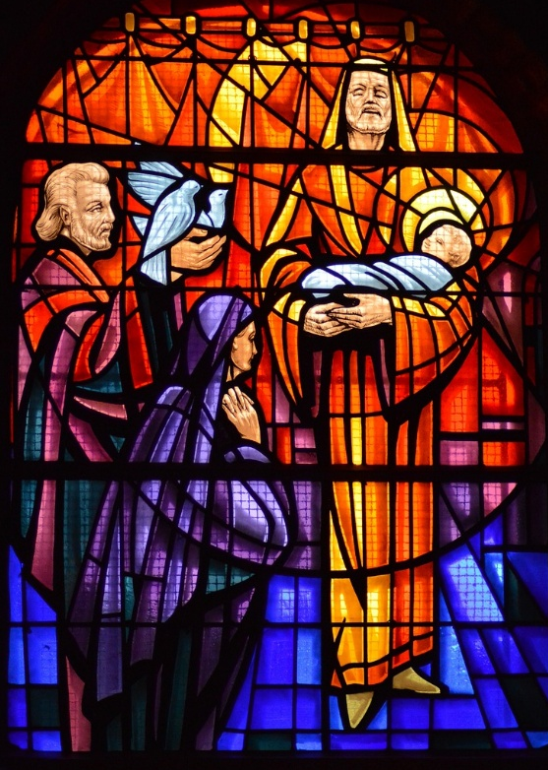

Today’s Service is Holy Communion
If you have a prayer request, please pass to the Church Warden

Please take this leaflet home with you for reference

