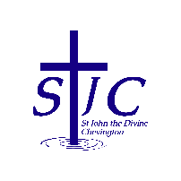
St John the Divine Welcome to our service today
Chevington 18th January 2026
Second Sunday of Epiphany

PCC meeting  Our next PCC meeting has been rescheduled to Sunday February 1st – please pass the message to any PCC members who are not here today.  = . = . = . = . = . = . = . = . = . = . = . = . = . = . = . = . = . = . = . = . = . = . = . = . = . =  What’s on  Sunday 18th January  9am Holy Communion in St Cuthbert’s  10:30am Holy Communion in St John’s  Wednesday 21st January  12 noon Prayers for the Week of Christian Unity, le by Coquet Churches Together in St Cuthbert’s, includes soup lunch  2pm Coquet Churches Together meet in St Cuthbert’s  Sunday 25th January  9am Holy Communion in St Cuthbert’s  10:30am Holy Communion in St John’s  = . = . = . = . = . = . = . = . = . = . = . = . = . = . = . = . = . = . = . = . = . = . = . = . = . =  This week, please pray for  We pray this week for all those who live in East View, Elm Court and Guyzance Avenue and for the residents and staff at Hazelmead  From the memorial book |  | Church contacts  Priest in charge Revd Rachael Dines  revd.rachael.dines@gmail.com  01665 497631 / 07763 211901  Churchwardens  Anthony Reay – 07429 929537  Sheila Orgill (also Parish Safeguarding Officer) – 07484 825203  Reader Cynthia Bishop – 07498 182350  Website https://www.achurchnearyou.com/church/16282/  Facebook St John the Divine Chevington  Churchwardens St Cuthbert’s Amble  Richard Colson – 07724 687107  Linda Williams – 07720 716794  = . = . = . = . = . = . = . = . = . = . = . = . = . = . = . = . = . = . = . = . = . = . = . = . = . =  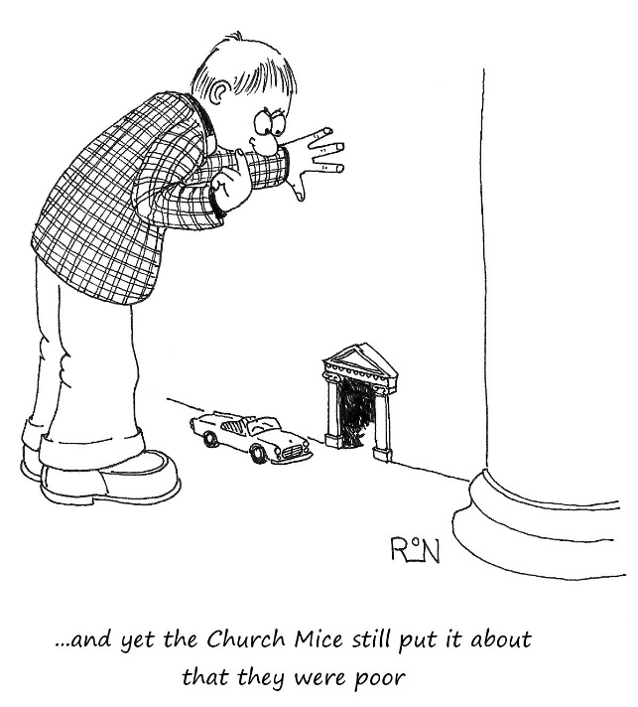
  Jean | Ditchburn | 1999
  Frederick | Donkin | 1944
  Will | Douglas | 1975
  Norman | Frasier | 1996
  Ken | Gibbison | 2005
  Elsie | Ryan | 1994
  Thomas William | Smith | 1984
  Ena | Smith | 2010

