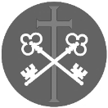
St Peter and the Holy Apostles, Plymouth- Sunday 25th January 2025
The Third Sunday in Ordinary Time (Year A)
The final day in the week of prayer for Christian Unity
Welcome to the Parish Mass
Welcome to St Peters Church. This sheet provides all that you will need for today’s Mass. If you need any assistance before, during or after the service or need a large print copy of this order of service please speak to one of our welcome team. (identifiable by a lanyard)
Please respond to the words in non-italic Bold, The Hymns are sung by all. Please inform the people on the door when you enter if you require a Gluten Free Host
…………………………………………………………………………………
We Stand for The Entrance Hymn

1. The race that long in darkness pined
has seen a glorious light;
the people dwell in day, who dwelt
in death’s surrounding night.
2. To hail thy rise, thou better sun,
the gath'ring nations come,
joyous as when the reapers bear
the harvest treasures home.
3. To us a child of hope is born,
to us a Son is giv'n;
him shall the tribes of earth obey,
him all the hosts of heav'n.
4. His name shall be the Prince of Peace,
for evermore adored,
the Wonderful, the Counsellor,
the great and mighty Lord.
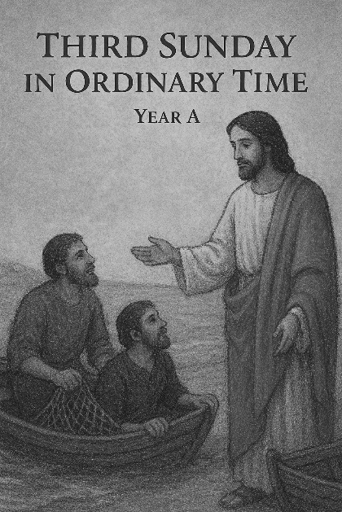
5. His pow'r increasing still shall spread,
his reign no end shall know;
justice shall guard his throne above,
and peace abound below.

The Introductory Rite
In the name of the Father and of the Son and of the Holy Spirit. Amen.
Following the greeting we respond.
And with your spirit.

The Priest introduces the Mass
The Penitential Rite
Brothers and sisters, let us acknowledge our sins,
and so prepare ourselves to celebrate the sacred mysteries.

I confess to almighty God and to you, my brothers and sisters, that I have greatly sinned, in my thoughts and in my words, in what I have done and in what I have failed to do, through my fault, through my fault, through my most grievous fault; therefore I ask blessed Mary ever-Virgin, all the Angels and Saints, and you, my brothers and sisters, to pray for me to the Lord our God.

May almighty God have mercy on us, forgive us our sins, and bring us to everlasting life. Amen.

Either:
Lord, have mercy. Lord, have mercy.
Christ, have mercy. Christ, have mercy.
Lord, have mercy. Lord, have mercy.
Or:
Kyrie, eleison. Kyrie, eleison.
Christe, eleison. Christe, eleison.
Kyrie, eleison. Kyrie, eleison.

The Gloria
Glory to God in the highest, and on earth peace to people of good will.
We praise you, we bless you, we adore you, we glorify you, we give you thanks for your great glory, Lord God, heavenly King, O God, almighty Father.
Lord Jesus Christ, Only Begotten Son, Lord God, Lamb of God, Son of the Father, you take away the sins of the world, have mercy on us; you take away the sins of the world, receive our prayer; you are seated at the right hand of the Father, have mercy on us.
For you alone are the Holy One, you alone are the Lord, you alone are the Most High, Jesus Christ, with the Holy Spirit, in the glory of God the Father. Amen.

The Collect
Almighty ever-living God, direct our actions according to your good pleasure, that in the name of your beloved Son we may abound in good works. Through our Lord Jesus Christ, your Son, who lives and reigns with you in the unity of the Holy Spirit, God, for ever and ever. Amen.

We sit for The First Reading- Isaiah 9:1b-4

In the former time the Lord brought into contempt the land of Zebulun and the land of Naphtali, but in the latter time he has made glorious the way of the sea, the land beyond the Jordan, Galilee of the nations. The people who walked in darkness have seen a great light; those who dwelt in a land of deep darkness, on them has light shone. You have multiplied the nation; you have increased its joy; they rejoice before you as with joy at the harvest, as they are glad when they divide the spoil. For the yoke of his burden, and the staff for his shoulder, the rod of his oppressor, you have broken as on the day of Midian.

The word of the Lord. Thanks be to God.

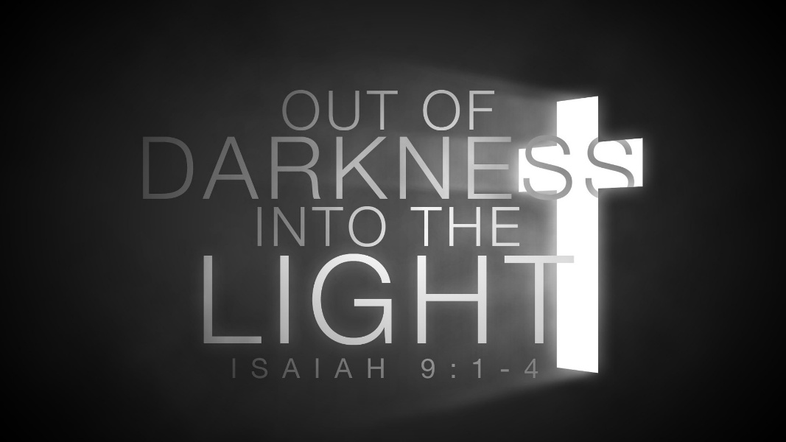

The Responsorial Psalm- Ps 27(26):1. 4. 13-14. ℟1a

The Lord is my light and my salvation.

The Lord is my light and my salvation; whom shall I fear?
The Lord is the stronghold of my life; whom should I dread? R

There is one thing I ask of the Lord, only this do I seek:
to live in the house of the Lord all the days of my life,
to gaze on the beauty of the Lord, to enquire at his temple. R

I believe I shall see the Lord’s goodness in the land of the living.
Wait for the Lord; be strong; be stout-hearted, and wait for the Lord! R

The second Reading- 1 Corinthians 1:10-13, 17

I appeal to you, brothers and sisters, by the name of our Lord Jesus Christ, that all of you agree, and that there be no divisions among you, but that you be united in the same mind and the same judgement. For it has been reported to me by Chloe’s people that there is quarrelling among you, my brothers and sisters. What I mean is that each one of you says, ‘I follow Paul’, or ‘I follow Apollos’, or ‘I follow Cephas’, or ‘I follow Christ.’ Is Christ divided? Was Paul crucified for you? Or were you baptised in the name of Paul? For Christ did not send me to baptise but to preach the gospel, and not with words of eloquent wisdom, lest the cross of Christ be emptied of its power.

The word of the Lord. Thanks be to God

We stand for- The Gospel Procession and Acclamation- Cf. Matthew 4:23

Alleluia, alleluia.
Jesus proclaimed the gospel of the kingdom
and healed every affliction among the people.
Alleluia.

The Gospel- Matthew 4:12-23

The Lord be with you. And with your spirit.
A reading from the holy Gospel according to N. Glory to you, O Lord.

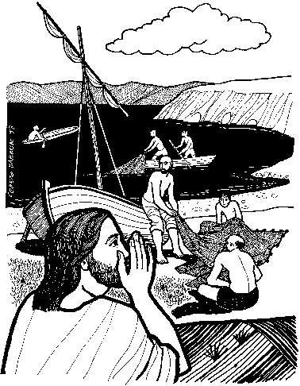
When Jesus heard that John had been arrested, he withdrew into Galilee. And leaving Nazareth he went and lived in Capernaum by the sea, in the territory of Zebulun and Naphtali, so that what was spoken by the prophet Isaiah might be fulfilled: ‘The land of Zebulun and the land of Naphtali, the way of the sea, beyond the Jordan, Galilee of the Gentiles — the people dwelling in darkness have seen a great light, and for those dwelling in the region and shadow of death, on them a light has dawned.’ From that time Jesus began to preach, saying, ‘Repent, for the kingdom of heaven is at hand.’
While walking by the Sea of Galilee, he saw two brothers, Simon (who is called Peter) and Andrew his brother, casting a net into the sea, for they were fishermen. And he said to them, ‘Follow me, and I will make you fishers of men.’ Immediately they left their nets and followed him. And going on from there he saw two other brothers, James the son of Zebedee and John his brother, in the boat with Zebedee their father, mending their nets, and he called them. Immediately they left the boat and their father and followed him.
And he went throughout all Galilee, teaching in their synagogues and proclaiming the gospel of the kingdom and healing every disease and every affliction among the people.
The Gospel of the Lord. Praise to you, Lord Jesus Christ.

We sit for The Homily

We stand The Creed
I believe in one God, the Father almighty, maker of heaven and earth,
of all things visible and invisible.
I believe in one Lord Jesus Christ, the Only Begotten Son of God, born of the Father before all ages. God from God, Light from Light, true God from true God, begotten, not made, consubstantial with the Father; through him all things were made. For us men and for our salvation he came down from heaven,
At the words that follow, up to and including ‘and became man’, all bow.
and by the Holy Spirit was incarnate of the Virgin Mary, and became man.
For our sake he was crucified under Pontius Pilate, he suffered death and was buried, and rose again on the third day in accordance with the Scriptures.
He ascended into heaven and is seated at the right hand of the Father. He will come again in glory to judge the living and the dead and his kingdom will have no end.
I believe in the Holy Spirit, the Lord, the giver of life, who proceeds from the Father and the Son, who with the Father and the Son is adored and glorified, who has spoken through the prophets.
I believe in one, holy, catholic and apostolic Church. I confess one Baptism for the forgiveness of sins and I look forward to the resurrection of the dead and the life of the world to come. Amen.


We remain standing for The Prayers of the Faithful

Each biding concludes with the following said or sung-

We pray to the Lord. Lord in your Mercy hear our prayer.

The Priest Concludes the Prayers of the Faithful
No collection is taken during the Mass, but there is a collection box at the back of church for you to give your financial contribution. All money collected helps towards the mission and ministry of our churches. If you would prefer, a card reading machine is available at the back of the church for your contribution.
The Offertory Hymn

1. Dear Lord and Father of mankind,
forgive our foolish ways;
re-clothe us in our rightful mind,
in purer lives thy service find,
in deeper reverence praise,
in deeper reverence praise.
2. In simple trust like theirs who heard,
beside the Syrian sea,
the gracious calling of the Lord,
let us, like them, without a word
rise up and follow thee,
rise up and follow thee.
3. O Sabbath rest by Galilee!
O calm of hills above,
where Jesus knelt to share with thee
the silence of eternity,
interpreted by love!
interpreted by love!
4. Drop thy still dews of quietness,
till all our strivings cease;
take from our souls the strain and stress,
and let our ordered lives confess
the beauty of thy peace,
the beauty of thy peace.
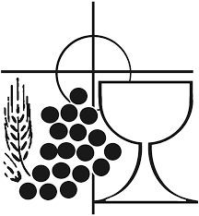
5. Breathe through the heats of our desire
thy coolness and thy balm;
let sense be dumb, let flesh retire;
speak through the earthquake, wind, and fire,
O still small voice of calm,
O still small voice of calm.
The Liturgy of the Eucharist
Pray, brethren (brothers and sisters), that my sacrifice and yours may be acceptable to God, the almighty Father.
May the Lord accept the sacrifice at your hands for the praise and glory of his name, for our good and the good of all his holy Church.

The Lord be with you. And with your spirit.
Lift up your hearts. We lift them up to the Lord.
Let us give thanks to the Lord our God. It is right and just.
The Priest continues with the Preface. The Sanctus is the said or sung:
Holy, Holy, Holy Lord God of hosts.
Heaven and earth are full of your glory. Hosanna in the highest.
Blessed is he who comes in the name of the Lord. Hosanna in the highest.

The Priest continues the Eucharistic prayer. The following is said or sung
The mystery of faith…. We proclaim your Death, O Lord, and profess your Resurrection until you come again.
The Priest concludes the Eucharistic prayer.

Through him, and with him, and in him, O God, almighty Father, in the unity of the Holy Spirit, all glory and honour is yours, for ever and ever. Amen.

The Lord’s Prayer
At the Saviour’s command and formed by divine teaching, we dare to say:
Our Father, who art in heaven, hallowed be thy name; thy kingdom come, thy will be done on earth as it is in heaven. Give us this day our daily bread, and forgive us our trespasses, as we forgive those who trespass against us; and lead us not into temptation, but deliver us from evil.
Deliver us, Lord, we pray… and the coming of our Saviour, Jesus Christ.
For the kingdom, the power and the glory are yours now and for ever.

The Peace
Lord Jesus Christ, who said to your Apostles: Peace I leave you, my peace I give you,
look not on our sins, but on the faith of your Church, and graciously grant her peace and unity in accordance with your will. Who live and reign for ever and ever. Amen.
The peace of the Lord be with you always: And with your spirit.
Let us offer each other the sign of peace.
All are invited to make an acknowledgement to each other to mark the sign of the peace.

The Agnus Dei
All say or sing:
Lamb of God, you take away the sins of the world,
have mercy on us.
Lamb of God, you take away the sins of the world,
have mercy on us.
Lamb of God, you take away the sins of the world,
grant us peace.

The Invitation to Communion
Behold the Lamb of God, behold him who takes away the sins of the world. Blessed are those called to the supper of the Lamb.
Lord, I am not worthy that you should enter under my roof, but only say the word and my soul shall be healed.

All who are regular communicants in their own tradition are welcome to receive the sacrament if you are not a communicant you are welcome to come forward at this point in the service to receive a blessing To indicate that it is just a blessing you require, please take this service sheet up with you. We have returned to offering the chalice at the time of communion but please do not feel any pressure to receive from the common cup as the church teaches that the sacrament is received fully in one kind. We request that you do not intinct (dip) your host in the Chalice but either take a sip from the cup or return directly to your seat. This is for reasons of good hygiene.

The Communion Hymn
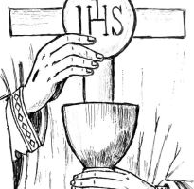
1. O thou, who at thy Eucharist didst pray
that all thy church might be for ever one,
grant us at every Eucharist to say
with longing heart and soul, 'Thy will be done':
O may we all one bread, one body be,
through this blest sacrament of unity.
2. For all thy church, O Lord, we intercede;
make thou our sad divisions soon to cease;
draw us the nearer each to each, we plead,
by drawing all to thee, O Prince of Peace:
thus may we all one bread, one body be,
through this blest sacrament of unity.
3. We pray thee too for wanderers from thy fold;
O bring them back, good Shepherd of the sheep,
back to the faith which saints believed of old,
back to the church which still that faith doth keep:
soon may we all one bread, one body be,
through this blest sacrament of unity.
4. So, Lord, at length when sacraments shall cease,
may we be one with all thy church above,
one with thy saints in one unbroken peace,
one with thy saints in one unbounded love:
more blessèd still, in peace and love to be
one with the Trinity in Unity.
We stand for The Prayer After Communion

Grant, we pray, almighty God, that, receiving the grace by which you bring us to new life,we may always glory in your gift. Through Christ our Lord. Amen

We remain standing for Our Mission Prayer
Lord Jesus, you call us to be your missionary disciples.
Guide and strengthen us to share your love with all we meet.
Give us courage to reach out to help others.
Give us wisdom to know how best to care,
And give us hope to believe we can make a difference.
Bless us all who bring your compassion and mercy to the poor and marginalised.
Together, may we make known your love on earth.
We make our prayer through Christ Our Lord. Amen.

The priest may give some brief notices
The Concluding Rites and The Dismissal

The Lord be with you. And with your spirit.
May almighty God bless you, the Father, and the Son, ✠ and the Holy Spirit. Amen.

Go forth, the Mass is ended. Thanks be to God

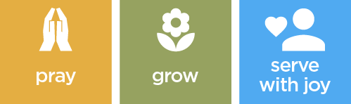

The Final Hymn

1. Jesus calls us! — in the tumult
of our life's wild, restless sea;
day by day his voice re-echoes
saying, 'Christian, follow me!'
2. As of old, apostles heard it
by the Galilean lake,
turned from home and toil and kindred,
leaving all for his dear sake.
3. Jesus calls us — from the worship
of the vain world's golden store,
from each rival that would claim us,
saying, 'Christian, love me more!'
4. In our joys and in our sorrows,
days of toil and hours of ease,
still he calls, in cares and pleasures,
'Christian, love me more than these!'
5. Jesus calls us! — by your mercies,
Saviour, make us hear your call,
give to you our heart's obedience,
serve and love you best of all.
The Angelus
The Angel of the Lord declared unto Mary. And she conceived of the Holy Spirit.

Hail Mary, full of grace, The Lord is with Thee; Blessed art thou among women,
And blessed is the fruit of thy womb, Jesus.
Holy Mary, Mother of God, Pray for us sinners,
Now and at the hour of our death.

Behold the handmaid of the Lord.
Be it done to me according to thy word.
Hail Mary. . .

And the Word was made flesh.
And dwelt among us.
Hail Mary…

Pray for us, O holy Mother of God.
That we may be made worthy of the promises of Christ.

Let us pray: Pour forth, we beseech Thee, O Lord, Thy grace into our hearts, that we to whom the Incarnation of Christ Thy Son was made known by the message of an angel, may by His Passion and Cross be brought to the glory of His Resurrection. Through the same Christ Our Lord. Amen.
……………………………………………………………………………..
The Notices

Help Needed for our Winter night Shelter-
help is needed to support our winter night shelter between December and March on Wednesdays… For further information please speak to Fr David or Ben

New Year De-clutter- On Mondays throughout January we will be tackling areas of clutter in St Peters- all help appreciated- we would appreciate cars being available to help take rubbish to Chelson meadows recycling centre. This will take place 11am- 2pm- please bring a packed lunch- hot drinks provided

Fundraising is an important form of income for the Church. Over £2,800 was raised in 2025 by our 2 types of raffles. The Sunday raffle raised £2,119. Thank you to everybody who bought tickets each week and to those who supply the prizes. If you would like to help out by supplying prizes, please speak to Graham or Jenny. The Big Raffle raised £710. This is drawn twice a year, at Easter and at Christmas. Tickets are priced at 50p each and are on sale throughout the year. If you buy tickets before the Easter draw, you have 2 chances of winning, as these same numbers are included in the Christmas draw. Again, thank you to everybody who bought tickets throughout the year.

We operate a Christmas Savings scheme. As we all know, Christmas can be an expensive time of year, but by saving throughout the year, you can spread that cost, with saved money being paid out in early November. You can save as little or as much as you want to, when you want to. If you are interested in joining the scheme or would like more information, please speak to Graham or Jenny.

Big Lent Walk This Lent Fr David is going to take part in the The Big Lent Walk, which involves walking 200km in 40 days. The purpose is to raise money to supply clean water to places in Ethiopia and Peru and is organised by Cafod.

……………………………………………………………………………………

For Prayer

Those who have asked for our prayers…. Denise, Janice Allin, Leslie Porch,
Sheila Tucker, Tina Smart, Kathy Haydon, Bobby Lilicrap, June Brock,
Emma Addison, Georgie Maher, Ian Craggs, Brenda Alderson, Lois Tobin, Brenda Steed, Anne Lewis, Jenny Harvey, Jackie Morrison, Anna, Gwen Lamb, Anna Lynch, Helen Lewis, Val Bradden, Cynthia Way, Pauleen Stewart, Amelia Coughlan, Roger Lewis, Shaun Carrie, Fr Jon Bielawski, Catherine Samuel, Julian Davies, Paul Kitchen

Recently Departed- Ron Morrison, Jackie Fisher, Gina Dukes

Anniversaries of Death-
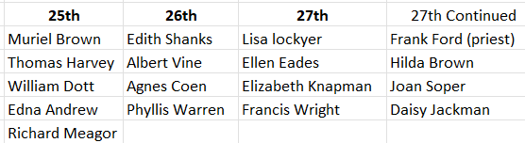
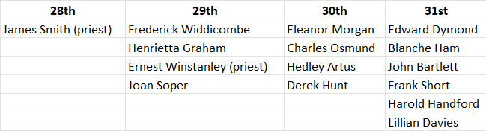

The Mission Community of St Peter and the Holy Apostles
St Peter, Wyndham Square + St Thomas, Royal Navy Avenue + St James-the-Less, Ham Drive
A Church of England Parish in the care of the Bishop of Oswestry
Parish Priest Fr. David Way SSC: 01752 240119 fr.davidway@gmail.com
.com
Mission Development Minister/ LLM/ Parish Ordinand: Ben Otley 07939800544 benotley.mission.plym@gmail.com

Parish Website: plymouthstpeter.co.uk ~ FOR MUCH MORE INFORMATION ON EVENTS, ETC.

This week’s services
Sunday 25th-  The Third Sunday in  Ordinary Time | 8.30am St Thomas Fr DW  10.00am St Peter | Mass with Hymns  Sung Mass
Monday 26th- St Timothy and St Titus | St Peter 10.00am Fr PL | Mass
Tuesday 27th- Weekday in OT | St Peter 10.00am Fr DW | Mass
Wednesday 28th- St Thomas Aquinas | St Peter 10.00am Fr DW | Mass
Thursday 29th- Weekday in OT | St Peter 10.00am Fr DW | Mass
Friday 30th- Weekday in OT | St Peter 10.00am Fr DW | Mass
Saturday 31st- St John Bosco | St Peter 10.00am Fr DW | Mass
Sunday 1st February  The Fourt Sunday in  Ordinary Time | 8.30am St Thomas Fr DW  10.00am St Peter Fr DW  6.00pm St Peter | Mass with Hymns  Sung Mass  Evening Prayer and Benediction
St Peters is open daily 8.30am- 12noon- Place of Welcome, Place of Prayer, food larder etc.

Safeguarding: If you have any concerns regarding the safety of children and others who are vulnerable, regardless of age, you must tell the Duty Priest or our parish Lay Safeguarding Representative- Jackie Morrison- email randj49@gmail.com Tel 07848859124.
For online donations please scan the QR code

