The North Lafford Benefice Newsletter
January 2026

Reflection from the Rectory

Journeying with God
2025 is almost over. 2026 lies before us. Epiphany is the first major festival of the 2026 calendar. We see the arrival of the wise men as they kneel before Jesus, presenting him with gifts which will reflect his life; gold for the King; frankincense for the presence of God; myrrh for the suffering to come. They were costly, precious gifts. Most of the time we think of the wise men and the gifts without really reflecting on their journey from the East. What portents caused them to set off in the first place? It would have been a difficult journey, not only in terms of travelling but also when they met with Herod. At once they felt something was not right, and they were right as God sent a messenger to tell them to return home by a different route.
Our journey as Christians is a long one, a lifelong one! We too are called to set off on the journey, through our baptism and confirmation. Then we start to deepen our faith, through worship, bible study, gazing into the crib at Christmas time at the joy of a new-born baby. We then follow Jesus very closely as he begins his ministry and in Jerusalem where he is crowned in the most awful of ironies and then reveals his true light to us at the resurrection.
In amongst all that we learn from Jesus, we have to learn from one another. That will mean doing so through the times of wonder and joy but also the challenges and difficulties of life. It will mean laying down somethings and taking up new. The prophet Micah tells us: “He [God] has told you, O mortal, what is good; and what does the Lord require of you but to do justice, and to love kindness, and to walk humbly with your God?”
I pray that during 2026 we will walk nearer our God, nearer one another and pour blessings on all those whom we meet in Jesus’s name.
With blessings for 2026.

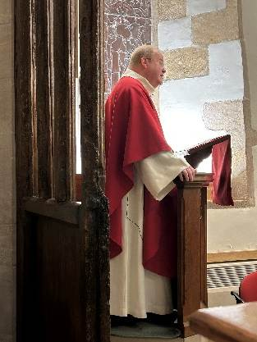
Archdeacon Gavin
We were delighted to welcome Archdeacon Gavin to the Benefice not once but twice. He preached and presided at both Christ the King Sunday at St Andrew’s Leasingham and St Andrew’s Day Patronal at St Andrew’s Cranwell village. The archdeacon was warmly greeted by all of those who attended the services. We hope to see him again soon.

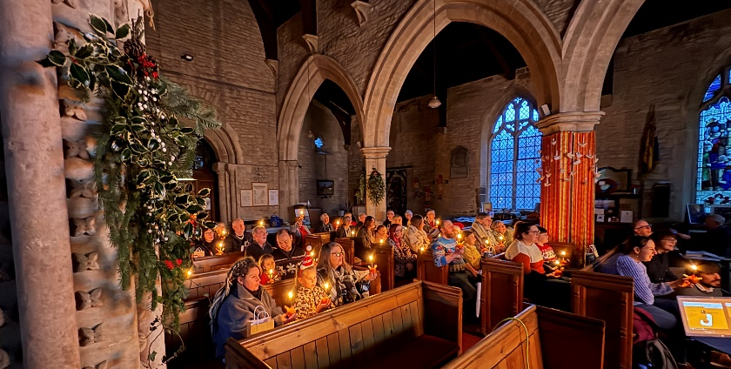
Benefice Christingle 2025
It was with great joy that the Benefice came together at All Saints Ruskington on the 19th of December to celebrate Christingle. Once the rules of do not eat the seasons (sweets) was understood, there was merriment and reflection as we thought about what God has done for us in and through his son, Jesus.
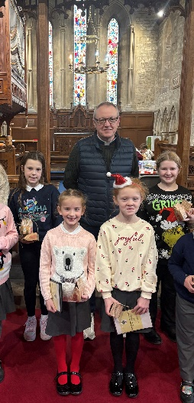
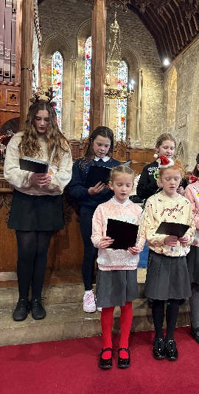
The Winter Fair at Ruskington
The 6th of December, St Nicholas Day, was the day of the All Saints Winter Fair. There was so much going on that day both at the Winchelsea Centre and in Church. There were all kinds of stalls from cake to craft, tea and coffee and bacon rolls and many more. Everyone had a really good time, and the event raised the profile of the Church as well as some much needed funds. In the Church we were treated to an organ recital by Alwyn Kirk, Christmas Carols by Chestnut Street School Choir, the Ruskington Pluckers ukulele orchestra and our annual rendition of hand bells. A wonderful day was had by all. Thank you to all who helped organise the event and to those who joined us on the day. We hope to see you all again soon.
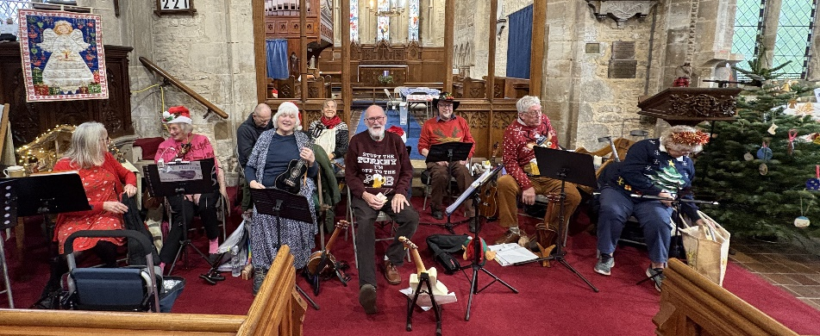

The Ruskington Pluckers
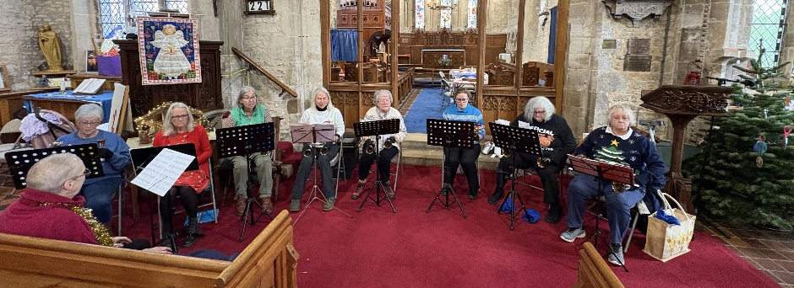

The Hand bells

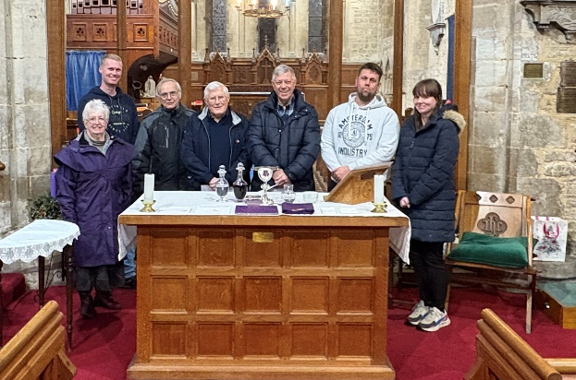
New Eucharistic Assistants
On the 2nd of December we welcomed our new Eucharistic Assistants for their training evening. There were also some refresher students too! Colin, Ian, Beth, Dan, Jane, Dunstan and Steve received a comprehensive brief on how to prepare the communion table for service and how to serve at the Eucharist. We prayed afterwards asking God to deepen our understanding of what this role means not only to each individual but to the whole church family. Thank you all for answering this calling to serve our communities. Reverend Al.


The Advent Exploration 2025
This year we explored what it meant to be a Christian in the modern world through the lens of the Advent Wreath. We thought about Peace, Joy, Love and Hope. The exploration was very well attended. Thank you to all of you who took part, for your insight and your deepening faith. Thank you too to Corinna who led the 3rd session which focussed on Joy. I look forward to our Bible Studies starting again soon as well as looking towards our Lent Exploration for 2026. Reverend Al.

Christmas Services
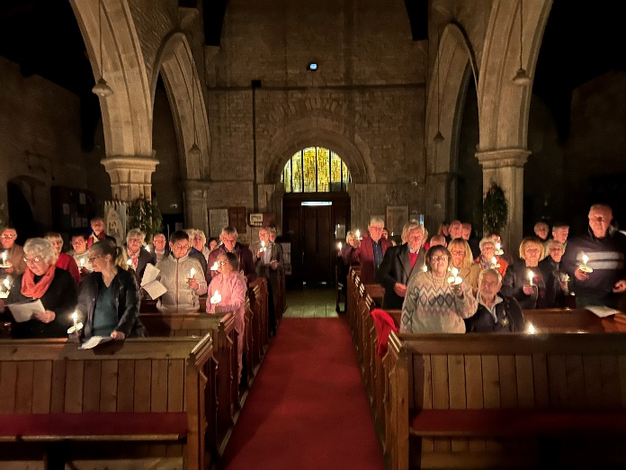
This year saw an increase in the number of people who have attended worship. From our 4 Carol Services, Christingle, 3 Crib Services, 4 Christmas Eve Services and 3 Christmas Day Services the joy of the season was in ample evidence. No more so than the Crib service which, to say the least, was hectic. The commitment and effort of the people who organise and support church services is never to be underestimated. Thank you to everyone who helped to prepare the churches and supported the ministry team for the whole of December. Reverend Al.

Benefice Community – All Sorts Back on the 12th January 2026

The Benefice all age outreach offering continues through December on Mondays at 2pm in the Winchelsea Centre Ruskington. The space is designed as a time for fellowship, activities, and conversation for people of all ages. Please come along and enjoy time with friends and perhaps make some new ones. You are always welcome.

News from around the Benefice

St Edith’s Church, Anwick

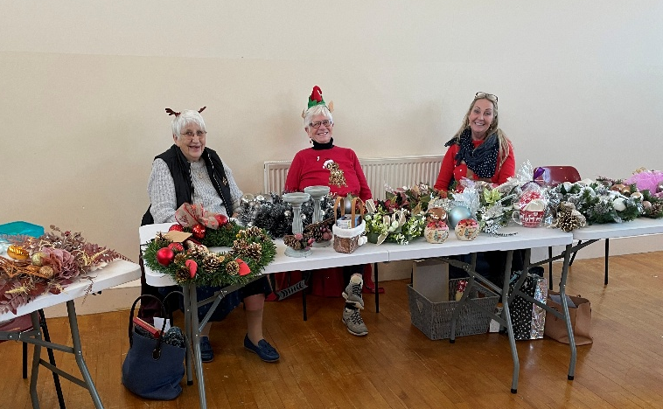
The News from St Edith’s. The December coffee morning, which was an extended one, with Soup and Roll being served, kindly provided by Shirley and Yvonne. Thank you to them, and all who came.

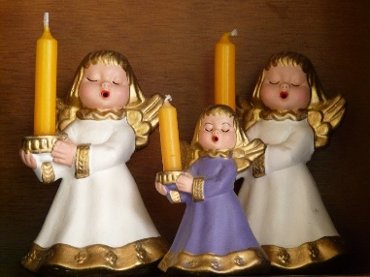

The Carol Service this year was a wonderful attendance. After the Service Mince Pies, Tea and Coffee was served, which was such a lovely ambience for the start of Christmas.

News From St Andrew’s Church, Cranwell Village
On Saturday 6 December St Andrew’s Church, Cranwell held their Annual Charities Coffee Morning, with stalls from St Barnabas, Lincolnshire Greyhounds Trust, Lincs & Nott’s Air Ambulance, Sleaford Museum, 1st Cranwell (RAF) Beavers, and 1st Cranwell Rainbows. It was a very lively and busy morning.
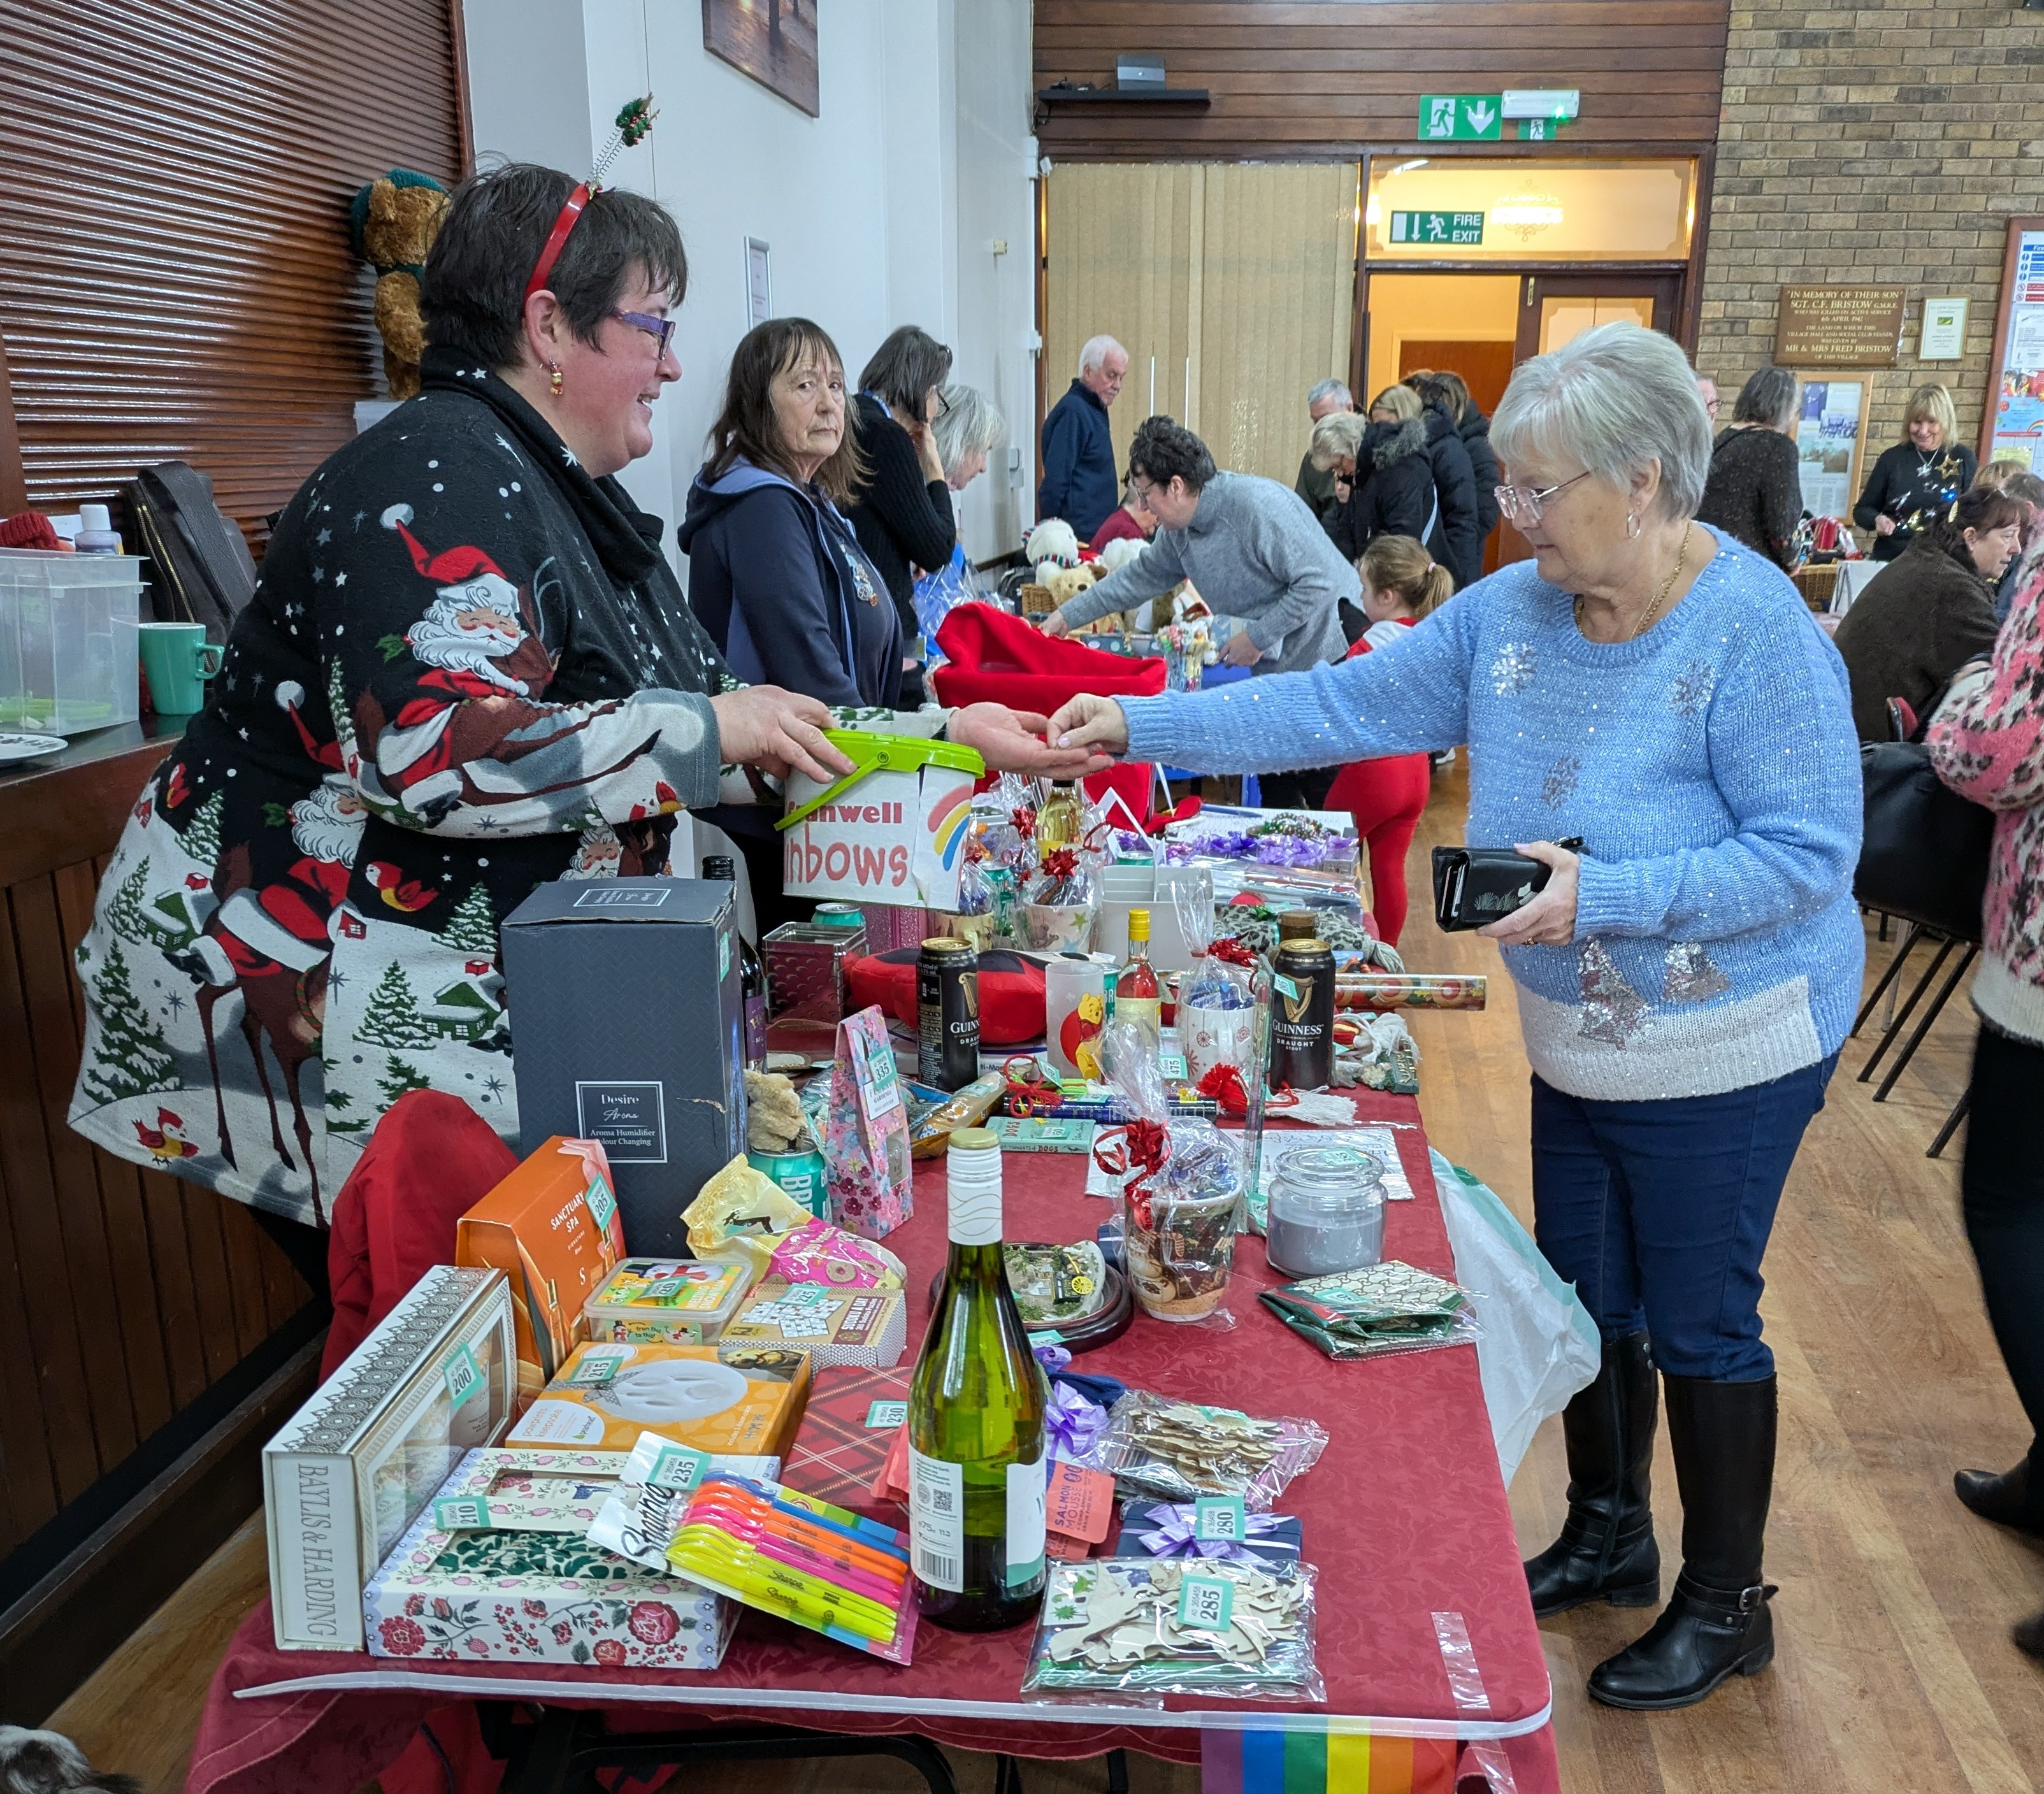
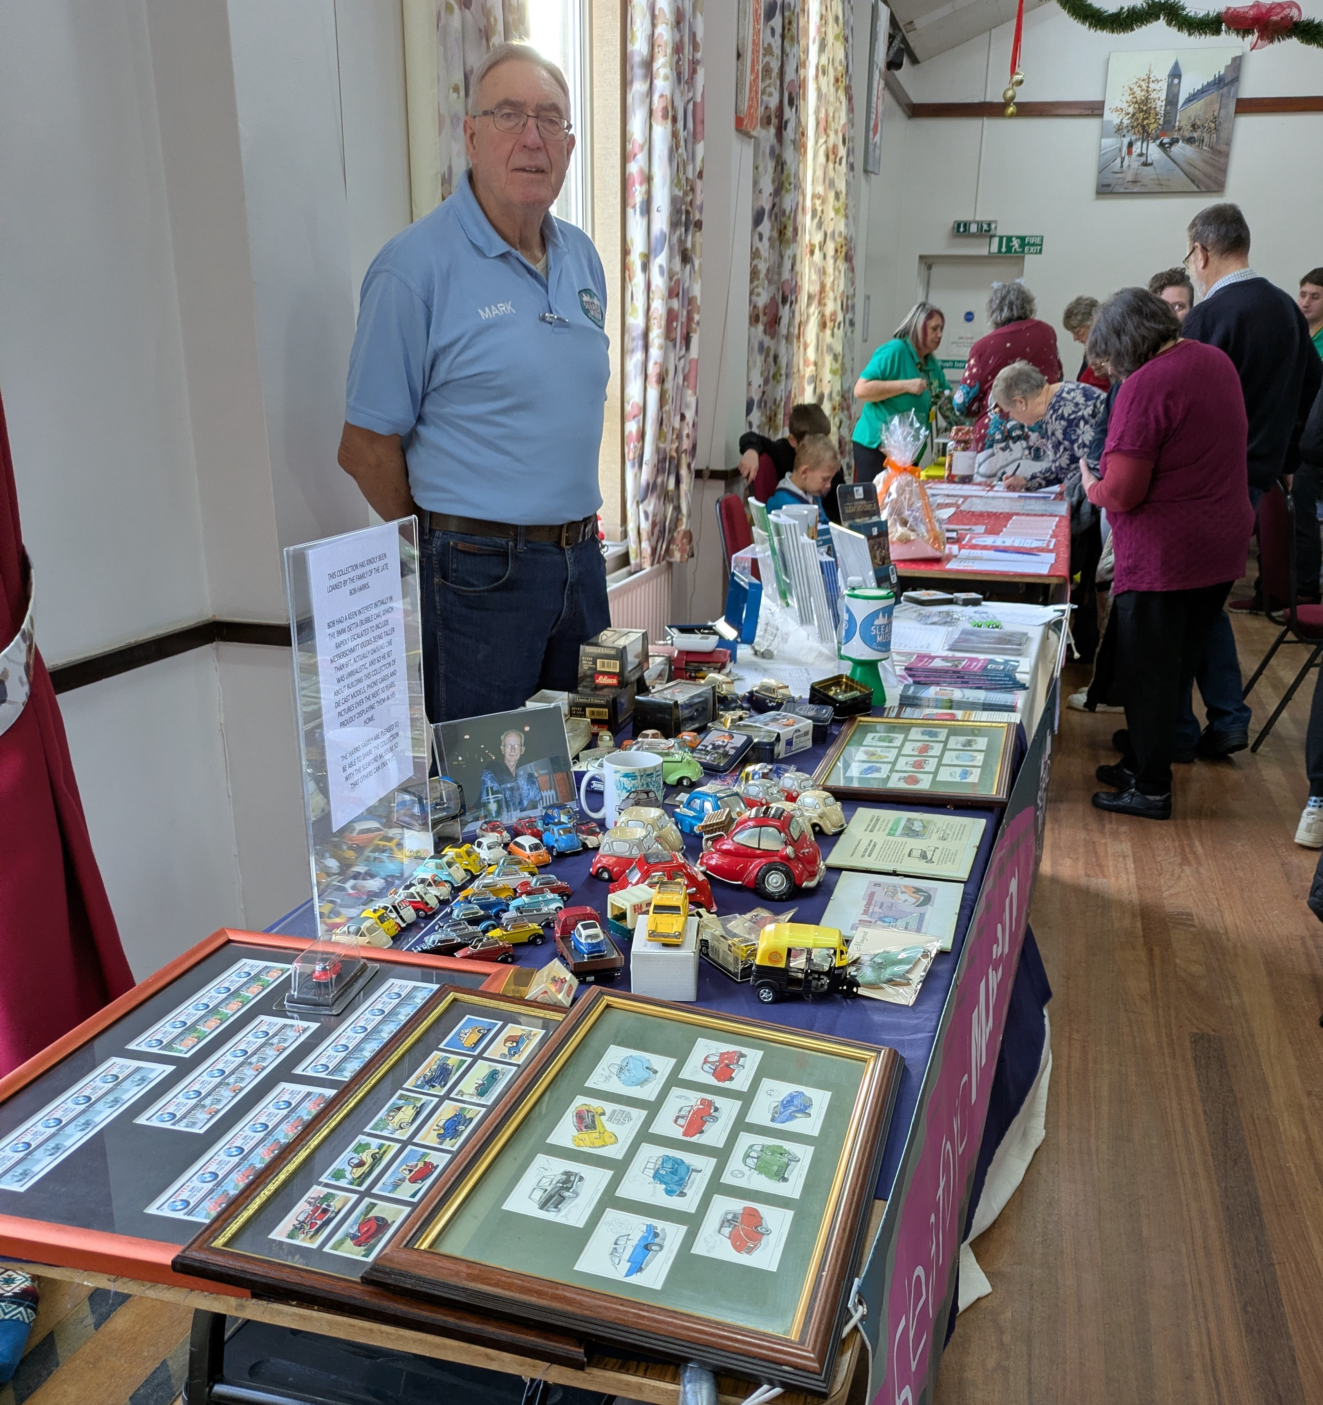
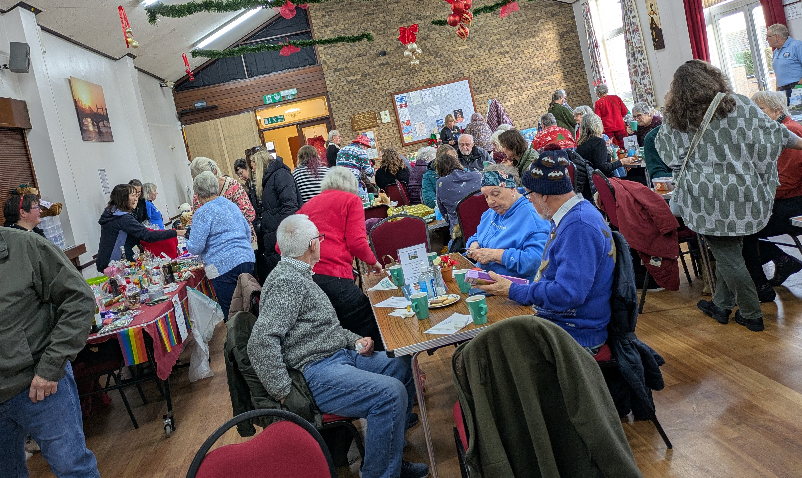

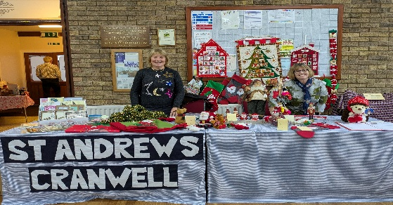
On Saturday 29 November the ladies from St Andrew’s Church had a stall at the Village Annual Christmas Fair to raise funds for the Church, it was very nearly a sell-out.

Christmas Tree Festival
The weekend of the 13th and 14th December saw the start of St Andrew’s Church, Cranwell first ever Christmas Tree Festival. Nine trees were displayed in the Church from local organisations, groups and businesses – all individually themed. On the evening of the 13th there was a celebratory viewing with mulled wine and mince pies available, plus a musical performance from the newly formed Community Choir. The Church was full of the local community with a lovely Christmas atmosphere. The trees have remained during the Christmas period and have meant lots of additional visitors to the Church during the last 2 weeks.
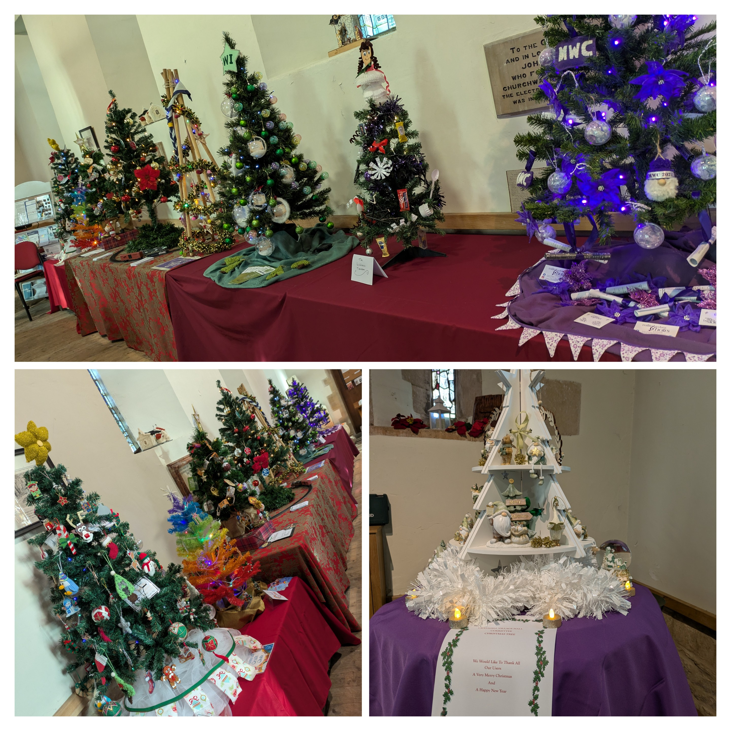
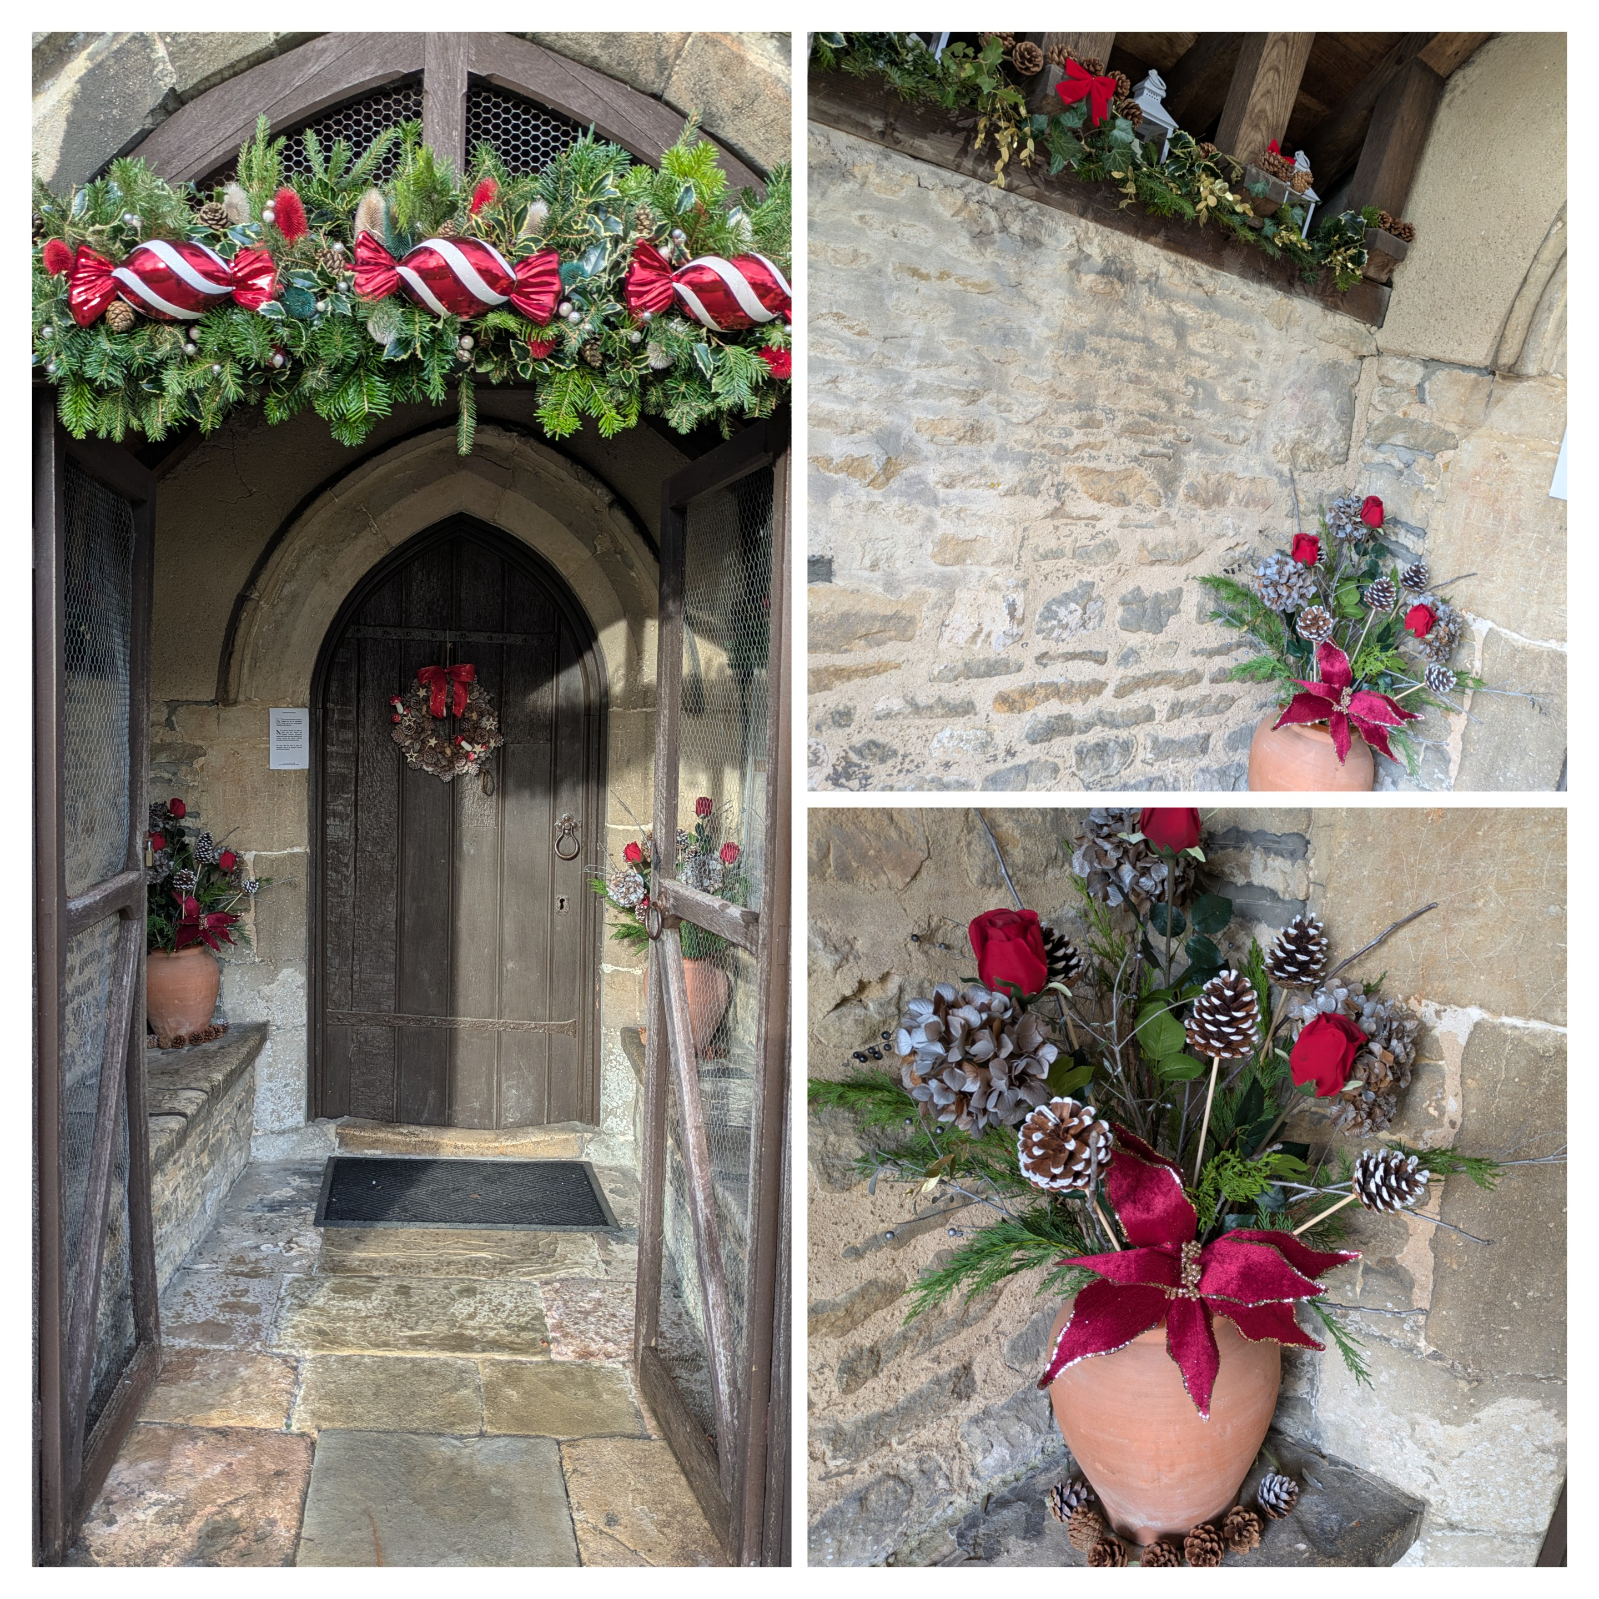

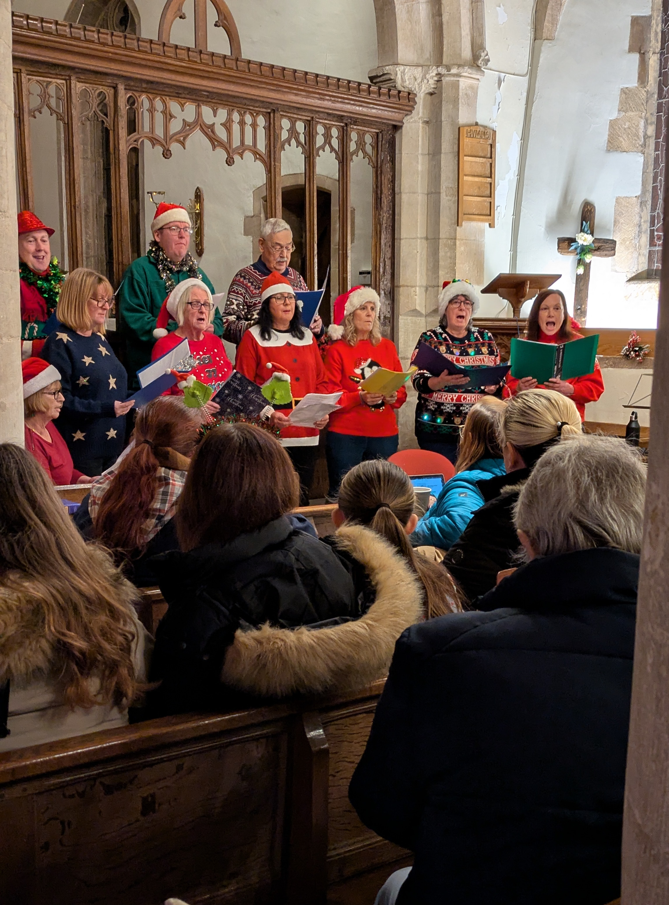
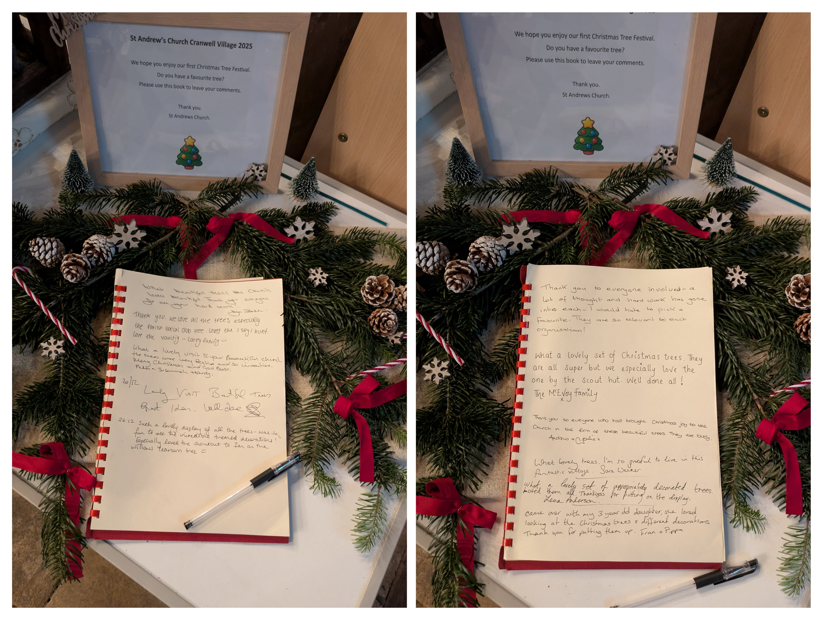

News from St Andrew’s Church, Leasingham
Leasingham Community enjoyed a series of events along the Advent journey to Christmas starting with the Advent Living Calendar which began on December 1st at the Duke of Wellington public house with their switch on of their outdoor, indoor and garden light show. The school choir sang and festive food was served. St Andrew's had a stall along with other village organisations and was well supported.

Leasingham choir and members of the congregation sang carols as part of a Festive evening at the Duke of Wellington on a Friday evening in mid-December when members of the public gathered to join in and enjoy festive food and have a joyous time.

Our coffee morning was particularly well supported with a variety of stalls to peruse which led to a very festive social gathering of many friends and acquaintances. A big thank you to all who supported the event and those who kindly volunteered during it helping out.
The next coffee morning will be on Saturday January 10th between 10.00am and 11.30am in Leasingham Village Hall with a tombola, raffle, homemade cakes, books and jigsaws for sale.

Our Carol Service was enjoyed by all those attending as was the Crib Service which was a totally joyous celebration with many attendees taking pleasure at looking at our new Nativity figures carved from olive wood sourced from Bethlehem and were blessed by Rev Rosemary.

Leasingham Church was beautifully decorated and many thanks go to Manor Farm Shop for their kind gift of the Christmas Tree which some of the Children from St Andrew's school helped decorate after their St Andrew's School Christmas Service. Thanks also to the four flower arrangers who made the Church look so special with their decorations and arrangements.

Chestnut Retirement Home
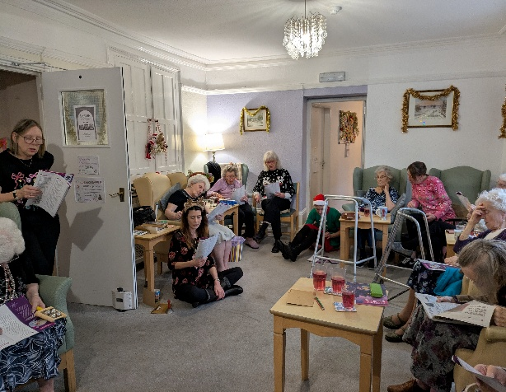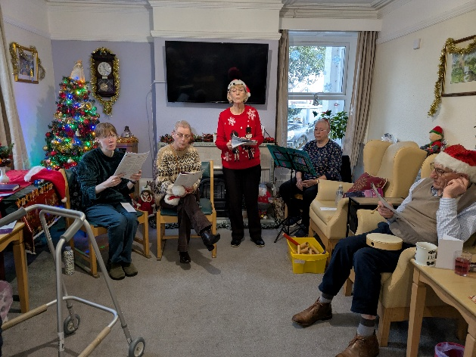
All Saints Church Choir visited the residence of Chestnut Retirement Home, entertaining everyone with joyous Christmas Carols. The residences and staff were very enthusiastic and loved making merriment with the instruments the choir brought along with them, as well as joining in with the well-known carols. They especially enjoyed singing Silent Night.

December Coffee Mornings around the Benefice


Do you enjoy a coffee and some good conversation on a Saturday morning? With a warm welcome, stalls to tempt and a hot drink to quench your thirst, why not tour the Benefice?

2nd January Anwick Village Hall at 10.00am
2nd January Cranwell Village Hall at 10.00am
10th January Leasingham Village Hall 10-11.30am
17th January Ruskington Winchelsea Centre at 9.30am - noon


Please remember to send your Newsletter article to northlafford@gmail.com

Articles should be submitted by the 20th January to ensure its inclusion in February edition

An opportunity for the purchase of an affordable home

Ruskington Parish Council have been asked by North Kesteven District Council to help publicise an opportunity for local residents to purchase affordable homes in Ruskington. As part of the Flaxwell Fields development, three two-bedroom bungalows with wet rooms are available at a discounted price of £139,440 (66.2% of market value).

Priority will be given to those with a local connection to Ruskington or adjoining parishes. Eligible purchasers must be approved by NKDC.

Further details:
- Contact Winkworth (Matt Bouch) on 01529 303377 or mbouch@winkworth.co.uk
- More information is available at www.n-kesteven.gov.uk
Thank you for helping us ensure that local people are aware of this opportunity. If you have any questions, please do not hesitate to get in touch.


All Saints Ruskington Parish Giving Scheme

The All Saints Ruskington Parish Giving Scheme (PGS) is now live online.
The Parish Giving Scheme (PGS) is a simple and secure way, for those wanting to make a regular donation, to the upkeep of the Church. Allowing the Treasurer to be able to budget church funds. If you are a UK tax payer this scheme also allows the Church to claim back 25% of your donation via Gift Aid. You can give monthly, quarterly, annually or a one of gift. You set the amount which cannot be changed unless you authorise it. You can cancel your PGS at any time. It’s as simple as A B C:
- Using your search engine, log onto the Church of England Parish Giving Scheme page to register and complete your details
- Confirm your details and activate
- Complete your bank account details and gift aid form and then submit
You will receive a confirmatory letter within 24 hours
The All Saints Ruskington PGS point of contact for any issues or further information is Jeremy Field. Jeremy.field4@icloud.com or ring 078 112 46 112.
Thank you for supporting the All Saints Ruskington PGS

Readings for January 2026
 | 1st Reading | 2nd Reading | Gospel reading
4th January  Epiphany Sunday  Translated from 6 January)  White | Isaiah 60.1-6 | Ephesians 3.1-12 | Matthew 2.1-12
11th January  Baptism of Christ  Gold | Isaiah 42:1-9 | Acts 10:34-43 | Matthew 3:13-end
18th January  Epiphany 2  White | Isaiah 49:1-7 | 1 Corinthians 1:1-9 | John 1:29-42
25th January  Paul’s conversion  White | Acts 9:1-22 | Galatians 1.11-16a | Matthew 19:27-end

Monthly Service Planner - North Lafford Group - January 2026
Date | Time | Service (Ruskington All Saints)
01 January 2026 | 10am | New Year's Day Mass
04 January 2026 | 11am | Holy Communion - Epiphany Sunday
11 January 2026 | 11am | Morning Praise - Epiphany
18 January 2026 | 11am | Holy Communion - Epiphany
18 January 2026 | 3pm | Sunday@3
25 January 2026 | 11am | Morning Praise - Epiphany
Date | Time | Service (Anwick St Edith's)
04 January 2026 | 11am | Morning Praise- Epiphany Sunday with St Edith's at St Mary's
18 January 2026 | 9.30am | Holy Communion - Epiphany with St Mary's At St Edith's
18 January 2026 | 3pm | Sunday@3
Date | Time | Service (Cranwell St Andrew's)
04 January 2026 | 11am | Morning Praise - Epiphany
11 January 2026 | 11am | Holy Communion - Epiphany
18 January 2026 | 11am | Morning Praise - Epiphany
18 January 2026 | 3pm | Sunday@3
25 January 2026 | 11am | Morning Praise - Epiphany
Date | Time | Service (Leasingham St Andrew's)
04 January 2026 | 9.30am | Morning Praise - Epiphany Sunday
11 January 2026 | 9.30am | Morning Praise - Epiphany
18 January 2026 | 9.30am | Morning Praise - Epiphany
18 January 2026 | 3pm | Sunday@3
25 January 2026 | 9.30am | Holy Communion - Epiphany
Date | Time | Service (Evedon St Mary's)
04 January 2026 | 11am | Morning Praise–Epiphany Sunday with St Edith’s at St Mary’s
18 January 2026 | 9.30am | Holy Communion - Epiphany with St Mary's At St Edith's
18 January 2026 | 3pm | Sunday@3

The Ministry Team

Revd Al Jenkins, Priest in Charge
Work Mobile: 07961 654486
revdajenkins@gmail.com

Revd Rosemary Jenkins, Priest
Revd Nigel Panting, Deacon
Richard Vickers, Reader
Corinna Langridge, Reader
Jane Hansford, ALM
Di Holt, ALM
Caroline Morrice, ALM

The North Lafford Benefice Office is located
At Myers House (next to the Winchelsea Centre) Ruskington
Opening hours Tuesday and Friday 9.30am – 12.30pm

