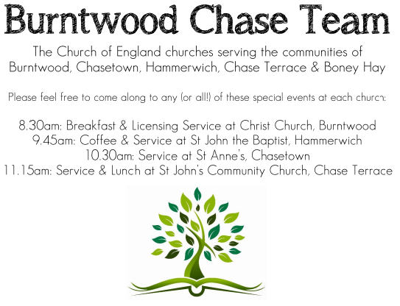
CHRIST CHURCH

SERVICE ON SUNDAY 18th JANUARY 2026 at 10am

Holy Communion

The Second Sunday after The Epiphany

Readings:
Isaiah 49: 1-7

Listen to me, O coastlands,
pay attention, you peoples from far away!
The Lord called me before I was born,
while I was in my mother’s womb he named me.
² He made my mouth like a sharp sword,
in the shadow of his hand he hid me;
he made me a polished arrow,
in his quiver he hid me away.
³ And he said to me, ‘You are my servant,
Israel, in whom I will be glorified.’
⁴ But I said, ‘I have laboured in vain,
I have spent my strength for nothing and vanity;
yet surely my cause is with the Lord,
and my reward with my God.’
⁵ And now the Lord says,
who formed me in the womb to be his servant,
to bring Jacob back to him,
and that Israel might be gathered to him,
for I am honoured in the sight of the Lord,
and my God has become my strength—
⁶ he says,
‘It is too light a thing that you should be my servant
to raise up the tribes of Jacob
and to restore the survivors of Israel;
I will give you as a light to the nations,
that my salvation may reach to the end of the earth.’
⁷ Thus says the Lord,
the Redeemer of Israel and his Holy One,
to one deeply despised, abhorred by the nations,
the slave of rulers,
‘Kings shall see and stand up,
princes, and they shall prostrate themselves,
because of the Lord, who is faithful,
the Holy One of Israel, who has chosen you.’

John 1: 29-42
²⁹ The next day he saw Jesus coming towards him and declared, ‘Here is the Lamb of God who takes away the sin of the world! ³⁰ This is he of whom I said, “After me comes a man who ranks ahead of me because he was before me.” ³¹ I myself did not know him; but I came baptizing with water for this reason, that he might be revealed to Israel.’ ³² And John testified, ‘I saw the Spirit descending from heaven like a dove, and it remained on him. ³³ I myself did not know him, but the one who sent me to baptize with water said to me, “He on whom you see the Spirit descend and remain is the one who baptizes with the Holy Spirit.” ³⁴ And I myself have seen and have testified that this is the Son of God.’
³⁵ The next day John again was standing with two of his disciples, ³⁶ and as he watched Jesus walk by, he exclaimed, ‘Look, here is the Lamb of God!’ ³⁷ The two disciples heard him say this, and they followed Jesus. ³⁸ When Jesus turned and saw them following, he said to them, ‘What are you looking for?’ They said to him, ‘Rabbi’ (which translated means Teacher), ‘where are you staying?’ ³⁹ He said to them, ‘Come and see.’ They came and saw where he was staying, and they remained with him that day. It was about four o’clock in the afternoon. ⁴⁰ One of the two who heard John speak and followed him was Andrew, Simon Peter’s brother. ⁴¹ He first found his brother Simon and said to him, ‘We have found the Messiah’ (which is translated Anointed). ⁴² He brought Simon to Jesus, who looked at him and said, ‘You are Simon son of John. You are to be called Cephas’ (which is translated Peter).
COLLECT FOR TODAY
Heavenly Father,
you have called us in the Body of your Son
Jesus Christ
to continue his work of reconciliation
and reveal you to the world:
forgive us the sins which tear us apart;
give us courage to overcome our fears,
and to seek that unity which is your gift and
your will;
through Jesus Christ your Son our Lord,
who is alive and reigns with you,
in the unity of the Holy Spirit,
one God, now and for ever.

WHAT’S GOING ON
Upcoming Services
Wednesday 21st January Morning Prayer 9.30am
Sunday 25th January Christingle 10am

Sunday 25th January Farewell Service for Rev’d Richard Westwood
At St Anne’s Church, Chasetown at 4pm
Everyone is welcome to attend this Service

Wednesday 28th January Morning Prayer 9.30am
Sunday 1st February Holy Communion 10am
Monday 2nd February Cameo Cafe 10-12 noon

Christingle
The Church will be open on Saturday 17th January at 10:30am to make the Christingle oranges. Any help would be appreciated.

FLOODLIGHTING
If you think about commemorating a special occasion by floodlighting our Church. Please contact Chris Brown on 01543 683862 for details.

PRAYER CHAIN
Christ Church is blessed with a very active prayer chain. If you, or anyone you know, feel that they would like others to pray for them, please speak to Chris Brown on 01543 683862.

HOME COMMUNION
For anyone who is unable to attend church and would like a Home Visit and Communion, please contact the Vicar and he will be able to carry this out.

VICAR CONTACT DETAILS

Rev’d Stephen Morgan Tele: 07305 852152

CHURCH WARDENS CONTACT DETAILS
Judith Rogers Tele: 01543 324718
Mike Holmes Tele: 01543 672970
Church Office Tele: 01543 642187 [leave a message and we will respond]
Church Web Site:www.christchurchburntwood.org.uk
Church Email: christchurchburntwood15@gmail.com
Facebook: www.facebook.com/group/christchurchburntwood/

Other Contacts
Matt Wallace St. John’s, Chase Terrace— Tele: 01543 670078
Richard Westwood St. Anne’s, Chasetown—Tele: 01543 686111

NEXT SUNDAY SERVICE
Sunday 25th January at 10am
Christingle
Isaiah 9: 1-4
Matthew 4: 12-23
3rd Sunday of Epiphany

