Westfield Church Notices Sunday 18th January

Valerie writes:
The Joy of Surprise Gifts
At Messy Church last Saturday we were talking about gifts. Sandi asked if anyone had received any surprises. My surprise, bought for me by my husband, is the book 'The Greatest Story Ever Told', written by Bear Grylls.
It's the very readable account of the story of Jesus written through the eyes and voices of those who walked beside him, those who met him and were witnesses to his teaching, healing and friendship.
Despite all Bear's adventures and exploring, TV presenting and survival challenges, he says that writing this book is the best thing he's ever done and the work that he is most proud of.
'Then Jesus told Thomas, 'so you believe because you've seen with your own eyes. Blessed are they who did not see and yet believed'.
John 20 v29
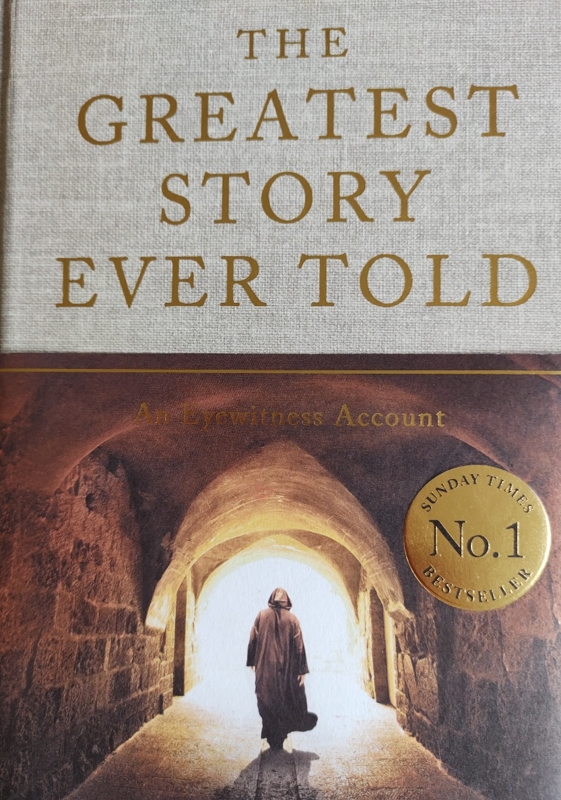

What’s on:

Sunday 18th January
8.00am: Prayer Book Communion
9.30am: Holy Communion
Tuesday 20th January
7.30pm: Prayer Group at Brenda’s
Wednesday 21st January
9.30am: Holy Communion
10.30am: Warm Space Community Hub
7.30pm: Home Groups at Dawn and Jess and Cathy and Howard’s

Messages:

The Alpha Course is back!

We are excited to begin the new year with Alpha and everyone is invited. Alpha
will begin with a soup lunch, then there’s a video to watch and discuss over a
cuppa and cake.

What: 11 week course exploring Christianity and some of the big questions of
Life

When: Weekly on Thursdays from 15th January to 26th March 12.30pm -
2.30pm plus Saturday 28th February

Where: St Peter’s Fairlight on the corner of Waites Lane and Broadway

Got any questions? Want to register your interest? Please phone or email Kizzy
(07356 077755 or email revkpenfold@outlook.com).

FSN

Collections for FSN in January will be on: Sunday 25th January at Westfield Church, or to Kathy and Eric’s house by the morning of Wednesday 28th January.
Kathy & Eric Darvill

Caring for God’s Creation

Are you looking for simple ideas on how to take action for the climate and nature?

Our new Eco tips calendar for 2026 will keep you and your church inspired throughout the year. It has fresh ideas each month and will help to foster a lasting commitment to a greener lifestyle.

Use the link below to Access the Eco Calendar to find ideas about sustainability and living a greener lifestyle.

https://arocha.org.uk/easy-eco-tips-2026-calendar/

Guestling and Fairlight

Please note that all church services in Fairlight during January will take place at St. Peter's (corner of the Broadway) because it is easier to heat.

Please see attached Guestling and Fairlight Parish Newsletter

Sarah – Parish Administrator

Prayer:

If you would like a situation prayed about urgently, please contact the church Prayer Share. Contact Dawn 01424 255423 / 0750 7745 159

If you know anyone who would like to be added to the notices, please send me an email with their details. If you don’t want to receive this email each week, or would rather receive it in a different format, please let me know.
Please give information for notices to me by Thursday morning (contact details below).
Have a good week everyone,
Tony Demarco tonydemarcohastings@gmail.com

