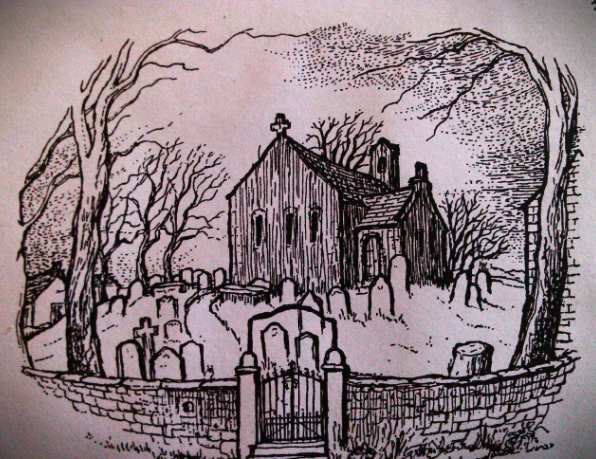

Next service at St Mary’s Beaumont

Sunday 25th January 2026
Holy Communion 9:30am

