
SPIRE & LIGHT United Churches
United Benefice of St Keverne, St Ruan with St Grade & St.Wynwallow (The Lizard)

*If you do not wish to receive these notices, please let your Churchwarden know*

25th January 2026
3rd Sunday of Epiphany


Readings
Isaiah 9:1-4
1 Corinthians 1:10-18
Matthew 4:12-23

9.30am – Morning Prayer - St.Peter’s, Coverack
9.30am – Holy Communion - St.Ruan, Ruan Minor
11am – Holy Communion – St.Keverne CHURCH HALL
11.15am – Morning Prayer – St.Wynwallow, The Lizard

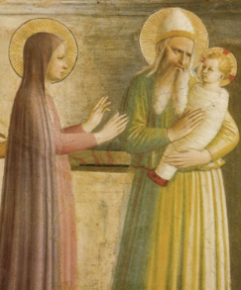
Next week – Sunday 1st February - Candlemas
9.30am – Holy Communion - St.Peter’s, Coverack
9.30am – Holy Communion (BCP) - St.Wynwallow, The Lizard
11am – Morning Prayer (BCP) - St.Keverne
11.15am – Morning Prayer – St.Ruan, Ruan Minor

BISHOP DAVID IS IN KERRIER FOR CANDLEMAS
All are welcome to join with Bishop David for any of the below:
3PM – WILD CHURCH – MULLION
4.30PM – AFTERNOON TEA – GERMOE CHURCH HALL
6PM – SERVICE OF THE WORD – GERMOE CHURCH
(Please park at the school – drop off at the church only – thank you)



*PLEASE NOTE – UNTIL FURTHER NOTICE
ALL ST.KEVERNE SERVICES WILL TAKE PLACE IN THE CHURCH HALL *


The Prayer Spot

At the start of this New Year in our Benefice, remind us we are all Brothers and Sisters in Christ brought to faith by the same saviour Jesus Christ with a duty to everyone in our benefice - those in church and those outside the church, we need to pray for them all. We also ned to pray for those in care homes and all their families and all who care for them, that they will receive the help they need to do all required of them. We pray for all NHS staff, for our own health centres and all clergy during this time of year. We pray that God will guide them in all they have to do. We belong to a benefice of six churches of the Lizard, Ruan, Grade, Cadgwith, Coverack , St Keverne - we have a duty of care to all those in our churches to be together in all we do in the name of Jesus Christ our Saviour. God has given us this great gift of prayer to pray for his help and guidance in our lives and the lives of others to ask him to be with us in all we do in his Name.
We pray for –
- those in our community who need God’s help in their lives which can sometimes be difficult.
- the people in the Ukraine who need God’s help in these difficult times. We pray for God’s presence in their lives
- all those who need hospital treatment, that God will be present with them and their families and will meet their needs
- the churches in our Benefice - that God will give us all the gift of love to share with all our church members
- for our Clergy, that God will guide them in all they do for us
We thank you Heavenly Father for those gifts given to us of forgiveness, kindness , justice, generosity and peace, all gifts to share with others.
Remember God is ever present in your life and will answer your prayers in Jesus wonderful name. Be blessed in all you do.
Faithful Father we begin today giving you thanks, your love endures for ever, it never fails. Though there are many ways which we have failed, we have not exceeded the supply of your mercy and grace. We thank you for revealing yourself to us through your word, as we open our bibles today, we pray you would hear our voice. We ask that your Holy Spirt would be at work in opening our ears to hear and our heart to receive your word. May we be transformed into your likeness, through Jesus Christ our Lord. Amen
Sam Buchanan

The Diocese of Truro’s Prayer Diary for this week and next

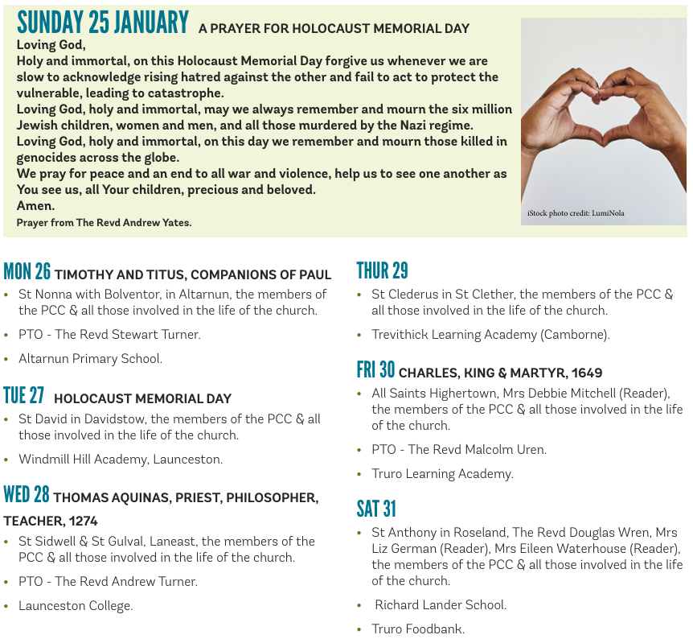

On the Way Prayers
At the end of the Week of Prayer for Christian Unity, we pray first for unity within our Deanery. ‘So we, who are many, are one body in Christ, and individually we are members one of another’ (1 Corinthians 12.5). Lord help us always to remember this.

We pray for our clergy – for Heidi and Susie – and for the fact that this week the advert for a third stipendiary post will be advertised. Lord we pray that you will be calling someone to come and join our ministry team and specifically to lead pastoral work across our deanery. We pray for the fact that the house for duty post will shortly be advertised too. Our DIT meets tomorrow so please let us now pray for all the members of that group who work so hard for us all. This week has seen the start of the interview process for the next Bishop of St Germans; Lord we pray for all who may be seeking to come and serve you in the Diocese of Truro.

Now we pray for unity across the world – unity that will only come with peace. The world seems in a bit of turmoil right now – not only are wars continuing to rage, but tension is also rising between nations who purport to be allies. Calm the leaders of our nations, give them courage to stick to what is right to promote peace and unity.

Let us now pray for all families in our Deanery – for unity between members. There is always sorrow when family members fall out; children suffer. Bishop David has asked us all to keep working on the Growing Younger agenda – help us all to find ways to work with children, young people and families. And when we don’t know what to do, just help us to remember the power of prayer. We pray for the 3 Wild Churches that are now up and running in our Deanery that gradually this work will flourish. We give thanks for the children who do get involved in any way in our churches.

Now, let’s take a moment to pray for anyone who needs to feel the power of our collective prayers and the comfort of God’s healing hands. Lord, heal and comfort all those who suffer in any way; through their pain may they feel your presence and through their fear may you bring them peace.

