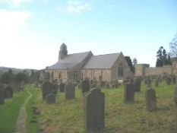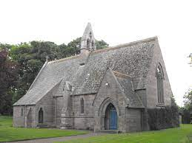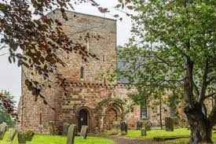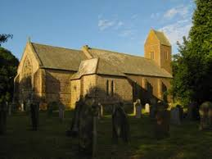
The Flake Parishes of
Ford, Lowick, Ancroft, Kyloe and Etal

A very warm welcome to you, especially if you are visiting.
Please take this sheet home with you and use it as a basis for prayer.
Children may be at all our services.

Sunday 25th January 2026
Conversion of Paul
Lowick 9.15am Holy Communion
Etal 11am Holy Communion

Sunday 1st February 2026
Lowick 9.15am Holy Communion in Village Hall
Etal 11am Holy Communion

Sunday 8th February 2026
Lowick 9.15am Holy Communion
Etal 11am Holy Communion

Sunday 15th February 2026
Lowick 9.15 Holy Communion
Etal 11am Holy Communion

Revd Charlotte Osborn (Vicar) 01289 388591 ceosborn@mail.com 07957 367457
Revd Alex Firman (Assistant Curate) 07935 732811
alex_firman@hotmail.co.uk
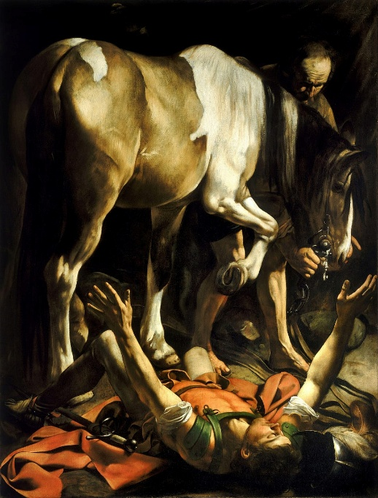
Today the church remembers the dramatic conversion of Saul the persecutor to Paul the devoted follower and apostle, a journey marked by temporary blindness, divine instruction through Ananias, baptism, and a lifelong mission to preach Christ. This is one of two paintings by Caravaggio entitled ‘Dazzled by Light’ and worthy of reflection as we recall that moment when the light of the gospel began to flood our own lives…and thank God for it
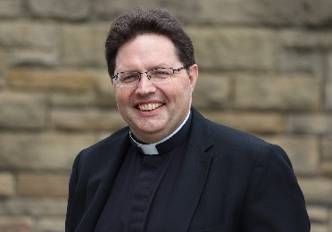
Saturday January 31st, we meet from all our parishes for a morning of prayer and vison casting with The Very Revd Lee Batson, Dean of Newcastle Cathedral, at The Hemmel on Fenham Farm. As we look out to Lindisfarne, so we hope to continue to build on the foundations laid by Aidan and Cuthbert for the churches in our parishes as we trust God for the future. 9am until 1pm, PCC members and all who would like to be part of this – please all register with dee.colam@gmail.com by 6pm this evening, 25th January since there will be a breakfast roll and lunch provided.

Other news
Davey Greene, a member of our youth group from Lowick, is training to run the Edinburgh half marathon in March this year in aid of Macmillan Cancer Support. He would be very glad of any encouragement in the form of sponsorship or donation and there are flyers at the back of church with details of how to give.
Norham Deanery Development Group meets in Holy Island vicarage at 11am on Tuesday 3rd February.

Men’s Breakfast Saturday 7th February in the White Swan Lowick 8.30am-10am. Book with Kevin on 07530 000941.

Ford and Etal PCC meets in the Estate Office at 5.30 pm on Tuesday 10th February.

Soup Saturday Lowick Village Hall 14th February 12-1.30pm.

The next gathering of DDG’s (Deanery Development Groups) across the Diocese will be at St Aidan’s, Morpeth on Saturday 21st February from 10am. An open meeting to discuss Buildings for Mission, including fundraising opportunities, Net Zero resources, the 101 Sustainable Churches Checklist, and a new calculator tool from the National Churches Trust to demonstrate the social impact of your church. Speak to Charlotte for a lift.

St John the Baptist, Lowick is registered on #easyfundraising which means you can raise free funds for them as you shop online this year, at no extra cost!
All the big names like John Lewis & Partners, Argos, eBay and more are ready to donate. Every donation makes a difference. Please sign up before midnight 29th January and you could win a £500 donation:
https://join.easyfundraising.org.uk/stjohnlowick/f43jbj/s2s/KlKNhASV/SE866/facebook/
We will shortly set up pages for Ford and Etal and Ancroft too.

Ash Wednesday 18th February. Holy Communion with Imposition of Ashes at both Etal and Lowick at 9.30am.

For our prayers
Please continue to pray for all who suffer in body, mind or spirit, especially Andrew Watson, Heather Piper, Chloe French, George Hall, Gail Calder, Sam Quilty, David and Revd Judith Dobson.
We rejoice with Kate and James who were married yesterday in Ford Church. We thank God for the ministry in these parishes during the vacancy of Revd Rob Kelsey who will retire on 31st December 2026.

We remember all who have recently died and those who mourn them, including the family and friends of Jim Turner (funeral Ancroft 30th January), Derek Moffet, and those whose anniversaries of death fall at this time: Lesley Stoker, Tony Haigh, Edna Sim, Robin Reavley, Christopher Duncan, Janet Hogg.

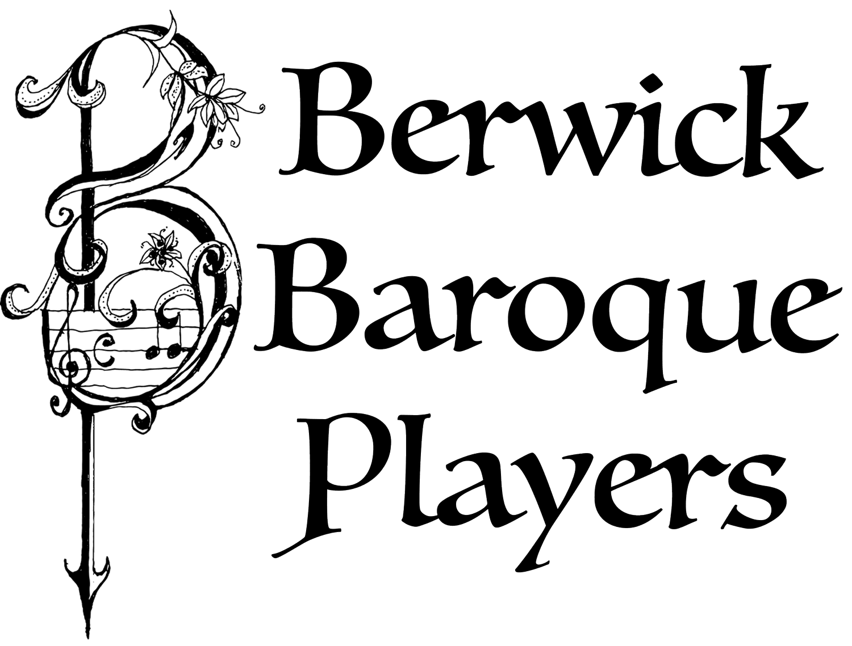
A huge thank you to this talented group of musicians, to George and Jane Farr for opening Pallinsburn to us and all who helped from our local team at Ford and Etal to make this such a successful evening.

Parish Contacts

Ancroft Leigh Yorke 07716 116739
Etal Andrew Joicey 01890 820540
Ford Kathleen Holmes 07951 099668
Lowick Niall Cartlidge 07850 876246

Websites: www.achurchnearyou.com
Instagram: https://www.instagram.com/the_flake_churches/
Facebook: the_flake_churches

Other licensed clergy
Revd Margaret Sentamu 077871 204745, Canon Nick Sagovsky,
Revd Marion Penfold 01289 305664

