Sunday 1st February 2026 The Presentation of Christ in the Temple (Candlemas)

Collect: Almighty and ever-living God, clothed in majesty, whose beloved Son was this day presented in the Temple, in substance of our flesh: grant that we may be presented to you with pure and clean hearts, by your Son Jesus Christ our Lord, who is alive and reigns with you, in the unity of the Holy Spirit, one God, now and for ever.

Malachi 3.1–5
Thus says the LORD God:
¹ See, I am sending my messenger to prepare the way before me, and the Lord whom you seek will suddenly come to his temple. The messenger of the covenant in whom you delight – indeed, he is coming, says the LORD of hosts. ² But who can endure the day of his coming, and who can stand when he appears? For he is like a refiner’s fire and like fullers’ soap; ³ he will sit as a refiner and purifier of silver, and he will purify the descendants of Levi and refine them like gold and silver, until they present offerings to the LORD in righteousness. ⁴ Then the offering of Judah and Jerusalem will be pleasing to the LORD as in the days of old and as in former years. ⁵ Then I will draw near to you for judgement; I will be swift to bear witness against the sorcerers, against the adulterers, against those who swear falsely, against those who oppress the hired workers in their wages, the widow, and the orphan, against those who thrust aside the alien,
and do not fear me, says the LORD of hosts.

Psalm 24. 7–10
R The Lord of hosts, he is the king of glory.
⁷ Lift up your heads, O gates; lift them high,
O everlasting doors; and the King of glory shall come in.
⁸ ‘Who is this King of glory?’ ‘The Lord, strong and mighty, the Lord, mighty in battle.’ R
⁹ Lift up your heads, O gates; lift them high,
O everlasting doors; and the King of glory shall come in.
¹⁰ ‘Who is he, this King of glory?’
‘The Lord of hosts, he is the King of glory.’ R

Hebrews 2.14–18
¹⁴ Since the children share flesh and blood, Jesus himself likewise shared the same things, so that through death he might destroy the one who has the power of death, that is, the devil, ¹⁵ and free those who all their lives were held in slavery by the fear of death. ¹⁶ For it is clear that he did not come to help angels, but the descendants of Abraham.¹⁷ Therefore he had to become like his brothers and sisters in every respect, so that he might be a merciful and faithful high priest in the service of God, to make a sacrifice of atonement for the sins of the people. ¹⁸ Because he himself was tested by what he suffered, he is able to help those who are being tested.

Luke 2.22–40
²² When the time came for their purification according to the law of Moses, Mary and Joseph brought Jesus up to Jerusalem to present him to the Lord. ²³ (as it is written in the law of the Lord, ‘Every firstborn male shall be designated as holy to the Lord’), ²⁴ and they offered a sacrifice according to what is stated in the law of the Lord, ‘a pair of turtle-doves or two young pigeons.’ ²⁵ Now there was a man in Jerusalem whose name was Simeon; this man was righteous and devout, looking forward to the consolation of Israel, and the Holy Spirit rested on him. ²⁶ It had been revealed to him by the Holy Spirit that he would not see death before he had seen the Lord’s Messiah. ²⁷ Guided by the Spirit, Simeon came into the temple; and when the parents brought in the child Jesus, to do for him what was customary under the law, ²⁸ Simeon took him in his arms and praised God, saying, ²⁹ ‘Master, now you are dismissing your servant in peace, according to your word; ³⁰ for my eyes have seen your salvation, ³¹ which you have prepared in the presence of all peoples, ³² a light for revelation to the Gentiles and for glory to your people Israel.’ ³³ And the child’s father and mother were amazed at what was being said about him. ³⁴ Then Simeon blessed them and said to his mother Mary, ‘This child is destined for the falling and the rising of many in Israel, and to be a sign that will be opposed ³⁵ so that the inner thoughts of many will be revealed – and a sword will pierce your own soul too.’ ³⁶ There was also a prophet, Anna the daughter of Phanuel, of the tribe of Asher. She was of a great age, having lived with her husband seven years after her marriage, ³⁷ then as a widow to the age of eighty-four. She never left the temple but worshipped there with fasting and prayer night and day. ³⁸ At that moment she came, and began to praise God and to speak about the child to all who were looking for the redemption of Jerusalem. ³⁹ When they had finished everything required by the law of the Lord, they returned to Galilee, to their own town of Nazareth. ⁴⁰ The child grew and became strong, filled with wisdom; and the favour of God was upon him.
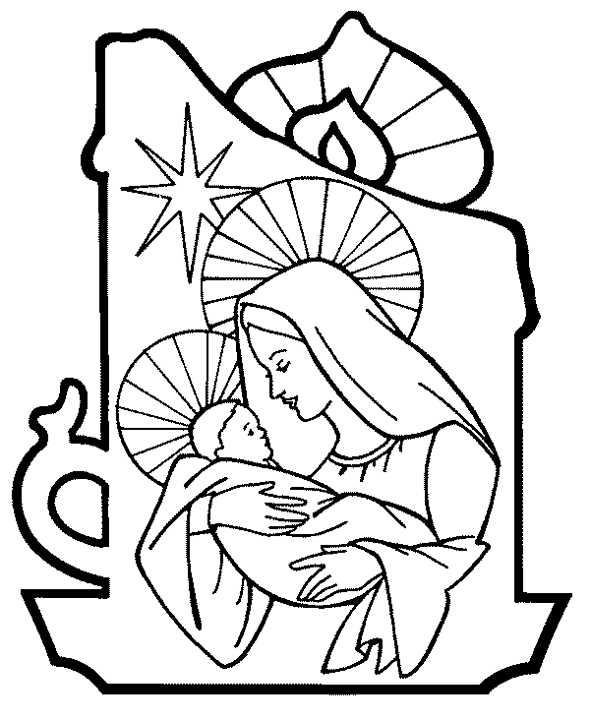
Post Communion Prayer: Lord, you fulfilled the hope of Simeon and Anna, who lived to welcome the Messiah: may we, who have received these gifts beyond words, prepare to meet Christ Jesus when he comes to bring us to eternal life; for he is alive and reigns, now and for ever.

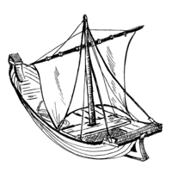
THE HAVEN BENEFICE OF SEAVIEW, ST HELEN’S, BRADING And YAVERLAND
Providing a Spiritual Harbour for ALL

Sunday 1st February
08.00 Said Eucharist (BCP), St John’s
09.30 Sung Eucharist, St Mary’s
10.00 Sung Eucharist, St Peter’s
18.00 Service of the Word, St Catherine’s

Tuesday 3rd February
10.00 Morning Worship, St Catherine’s

Wednesday 4th February
10.00 Morning Worship, St Mary’s
11.00 Prayer Circle, St Peter’s

Sunday 8th February
09.30 Service of the Word, St Mary’s
09.30 Sung Eucharist, St Helen’s
11.00 Sung Eucharist, St John’s

Wednesday 11th February
10.00 Morning Worship, St Mary’s
11.00 Prayer Circle, St Peter’s

Sunday 15th February
08.00 Said Eucharist (BCP), St John’s
09.30 Sung Eucharist, St Mary’s
10.00 Sung Eucharist, St Peter’s
17.30 Sung Evensong, St John’s (tbc)

Tuesday 17th February
10.00 Morning Worship, St Catherine’s

Wednesday 18th February (Ash Wednesday)
10.00 Holy Communion with Ashing, St Mary’s
11.00 Prayer Circle, St Peter’s
18.00 Holy Communion with Ashing, St Helen’s

Sunday 22nd February
09.30 Sung Eucharist, St Mary’s
09.30 Sung Eucharist, St Helen’s
11.00 Sung Eucharist St John’s
15.30 Eco Church, St Helen’s

Haven Benefice Church contacts:
Priest-in-Charge (Day off: Tuesday)
St Peter’s Seaview and Safeguarding -
Revd Karen Wilson on 07591240640
Email: revdkarenwilson@outlook.com
St Helen’s and St Catherine's, St Helens –
Sue Whitewick on 01983 568761
St Mary’s Brading –
Nigel Elton-Walters on 01983 406817
Safeguarding - Catherine Davis on 07940826034
St John’s Yaverland –
Kevin Norton on 07951407423
Curate at Haven Benefice
Revd Bevaly Rackett – 01983 407432
Email: revbevrackett@gmail.com
To add items to this news sheet
please contact Rev Bevaly

An unusual garment comprising 700 hand-sewn patches, including one from St Helen’s Eco Church, is due to arrive on the Island on Monday 9th February, and in the benefice the following weekend. Known as the Coat of Hopes (www.coatofhopes.uk), it was created in 2021 to ‘carry people’s hopes for the future of the planet’ to the COP26 climate conference in Glasgow, since when it has toured the mainland, inviting all who encounter it to wear it. Do make sure you see it – it will be walked from Ryde to St Helens on Saturday 14th and be in the village on the Sunday. More info from Helen or Andrew Bradstock.

The first Jumble Sale of the year at St Mary’s Church, Brading is on Saturday 7th February in the church hall. Doors open at 2pm. Jumble can be dropped off from 11am, Farmer Ralph will be there selling his eggs, veggies and meat and there will be refreshments available.

at St Helen’s Church is looking to start a New Social Events Team who will organise and lead social and fundraising events for the general church fund. We would be glad to hear from anyone who feels that they can add their skills/talents to help to organise events within a supportive team. Please let Revd Karen know if you are interested by calling her on 07591 240 640.

St Peter’s Church is forming a new Social Team to organise social and fundraising events. The team will be responsible for arranging events and for the running of them. We are looking for a minimum of six people to provide the foundation for the team. The team will be working with the PCC to organise new and exciting opportunities for fundraisers and social events. If you would like to be a part of the team or have any questions please contact Revd Karen or Chris on 07591 240 640.

Lent Lunches at St Peter’s church will be held on 4th, 11th, 18th and 25th March in the Undercroft. Helpers needed and a sign up sheet is being kept at the door of the church. Homemade soup with rolls, cheese and biscuits, Tea/Coffee all served from Noon.

Our Lent Course: ‘Draw Near’ - reflections for Lent will be held in St Mary’s church hall from 6pm on Wednesdays 25th Feb, 4th, 11th, and 18th March. Refreshments will be provided and everyone is invited to come along. If you would like a copy of the accompanying booklet please let Rev Karen know ASAP as the more we order the cheaper we can get them.

Website: www.havenchurches.org.uk
Or find us on achurchnearyou.com

Or follow us on Facebook: Haven Churches IOW

