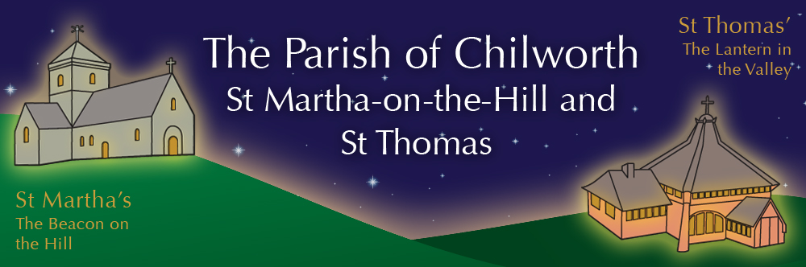

NOTICES: - 11th JANUARY 2026
Priest David Oakden – Revdavid@parishofchilworth.org.uk - 01483 534293 (day off Friday)
Do let me know of anybody or anything that you would like to be prayed for.
www.parishofchilworth.org.uk and find us on https://www.achurchnearyou.com

********* Matthew 3:16-17 (NRSVA)******
And when Jesus had been baptized, just as he came up from the water, suddenly the heavens were opened to him and he saw the Spirit of God descending like a dove and alighting on him. And a voice from heaven said, ‘This is my Son, the Beloved, with whom I am well pleased.’.
***********************************

Opportunities to pray together: -
Ecumenical Prayer Breakfast 1st Saturday of the month at the Vicarage, from 9am, prayer, coffee and croissant. Next is the 7th February – Thursday evening at St Thomas at 7:30 pm for an hour every other week. **15th January & 5th February 2026.

This Sunday Services: – Baptism of Christ
9:30 St P&P Albury Morning Worship with Judy Potter
11:15 St Martha’s Holy Communion

Next Sunday Services: - 18th January
9:30 St Thomas Holy Communion with Mike Currier.
11:15 St Martha’s Mattins with John Aston.

Looking further ahead: -
Tots and Toddlers: St T’s Monday 9:15am
Prayer Meeting: 15th Jan St T’s 7:30pm
PCC: 29th Jan St T’s 7:30pm

Food & Hygiene Bank: -
The Foodbank Larder box is located in the porch of St Thomas Church. Suggested items: - Long life milk /tins tuna/ tins meat/ sachets microwaveable rice /pasta sauces/curry sauces/cereal/spreads/ tea/ coffee/ hot chocolate/ tins soup/ baked beans. Please assist, especially as the autumn is now upon us.

Chilworth Tinies and Toddler Group: -
Mondays from 9:15 -10:30 meet in St Thomas, play chat, pray and support. Next meeting 5th Jan 2026.

LENT news: -
We intend to continue with our Lent Lunch reflections on Art at St Thomas during Lent, and we are exploring what else we could do across the Benefice for Lent, such as discussion groups, bible studies and so on. Do let your clergy know of any suggestions or ideas so we can plan appropriately.

Harry Moss’s next Adventure: -
Harry Moss, a local resident who generously helps out with so many maintenance tasks at both St Martha’s and St Thomas, is off again on an adventure in February. He is donating his old 4x4 car and with a team of others is driving it in a convoy to Ukraine, for the charity CONVOY4UKRAINE. Do support him and the charity not only with prayer but financially via his JustGiving page https://www.justgiving.com/page/harry-moss-2?utm_medium=FR&utm_source=EM

Service Pattern: -
The service pattern moving forward through 2026 is becoming clearer. St Thomas and St Peter & St Paul will alternate the 9:30 morning service. First Sunday will be Holy Communion at St Thomas - Chilworth, 2nd Sunday will be Morning Worship at St Peter and St Pauls - Albury, 3rd Sunday will be a morning service at St Thomas, - Chilworth, and will be either Holy Communion or a family service, 4th Sunday will be Holy Communion at St Peter & St Pauls - Albury.
St Martha’s will have a weekly 11:15am service, with the first and third Sundays being led either by visiting clergy or self-led, whilst the second and forth Sunday will be Holy Communion and led by David.
Fifth Sundays are still being worked on, and of course this pattern may get changed by circumstances, however it will assist with planning.

