NEWSLETTER NUMBER 303
SUNDAY SEES THE START OF THE NEW SERVICE ROTA. THE SERVICE TIME IS 10.30 A.M.

THOUGHT FOR THE WEEK
“To be good is noble, but to show others how to be good is nobler and no trouble”
Mark Twain

OUR SERVICE ON SUNDAY 11/1/2026 – BAPTISM OF CHRIST/ EPIPHANY 1
The service will be a Sung Eucharist starting at 10.30 a.m. The celebrant today will be Reverend Prebendary Christopher Rowley. There will be coffee and chat after the service so please stay and chat if you can.

LOOKING FORWARDS – REV ANDY
New Beginnings
Happy New Year everyone! I hope that 2026 has started well for you, and if you have made any New Year resolutions that they are going well. People often start a new year by making promises to themselves that they will do better or try harder than last year, perhaps kick a habit or take up something healthy or perhaps just recover from a Christmas of excess. This new year sees the churches of the West Tone Benefice start a new rota of services and events. Our goal in designing it has been to widen our invitation to a broader range of people of all ages and backgrounds, in the hope that they will become part of our church community. Whether they do or not, what matters most is that we show them that we care about them and are looking for ways to help their lives flourish in the year ahead. Last Sunday saw the first gathering of the West Tone Shanty Singers. We had a fantastic time as 24 enthusiastic voices of all ages and skill levels gathered in All Saints Church to learn about and enjoy some sea shanties. Everyone is welcome to come and join in this fun, whether you are a seasoned singer or just looking for a fun community. No experience is needed, just a willingness to belt out a tune. Why not come along on Sunday 1st February at 6.00pm.
This Sunday we will be holding an All Age Communion service at Saint Bartholomew's Church, Bathealton starting at 10.00am. The aim over the months ahead will be to shape this service in such a way that those who wish to come to Holy Communion as a family can do so trusting that all ages will be catered for. Later on Sunday at 6.00pm The Pub Explorers will be meeting in The Martlet Inn, Langford Budville, for the first time. This informal and relaxed setting will host those who are looking for answers to the big questions in life and those interested in sharing their thoughts, yet with a willingness to hear other people's too. All are welcome.
Over the coming weeks, I will share more with you about how these new services and events are going and introduce you to what is coming up next. It will be an exciting time and one that will bring its challenges, as together we experience change, try new things, plant new seeds and watch patiently and prayerfully to see if they grow and bear fruit. You may be someone who does not intend to start 2026 with a new resolution or with the willingness to do something different and if that's you, then worry not, because our existing services will remain in the monthly rota, albeit at different times. If these changes have left you confused then look at the up to date rota at www.westtone.org.uk/services. However
if you are somebody looking for a challenge, seeking to grow their faith by embracing those beyond our church walls, then please let me know. I am interested to hear from anyone who is up for the exciting journey of starting new things, learning from how they go and adapting them to meet the needs of those people we are not best connected with yet. I look forward to hearing from you if this is something which fills your heart with joy.

ROTA FOR SUNDAY 11/1/2026
Sidesmen:- Alison Toogood and Ann Fry
Reader:- John Evans
Coffee:- Alison Toogood and Ann Fry
Flowers:- Alison Toogood

READINGS FOR SUNDAY 11/1/2026
Collect:- Eternal Father, who at the baptism of Jesus revealed him to be your Son, anointing him with the Holy Spirit: grant to us, who are born again by water and the Spirit, that we may be faithful to our calling as your adopted children; through Jesus Christ your Son our Lord, who is alive and reigns with you, in the unity of the Holy Spirit, one God, now and for ever. Amen

Readings:-
Isaiah Chapter 42, vv 1 – 9
Acts Chapter 10, vv 34 – 43
Matthew Chapter 3, vv 13 – end

PRAYER LIST
Elizabeth Miles
Eunice Durrance
Ian Sansom
John Wilkie
Mike Toogood
Pam Wilkie
Paul Tatnall
Stephen Daley
Susan Dobson

YEARS MIND FOR JANUARY
11th Kathleen Rabson
17th William Ernest (Bill) Lane

SUNDAY SEES THE START OF THE NEW SERVICE ROTA. THE SERVICE TIME IS 10.30 A.M.

OUTREACH GROUPS
Soup ‘n’ a Bite
The next meeting will be tomorrow, Saturday, 10th January 2026 at 12.00 noon. It will be back to the normal fare of soup, bread, cheese and fruit. The following one will be on Saturday, 14th February 2026

Recycled Teenagers
The next meeting will take place on Tuesday, 27th January 2026 at 2.30 p.m.
Knit, Sew and Natter
The next meeting will be on Thursday, 5th February 2026 at 2.00 p.m. It will be the usual
meeting with lots of chat and refreshments.
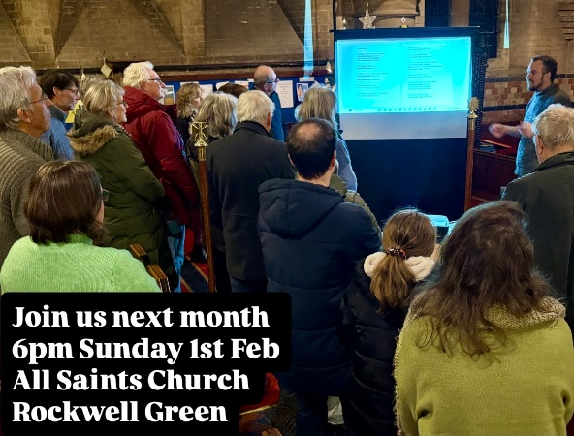
Shanty Group
Ian Hollingsworth has sent the following message re this group.
I would like to say 'thank you' on behalf of Kitty and myself for the lovely warm church last night. The first Shanty Group session was a huge success with more than 20 folks present and a terrific atmosphere of enjoyment and togetherness. It was a joy to be there, made even better because it was warm and welcoming.

OUR NEXT SERVICE
This will be a Sung Eucharist starting at 10.30 a.m. on Sunday 18th February 2026. The celebrant will be Rev David Burton. Coffee and chat will be provided after the service.

FORTHCOMING EVENTS
Have you got any good ideas for any fund-raising events? The committee would love to know what sort of events you would like to see being organised.

OTHER INFORMATION
From Rev Andrew Norris
The “Home Service” is a weekly programme which is broadcast on 105.3 FM on Wednesdays at 11.00am and repeated Sunday at 10.00 am. It is also available via the internet at any time on www.10radio.org This week sees the celebration of the wise men's journey and visit to the Christ child reflected in the theme of Epiphany. Canon Stephen Bowen leads our act of worship focussing on this.


FUN CORNER
The timing of this one is bit later in the year than the poem implied!

SUNDAY SEES THE START OF THE NEW SERVICE ROTA. THE SERVICE TIME IS 10.30 A.M.

