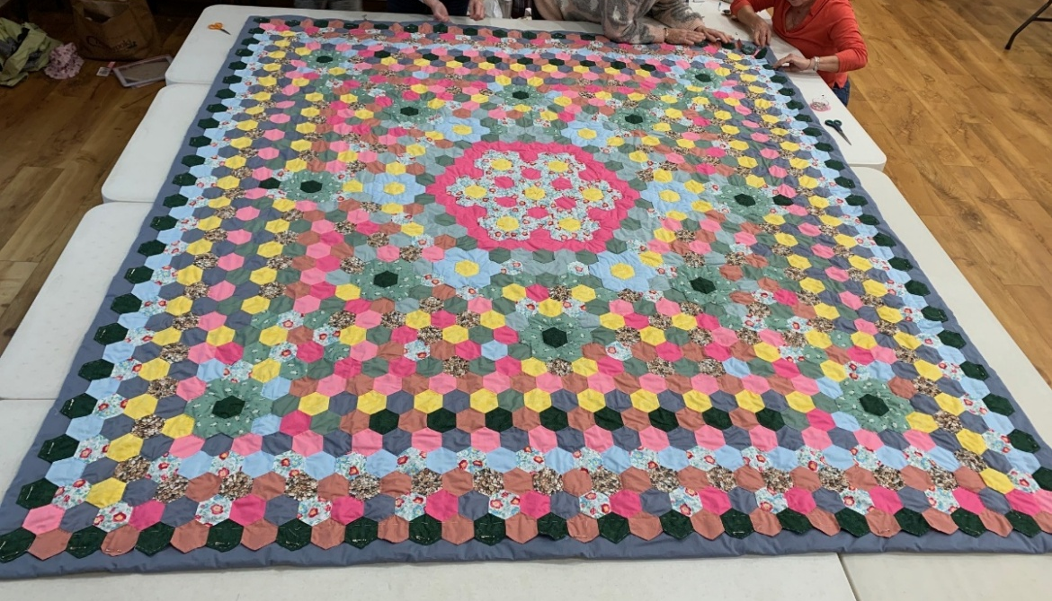
Nettlestead Community Quilt
RAFFLE
Hand sewn King sized Quilt made by ladies from Nettlestead, Somersham, Offton, Willisham, Barking and Battisford taking 1,572 hours over 18 months will be raffled on 28 March 2026 to raise funds for Nettlestead Church fabric fund.
You can purchase raffle tickets
£2 a ticket or £10 for a book of 5 tickets from:
Somersham Community Shop, IP8 4PF
The Duke of Marlborough pub, Somersham IP8 4QA
The Limeburners pub, Offton, IP8 4SF

Don’t miss your chance to win this wonderful heirloom!
For more information email: p.m.shephard@icloud.com

