Sunday 11th January 2026 Baptism of Christ

Collect: Eternal Father, who at the baptism of Jesus revealed him to be your Son, anointing him with the Holy Spirit: grant to us, who are born again by water and the Spirit, that we may be faithful to our calling as your adopted children; through Jesus Christ your Son our Lord, who is alive and reigns with you, in the unity of the Holy Spirit, one God, now and for ever.

Isaiah 42.1–9
Thus says the LORD:
¹ Here is my servant, whom I uphold, my chosen, in whom my soul delights; I have put my spirit upon him; he will bring forth justice to the nations. ² He will not cry or lift up his voice, or make it heard in the street; ³ a bruised reed he will not break, and a dimly burning wick he will not quench; he will faithfully bring forth justice. ⁴ He will not grow faint or be crushed until he has established justice in the earth; and the coastlands wait for his teaching.⁵ Thus says God, the LORD, who created the heavens and stretched them out, who spread out the earth and what comes from it, who gives breath to the people upon it and spirit to those who walk in it: ⁶ I am the LORD, I have called you in righteousness, I have taken you by the hand and kept you; I have given you as a covenant to the people, a light to the nations, ⁷ to open the eyes that are blind, to bring out the prisoners from the dungeon, from the prison those who sit in darkness. ⁸ I am the LORD, that is my name; my glory I give to no other, nor my praise to idols. ⁹ See, the former things have come to pass, and new things I now declare; before they spring forth, I tell you of them.

Psalm 29
R The Lord shall give his people the blessing of peace.
¹ Ascribe to the Lord, you gods,
ascribe to the Lord glory and strength.
² Ascribe to the Lord the glory due to his name;
worship the Lord in the beauty of holiness. R
³ The voice of the Lord is upon the waters; the God of glory thunders; the Lord is upon the mighty waters.
⁴ The voice of the Lord is a powerful voice;
the voice of the Lord is a voice of splendour. R
⁵ The voice of the Lord breaks the cedar trees;
the Lord breaks the cedars of Lebanon;
⁶ He makes Lebanon skip like a calf,
and Mount Hermon like a young wild ox. R
⁷ The voice of the Lord splits the flames of fire;
the voice of the Lord shakes the wilderness;
the Lord shakes the wilderness of Kadesh.
⁸ The voice of the Lord makes the oak trees writhe
and strips the forests bare.
⁹ And in the temple of the Lord all are crying, ‘Glory!’ R
¹⁰ The Lord sits enthroned above the flood;
the Lord sits enthroned as king for evermore.
¹¹ The Lord shall give strength to his people; the Lord shall give his people the blessing of peace. R

Acts 10.34–43
³⁴ Peter began to speak to those assembled in the house of Cornelius. ‘I truly understand that God shows no partiality, ³⁵ but in every nation anyone who fears him and does what is right is acceptable to him. ³⁶ You know the message he sent to the people of Israel, preaching peace by Jesus Christ – he is Lord of all. ³⁷ That message spread throughout Judea, beginning in Galilee after the baptism that John announced: ³⁸ how God anointed Jesus of Nazareth with the Holy Spirit and with power; how he went about doing good and healing all who were oppressed by the devil, for God was with him. ³⁹ We are witnesses to all that he did both in Judea and in Jerusalem. They put him to death by hanging him on a tree; ⁴⁰ but God raised him on the third day and allowed him to appear, ⁴¹ not to all the people but to us who were chosen by God as witnesses, and who ate and drank with him after he rose from the dead. ⁴² He commanded us to preach to the people and to testify that he is the one ordained by God as judge of the living and the dead. ⁴³ All the prophets testify about him that everyone who believes in him receives forgiveness of sins through his name.’

Matthew 3.13–17
¹³ Jesus came from Galilee to John at the Jordan, to be baptized by him. ¹⁴ John would have prevented him, saying, I need to be baptized by you, and do you come to me?’ ¹⁵ But Jesus answered him, ‘Let it be so now; for it is proper for us in this way to fulfil all righteousness.’ Then he consented. ¹⁶ And when Jesus had been baptized, just as he came up from the water, suddenly the heavens were opened to him and he saw the Spirit of God descending like a dove and alighting on him. ¹⁷ And a voice from heaven said, ‘This is my Son, the Beloved, with whom I am well pleased.’

Post Communion Prayer: Lord of all time and eternity,
you opened the heavens and revealed yourself as Father in the baptism of Jesus your beloved Son: by the power of your Spirit complete the heavenly work of our rebirth through the waters of the new creation;
through Jesus Christ our Lord.


THE HAVEN BENEFICE OF SEAVIEW, ST HELEN’S, BRADING And YAVERLAND
Providing a Spiritual Harbour for ALL

Sunday 11th January
09.30 Sung Eucharist St Mary’s
09.30 Sung Eucharist, St Helen’s
11.00 Sung Eucharist, St John’s

Wednesday 14th January
10.00 Morning Worship, St Mary’s
11.00 Prayer Circle, St Peter’s

Sunday 18th January 2026
08.00 Said Eucharist (BCP), St John’s
09.30 Sung Eucharist, St Mary’s
10.00 Sung Eucharist, St Peter’s

Tuesday 20th January
10.00 Morning Worship, St Catherine’s

Wednesday 21st January
10.00 Morning Worship, St Mary’s
11.00 Prayer Circle, St Peter’s

Sunday 25th January
09.30 Sung Eucharist, St Mary’s ?
09.30 Sung Eucharist, St Helen’s
11.00 Sung Eucharist St John’s
15.30 Eco Church, St Helen’s

Wednesday 28th January
10.00 Morning Worship, St Mary’s
11.00 Prayer Circle, St Peter’s

Sunday 1st February
08.00 Said Eucharist (BCP), St John’s
09.30 Sung Eucharist, St Mary’s
10.00 Sung Eucharist, St Peter’s
18.00 Service of the Word, St Catherine’s

Haven Benefice Church contacts:
Priest-in-Charge (Day off: Tuesday)
St Peter’s Seaview and Safeguarding
Revd Karen Wilson on 07591240640
Email: revdkarenwilson@outlook.com
St Helen’s and St Catherine's, St Helens –
Sue Whitewick on 01983 568761
St Mary’s Brading –
Nigel Elton-Walters on 01983 406817
Safeguarding - Catherine Davis on 07940826034
St John’s Yaverland –
Kevin Norton on 07951407423
Curate at Haven Benefice
Revd Bevaly Rackett – 01983 407432
Email: revbevrackett@gmail.com

To add items to this news sheet please contact Rev Bevaly

You are warmly invited to Eco Church at 3.30pm on Sunday 25th January at St Helen's Church. After a short informal service, we shall be will be checking and cleaning the bird boxes (weather permitting) and discussing future plans. As usual, we shall finish with a shared supper.

You are welcome to join us for a Burns Lunch on Sunday 25th January, at 12.30pm in St Peter’s Church Hall. Tickets are £15, to book please email Suki.turner@icloud.com. (and do please let us know if you require Vegetarian Haggis). The ticket includes lunch and entertainment

A wonderful group of volunteers meets every Thursday morning to do some light work in St Helen's churchyard – mainly raking grass previously cut by our groundsman Dan; coppicing; and general clearing and tidying. As well as valuing the opportunity to be in the open air and get some gentle exercise, we also enjoy each other’s company, especially over coffee and biscuits in the church at half-time! You are very welcome to join us, and we would especially value having more people helping to organise the refreshments. Please contact Andrew for more info – andrewbradstock@gmail.com / 07503 200630.

Brading Bell Fund 8 Bell Club, tickets are available now for the chance to win a cash prize every month for the coming year. Just £12 per ticket per year from Margaret Downer or contact her at barry.downer@hotmail.com for more payment details. (Please note they have changed banks so contact Margaret for the correct details)

The first Jumble Sale of the year at St Mary’s Church, Brading is on Saturday 7th February in the church hall. Jumble can be dropped off from 11am and there will be refreshments available.

Website: www.havenchurches.org.uk
Or find us on achurchnearyou.com
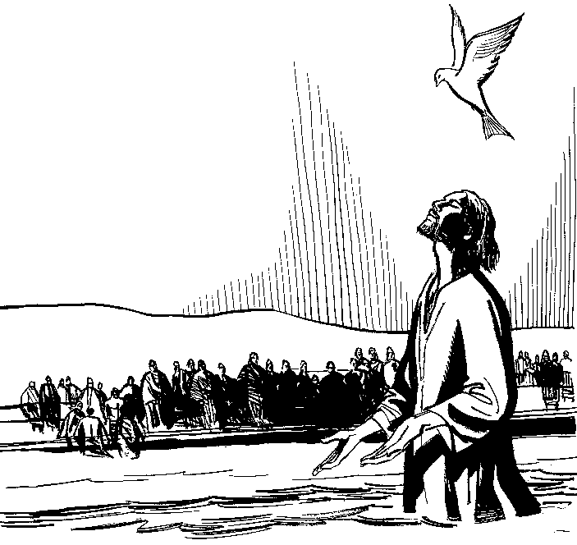
Or follow us on Facebook: Haven Churches IOW

