Psalm 67
Please stand, if able, and join in the verses in bold

May God be gracious to us and bless us
and make his face to shine upon us,
that your way may be known upon earth,
your saving power among all nations.
Let the peoples praise you, O God;
let all the peoples praise you.

Let the nations be glad and sing for joy,
for you judge the peoples with equity
and guide the nations upon earth.
Let the peoples praise you, O God;
let all the peoples praise you.

The earth has yielded its increase;
God, our God, has blessed us.
May God continue to bless us;
let all the ends of the earth revere him.

Glory be to the Father and to the Son and to the Holy Spirit,
as it was in the beginning, is now and ever shall be,
world without end. Amen
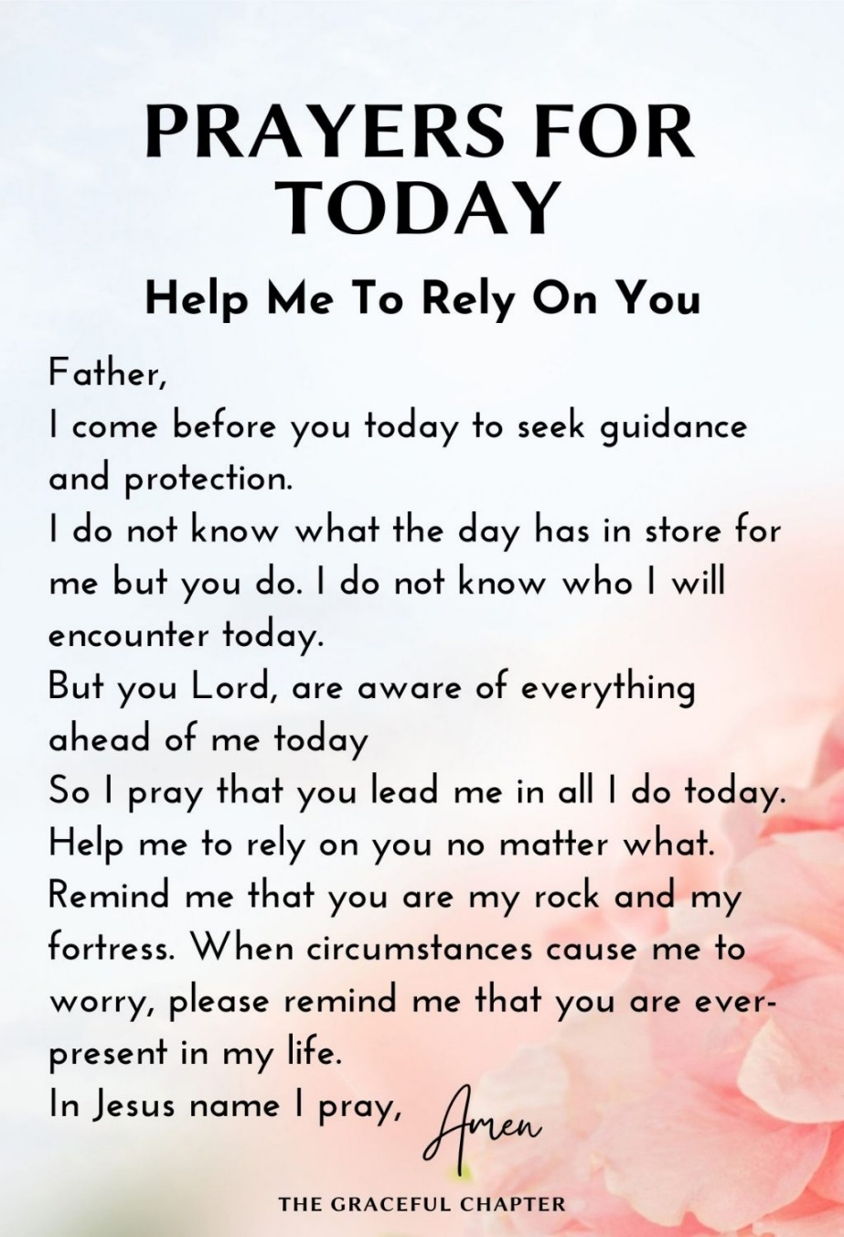
Mothers’ Union
The first meeting of the MU for 2026 is at 2pm on Wednesday 4th February in church, there is a short AGM, followed by singing of favourite hymns – all welcome.

In our weekly prayers for our parish
This week we pray for God’s blessing on Eaton Avenue, Elka Rise & Eliot Drive.
Distribution of Communion –currently the Priest will dip the communion wafer in the wine while we discern a safe way to bring the common cup back into worship, as we want everyone to feel included and safe. We also have gluten free wafers available.
Would you like to go to the Panto? Oh yes you would! Then please contact Julie Jones (the Reader) on 07528021021 as she has tickets at just £5 each for Mother Goose at Horsely Woodhouse by Stargazers at 3pm on Saturday 21st February. Lift might be possible too.
Refreshments After the Morning Service
Please stay seated after the service and a hot drink will be brought to you in the pews. Do not get up and head to the back of church, it is becoming a hazard, and a risk as trays of hot drinks could be knocked over.

All Saints Church
Church contact information
Contact: Rev’d Christine - revchristine@outlook.com
The Rectory, The Village, West Hallam, DE7 6GR
Landline 0115 646 1497
Rev’d Ailsa -revailsahunt@gmail.com
Tel - 07356064856

Churchwardens – Mrs Janet Wheeldon, -Tel: 0115 8771593
Mrs Linda Gregory – linda.gregory3@icloud.com
https://www.achurchnearyou.com/church/13402/
https://www.facebook.com/allsaintskirkhallam
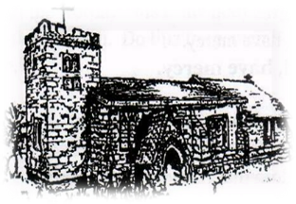
Kirk Hallam
Disabled Toilet in Friendship House.
Disabled Toilet in Friendship House.

Working with God to transform lives & communities.
Please can you ensure your mobile is on silence, or off during the service, it is affecting people with hearing aids and the loop system.
25th January – Third Sunday of Epiphany
10.00am CW Communion Service with Rev’d Christine
4.00pm BCP Evening Prayer with Rev’d Christine & Eileen

Forthcoming Events
Tues 27th 2.30pm Funeral of Ron Lewis in church
Tues 27th 6.00pm Home Group in Friendship House
Weds 28th 9.30am Morning Prayer at UCAS
Thurs 29th 7.00pm PCC Meeting in Church
Fri 30th 6.00pm Choir Practise in Friendship House
Sat 31st 10.00am Prayer Meeting in Friendship Huse
Weds 4th 2.00pm Mothers’ Union meeting in church

1st February – Fourth Sunday of Epiphany
10.00am CW Communion Service with Rev’d Christine
4.00pm BCP Evening Prayer with Rev’d Ailsa & Eileen
Our 4pm services are now in Friendship House until 15th February.
It’s Good to Talk! If you spot that someone is missing, please pop a news sheet through their door, & if you’ve time, call for a chat - just to check they’re OK & to let them know that they are not forgotten!
“Let us think of ways to motivate one another to acts of love and good works” Hebrews 10:24

