Mothers’ Union
The first meeting of the MU for 2026 is at 2pm on Wednesday 4th February in church, there is a short AGM, followed by singing of favourite hymns – all welcome.
Psalm 24: 1 to 10
Please stand, if able, and join in the verses in bold

The earth is the Lord’s and all that is in it,
the world, and those who live in it;
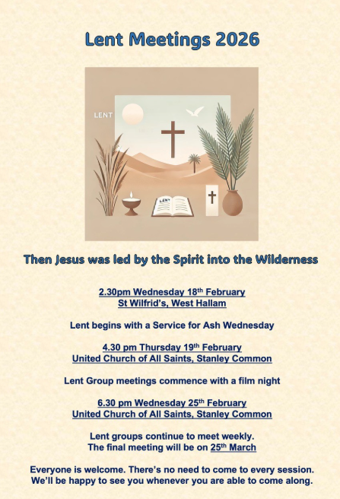
for he has founded it on the seas,
and established it on the rivers.

Who shall ascend the hill of the Lord?
And who shall stand in his holy place?
Those who have clean hands and pure hearts,
who do not lift up their souls to what is false,
and do not swear deceitfully.
They will receive blessing from the Lord,
and vindication from the God of their salvation.
Such is the company of those who seek him,
who seek the face of the God of Jacob.

Lift up your heads, O gates and be lifted up, O ancient doors!
that the King of glory may come in.
Who is the King of glory?
The Lord, strong and mighty, the Lord, mighty in battle.
Lift up your heads, O gates and be lifted up, O ancient doors!
that the King of glory may come in.
Who is this King of glory?
The Lord of hosts, he is the King of glory.

Glory be to the Father and to the Son and to the Holy Spirit,
as it was in the beginning, is now and ever shall be,
world without end. Amen

In our weekly prayers for our parish
This week we pray for God’s blessing on Earlham Close, Festival Road & Friars Court.
Distribution of Communion –currently the Priest will dip the communion wafer in the wine while we discern a safe way to bring the common cup back into worship, as we want everyone to feel included and safe. We also have gluten free wafers available.
Would you like to go to the Panto? Oh yes you would! Then please contact Julie Jones (the Reader) on 07528021021 as she has tickets at just £5 each for Mother Goose at Horsely Woodhouse by Stargazers at 3pm on Saturday 21st February. Lift might be possible too.
Refreshments After the Morning Service
Please stay seated after the service and a hot drink will be brought to you in the pews. Do not get up and head to the back of church, it is becoming a hazard, and a risk as trays of hot drinks could be knocked over.

All Saints Church
Church contact information
Contact: Rev’d Christine - revchristine@outlook.com
The Rectory, The Village, West Hallam, DE7 6GR
Landline 0115 646 1497
Rev’d Ailsa -revailsahunt@gmail.com
Tel - 07356064856

Churchwardens – Mrs Janet Wheeldon, -Tel: 0115 8771593
Mrs Linda Gregory – linda.gregory3@icloud.com
https://www.achurchnearyou.com/church/13402/
https://www.facebook.com/allsaintskirkhallam
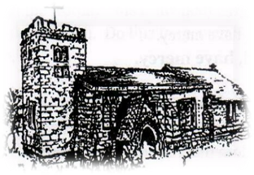
Kirk Hallam
Disabled Toilet in Friendship House.
Disabled Toilet in Friendship House.

Working with God to transform lives & communities.
Please can you ensure your mobile is on silence, or off during the service, it is affecting people with hearing aids and the loop system.
1st February – Candlemas &
Presentation of Christ in the Temple
10.00am CW Communion Service with Rev’d Christine
4.00pm BCP Evening Prayer with Rev’d Ailsa & Eileen

Forthcoming Events
Tues 3rd 10.00am Interring ashes of John Sulley
Tues 3rd 6.00pm Home Group in Friendship House
Weds 4th 9.30am Morning Prayer at UCAS
Weds 4th 2.00pm Mothers’ Union meeting in church
Fri 6th 6.00pm Choir Practise in Friendship House
Sat 7th 10.00am Prayer Meeting in Friendship Huse

8th February – Second Sunday Before Lent
10.00am Iona Communion Service with Rev’d Christine & Julie
4.00pm Iona Evening Prayer with Rev’d Christine
Our 4pm services are now in Friendship House until 15th February.
It’s Good to Talk! If you spot that someone is missing, please pop a news sheet through their door, & if you’ve time, call for a chat - just to check they’re OK & to let them know that they are not forgotten!
“Forget the former things, do not dwell on the past. See, I am doing a new thing!’ Isaiah 43;18-19a

