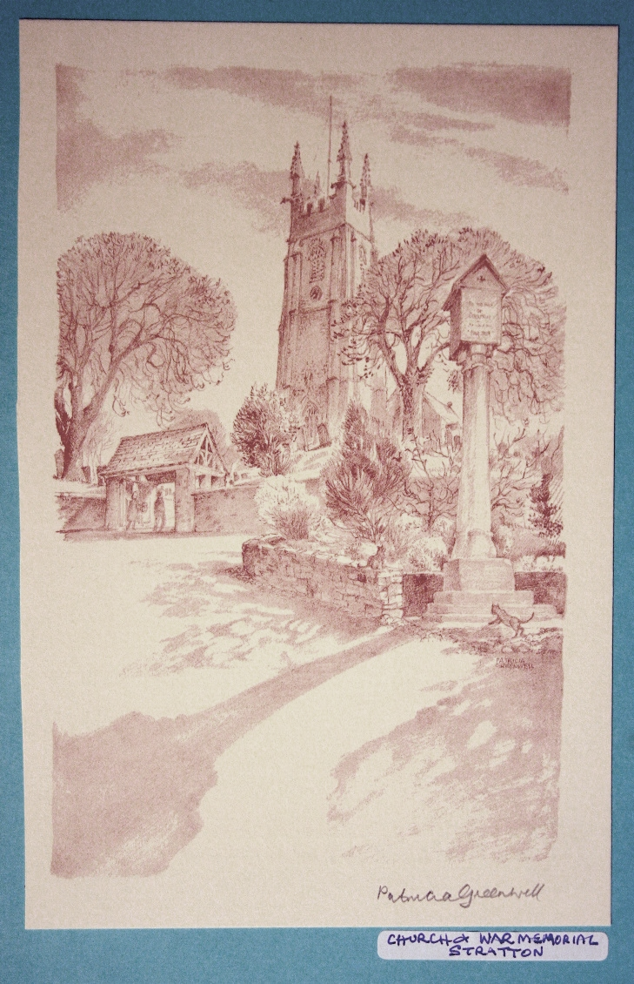
The Parish Church
of St Andrew, Stratton

Priest in Charge
The Revd Teresa Folland
Tel: 01288 352599
e-mail: teresa.folland@gmail.com
Churchwarden
Mrs Diana Ohlson
Tel: 01288 354441
e-mail: dohlson24@gmail.com

JANUARY and FEBRUARY 2026

A Prayer for Peace
Let there be love and understanding among us.
Let peace and friendship be our shelter from life’s storms. Eternal God, help us to walk with good companions, to live with hope in our hearts and eternity in our thoughts, that we may lie down in peace and rise to find our hearts waiting to do your will. Amen


The Church family at St Andrew’s would like to take this opportunity to wish you all a
happy, blessed, peaceful and healthy New Year 2026.

*****************************************
60 Years Ago on February 5th 1966
On the first Sunday of the month at St Andrew’s Church, the morning service of Sung Eucharist is held as a family service. Children attend with their parents for Sunday School. Sunday morning was unique when for the first time on record a father and son acted as servers at the same service and congratulations are offered to Mr Gerald Davey and his son Andrew who carried out these duties.
Taken from the Cornwall Weekly News and submitted by Miss Geraldine Davey.
Dates for your diary

Jan 1st New Years Day Lunch at 12 noon, hot meal with wine provided and a quiz, please bring some pudding to share. Book your place with Judy.
Jan 15th Pastoral Meeting at 6 Old Drovers Way 10am
Jan 24th Supper Party for Burns Night 7pm at Crossways, New Rd. Ticket £20
Feb 12th FoStA Committee Meeting 3pm at Stamford House
Mar 5th Old Cornwall Society St Piran’s Day celebration at St Werburgh’s Parish Church, Warbstow PL15 8UP at 3pm. All welcome
Services at St Andrew’s January 2026
4th Jan 2nd Sunday of Christmas Epiphany
Readings: Isaiah 60-1-6; Psalm 72:[1-9] 10-15; Ephesians 3:1-12; Matt 2:1-12.
Morning Worship 9.30am – LWLs
Evensong 4pm with Val Hopper
Cantor: Dafydd Thomas
Psalm:135:1-14
Readings: Isaiah 41:21- 42:4 and Colossians 1:1-14 Reader: Andrew Davey
7th Jan Christian Meditation 9.30am
Midweek Mass Wed. 10.30am – Officiant: Rev Teresa
11th Jan The Baptism of Christ 1st Sunday of Epiphany
Readings: Isaiah 42:1-9; Psalm 29; Acts 10:34-43, Matthew 3:13-end.
Parish Mass 9.30am – Officiant: Rev Jane Bradbury
14th Jan Christian Meditation 9.30am
Midweek Mass Wed. 10.30am – Officiant: Rev Doug Adams
18th Jan 2nd Sunday of Epiphany Week of Prayer for Christian Unity 18-25th Jan
Readings: Isaiah 49:1-7; Psalm 40:1-12; 1 Corinthians 1:1-9; John 1:29-42.
Morning Worship 9.30am – Officiant: LWLs
21st Jan Christian Meditation 9.30am
Midweek Mass Wed. 10.30am – Officiant: Rev Jane Bradbury
25th Jan 3rd Sunday of Epiphany
Readings: Isaiah 9:1-4; Psalm 27:1, 4-12; 1 Cor 1:10-18; Matthew 4:12-23.
Parish Mass 9.30am – Officiant: Rev Teresa Folland
28th Jan Christian Meditation 9.30am
Midweek Mass Wed. 10.30am – Officiant: Rev Richard WS

Services at St Andrew’s February 2026
1st Feb The Presentation of Christ in the Temple (Candlemass)
Readings: Malachi 3:1-5; Ps 24:[1-6] 7-end; Hebrews 2:14-end; Luke 2:22-40.
Morning Worship 9.30am - LWLs
Evensong 4pm – Officiant: Sheila Waring
Cantor: David Goodwin
Psalm: 118
Readings: 1 Samuel 1:19b – end Hebrews 4:11-end Reader: Val Hopper
4th Feb Christian Meditation 9.30am
Midweek Mass Wed. 10.30am – Officiant: Rev Teresa Folland
8th Feb 2nd Sunday before Lent
Readings: Genesis 1:1 – 2:3; Ps 136; Romans 8:18-25; Matthew 6:25-end.
Parish Mass 9.30am – Officiant: Rev Teresa Folland
11th Feb Christian Meditation 9.30am
Midweek Mass Wed 10.30am – Officiant: Rev Doug Adams
15th Feb Sunday before Lent
Readings: Exodus 24:12-end; Ps 2 or 99; 2 Peter 1:16-end; Matthew 17:1-9.
Morning Worship 9.30am - LWLs 18th Feb ASH WEDNESDAY
Christian Meditation 9.30am
Midweek Mass Wed 10.30am – Officiant: Rev Jane Bradbury
22nd Feb 1st Sunday of Lent
Readings: Genesis 2:15-17, 3:1-7; Ps 32; Romans 5:12-19; Matthew 4:1-11.
Parish Mass 9.30am – Officiant: Rev Jeffery Terry
25th Feb Christian Meditation 9.30am
Midweek Mass Wed. 10.30am – Officiant: Rev Doug Adams


FROM THE PARISH REGISTERS 2025/26

Burial of Ashes
Ann Morgan 20th November 11am
Funerals
THANKGIVING SERVICE for the Life of
Jean Allin on 14th November 2025 at 3pm
SERVICE to CELEBRATE the LIFE of Beryl Jones 18th November 2025 at 11am
IN LOVING MEMORY and in CELEBRATION for the LIFE of Yvonne Bishop on 3rd December 2025 at 3pm at North Devon Crematorium

Events in Jan and Feb at St Andrews

New Years Day Lunch –
Once again we are holding a celebratory lunch on Jan 1st at 12pm. There will be decorations, wine and a choice of 4 hot meals to choose from. We invite our guests to bring along items to share for the pudding course – trifle, mince pies, cheese and biscuits, sweets – whatever is left over from Christmas!! If you know someone who would be on their own or missing family and friends on this day, do please bring them along with you for some festive cheer and a tasty start to the year. The cost is £8 per person and it would be helpful to know numbers to cater for, so please book seats with Judy on 01288 359108

Candlemas Evening Meal –
Instead of a hot lunch at the end of Jan we are holding a candlelit evening meal at 6pm on Friday 30th Jan. Last year we really enjoyed eating by candlelight in our beautiful church setting and I hope you will join us again this time. The cost is £8 per person for a two-course meal and we invite you to bring your own wine. Non-alcoholic drinks will be available. Please book on 01288 359108

Lent Lunches -
Easter is early in 2026, so Lent begins in February. This means there will be no hot lunch that month, but Lent Lunches will be held on Feb 20 and 27, and March 6 at St Andrews Church at 12pm. The following three weeks will be held at St Swithins. Any donations given for these lunches will be sent to a charity.
The Children’s Society –
Very many thanks to all who have donated towards the work of this important society. So far the total collected this year is approximately £330. If you still have a box to be emptied, or would like a box for next year, please contact Judy on 01288 359108.

Supporting St Andrews Church –
At our gift day last year 20 people took home a donations box to help pay for our ever-increasing running costs as we are not allowed to use grants or bequests to pay for utility bills for heating etc. We are very grateful that the total given in the boxes this year was in excess of £300. The cost to keep St Andrew’s church going is now over £51,000 per year so if you know of a neighbour or friend who would be happy to take a box and feel this would be an easy way to help keep our church open and accessible to others, do please ask Judy on 01288 359108 for a donations box for this coming year. Small change is not always to hand these days, but a regular 50p or £1 coin in the box soon adds up!!! Judy Dunne

St Andrew’s Gift Day & Craft Fayre 2025
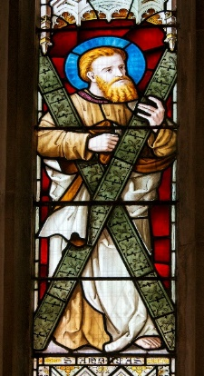
A very big ‘Thank You’ to everyone who helped to make Gift Day and the Craft Fayre such a big success on Saturday November 29th. The church was filled with stalls of a variety of wonderful handmade crafts that attracted a steady flow of customers throughout the day. A special thanks to Kim Gouldson for co-ordinating the stalls. It was a very successful day raising over £1,887 towards the church funds.

THANK YOU Thank You to all those who volunteer at St Andrew’s during the year. Without the many people that work tirelessly within the church and around the church yard, St. Andrew’s would not be the welcoming and beautiful church that it is. So, a huge vote of thanks to; Diana our Churchwarden and the members of the PCC, Andrew who faithfully serves at the altar each Sunday, Dafydd our organist, the Bellringers, flower arrangers, members of the social and fundraising committee for their imaginative ideas, members of the fabric Committee for their commitment to the maintenance of the building and for the support shown by the members of FoStA spread far and wide. This year we would like to say a special thank you to all those who have taken on the upkeep of parts of the churchyard, many are members of the Stratton community who give their time helping with the creation of an environmentally friendly space that all can enjoy. There will be many other individual people who quietly go about doing all the little but unseen jobs that are vital to the life of our church who we also thank.
Flowers in Church
A big thank you to all who throughout the year have added to the beauty of our church building and worship with lovely vases of flowers. They have been wonderful reminders of the beauty of God’s creation and the wonders of the natural world around us. We miss them in Advent and Lent when there aren’t any flowers in church.
If you feel able to help and be part of the rota you would be very welcome – you don’t have to be a florist to help out so,
if this is something you feel able to do, please speak to Sheila Waring.
Bude Food Bank
Please remember that we have a collection point in the church for items for the Food Bank. When the container has been filled, the contents are taken to Bude. Please be as generous as you can as there is a great deal of need in the area.
Used Stamps
We are still collecting used postage stamps to support MND (Motor Neurone Disease) Thank you to all who have saved their stamps. There is a box at the back of the church for your donations.
Mothers’ Union
December was a busy month for the MU. The 16 Days of Activism continued until 10th December and we had a Red Chair in each of the churches of the benefice. The chair is a stark symbol to raise awareness of all the women who have lost their lives at the hand of a partner or close family member; globally one in three women die due to gender-based violence.
At the beginning of the month branch members and friends gathered at St. Andrew’s church to share in an Advent Carol service. We listened to readings and reflections to help us prepare to welcome the Baby Jesus on Christmas day.
This month sees the beginning of a year of celebration for MU. The MU was founded by Mary Sumner 150 years ago, and from a small meeting of women in Winchester the organisation has grown into a worldwide membership of over 4 million women and men. There will be events in the diocese, nationally and globally throughout the year.
On behalf of all our branch members I would like to wish you all a peaceful New Year.
Next meeting January 5th 2pm at Stamford House, Stamford Hill EX23 9YE.
It will still be the Christmas Season in church so there will be festive carols with refreshments.
Sheila Waring.
Christmas Tree Festival A huge thank you to everyone who took part in the festival. Full report in the next News Sheet
East Window Restoration Update
Holy Well Glass continue work on our East Window and they have said that if anyone would like to visit their workshop in Wells to view the ongoing restoration, they would be very welcome. Please phone in advance. We are looking forward to the return of the window early this year. Further information to follow when available.
Contributions to the restoration would still be gratefully received.
100 Club renewed – bigger & better monthly draw! Open to all.
We are pleased to let everyone know that the 100 Club for raising funds for St Andrew’s is relaunched. Although there is a slight increase in monthly membership cost of 66p per month, the prizes are bigger and there are super draws at Easter and Christmas. Everyone, including current members, needs to complete a new application form to be in the new 100 Club so that we have up to date contact details to deliver cash winnings. To be included all applications need to be returned by 1st January 2026. If you pay by standing order please make sure your payment is updated to £5 per month and that you give the reference ‘100 Club’ so that the treasurer can more easily check your membership. All the information about the relaunched 100 club is on the application form, together with all the rules. To be in with a chance of winning you need to make sure your payments are up to date. Winners will be posted in the church porch and on the Facebook page. Application forms aare available in church together with a box for completed forms. Good luck and thank you for your support. Any queries you can reach us on colesddj@gmail.com or 01288 359601 David and Jennie Coles
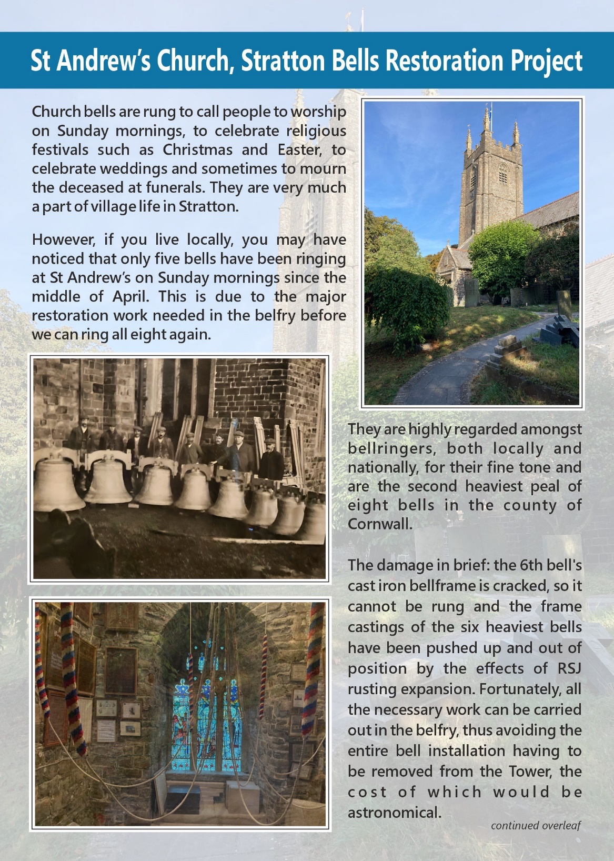
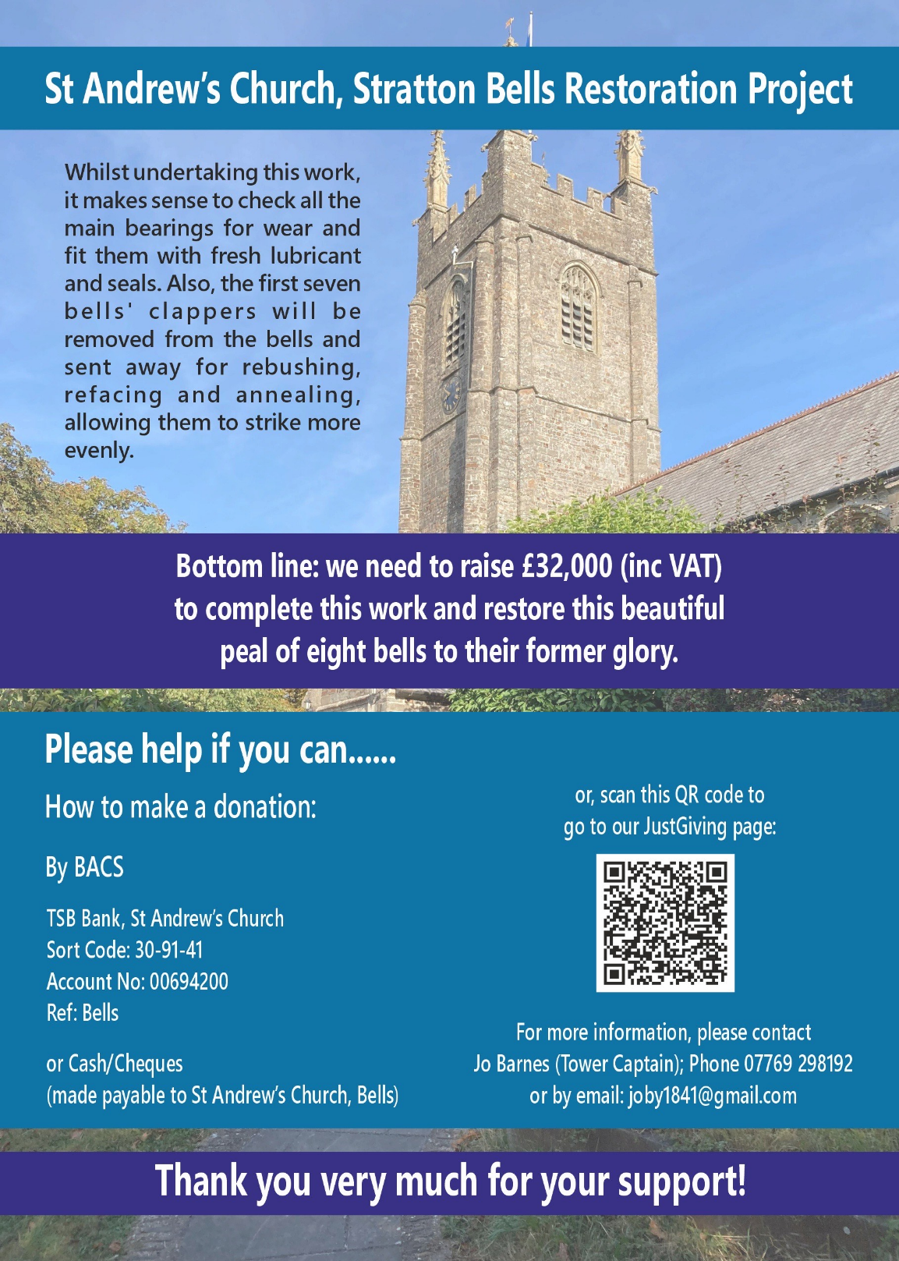
In the month of January we remember in our prayers all those living in: Sunday 4th Spicers Lane, Huntfield Close, Treworden Close, Gibraltar Sq Church Square Sunday 11th Corner Gardens, Fore St., Old Post Office Hill Sunday 18th Holsworthy Rd., Howells Rd., The Leat Sunday 25th Howard Lane, Parc Fer Cl., Barnfield Park, Bridge Street, Union Hill and Bowden
In the month of February we remember in our prayers all those living in:
Sunday 1st Poundfield Lane, Hospital Rd, Ward Close
Sunday 8th St Martin’s Road, St Peter’s Road, Gladwell Gardens and the
Binhamy Estate Sunday 15th St Andrew’s Road, St Michael’s Road, St Olaf’s Road
Woodley Close
Sunday 22nd New Rd, Pathfields, Stamford Hill, Poundfield, Poundfield Cl.

Those who have asked for our prayers:
Allan Gouldson, Lyzette Bevan, Bella, Karen Hunting, Baby Henry. We pray too for those of our Church Family who are ill at home or housebound.
We remember in our prayers those preparing for the sacraments of the church.
The recently departed:
May they rest in peace and rise in glory.

Those in our Year’s Mind in January the week beginning:
Sunday 4th John Beswick, Vera Davis, John Gibbins, Lillian Brown, Raymond Badcock, Mary Slater, Philip Collins, Christine Dunne,
Sunday 11th Simon White, William Carter, Audrey Jolley,
Steven Buckingham, Dennis Gardener, George Hynes.
Sunday 18th Phyllis Brooks, James Jolley, Lydia Stonelake, Denis McCabe, Celia Martin, Richard Johns, Frank Walker, Arthur Dodgson, Richard Cruikshank, Harry Langdon, Louisa Cobbledick, Francis Abbott.
Sunday 25th Mamie Yeo, Gertrude Garland, John Sweet, Arthur Mitchell, Dorothy Phillips, Samuel Fry, Harold Hockin, Gladys Clark, Marjorie Sandercock, Stella Clarke.

Those in our Year’s Mind in February the week beginning:
Sunday 1st Cyril Burley, Brian Barlow, Alfred Snowden, Hannah Boynton,
Megan White, Ivy Gardener, Doris Walker, Robert Whiteman.
Sunday 8th Christine Snowden, Pamela Gibbins. Kenneth Thomas, Angela Carpenter, Ruth Raper, Charlie Bailey, Mary Green, Hilary Pitt, Philip Etheridge, Doris Bailey, Monica Clifton, Julia Mitchell.
Sunday 15th Florence Saywell, John Thorne, Lilian Carswell, Beryl Moriarty,
Alison Fisher, Edna Hatfield, Jack Clark. Lean Bee Fish.
Sunday 22nd Lean Bee Fish, Peter Barker, Roger Axford, Barbara Johnston, Vivienne Salkield, Joyce Nunn.

All those in our own special remembrance.

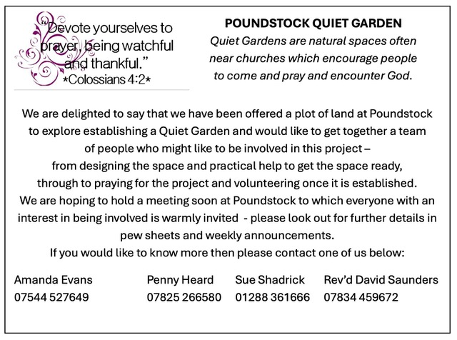

For your information -
A review of the 2 monthly production of the Parish News Sheet has taken place and after some thought and discussion the editors have made the decision to go back to publishing monthly. It seems that this will suit everyone concerned and will therefore commence in March 2026.
News Sheet Editors: Val Barker Tel: 353435 and Sheila Waring Tel: 321813

