Psalm 29
Please stand, if able, and join in the verses in bold

Ascribe to the Lord, O heavenly beings,
ascribe to the Lord glory and strength.
Ascribe to the Lord the glory of his name;
worship the Lord in holy splendour.

The voice of the Lord is over the waters;
the God of glory thunders, the Lord, over mighty waters.
The voice of the Lord is powerful;
the voice of the Lord is full of majesty.

The voice of the Lord breaks the cedars;
the Lord breaks the cedars of Lebanon.
He makes Lebanon skip like a calf,
and Sirion like a young wild ox.

The voice of the Lord flashes forth flames of fire.
The voice of the Lord shakes the wilderness;
the Lord shakes the wilderness of Kadesh.

The voice of the Lord causes the oaks to whirl,
and strips the forest bare; and in his temple all say, ‘Glory!’

The Lord sits enthroned over the flood;
the Lord sits enthroned as king for ever.

May the Lord give strength to his people!
May the Lord bless his people with peace!

Glory be to the Father and to the Son and to the Holy Spirit,
as it was in the beginning, is now and ever shall be,
world without end. Amen
Our 4pm services are now in Friendship House
until Sunday 15th February.
Fr Julius and Mrs Esther Anozie

Thank you to everyone who came along for the Wedding Breakfast for Fr Julius and Esther, it was a lovely occasion – and that’s just for us in Kirk Hallam, let alone everyone with the couple too! Here are a few photos… more to follow…

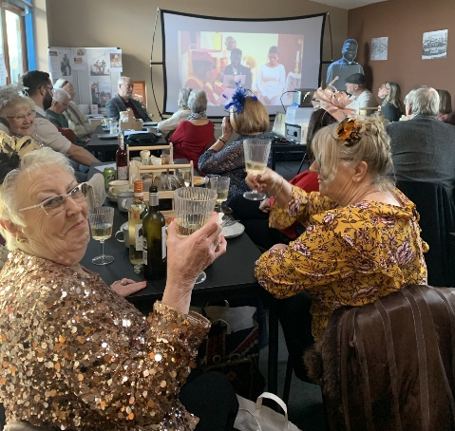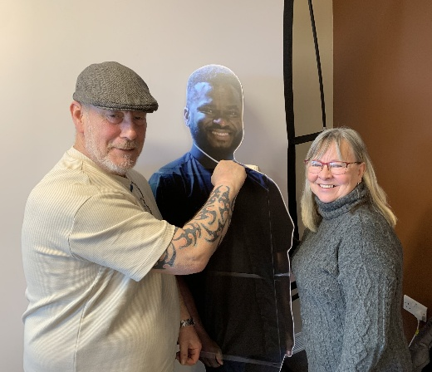

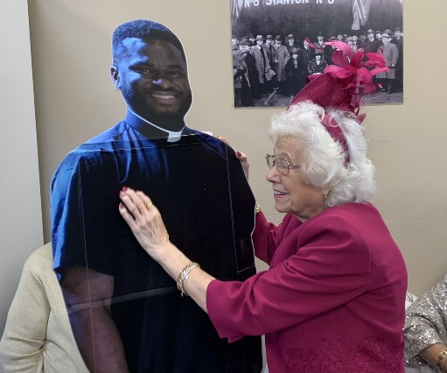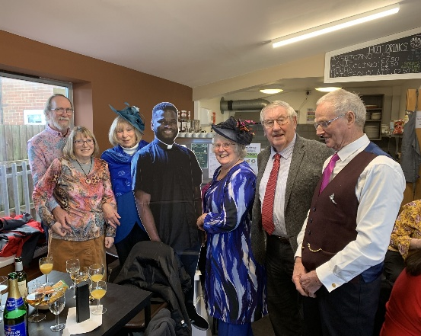
Distribution of Communion –currently the Priest will dip the communion wafer in the wine while we discern a safe way to bring the common cup back into worship, as we want everyone to feel included and safe. We also have gluten free wafers available.

In our weekly prayers for our parish
This week we pray for God’s blessing on Cherry Tree Close, Coniston Drive & Crosshill Drive.
Refreshments After the Morning Service
Please stay seated after the service and a hot drink will be brought to you in the pews. Do not get up and head to the back of church, it is becoming a hazard, and a risk as trays of hot drinks could be knocked over.

We are blessed to have energetic young people and less mobile more mature folk, using walking sticks, so please lets show care for each other and let drinks and biscuits etc be brought to you.

All Saints Church
Church contact information
Contact: Rev’d Christine - revchristine@outlook.com
The Rectory, The Village, West Hallam, DE7 6GR
Landline 0115 646 1497
Rev’d Ailsa -revailsahunt@gmail.com
Tel - 07356064856

Churchwardens – Mrs Janet Wheeldon, -Tel: 0115 8771593
Mrs Linda Gregory – linda.gregory3@icloud.com
https://www.achurchnearyou.com/church/13402/
https://www.facebook.com/allsaintskirkhallam
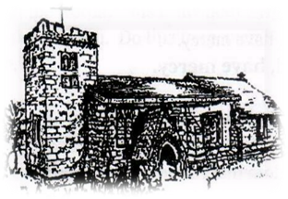
Kirk Hallam
Disabled Toilet in Friendship House.
Disabled Toilet in Friendship House.

Working with God to transform lives & communities.
Please can you ensure your mobile is on silence, or off during the service, it is affecting people with hearing aids and the loop system.
11th January – Baptism of Christ
10.00am Iona Communion Service with Rev’d Jan & Rev’d Alan
4.00pm Iona Evening Prayer in Friendship House with Rev’d Ailsa

Forthcoming Events
Tues 13th 11.00am Funeral of Lynda Hickman at
Markeaton Crematorium
Tues 13th 6.00pm Home Group in Friendship House
Weds 14th 10.00am PAT Testing in church
Fri 16th 6.00pm Choir Practise in Friendship House
Sat 17th 10.00am Prayer Meeting in Friendship Huse
Mon 19th 10.00am Funeral in church for Janet Ford

18th January – Second Sunday of Epiphany
10.00am CW Communion Service with Rev’d Christine
4.00pm BCP Communion Friendship House with Rev’d Christine
It’s Good to Talk! If you spot that someone is missing, please pop a news sheet through their door, & if you’ve time, call for a chat - just to check they’re OK & to let them know that they are not forgotten!
Romans 6:3-4: “Or don’t you know that all of us who were baptized into Christ Jesus were baptized into his death? We were therefore buried with him through baptism into death in order that, just as Christ was raised from the dead through the glory of the Father, we too may live a new life.”

