
ST. ANN’S, BELFIELD NEWS LETTER
WORSHIP

Church open
St Ann’s is open for public worship Sundays and Wednesdays at 10.30am

Streamed service
On-line via twitch.tv/revdgill and for 1 week after. Downloads on request.

Prayers for the sick
Ghislaine Glover, Cath Boon and Roger and Trevor

Prayers for home members
Bob (in Mona Cliffe Care Home), Dorothy (in Braeside)

Those who have died
Kathleen (Kath) Chadwick.
Kath’s funeral will be at St Ann’s, Monday 2nd Feb 12.15pm

The anniversary of the dearly departed Harold Fielden, Jean Cooke, Edith Fenton, Thomas Fletcher, Trevor Huntley, Marjorie Hilton and Canon David Finney.


Scan this with your phone to contribute to St Ann’s mission and ministry

Breathe
A time of quiet contemplative worship on Sunday 11th January at 7pm. at Christ church hall. Note new time and venue. All welcome.

PCC Meeting St Ann’s, Monday 12th Jan, 6.30pm at the Vicarage Please pray as we make decisions on our way forward. Speak to a PCC member if you have any concerns or thoughts you want to share – they are your elected representatives.

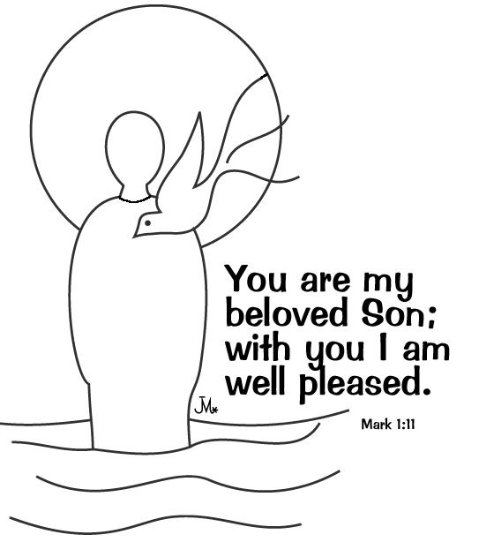

Sunday January 11th 2026
Baptism of Christ
Geoff Hurst - Service of the Word

Please note all services will be held in the Parish Hall for the present.

Hymns :- All H&W
246 Take my life
251 The holly and the ivy
164 Lord Jesus Christ
166 Lord the light of your love.

Organist (Keyboard) Mr. John Keate

NOTICES
Week of Prayer of Christian Unity,
18th – 25th Jan

Loving God, You have called us to unity. May our response to Your call lead us to actively seek justice and reconciliation and share Your light with the world. Amen.
Daily readings and prayers available at:
WPCU-2026-English-Pamphlet.pdf

Benefice Motto, 2026!
Something to give some prayer and thought to for our new motto. Suggestions to Rev Gill, please. Thank you to those who’ve contributed. We’ll decide this at the next PCCs.

