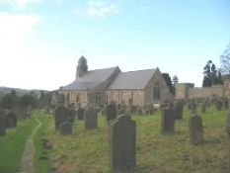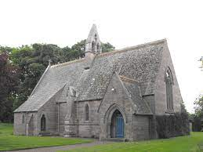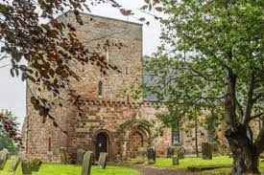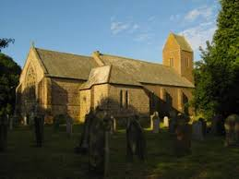
The Flake Parishes of
Ford, Lowick, Ancroft, Kyloe and Etal

A very warm welcome to you, especially if you are visiting.
Please take this sheet home with you and use it as a basis for prayer.
Children are welcome in all our services.

Sunday 18th January
Lowick 9.15am Holy Communion
Etal 11 am Holy Communion

Sunday 25th January
Conversion of Paul
Lowick 9.15am Holy Communion
Etal 11am Holy Communion

Sunday 1st February 2026
Lowick 9.15am Holy Communion
in Village Hall
Etal 11am Holy Communion

Sunday 8th February
Lowick 9.15am Holy Communion
Etal 11am Holy Communion

Revd Charlotte Osborn (Vicar) 01289 388591 ceosborn@mail.com 07957 367457
Revd Alex Firman (Assistant Curate) 07935 732811
alex_firman@hotmail.co.uk
Today Isaiah addresses us – the coastlands, and we meet John the Baptist again in fuller measure, as he describes Jesus as the Lamb of God who takes away the sins of the world – words we repeat each week before we come to receive bread and wine.

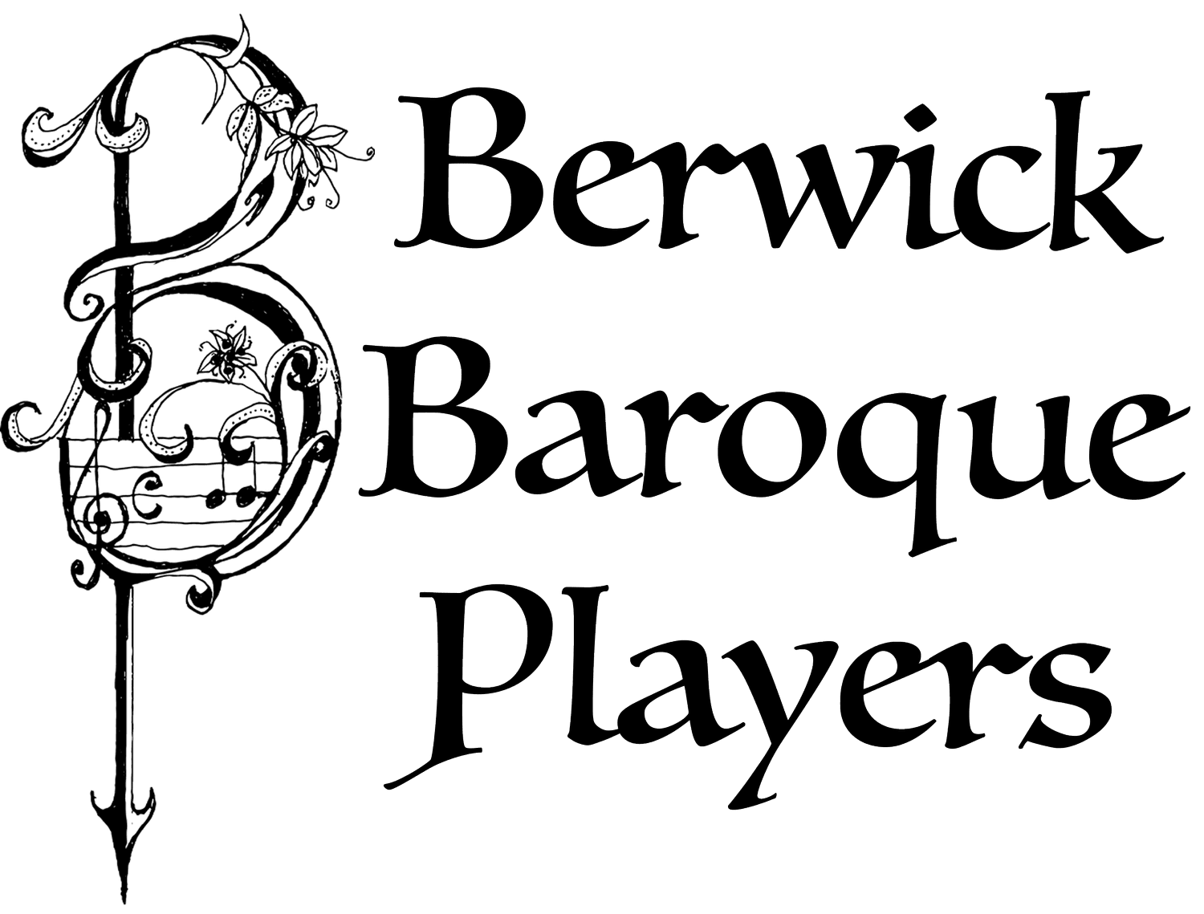
On Thursday 22nd January from 6.30 – 8pm (note slight change of time) we are kindly invited by George and Jane Farr to Pallinsburn House for drinks and canapes and a New Year Concert given by the wonderful Berwick Baroque. Monies raised will go towards the installation of a much-needed loo and servery in Ford Church. Tickets booked with Rosanna on RMcCorkell@savills.com or from Charlotte, for a suggested donation of £20 on the door

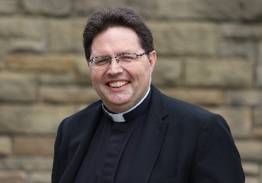
Please mark the date of Saturday January 31st when the PCC’s from all our parishes will meet for a morning of prayer and vison casting with The Very Revd Lee Batson, Dean of Newcastle Cathedral, at The Hemmel on Fenham Farm. As we look out to Lindisfarne, so we hope to continue to build on the foundations laid by Aidan and Cuthbert for the churches in our parishes as we trust God for the future. 9am until 1pm, primarily for PCC members but open to others who would like to be part of this – please all register with dee.colam@gmail.com by 25th January since there will be a breakfast roll and lunch provided!

For our prayers
Please continue to pray for all who suffer in body, mind or spirit, especially Andrew Watson, Heather Piper, Chloe French, George Hall, Gail Calder, Sam Quilty. We rejoice with Kate and James who will marry at Ford on Saturday.
We remember all who have recently died and those who mourn them, including the family and friends of Jim Turner (funeral in Ancroft Church 30th January), Derek Moffat, and those whose anniversaries of death fall at this time: Rita Oliver.

Other news
Davey Greene, a member of our youth group from Lowick, is training to run the Edinburgh half marathon in March this year in aid of Macmillan Cancer Support. He would be very glad of any encouragement in the form of sponsorship or donation and there are flyers at the back of church with details of how to give.

Norham Deanery Development Group meets in Holy Island vicarage at 11am on Tuesday 3rd February.
Men’s Breakfast Saturday 7th February in the White Swan Lowick 8.30am-10am. Book with Kevin on 07530 000941.

Ford and Etal PCC meets in the Estate Office at 5.30 pm on Tuesday 10th February.

Soup Saturday Lowick Village Hall 14th February 12-1.30pm.

The next gathering of DDG’s (Deanery Development Groups) across the Diocese will be at St Aidan’s, Morpeth on Saturday 21st February from 10am. An open meeting to discuss Buildings for Mission, including fundraising opportunities, Net Zero resources, the 101 Sustainable Churches Checklist, and a new calculator tool from the National Churches Trust to demonstrate the social impact of your church. Speak to Charlotte for a lift.
St John the Baptist, Lowick is registered on #easyfundraising which means you can raise free funds for them as you shop online this year, at no extra cost!
All the big names like John Lewis & Partners, Argos, eBay and more are ready to donate. Every donation makes a difference. Please sign up before midnight 29th January and you could win a £500 donation:
https://join.easyfundraising.org.uk/stjohnlowick/f43jbj/s2s/KlKNhASV/SE866/facebook/
We will shortly set up pages for Ford and Etal and Ancroft too.

Ash Wednesday 18th February. Holy Communion with Imposition of Ashes at both Etal and Lowick at 9.30am.

Parish Contacts

Ancroft Leigh Yorke 07716 116739
Etal Andrew Joicey 01890 820540
Ford Kathleen Holmes 07951 099668
Lowick Niall Cartlidge 07850 876246

Websites: www.achurchnearyou.com
Instagram: https://www.instagram.com/the_flake_churches/
Facebook: the_flake_churches

Other licensed clergy

Revd Margaret Sentamu 077871 204745
Canon Nick Sagovsky
Revd Marion Penfold 01289 305664

