Sunday 18th January 2026
Welcome to our service of Holy Communion
Led by Rev Liz Rowles

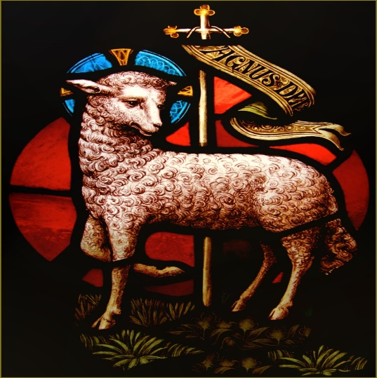

Hymns
640 The Church's One Foundation
Will you come and Follow me (see below)
673 There is a redeemer
132 Father hear the Prayer we offer
499 O Happy Day

Will you come and follow me

Will you come and follow me if I but call your name?
Will you go where you don't know and never be the same?
Will you let my love be shown?
Will you let my name be known?
Will you let my life be grown in you
And you in me?
Will you leave yourself behind if I but call your name?
Will you care for cruel and kind and never be the same?
Will you risk the hostile stare
Should your life attract or scare?
Will you let me answer prayer in you
And you in me?
Will you let the blinded man see if I but call your name?
Will you set the prisoners free and never be the same?
Will you kiss the leper clean
And do such as this unseen?
And admit to what I mean in you
And you in me?
Will you love the "you" you hide if I but call your name?
Will you quell that fear inside and never be the same?
Will you use the faith you've found
To reshape the world around
Through my sight and touch and sound in you
And you in me?
Lord, your summons echoes true when you but call my name
Let me turn and follow you and never be the same
In your company I'll go
Where your love and footsteps show
Thus I'll move and live and grow in you
And you in me

Readings
Isaiah 49. v1-7
1 Corinthians 1. v1-9
Gospel
John 1.29-42

In our Prayers
Anne Frost, Lily Barnes, Margaret Curtis, Eileen Kilner, Debra Maskrey, Brenda Millward, Freda Paulson, Sofia Ribeiro, Joyce Ross and Ray and Catty Smith

In Memoriam
Ted Campbell, John Maddocks, Arthur Pye, Penny Stead, Clifford Stubbins and Frances Vann

This week’s services

Prayer Service at St Winifred’s Church – Today at 3pm
To mark the start of week of prayer for Christian Unity. All welcome.

Holy Communion and Bible Discussion Group at St John’s – Tuesday 20th January 10:00am
Please feel free to come to the Bible Discussion Group at 10:30am if unable to attend from 10am. Join us for our Bible Study Discussion on Isaiah - New Book of the Bible for the New Year. Look forward to seeing you there!

Holy Communion at St Paul’s – Wednesday 21st January 9:45am
Followed by refreshments, all welcome.

EVENTS AND NEWS

Coffee and Conversation at St John’s – Monday 19th January 1:30pm-3:30pm
All welcome.

Prayer and Meditation at St John’s – Thursday 22nd January at 7:30pm
The theme is Light of the World as we look to God to give us His light in this New Year. Everyone welcome.

Candlemass Party at St John’s – Saturday 7th February 5pm-7pm
Bring and Share meal, tea/coffee provided or bring your own bottle (and glasses!) Fun and games for all ages! This is a free event (but donations are very welcome)

Next Sunday’s services
Patronal Service at St Paul’s (joint service) – 10:30am

Next Sundays Rota
No service at St John’s next week – joint service at St Paul’s

Peace be with you,
Liz Rowles. Revd Liz Rowles
Team Vicar at St John’s, Heaton Mersey &
St Paul’s, Heaton Moor
E: revlizrowles@outlook.com T: 0161 964 3928
Jacquie Brennan (St John’s) T: 07880 932 171
Peter Smith Reader Emeritus. T: 07709649789. petercelia16@gmail.com.
Anne Pinkerton (admin) stjohnsandstpaulsa@gmail.com
Jonathan Tennet Church Warden (St John’s) E: jonathantennet@yahoo.co.uk
Alan and Joan Lowe Deputy Church Wardens (St John’s) E: lowejoan13@gmail.com or lowealan3@sky.com
Ann Worthington Deputy Church warden St Paul’s T: 07831 747416
Visit our A Church Near You page:
https://www.achurchnearyou.com/church/15829/service-and-events/events-all/
https://www.achurchnearyou.com/church/15828/
Or visit the QR code:



